6 Secrets On How to Choose, Cook and Eat a Perfect Steak
Now when you know much about the popular steak cuts and gradations of cooking it is time to get familiar with 6 secrets on how to choose, cook and eat a perfect steak.

1. NO FROZEN Steaks
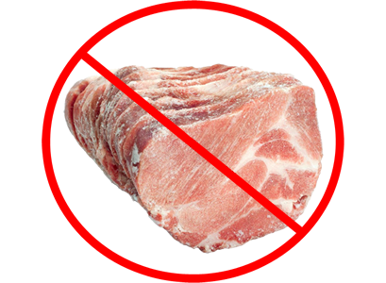
There is nothing worse than a slab of meat that was cooked right after being taken out from the freezer. To be baked or grilled evenly, it should be thawed out first. Otherwise, it will be raw inside and burnt outside. Such a steak won’t look or taste good for sure.

Before being grilled or pan-fried, there should be no moisture on the steak. To achieve that palatable deep-brown crust on it, it should be seared at about 150°C (300°F). High-temperature searing ensures crusty outside and very tender and flavorful inside of the steak. It is moisture what usually doesn’t allow the meat to get a brown crust.
If the steak has no brown crust, it means that it was either moist or frozen before being put on a grill or pan.

2. Pay Attention to Its Appearance and Size
Color: It is important that meat is bright-colored. Stay away from lifeless pale and gray slabs of meat. You are a lover of good food but not a zombie.
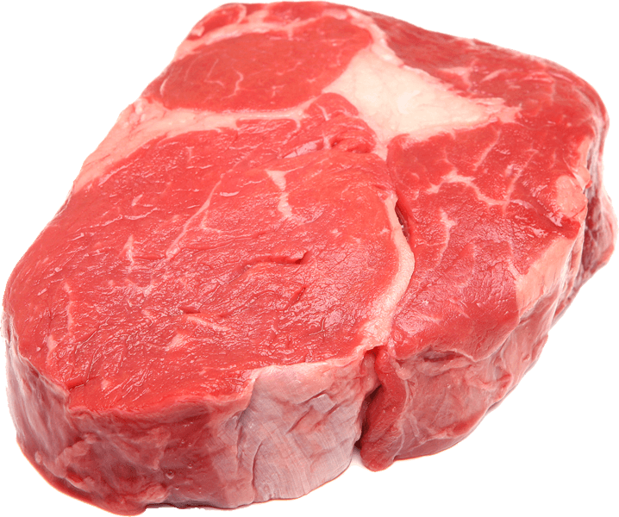
Thickness: Steaks are juicier, tenderer, and tastier when cut in thicker slabs. Keep in mind that except for being less tasty, puny steaks are more likely to be overcooked and, thus, dried out. A good steak is, at least, 1-inch thick, but if you want a perfect slab of mean, don’t choose those ones that are less than one and a half inches thick.

3. Check It From the Inside
This is exactly how a properly-cooked steak looks like. 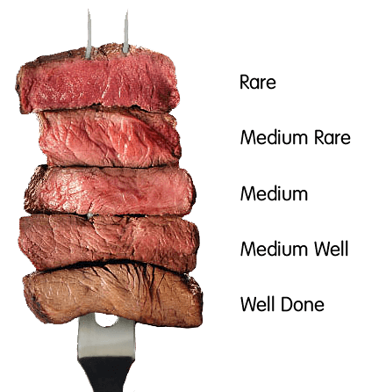
Give attention to its color: it should be consistent throughout the whole slab and may be brighter or darker, depending on the gradation of cooking. This is how you want your steak to look like.
This is what you really don’t want to have on your plate.
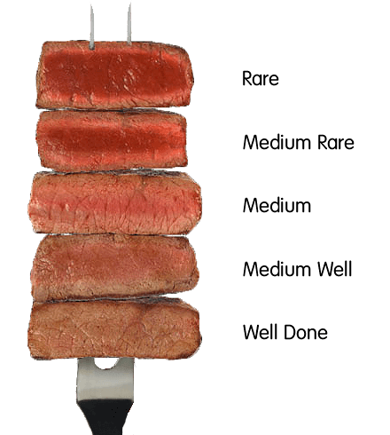
This is exactly how a steak looks if cooked while being frozen. When you slice into the slab, on the inside you will see brighter and darker layers meaning that it was cooked unevenly. A properly-cooked steak should NEVER look like this.
That’s why it is extremely important to thaw a steak out before grilling it. It takes about thirty minutes or even more to bring the meat to normal temperature. Don’t be in a hurry when it comes to cooking a perfect steak.

4. Wait before Starting to Eat
Wait about 5-10 minutes before cutting into your steak. The cooked steak needs this time for its juices, which have been concentrated in the center of the slab during the cooking process, to spread back out.
If you start cutting the steak into smaller pieces the very moment it arrives, you are likely to spill its juices out on the plate. In this case, your steak will probably taste dried out and flavorless.
To enjoy a perfectly-cooked steak, let its juices reabsorb. There is no reason to worry about your steak getting cold.
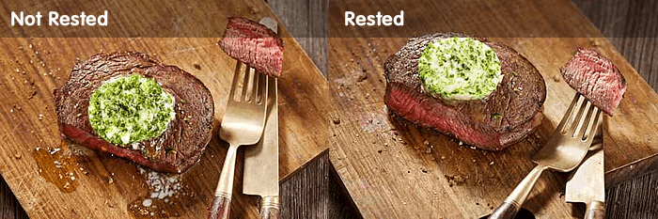
You should know how much time ago your steak was cooked before being served. If it is piping hot, wait for a while.

5. Slice It Properly
The way you eat your steak is of great importance: its tenderness greatly depends on how you slice it.
Have a closer look at the meat and you will see thin lines that go down its length. This is how a grain looks like. If you don’t want your meat to be chewy, then you better cut it against the grain. Otherwise, be ready to end up with the beef that is very tough to deal with.

6. Don’t Add Any Sauce or Gravy
Perfectly-cooked and seasoned meat doesn’t need to be served with sauce or gravy. While gravy makes tough steaks tenderer, sauces mask their natural flavor. If the steak is done properly, all steak sauces are just out of place.
You pay for the gorgeous natural taste of premium meat, why spoil it with sauces?

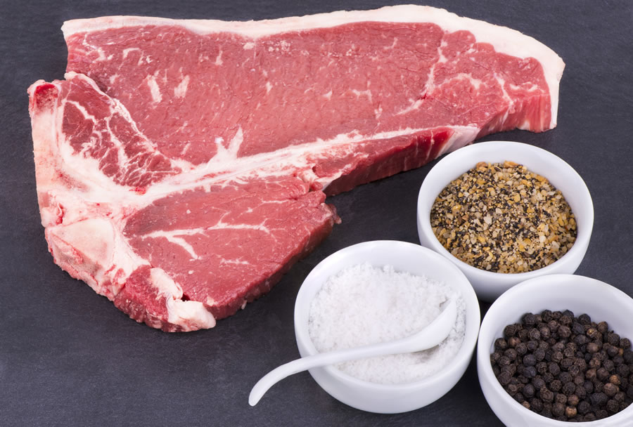
A perfect steak has to be no more than just seasoned with salt and pepper. Those who want to enjoy more intense flavors can dress it with some olive oil and garlic paste, and no marinades are acceptable.

Keep in mind that adding extra sauces is a lot like meaning that the steak doesn’t taste properly by itself. To see how tasty and juicy the steak really is, forget about any kind of dressing. However, tastes differ, so be free to experiment.

