ID | Summary | Description | Environment
1 | The button (down arrow) does not perform any actions | 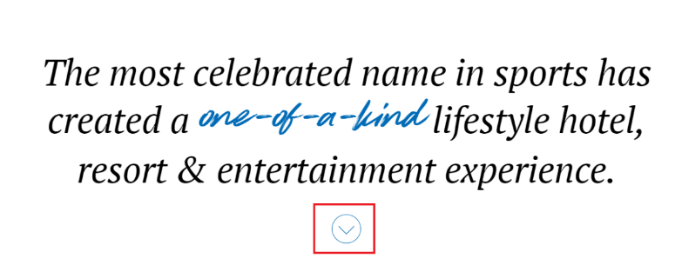  When the button is pressed, the page does not drop  Steps to Reproduce:  - Follow the link https://test.glivera.com/team/tasks/test_works/for-testing/index.html  - Press the button  Exp: when user hover the button, it should increase, when pressed, the page should drop to the first photo  Act: when user hover the button, it increases, but after pressing no activities occur | OS: Win 10 x64  Browser version: Google Chrome  102.0.5005.63
2 | The icon button does not drop the page | 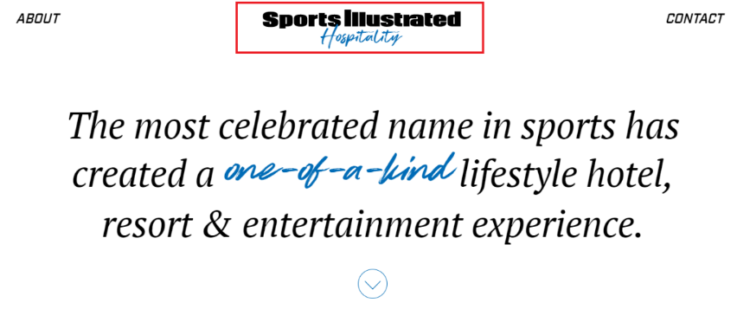  At the top of the page when you click the icon button, the page does not drop  Steps to Reproduce:  - Follow the link https://test.glivera.com/team/tasks/test_works/for-testing/index.html    - Press the button  Exp: when button pressed, the page should drop to the first photo  Act: after pressing no activities occur | OS: Win 10 x64  Browser version: Google Chrome  102.0.5005.63
3 | The button is underlined all the time | 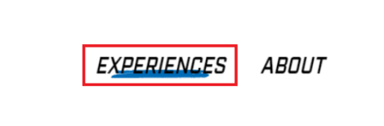  The button is underlined when the cursor is not on it  Steps to Reproduce:  - Follow the link https://test.glivera.com/team/tasks/test_works/for-testing/index.html  - Pay attention to upper left corner  Exp: the button should be underlined when the cursor is on it  Act: button underlined all the time | OS: Win 10 x64  Browser version: Google Chrome  102.0.5005.63
4 | The buttons at the top do not perform any action | 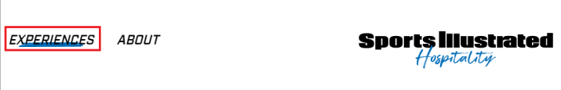  The buttons “EXPIRIENCES”, “CONTACT”, “PRESS”, “SI” do not perform any actions after clicking on them  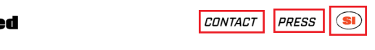  Steps to Reproduce:  - Follow the link https://test.glivera.com/team/tasks/test_works/for-testing/index.html  - Press the buttons: “EXPIRIENCES”, “CONTACT”, “PRESS”, “SI”  Exp: after pressing one of the buttons “EXPIRIENCES”, “CONTACT”, “PRESS”, “SI”, the page should go down to the next photo  Act: after pressing on buttons no activities occur | OS: Win 10 x64  Browser version: Google Chrome  102.0.5005.63
5 | No action is taken after pressing the button | 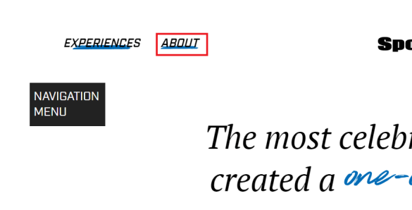  The button “ABOUT” do not perform any actions after clicking on it  Steps to Reproduce:  - Follow the link https://test.glivera.com/team/tasks/test_works/for-testing/index.html  - Press the button “ABOUT”  Exp: after pressing the button, the page should go down to the information block  Act: after pressing on button no activities occur | OS: Win 10 x64  Browser version: Google Chrome  102.0.5005.63
6 | The photo on the site does not match the photo in the requirements | 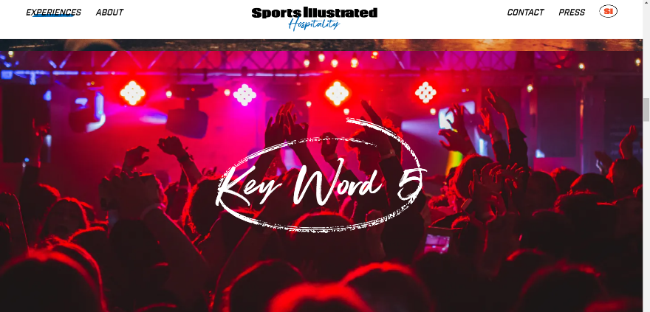  The photo on the site does not match the photo in the requirements  Steps to Reproduce:  - Follow the link https://test.glivera.com/team/tasks/test_works/for-testing/index.html  - Scroll page down to “Key word 5”  - Pay attention to photo on the background  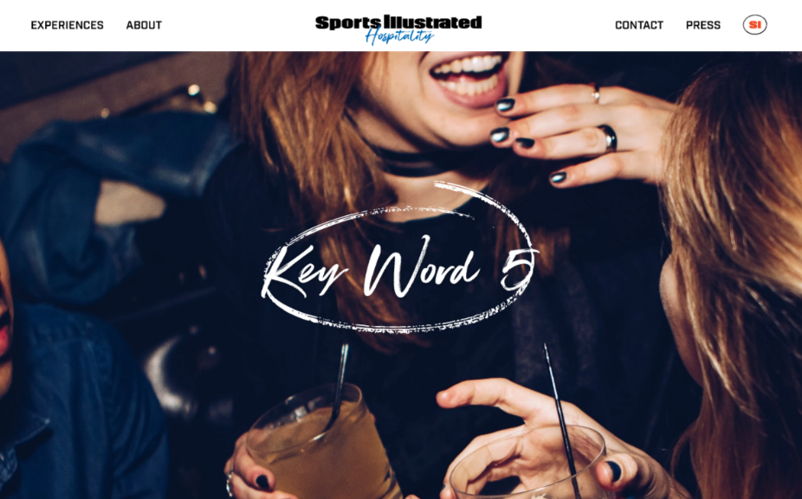  Exp:  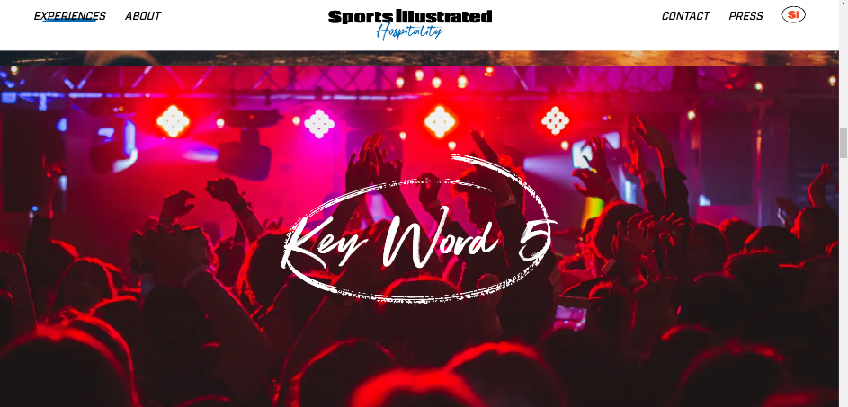  Act: | OS: Win 10 x64  Browser version: Google Chrome  102.0.5005.63
7 | The image size is smaller than required | The width of the image does not match the width of the page  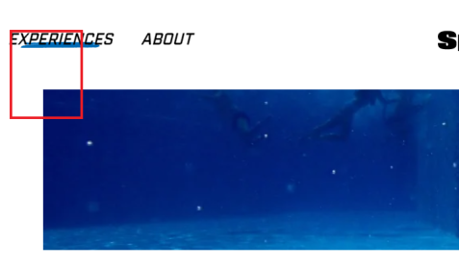  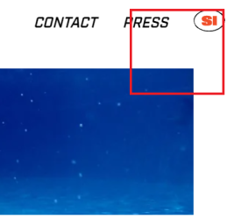  Steps to Reproduce:  - Follow the link https://test.glivera.com/team/tasks/test_works/for-testing/index.html  - Scroll page down to photo with divers  - Pay attention to photo  Exp:  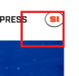  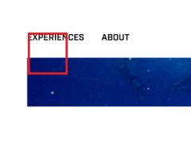  Act: | OS: Win 10 x64  Browser version: Google Chrome  102.0.5005.63
8 | The text font does not meet the requirements | 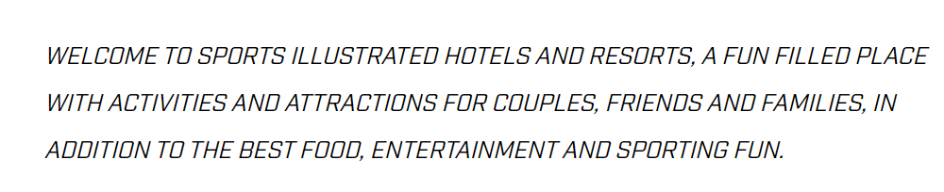  Text font on site is PT Serif Italic  Steps to Reproduce:  - Follow the link https://test.glivera.com/team/tasks/test_works/for-testing/index.html  - Scroll page down to photo with divers  - Pay attention to text under the photo  Exp: text written in Indystry Bold font  Act: text written in PT Serif Italic font | OS: Win 10 x64  Browser version: Google Chrome  102.0.5005.63
9 | No action is taken after pressing and hover the button | 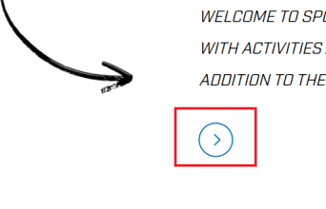  The button does not respond to pointing or pressing  Steps to Reproduce:  - Follow the link https://test.glivera.com/team/tasks/test_works/for-testing/index.html  - Scroll page down to photo with divers  - Pay attention to button under the text    Exp:    Act: | OS: Win 10 x64  Browser version: Google Chrome  102.0.5005.63
10 | The text font does not meet the requirements | Text font on site is PT Serif Italic  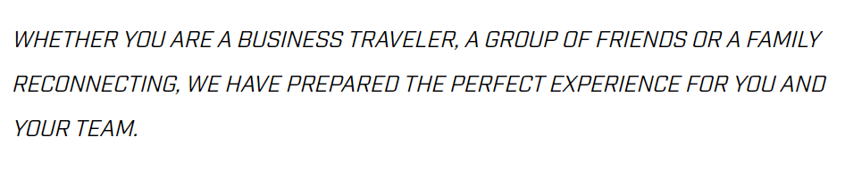  Steps to Reproduce:  - Follow the link https://test.glivera.com/team/tasks/test_works/for-testing/index.html  - Scroll page down to experience block  - Pay attention to text under the photo  Exp: text written in Indystry Bold font  Act: text written in PT Serif Italic font | OS: Win 10 x64  Browser version: Google Chrome  102.0.5005.63
11 | There is no photo on the page | 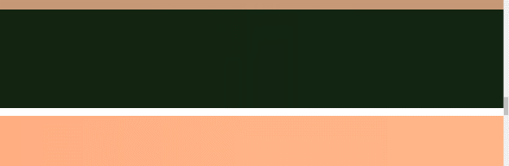  There is no photo on the page  Steps to Reproduce:  - Follow the link https://test.glivera.com/team/tasks/test_works/for-testing/index.html  - Scroll page down to experience block  - Pay attention to photo before experience block  Exp:  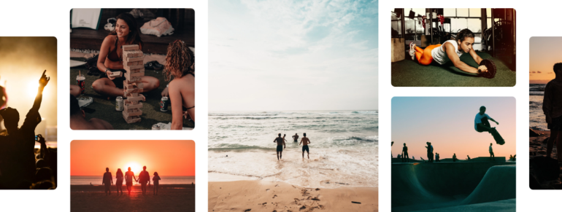  Act: 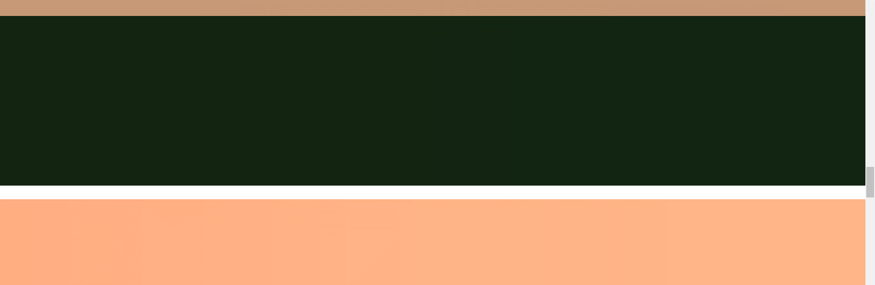 | OS: Win 10 x64  Browser version: Google Chrome  102.0.5005.63
12 | No action is taken after pressing and hover the button | The button does not respond to pointing or pressing  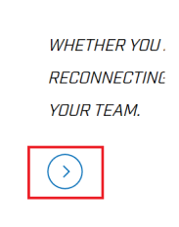  Steps to Reproduce:  - Follow the link https://test.glivera.com/team/tasks/test_works/for-testing/index.html  - Scroll page down to experience block  - Pay attention to button under the text  Exp:  Act: | OS: Win 10 x64  Browser version: Google Chrome  102.0.5005.63
13 | There is no design element | 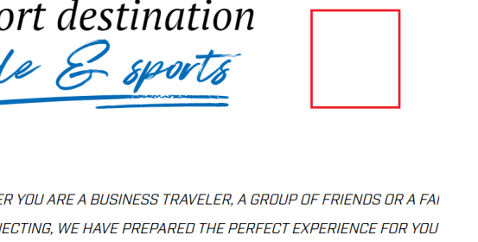  No "arrow" in the "experience" block  Steps to Reproduce:  - Follow the link https://test.glivera.com/team/tasks/test_works/for-testing/index.html  - Scroll page down to experience block  - Pay attention to place over the text  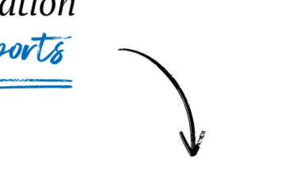  Exp:  Act: | OS: Win 10 x64  Browser version: Google Chrome  102.0.5005.63
14 | The design does not match the layout | There is no indentation between blocks as in the page design    Steps to Reproduce:  - Follow the link https://test.glivera.com/team/tasks/test_works/for-testing/index.html  - Scroll page down to contact block  - Pay attention to place under the text  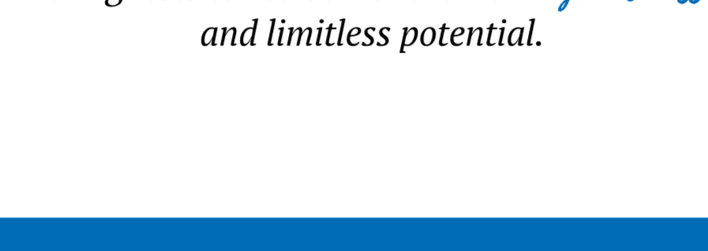  Exp:  Act:   | OS: Win 10 x64  Browser version: Google Chrome  102.0.5005.63
15 | The text font does not meet the requirements | Text font on site is Industry Book with cursive  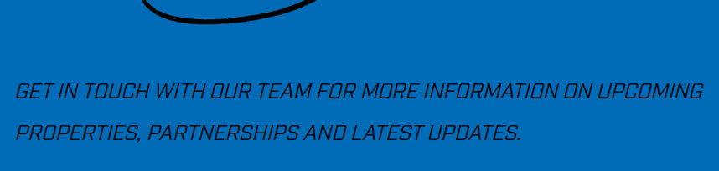  Steps to Reproduce:  - Follow the link https://test.glivera.com/team/tasks/test_works/for-testing/index.html  - Scroll page down to contact block  - Pay attention to text in block  Exp: text written in Industry Bold font  Act: text written in Industry Book with cursive | OS: Win 10 x64  Browser version: Google Chrome  102.0.5005.63
16 | Side title does not match page size | Side title does not match page size (titles: “ABOUT US”, “EXPERIENCES”, “CONTACT”)  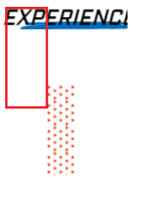  Steps to Reproduce:  - Follow the link https://test.glivera.com/team/tasks/test_works/for-testing/index.html  - Scroll page down to block with side title  - Pay attention to side title  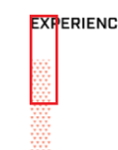  Exp:  Act: | OS: Win 10 x64  Browser version: Google Chrome  102.0.5005.63
17 | The "about" button is not underlined on “about” page | 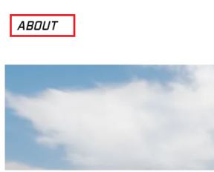  The "about" button is not underlined on “about” page  Steps to Reproduce:  - Follow the link https://test.glivera.com/team/tasks/test_works/for-testing/index.html  - Move the cursor to the navigation menu  - Press about button  - Pay attention to upper side of page  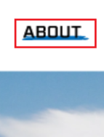  Exp:  Act:  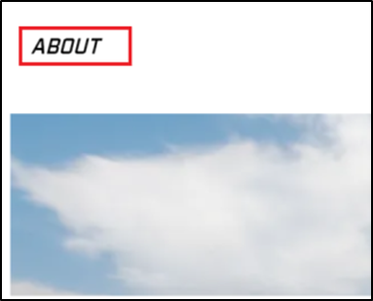 | OS: Win 10 x64  Browser version: Google Chrome  102.0.5005.63
18 | The text font does not meet the requirements |   The text font does not meet the requirements  Steps to Reproduce:  - Follow the link https://test.glivera.com/team/tasks/test_works/for-testing/index.html  - Move the cursor to the navigation menu  - Press about button  - Scroll down to “Locations” block  - Pay attention to second photo in block  Exp: text written in SuperFlyTwo font  Act: text written in Industry Book font | OS: Win 10 x64  Browser version: Google Chrome  102.0.5005.63
19 | The font of the word "team" does not meet the requirements | 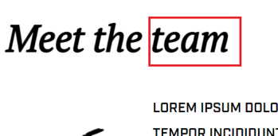  The font of the word "team" does not meet the requirements  Steps to Reproduce:  - Follow the link https://test.glivera.com/team/tasks/test_works/for-testing/index.html  - Move the cursor to the navigation menu  - Press about button  - Scroll down to “The team” block  - Pay attention to header of block  Exp:  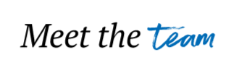  Act: | OS: Win 10 x64  Browser version: Google Chrome  102.0.5005.63
20 | The indentation on the left is greater than the indentation on the right | The indentation on the left is greater than the indentation on the right  Steps to Reproduce:  - Follow the link https://test.glivera.com/team/tasks/test_works/for-testing/index.html  - Move the cursor to the navigation menu  - Press about button  - Scroll down to “The team” block  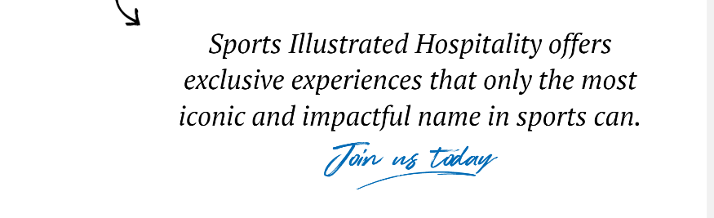  - Pay attention to last paragraph  Exp:  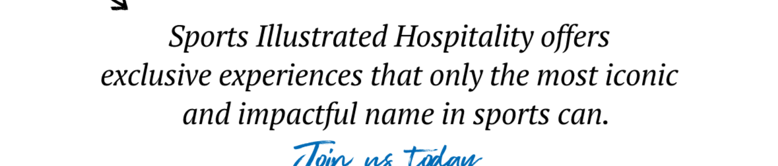  Act: | OS: Win 10 x64  Browser version: Google Chrome  102.0.5005.63

Questions to BA:
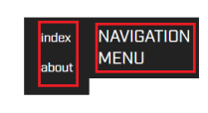
- Will there be a navigation menu in the release version of the site? If yes, it have bug with font
- In the requirements of the buttons “PRIVACY POLICY” and “PRIVACY POLICY” are not highlighted when hovering over them, but the site is highlighted, where is the error?
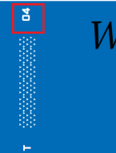
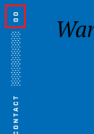
- In the requirements on the page about the "contact block" has the number 00, and on the site 04, an error in the requirements or is it a bug?

