TOP-20 the Best Night Clubs In The World
True fans of techno, electronic music and underground parties know how important it’s to choose the right place for a party with a unique atmosphere. Rave scene around the world continues to evolve, experimenting with locations and formats and offering more and more options for quality entertainment.

We’ve compiled a selection of the 20 best nightclubs in the world that specialize in electronic, techno and house music. Each of them is listed in the ratings of top clubs from reputable magazines and helps to shape not only their local music scene, but also influences the world.

Berghain/Panorama Bar, Berlin
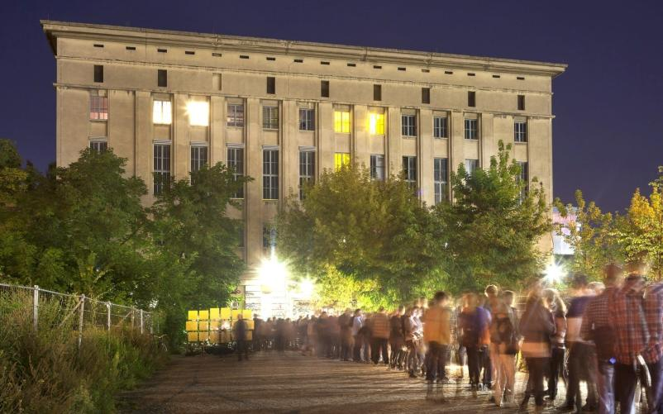
Probably everyone who’s even slightly connected with the music industry has heard about Berghain.
This is an iconic and one of the best techno clubs in the world, which opened in 2004 as the reincarnation of another popular Berlin club Ostgut. Since 2008 Berghain has consistently ranked in the Top-20 of the best clubs in the world according to DJ Mag.
The name of Berghain combines the names of two Berlin districts — Kreuzberg and Friedrichshain. The club itself is located in the building of a former power plant on the border of these two areas.
Berghain is famous for its open-minded atmosphere and tight face control. There are no clear guides on how to pass the control at the entrance (nobody knows). Regular visitors prefer to say that this’s a matter of chance and increasingly depends on the mood of the face-checkers at the entrance.
The most famous techno musicians and DJs of the world perform in the Berghain. For many electronic musicians, Berghain is the top of all dreams of venues where they would like to play their set. In ordinary clubs there is a concept of a headliner who plays in the most active period of time. There is no such thing at Berghain, because only significant musicians perform here.
Berghain has several stages: the main one with sets from more mainstream musicians, a dark stage with hard techno and Panorama Bar, an upstairs space dedicated to house music.
One of the main features of the club is absolute secrecy. Photo and video shooting are prohibited in it and only those who‘ve visited it at least once know what is going on inside.
Address: 70 Am Wriezener Bahnhof, Berlin

Bassiani, Tbilisi
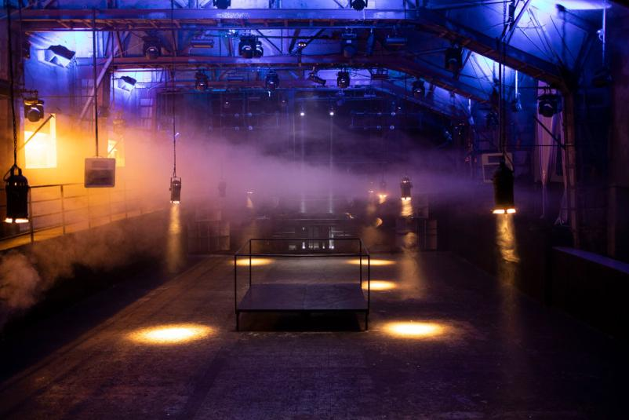
Bassiani is considered to be one of the most popular techno clubs in the world, attracting many electronic music fans from all over the world.

Bassiani — the biggest club in Georgia, which is located in the country's capital, Tbilisi. It opened in 2014 and is located in the building of the largest sports facility in the city, the Dynamo Arena. One of the club's features is the main dance floor, which was built on the site of an abandoned arena pool.

Bassiani can accommodate about 1200 people. Among the artists at the parties are both local Georgian techno DJs and world stars of the electronic scene. The atmosphere of brutal Georgian techno with a very dark musical sound is typical here, so the club will definitely appeal to fans of this style.

Like other large underground clubs, Bassiani positions itself as a free space where everyone can relax and plunge into the music. It’s distinguished by careful face control, photo and video shooting in the club is prohibited.
In addition to the main stage, Bassiani has another smaller separate hall called «Horum», where a series of LGBT parties are held.
Address: 2, Akaki Tsereteli Ave, Tbilisi

Printworks, London
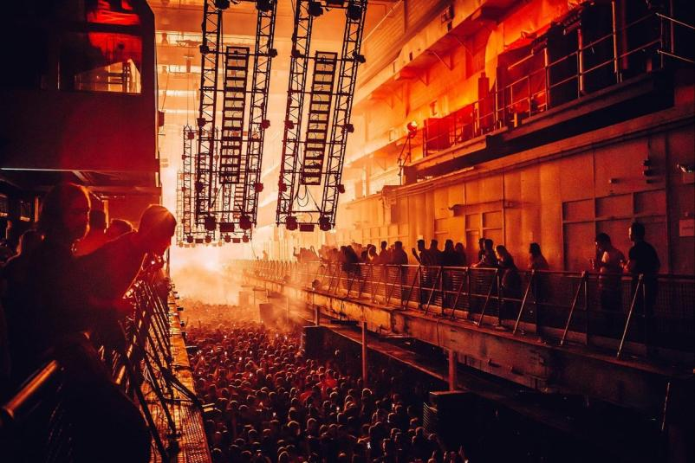

For almost every electronic music fan, London's Printworks club is one of the world's premier clubs.

Printworks opened in 2017 in a former newspaper printing office in Southwark, Central London. The club's team turned a unique location in the capital of Great Britain into a center of musical culture and a safe space for people to freely relax and express themselves. Location has the original industrial aesthetics: brick walls, giant machines and printing presses were left in their original form, instead, stages, bars and other areas were built around them.

Printworks is described as an «experimental, multipurpose cultural venue». In six years of working it has turned into one of the main nightclubs not only in Great Britain, but also in the whole world. In 2021 Printworks took seventh place in the ranking of the 100 best clubs in the world according to DJ Mag magazine.

Printworks has hosted the most influential artists of today's electronic scene, including stars of the caliber of Aphex Twin, The Chemical Brothers and Bicep.

Unfortunately, in 2023, the club will stop working at the old location — the owner of the building decided to redevelop it into an office space. The club command hasn’t yet announced its future plans, but there is still time to enjoy the atmosphere of the iconic London location.

Address: 1 Surrey Quays Road, London

K41, Kyiv
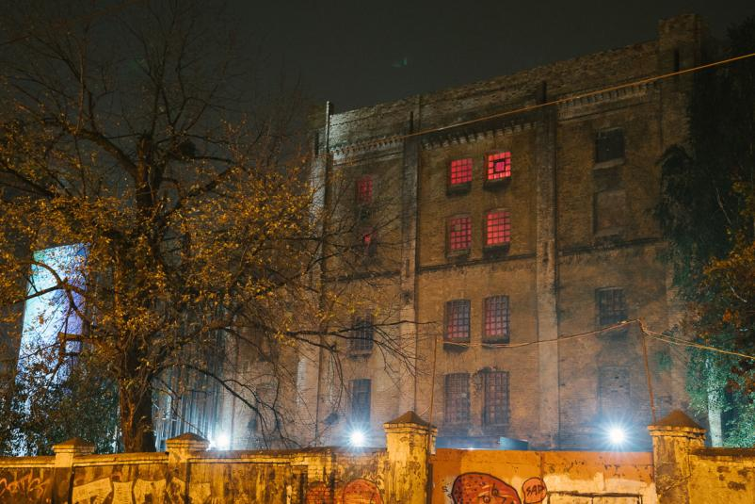

The Kyiv club at Kyrylivska, 41 (aka ∄ club) positions itself as a «safe non-binary space».

It opened in the fall of 2019 and in just a year took the status of the best underground club in Ukraine. Most often ∄ is compared with the Berlin Berghain and there are several reasons for it: serious face control, relaxed atmosphere, a ban on filming and hard music from the best world and Ukrainian DJs.

Another undeniable feature of K41 is industrial aesthetics. The club is located in the building of a former brewery, which the club team skillfully adapts depending on the concept of the party.

Before the lockdown in 2020, in ∄ took place perhaps one of the most liberated parties — in collaboration with the Berlin formation Pornсeptual, which explores sexuality and physicality.

What about the mysterious name. ∄ is a term which sounds like «THERE DOES NOT EXIST». Thus the team once again hints at the secrecy and mystery of the club, because everything that happens inside it remains there. The club doesn’t even maintain its own website and doesn’t have social networks. Only an unnamed Telegram channel works, where the organizers announce the dates of the parties and who will perform there.

Address: Kyrylivska Street, 41

KHIDI, Tbilisi
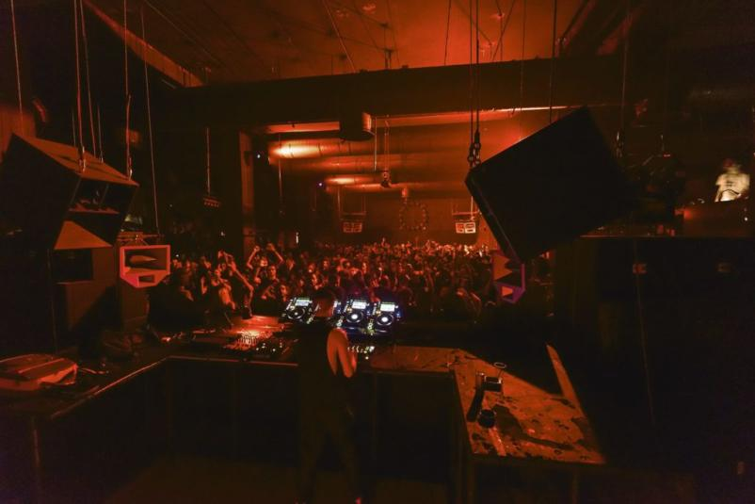
KHIDI, which means «bridge» in Georgian, is one of the most popular underground clubs in Georgia. It opened in the summer of 2016 and is located in the center of Tbilisi — under the Vakhushti Bagrationi Bridge.

The entire club room consists of three floors, on which there are stages with different genres of music, a small separate hall and an exhibition area. The club is designed for around 1000 people.

The music program at KHIDI is focused on a mix of great local and international techno artists. They can play live, hybrid or DJ sets. Big names in techno, like Boston 168, SHXCXCHCXSH, Scuba and others have already performed at the club.

In parallel with regular parties, the club team organizes avant-garde live performances with experimental music.

Address: President Heydar Aliyev Embankment, Tbilisi

Ministry of Sound, London
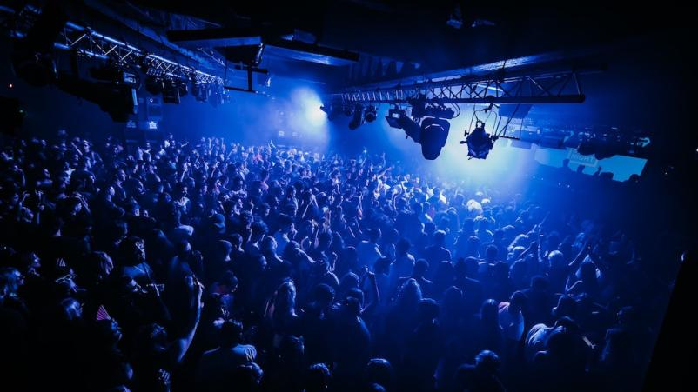
One of the oldest places on our list, which began work in 1991 and since that moment has remained in the top of the best nightclubs in the world.

The club's name and original logo are inspired by the emblems of British government ministries such as the Ministry of Defense. And the location itself is located in the premises of an old abandoned bus garage in South London.

The club has two halls, and in general the space can accommodate more than 1500 people. The main dance floor The Box is located on the first floor, the second one is on the balcony. The music is the same on both.

Also in the Ministry of Sound there are separate rooms and premises. They usually host parties dedicated to certain styles of music: trance or house.

The main emphasis at the Ministry of Sound has always been on sound quality. So in 2016, Ministry of Sound became the first nightclub to partner with the Dolby sound system. This now allows artists to control their own soundtracks, deliver specific sounds to the right parts of the dance floor, and create a more immersive experience for listeners.

Address: 103 Gaunt Street, London

Tresor, Berlin
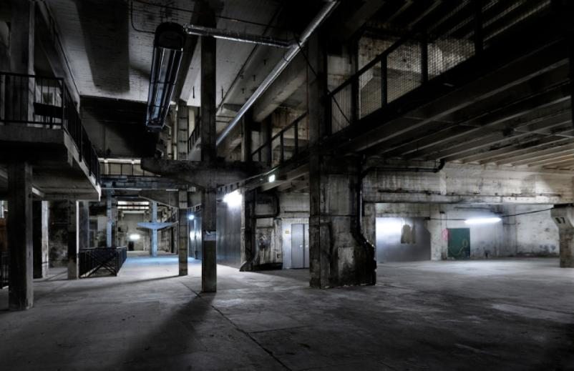
Today Berlin is considered the capital of techno music and the city with the most parties and clubs. Therefore, another location that fans of electronic music and the underground culture should visit is Tresor.

The history of the club began in 1991 in the basement at Leipzigerstrasse 126-128. In 2005, due to the demolition of the building, club was closed and then reopened in 2007 in the now famous building of the three-story old boiler house on Köpenickerstrasse.

Tresor had a significant impact on the development and formation of the techno scene not only in Germany, but throughout Europe. The unique sound installations of the club have become its hallmark — according to the team, even ambient sounds here like hard techno.

The club's location consists of three rooms connected by various tunnels and stairs. The room can accommodate about 1500 people.

In addition to its own parties, Tresor holds a variety of events in Berlin. From the reboot of Berlin's festival Atonal, an annual sound and visual arts festival, to art exhibitions in collaboration with neighboring contemporary gallery OHM.

More about the club can only say its slogan: «Trezor never sleeps».

Address: Köpenicker Str. 70, Berlin

DC-10, Ibiza
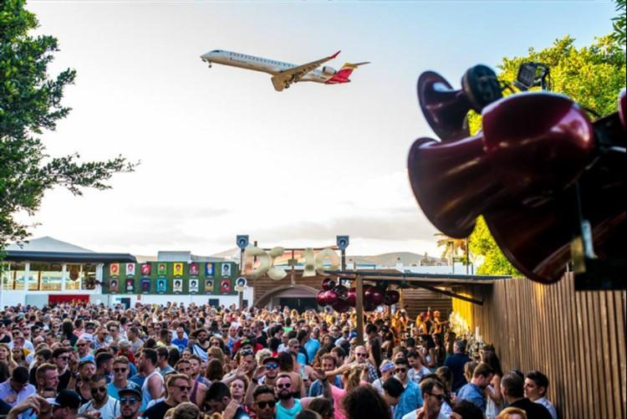
One of the best underground clubs in the world, of course, is located in Ibiza — the Mecca of hangouts and parties. Club DC-10 opened in 1999 and has become one of the main locations for fans of electronic music.

The DC-10 is housed in a former aircraft hangar near the Ibiza airport runway. This is what makes the location quite unusual and attractive.

From the very beginning club focused on acid house and minimal techno, and its residents were such popular musicians like Tania Vulcano, Loco Dice, Luciano and Ricardo Villalobos. One of the hallmarks of the location has become a series of CircoLoco parties, which are held on mondays and gather electronic music fans around the world.

While many clubs in Ibiza are looking to expand and reach ever larger audiences, DC-10 is taking a different approach. The club team prefers to keep their underground style and place more emphasis on music and guest artists, rather than on flashy special effects. Unlike other clubs, DC10 makes almost no massive advertising of their parties, thus implying that the guests of any of the future parties already know where and when it will take place.

Address: PM-802, Sant Josep de sa Talaia, Ibiza

Closer, Kyiv
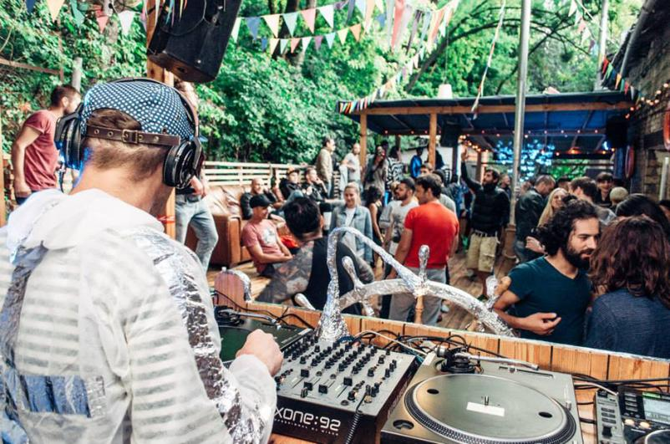
In 2013 Kyiv acquired, perhaps, one of the main club locations in Ukraine — Closer. From that moment to the present day, the club (together with the art space) has been operating on the territory of a former ribbon weaving factory in the industrial quarter of Kyiv. And the ribbon factory itself has turned into a whole art cluster, which consists not only of Closer, but also of several separate nightclubs, art and tattoo studios, galleries and bars.

For 9 years of work Closer has grown into an underground club of the European level, which, along with other iconic techno-locations, is included in the top list of the world's best clubs almost every year. Closer is one of the best Ukrainian clubs, which announced Kyiv on the world electronic stage and in many ways influenced the development of the local scene.

The Closer team also has four own music festivals: Strichka, Am I Jazz, and the techno and electronic music festivals Brave! Factory and Black! factory.
Closer positions itself as a place for people with a developed taste, who are open to the new. The art club is well known outside of Ukraine, so there were many foreign guests among the artists at Closer parties. Objekt, Boston 168, Powder, Model 500, Red Axes and Marcel Dettmann — this is just a short list of headliners.

In addition to the territory of the club, Closer boasts the Forest Pier. This is a two-story open-air terrace in front of the entrance to the club, combined with bars and seating areas. Trees and plants, in the shade of which the Forest Pier is located, give a special atmosphere to all this.

Address: Nyzhneyurkivska Street 31, Kyiv

De School, Amsterdam
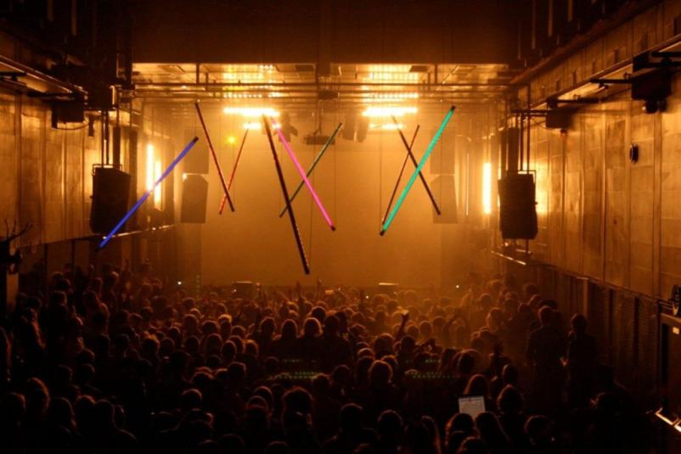

The Amsterdam De School began operating in 2016 on the premises of a former technical school. So its name really refers to its location.

The club with a capacity of about 700 people is made in the same school aesthetics of the 1960s: with long tiled corridors, large full-length windows at the entrance, former sports halls with original coloring and a dining room. The unusual design with Bauhaus accents and sculptures in the courtyard definitely makes this place stand out from the rest clubs.

De School is divided into several concert halls — the main one and a couple of smaller ones, and also has its own vegetarian cafe, exhibition space and garden.

De School specializes in underground house, techno and electronic music. One of the key features of the place is massive raves that will remind (or tell) you about the atmosphere of rebellious youth. In addition, in small concert halls the club's team arranges sets of cult Dutch DJs and bands, and sometimes shows art-house movies.

The style and aesthetic of the location itself also shaped the way parties are held here. A dark room is usually completely filled with smoke, so listeners can fully immerse themselves in the music without being distracted by visual cues.

Address: Doctor Jan van Breemenstraat 1, Amsterdam

The Warehouse Project, Manchester
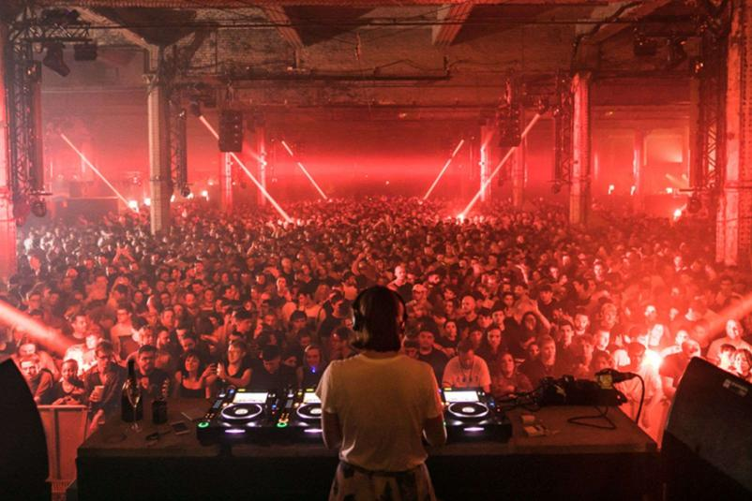

The Warehouse Project is another bright representative of the British electronic scene. The club opened in 2006 in the disused Boddingtons Brewery in Strangeways before moving to a building under Manchester Piccadilly station that had previously served as a bomb shelter for local residents. Today one of the largest British underground clubs can accommodate up to 10,000 visitors.

The main difference between The Warehouse Project and most other clubs is its concept: parties are held here during the limited season, and the club itself is not open all year round. The annual season lasts from September to the New Year period. Sometimes the work schedule includes one-time «off-season» parties, such as public holiday weekends.

Party headliners at The Warehouse Project are top electronic musicians such as Carl Cox, Sven Väth, Aphex Twin, Bonobo and Jeff Mills. In addition, the club's team places great emphasis on the development of the local electronic scene, inviting lesser-known British musicians to play.

In 2022, The Warehouse Project was ranked at 8 place on DJ Mag's list of the best clubs.

Address: Mayfield Train Station, The Depot, Manchester

Faust, Seoul
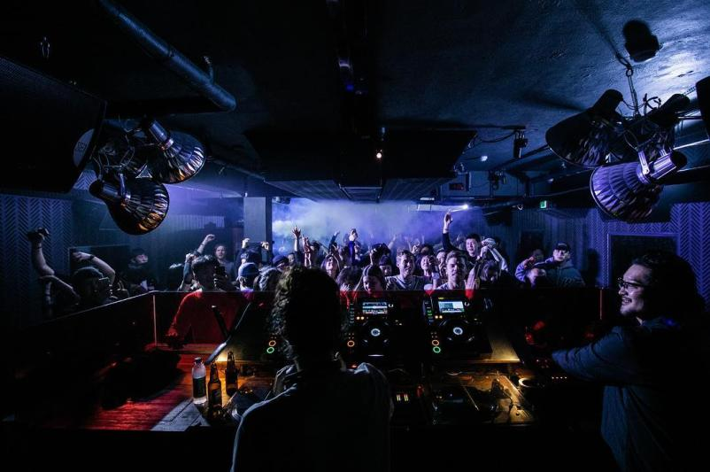

Faust Korean Club from 2015 is located in the heart of the Itaewon district, which is considered the center of Seoul's nightlife.

Unlike most Korean clubs located in the basement, Faust is located on the third floor of a small building — directly above a transgender bar without any markings.

Faust is a small two-room underground club that combines sets from the best representatives of the electronic scene and representatives of Korean electronics.

Most often Faust guests can hear house music at parties. The club's team also hosts local Der Faustian nights, a series of parties featuring local DJs and newcomers to electronic and house music. The club is positioned as a place where you can enjoy music and at the same time support young local DJs.

Faust is suitable for both true fans of the underground scene and for those who have a more neutral option for relaxing in a nightclub.

Address: 3F, 126-31, Itaewon-dong, Seoul

Watergate, Berlin
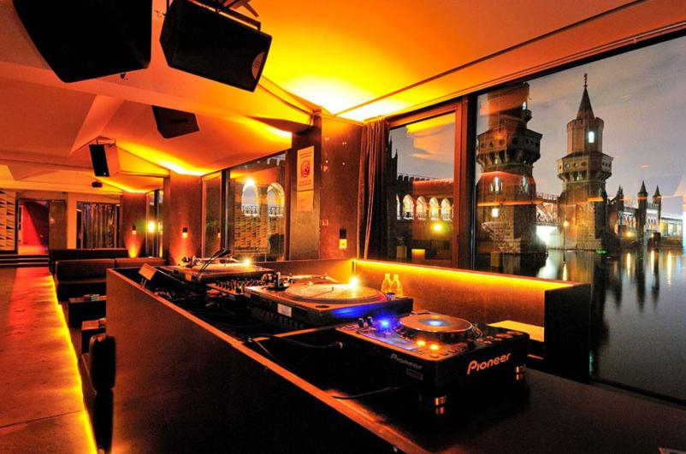

Berlin is famous for more than just Berghain. Local club Watergate opened in 2002 in the then less popular Kreuzberg area. Club space located in a small former office building on the banks of the river Spree

The club is divided into two floors and has a small terrace overlooking the Spree. Thanks to this, at sunset, the main dance floor is flooded with a beautiful warm sun and creates its own cozy atmosphere. The total capacity of the location is about 700 people.

Local DJs and international electronic artists cement Watergate's reputation as one of the best techno clubs in Germany. Over the years, this nightclub has established itself as one of the most Berlin-based locations for techno and house fans.

A selection of guest resident DJs has also propelled the club towards one of Berlin's most popular techno locations. Among the many artists playing sets at Watergate are Jimi Jules, ANNA, Sven Vath and Boo Williams.

Even though Watergate's entry policy is not as strict as other Berlin clubs, the party organizers are still quite selective. They filter the audience so that nothing prevents guests from enjoying the atmosphere of the club and feeling confident next to each other.

Address: Falckensteinstraße 49, Berlin

E1, London
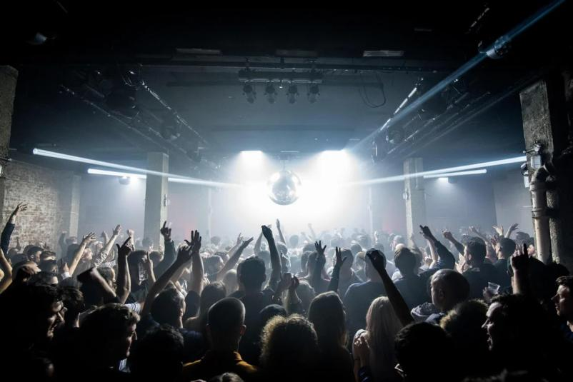

London club E1 opened in 2017 in East London and has become another link shaping the British electronic scene.

To understand the level of E1, it’s worth listing just a few names of electronic musicians who played sets within the walls of this club: Sven Väth, Luciano, Marcellus Pittman and Jeff Mills. Despite this, one of E1's top priorities is to develop the local music scene. That is why at the parties parts are played by British techno musicians who are just starting their journey and correspond to the style of this cult place.

E1 can truly be called a techno club with one of the most diverse genre content. At one party can play heavy techno with a lot of bass all the time, at another party it will be replaced by experimental Afro-house and garage. All this is accompanied by the work of one of the best Funktion-One sound systems, called the «wall of sound».

Address: 110 Pennington Street, London

Warehouse, Nantes
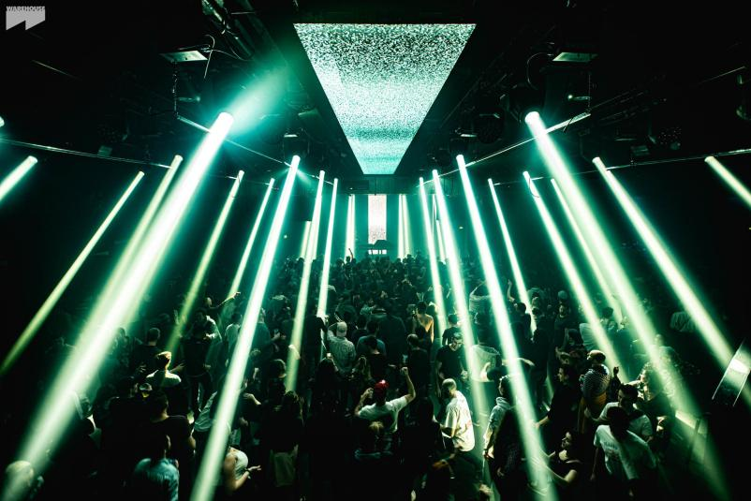
In 2017, one of the best club locations in France was opened in the premises of a 100-year-old former ship hangar. The Warehouse club, located in the western part of the country, specializes not only in electronic music and house, but also experiments with parties for fans of hardcore, disco and hits from the 80s and 90s.

The Warehouse consists of two rooms: the main room with an MDC sound system, video mapping and LED screens for the brightness of the parties, and a second more minimalist room with a Funktion-One sound system.

During the club's work, its parties have been headlined by cult classics from the electronic and techno scene, including Laurent Garnier and Terrence Parker, as well as contemporary stars such as Charlotte de Witte and Boris Brejcha.

Address: 21 Quai des Antilles, Nantes

FABRIK, Madrid
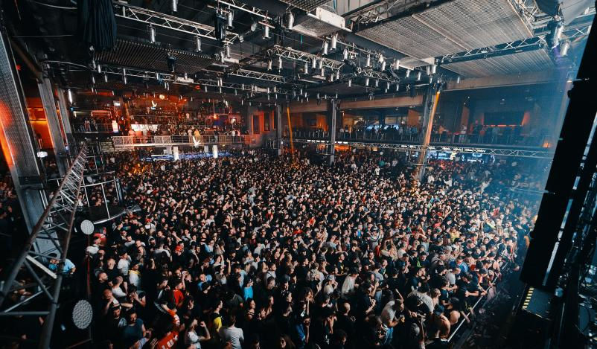
FABRIK is considered the place that reimagined the rave culture in Spain and put it on the world agenda.

The Spanish club FABRIK opened its doors in 2003. It’s located in the suburbs of Madrid and is one of the largest venues on this list. Club can accommodate 4,000 thousand clubbers, who will have for partying six unique dance floors with their own style.

One of the main features of FABRIK is amazing large-scale lighting equipment, smoke effects, laser shows, 6 huge screens with light installations and very high quality surround sound. All this along with world famous DJs, producers and artists who play their sets at the console. Among the long list of headliners are such names as Carl Cox, Steve Aoki, Sven Väth, Marco Carola and Luciano.

Along with weekly parties, the club's team holds its own techno festivals, including the famous La Resitencia.

Despite the large capacity, the club doesn’t neglect with face control at the entrance. But don’t worry ahead of time, everything isn’t as rigid and selective as in other major European clubs.

Address: Av. de la Industria, 82, Madrid

Smartbar, Chicago
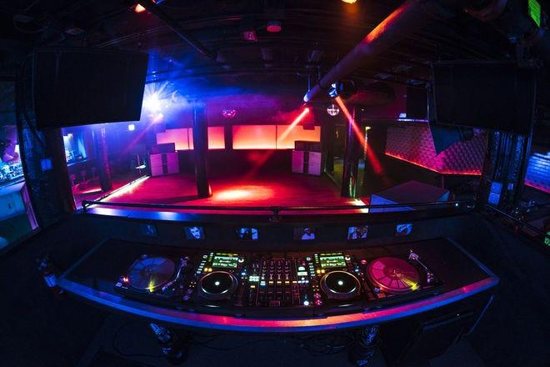
Smartbar has been the flagship of Chicago nightlife for over 30 years and one of the oldest clubs in the city. After so many years, it remains true to its underground nature, focused on independent music and quality sound.

Smartbar is located in the North Side of Chicago in the basement of a luxury building in a vibrant area filled with restaurants and bars.

Smartbar is constantly played by local DJs, whose line-up is sometimes replenished with international headliners. As for musical genres, most often you can hear varieties of EDM and house.

Address: 3730 N Clark Street, Chicago

Nowadays, New York

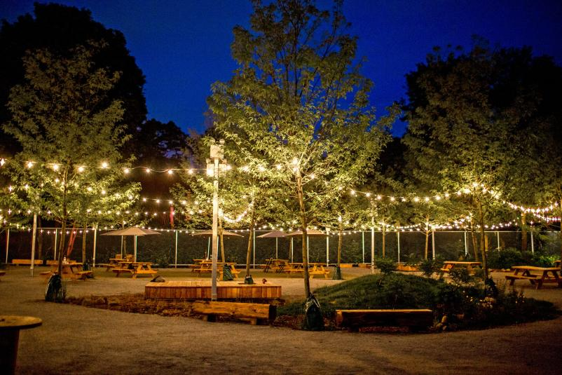
Nowadays is a nightclub and bar located on the border of New York's Bushwick and Ridgewood neighborhoods. In addition to the indoor area, the club has a large outdoor area in the backyard, created for unforgettable open-air parties.

One of the most famous parties from the Nowadays team is Mister Sunday. This is a Sunday afternoon hangout that usually runs from 15:00 to 21:00. The new indoor location of the club allows them to be held all year round, regardless of the weather outside.

Address: 56-06 Cooper Ave Flushing, New York

Culture Club Revelin, Dubrovnik
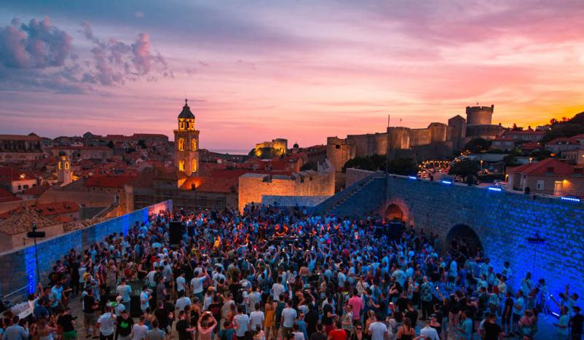
The Culture Club Revelin in Dubrovnik is worth visiting at least once for its majestic location inside a 500 year old medieval fortress. This medieval building that in 2010 turned into one of the main party locations in Croatia.

The hall with a capacity of 2000 people offers a view of the entire city, covered with huge three-meter-thick walls and majestic observation towers. All equipped with a state-of-the-art Martin sound system and boasting a mesmerizing light and laser show to fully complement the music from the world's famous and underground DJs.

Culture Club Revelin is in the top European clubs not only due to its location, but also for its high-profile line-ups. The headliners of the club's parties included Artbat, Roger Sanchez, Pete Tong, Jacky and Fatboy Slim.

Culture Club Revelin also contributes to the development of local musicians: the opportunity to play a set here is given to those who most impressed the owners with their recent performances or performances.

Address: Ul. Svetog Dominika 3, Dubrovnik

Colour, Melbourne
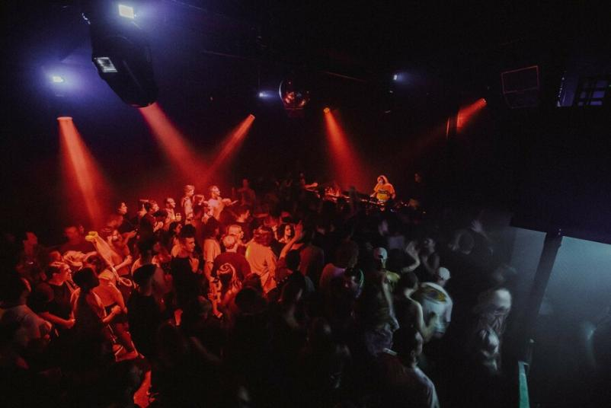

Color is a two-level space in Melbourne that combines a multi-purpose live music venue and nightclub. It opened its doors in 2018, so it can be considered one of the youngest clubs on our list. At the same time, Color is located in a historical old building of 1985. The total capacity of the location is 300 people.

Color is made in a minimalist style, which makes it significantly different from many cult and popular techno clubs. Despite this, his team still follows the underground direction familiar to the electronic scene.

The highlight of Color is the industry-leading Funktion-One sound system, allowing attendees to enjoy clear and immersive sound.

Address: 229 Queensberry Street, Melbourne

Want to rock people on the best dance floors of top clubs?

Resident Advisor is a well-known music media and a platform for announcements of various events. Most booking agents, who invite artists to performances, festivals and parties, pay attention not only to the statistics and social networks of musicians, but also look at their presence on Resident Advisor.

If you want to play in the famous top-list clubs and play at the biggest parties, then you should consider promoting with Resident Advisor. Artist Push team of professionals has extensive experience in this area and a whole range of services for high-quality promo.

