Meta title: What is Bitcoin?
Meta Description: Bitcoin was released as an open source software in 2009. It is often considered as the first crypto valute in the world and determined as digital money that exists only in digital form.
Исходники статей (с которой делался рерайт):
https://www.coindesk.com/information/what-is-bitcoin
https://blockgeeks.com/guides/what-is-bitcoin/
https://coincentral.com/beginners-guide-what-is-bitcoin/
Pictures:
https://pixabay.com/photos/bitcoin-crypto-currency-currency-495996/
https://pixabay.com/photos/bitcoin-coins-gold-money-currency-283587/
https://pixabay.com/illustrations/bitcoin-money-cash-barter-revenue-224233/
Уникальность: 100 %
Символов: 6042
Ссылка на проверку:
https://text.ru/spelling/5cab9f1c27270
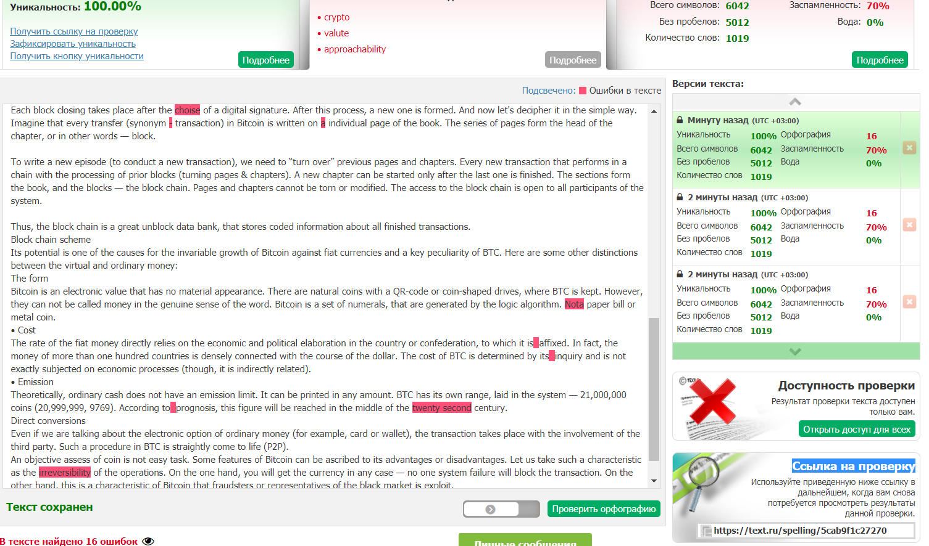

What is Bitcoin?
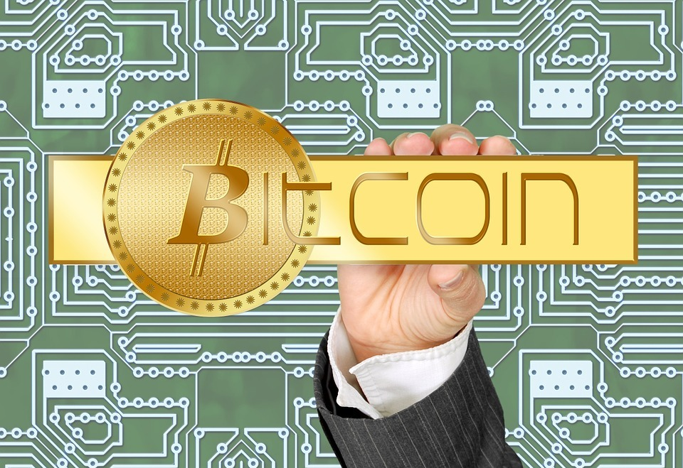
The Universe of Bitcoin buzzes of the passion, pry and perspective of rising above the heaven. An ordinary worker Joe or respected specialists bet on its fortune.
Ten years have passed since the Bitcoin release. Particularly, we saw the news about people, who acquired bitcoins and become millionaire children by chance. Nowadays, the giant potential of the crypto currencies allows directing resources in the right way.
This guide will help you to comprehend how to store or use your first pieces of digital money. While reading this blog, you will always be aware of events in the kingdom of bitcoins.
What does the Bitcoin currency mean?
Bitcoin was released as an open source software in 2009. It is often considered as the first crypto valute in the world and determined as digital money that exists only in digital form.
Everything is quite simple and systematically arranged: BTC owners transfer it through a peer-to-peer network. All the transactions are tracked through the block chain, which is generally called “a giant ledger”.
But, why it was created? Partial causes for it development in the field of such currency reveal its features:
• anonymity
• decentralizing
• safety
• approachability.

Ideally, the coin ecosystem must guarantee fast transactions without the involvement of a third member (bank, cash) with a high level of safeness.

Bitcoin is decentralized. It does not have an issuing authority or, for instance, a political establishment that can control the circulation.
Every transaction is always recorded. Each block in the block chain consists of data, that is encrypted in the Merkle Trees. Such a protection system resists fraud and corruption. It is reliable. If one of the files is damaged, the block chain prevents this process in the subsequent data sets.

“All this hype around the digital money is related to its anonymity. Man is tired of that Big Brother is watching for every their action. Everything is all tired. And Bitcoin in this sense is a breath of fresh air. ”
Sergey Mavrodi, 2013

BTC limit
Programming has reached the highest level of data processing. Now, the printing of the coins are not important, because the system makes easier to process a huge amount of information, track money location and ensure an exceptional accuracy of transactions.
Now there are about seventeen million in circulation. Since there is no regulatory power, that controls supplying. It all depends on the program. A limit has been set for the e-currency, restricted to twenty-one million coins.
Bitcoin is divided into tiny pieces. That is mean, that users can transmission as little as 0.00000001 piece of the BTC. Thus, this is not a problem with a currency scaling.
Experts are inclined to believe that BTC is deflationary money to fight with inflation.
What is block chain?
Anyone anywhere in the world can launch a bitcoin mining script on the laptop and feel like a small bank. An initial code of the script is issued in open form and everyone can see it in work.
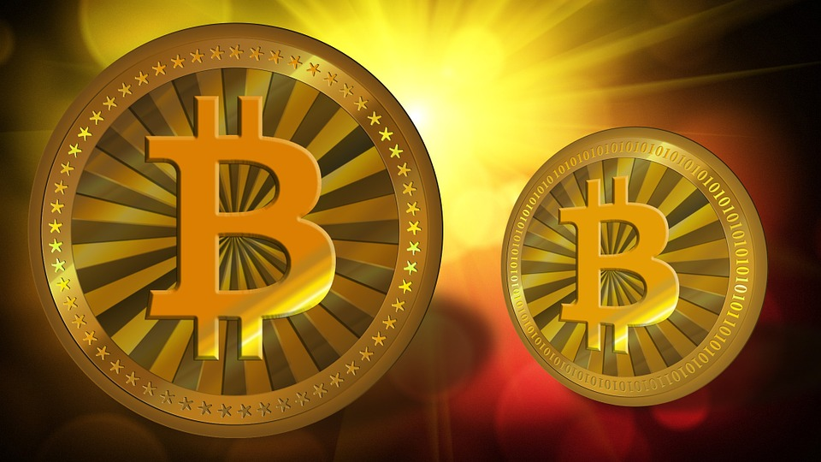
Total Bitcoin economic system is based on the block chain. It is organized like a sequence of transactions.

Each block closing takes place after the choise of a digital signature. After this process, a new one is formed. And now let's decipher it in the simple way. Imagine that every transfer (synonym — transaction) in Bitcoin is written on an individual page of the book. The series of pages form the head of the chapter, or in other words — block.
To write a new episode (to conduct a new transaction), we need to “turn over” previous pages and chapters. Every new transaction that performs in a chain with the processing of prior blocks (turning pages & chapters). A new chapter can be started only after the last one is finished. The sections form the book, and the blocks — the block chain. Pages and chapters cannot be torn or modified. The access to the block chain is open to all participants of the system.
Thus, the block chain is a great unblock data bank, that stores coded information about all finished transactions.
Block chain scheme
Its potential is one of the causes for the invariable growth of Bitcoin against fiat currencies and a key peculiarity of BTC. Here are some other distinctions between the virtual and ordinary money:
- The form
Bitcoin is an electronic value that has no material appearance. There are natural coins with a QR-code or coin-shaped drives, where BTC is kept. However, they can not be called money in the genuine sense of the word. Bitcoin is a set of numerals, that are generated by the logic algorithm. Not a paper bill or metal coin.
- Cost
The rate of the fiat money directly relies on the economic and political elaboration in the country or confederation, to which it is affixed. In fact, the money of more than one hundred countries is densely connected with the course of the dollar. The cost of BTC is determined by its inquiry and is not exactly subjected on economic processes (though, it is indirectly related).
- Emission
Theoretically, ordinary cash does not have an emission limit. It can be printed in any amount. BTC has its own range, laid in the system — 21,000,000 coins (20,999,999, 9769). According to prognosis, this figure will be reached in the middle of the twenty-second century.
- Direct conversions
Even if we are talking about the electronic option of ordinary money (for example, card or wallet), the transaction takes place with the involvement of the third party. Such a procedure in BTC is straightly come to life (P2P).
An objective assess of coin is not easy task. Some features of Bitcoin can be ascribed to its advantages or disadvantages. Let us take such a characteristic as the irreversibility of the operations. On the one hand, you will get the currency in any case — no one system failure will block the transaction. On the other hand, this is a characteristic of Bitcoin that fraudsters or representatives of the black market is exploit.
Read more details in the next article “How to Store Your Bitcoin”.
Faithfully yours, BTC reporter.

