Media (Digital Reporter)

All Celebs and Easter Eggs in Miley Cyrus’s Sexy Music Video “Mother’s Daughter”
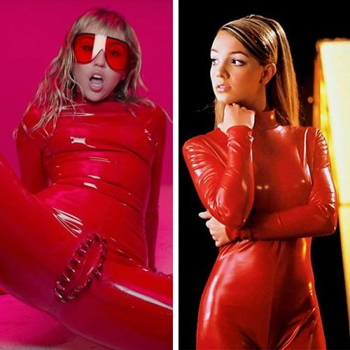

As you might have noticed, Miley Cyrus released the music video for “Mother’s Daughter,” which is her first single of the fresh EP She Is Coming.

The clip featured multiple references, Easter Eggs, and famous people, so Nexter.org gathered all of it in one piece. Enjoy and check if you spotted them all!

Miley Cyrus is coming back with latex

https://youtu.be/7T2RonyJ_Ts

The singer and actress Miley Cyrus surprised fans with new music video “Mother’s Daughter” for her single of the new EP She Is Coming (6 songs with a total length of 19 minutes).

The clip immediately attracted the attention of media and people because of its empowering message and bizarre shots.
Except for feminist phrases, “Every woman is a Riot” and “Not an Object”, and red latex suit, the video is full of references and other celebrities. See below the list of them:

Britney Spears’s “Oops!… I Did It Again” reference

Probably, one of the brightest references is the famous red catsuit of Britney Spears that she wore in “Oops!… I Did It Again” music video.

Just straight from ’00s fashion:

Source: Giphy

Vagina dentata
Miley’s costume was made with a silver-studded set of vagina dentata.
Vagina dentata is an old tale that a man would have his penis cut off as a result of intercourse.
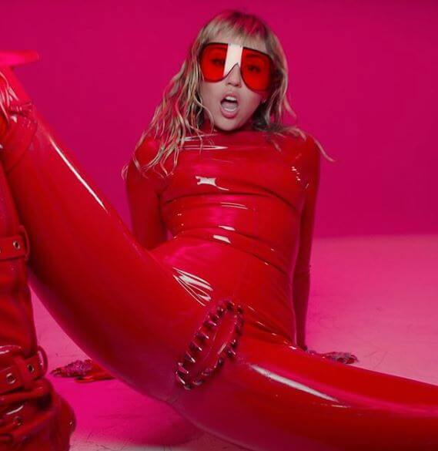
Source: Instagram/@mileycyrus
Trydryn Scott
“So pretty much in my everyday life I tend to express my freedom through my fashion – it’s like my voice because I don’t like to say too much I like to leave everything open for interpretation,” Scott says.
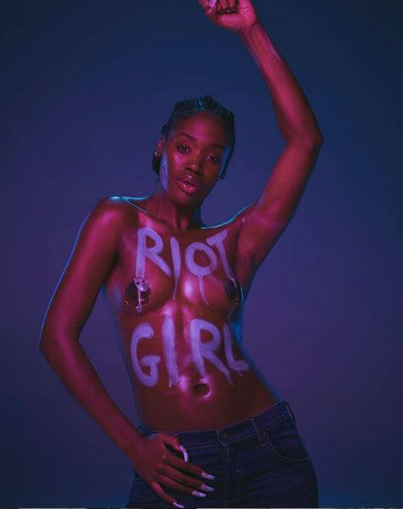
Source: Instagram/@mileycyrus
Aaron Philip
The first black, transgender and disabled model to sign for a fashion magazine – Paper.
“As a black girl in a wheelchair who happens to be trans – I just want to have a good life and do good in whatever my endeavors consist of, regardless of what that might mean in the face of oppression.”
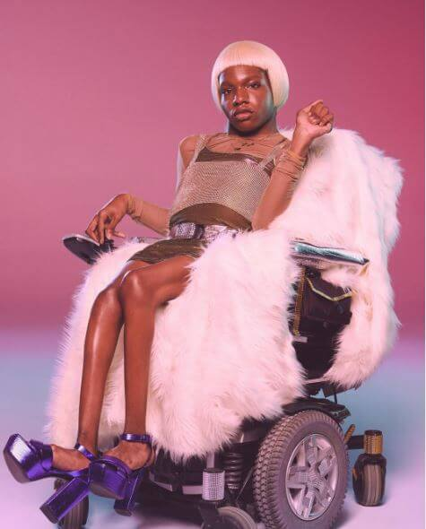
Source: Instagram/@mileycyrus
Angelina Duplisea
Body-positive model and actress says: “I’ve always been a fighter. Maybe not always in the most productive way, but fighting for myself, a friend or even for a stranger who is being bullied has always been a part of my personality.”
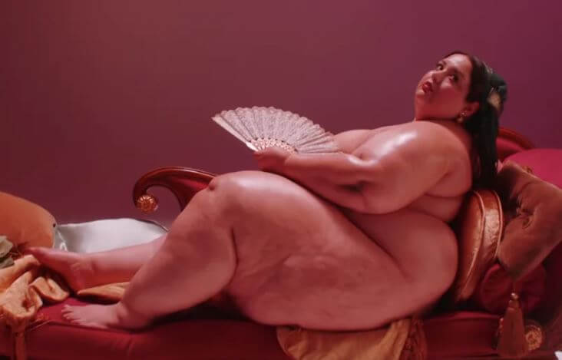
Source: Youtube
Mari Copeny
She’s just 11 years old but is already an activist. Way to go, girl! “I’m 11. My generation will fix this mess of a government. Watch us,” her website reads.
Copeny is also a philanthropist and a speaker that can be invited to your conference via the booking form of her website. Don’t miss this chance!
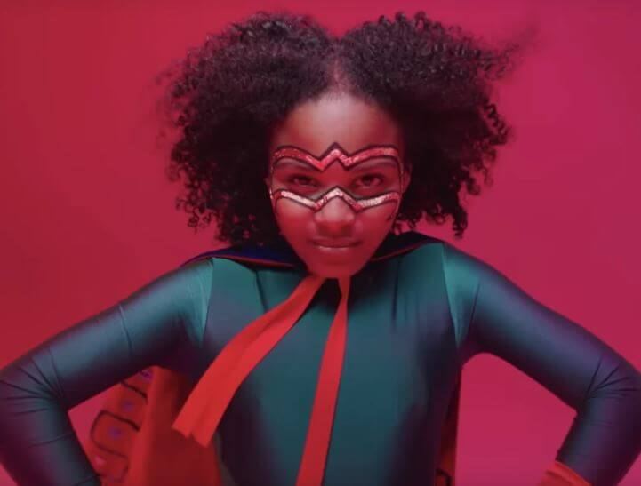
Source: Youtube
Tish Cyrus
The sweet and beautiful mother of Miley Cyrus and her manager. This particular shot if the cutest moment of the whole video.
Also, not many noticed that Miley and Tish wear matching Chanel tweeds. Gorgeous as heck!
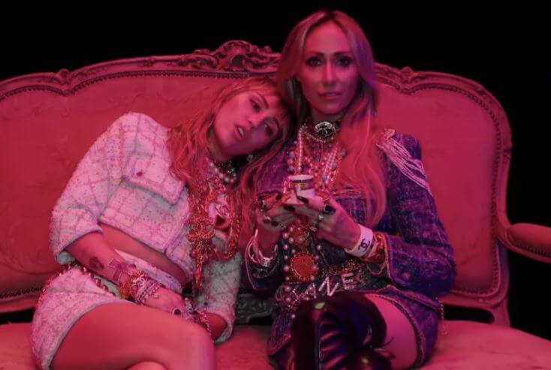
Source: Youtube
Melanie Sierra
Sierra is the founder of Let’s Talk Mother and the supporter of single mothers.
She states: “I had to fight my entire life to be seen and heard. I never felt prepared for the world. I never understood the significance of having self-worth. It was never instilled in me. My anxiety silenced me until I finally realized I had to express myself artistically to truly understand what freedom felt like.”
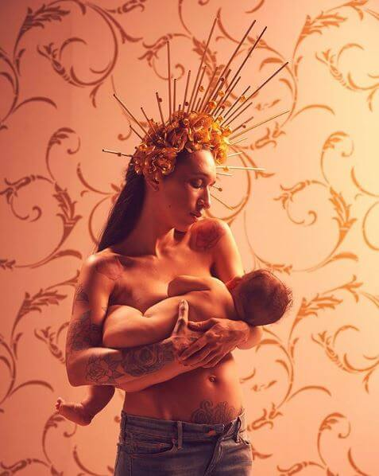
Source: Instagram/@mileycyrus

Casil McArthur
Trans model, activist, and singer that inspire us “to live and love freely”.
“I try to live as authentically as I can – and I want to create a space where everyone else can do the same,” he adds.
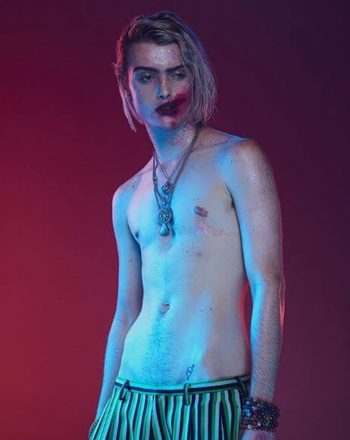
Source: Instagram/@mileycyrus

Amazon Ashley
Ashley is Miley’s friend that appeared many times in her music videos as a dancer.
“Sometimes I feel so helpless and discouraged because there is so much injustice discrimination and hatred in the world we live in…and now in particular under our current administration this dilemma is magnified tenfold,” she says.
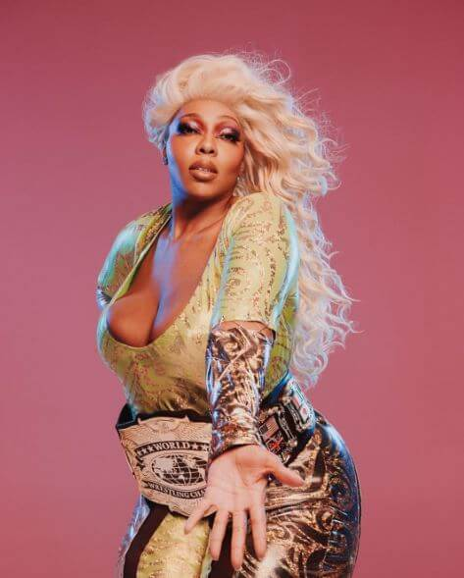
Source: Instagram/@mileycyrus

Vendela
The truth of life from the first shave-headed model of Playboy: “I’ve been asked why I shaved my head, “you were so pretty with your long hair”. I’ve been asked why I pose nude, “it might hurt your career”. I’ve been told I need to smile more, “don’t be so serious”. What people don’t realize is that I do all this because I want to. It’s simple.”
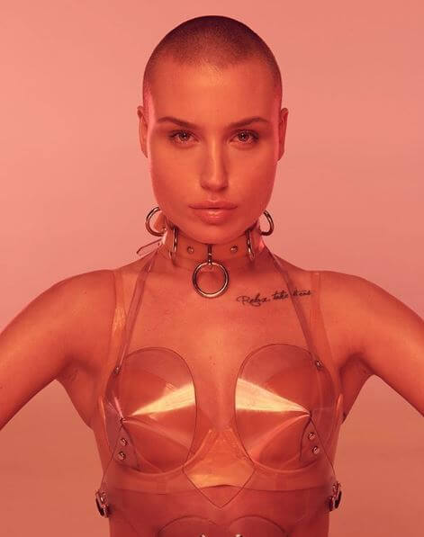
Source: Instagram/@mileycyrus
That’s all for now! If you found more references, please write down in the comments and we’ll feature the best ones.

