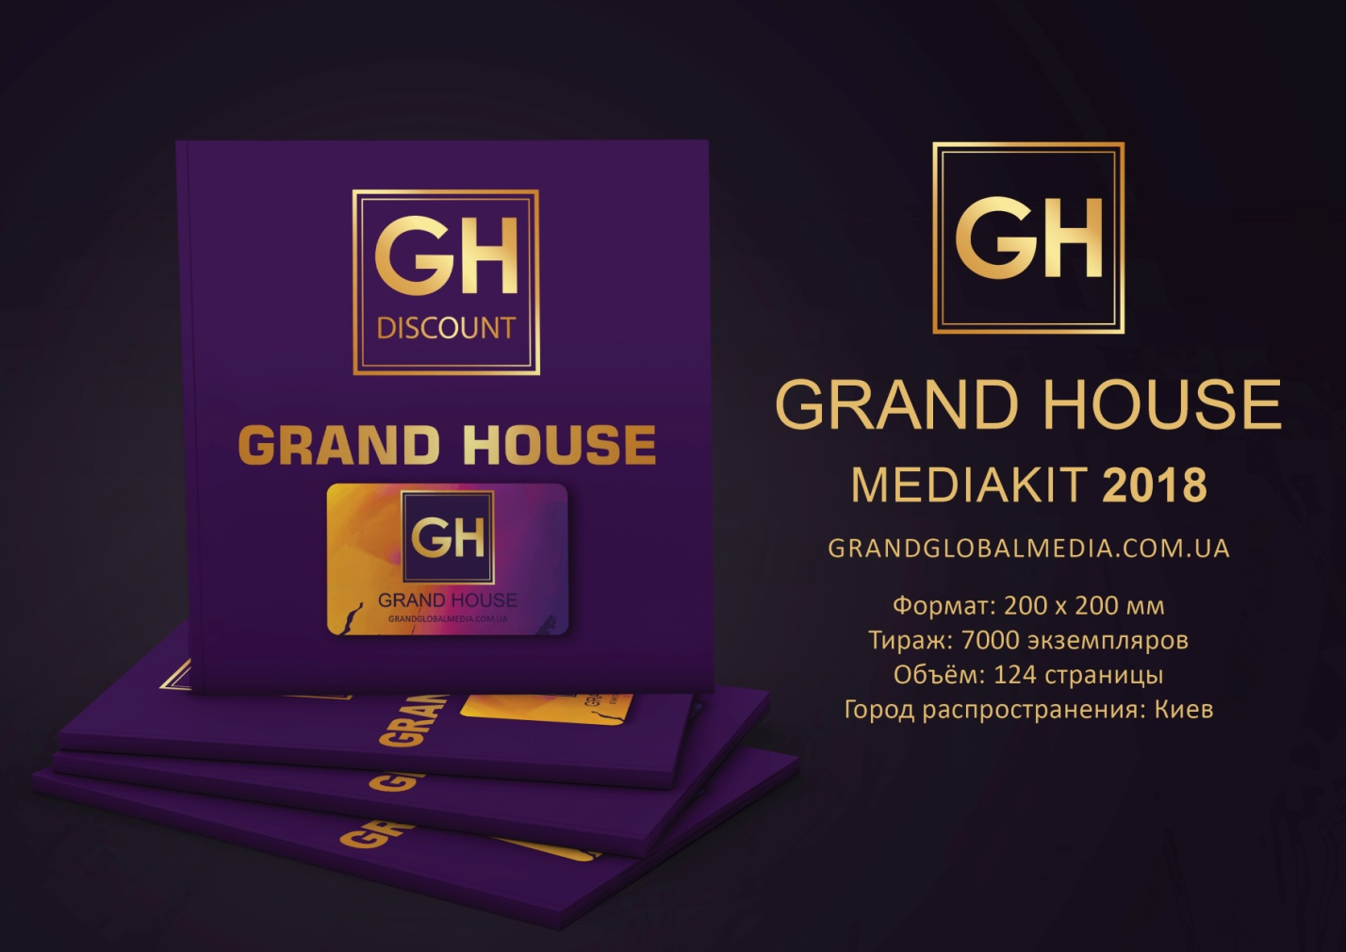
Format: 200х200 mm
Circulation: 7,000 copies
Volume: 124 pages
City of distribution: Kiev

THE ADVANTAGES OF ADVERTISING IN THE GRAND HOUSE
- The magazine positions the advertiser on the market as a reliable company, offering quality products and services
- Maximum effects and an absolute hit in the target audience
- Increases customer loyalty to goods and services
- Meet with professionals in the field of architecture and design
- Efficient and cost-effective advertising medium
- Increases the recognition of brands, specialists, heads of the companies, ensuring the effectiveness of their further commercial contacts with the potential buyers
- Due to the description of the advantages of goods and services, it forms the need of potential buyers in these goods and services
- Informs potential buyers about the goods and services offered by the advertiser
- Provides the long-lasting advertising effect
- Complex distribution allows direct access to the target audience


BENEFITS AND ADVANTAGES
- Individual approach. It is important to us that every client is satisfied with the result of investments
- Quality of service execution. 85% are our reliable partners who trust us
- Thanks to our program, you will increase sales in your company
- Possibility to get customers of the best complexes
- Price policy. Quality - Price – Effectiveness
- Opportunity to find reliable partners
- The high purchasing power of the TA
- We work in a single advertising segment
- High level of the Apartment Complexes
- The best distribution channels

BENEFITS AND ADVANTAGES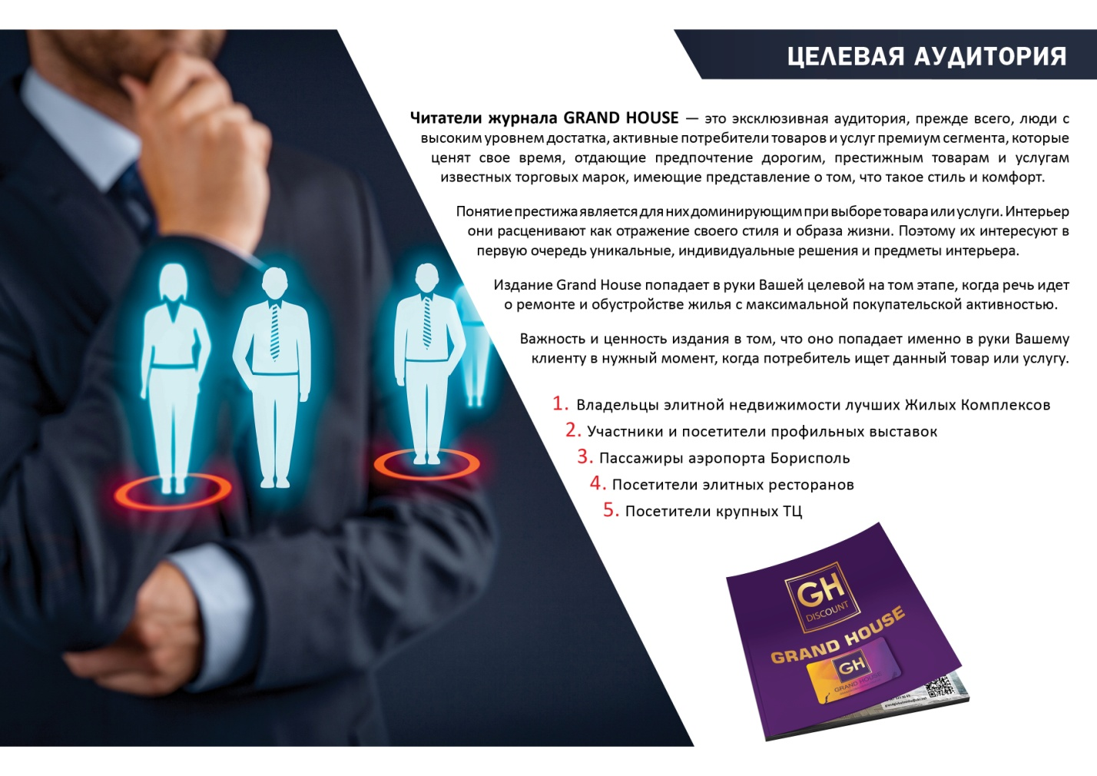
The readers of the GRAND HOUSE magazine is an exclusive audience, first of all, people with a high level of prosperity, active consumers of the premium segment goods and services, who value their time, preferring expensive, prestigious goods and services of well-known brands, who have an idea of what style and comfort is.
The concept of prestige is dominant for them in the choice of goods or services. They regard the interior as a reflection of their style and way of life. Therefore, they are primarily interested in unique, individual solutions and interior items.
The GRAND HOUSE edition falls into the hands of your target audience at the stage when it comes to the renovation and arranging housing with maximum purchasing activity.
The importance and value of the publication is that it falls into the hands of your client at the right time when the consumer is looking for a given product or service.
- The owners of the elite real estate of the best Apartment Complexes
- The participants and visitors of specialized exhibitions.
- The passengers of the Borispol airport
- The visitors to the elite restaurants
- The visitors to major shopping centers
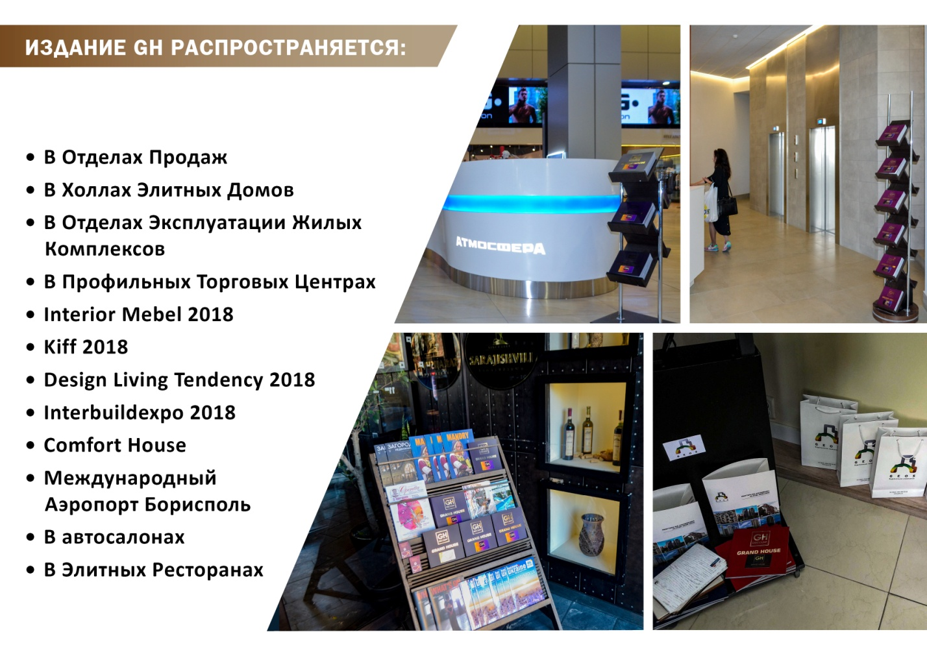

THE GH EDITION IS DISTRIBUTED:
- In Sales Departments
- In the Halls of Elite Homes
- In the Department of Maintenance of Apartment Complexes
- In Profile Shopping Centers
- Interior Mebel 2018
- Kiff 2018
- Design Living Tendency 2018
- Interbuildexpo 2018
- Comfort House
- Boryspil International Airport
- In the car dealerships
- In Elite Restaurants

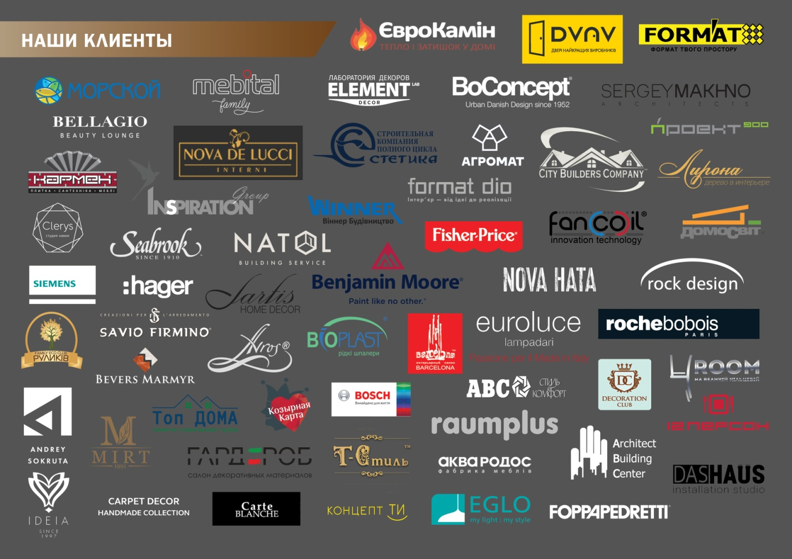
OUR CLIENTS
GRAND HOUSE
- 78% of readers primarily apply for the services of those companies whose products and works are represented in the magazine
- 81% of readers after getting acquainted with the company on advertising in the magazine go to the company's website to study more detailed information
- 53% of readers use the magazine to choose a reliable contractor and supplier of goods and services
- GRAND HOUSE is the best way to convey information about your company and find your customers among your target audience.
By giving preference to our company, you will find a reliable partner in our face and face of your future loyal customers who will recommend you as a professional in your industry and also increase the brand recognition of the product.
