“What is HDI and How It Could Be Improved”
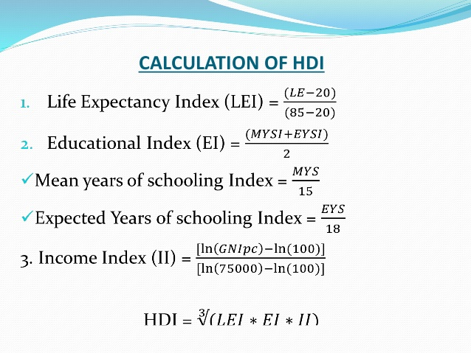
United Nations Development Program defines human development index (HDI) as a rate, which evaluates level of development of the country through several factors such as: “long and healthy life, access to knowledge and a decent standard of living.” (UNDP, 2015). Life expectancy index shows average life span of the citizens of this country. Educational index uses mean value of mean years of schooling and expected years of schooling. In order to calculate income index, it is necessary to use GNI per capita of the country. HDI is a geometric mean of three indexes, mentioned above (Hanks, 2018). Detailed calculations are attached in the Figure 1. The resulting value lies between 0 and 1, where 0 is minimum and 1 is maximum achievable index. For 2019 Norway is a holder of the highest rate (0.953), meanwhile Niger with 0.354 takes the last place in the list of the countries.
Figure 1. Calculation formula of HDI. Retrieved from https://www.slideshare.net/sarangmeshram2/hdihuman-development-index-48158169
According to the calculations, all the values are added to the rating by UNDP. This system of evaluation has as benefits as drawbacks at the same time. First, HDI gives us clear image of what is happening around the world. It takes into consideration not only economical aspects of our life, but also takes into account social side of human’s life. In addition, presence of such rating stimulates many countries to develop governmental structures such as educational system, medicine service and so forth.
On the other side, HDI has several serious disadvantages, which are making this measure irrelevant. In this rating some of the countries are absent and in some of the undeveloped countries may be not accurate. Also, countries with large area such as Russia and China have different level of development in different areas. Moreover, calculation of income index requires GNI, however it is not an indicator of citizen’s welfare. Sometimes, GNI could be high, meanwhile level of life in this country is low.
However, this tool of measurement still can be improved by adding complementary factors and it should consider mountain societies as well. For instance, factors, presented in the work of Gustav Ranis about mental well-being, political freedom and others (Ranis,2005). One of the solutions may become a creation of electronic government. All the citizens will be registered and information about them will be stored in secured database. It will make easy for UN to get information from countries, where many people are living in mountain area.

References:
- Ranis, G., 2005, Human Development: Beyond the HDI, Retrieved from https://ucaelearning.org/pluginfile.php/22405/mod_resource/content/1/Stewart%202005%20Beyond%20the%20Human%20Development%20Index.pdf
- Kreutzmann, H., The Importance of Development Indicators for Assessing Mountain Development, Retrieved from https://ucaelearning.org/pluginfile.php/22404/mod_resource/content/1/Kreutzmann2004-The%20importance%20of%20development%20indicators.pdf
- UNDP, 2015, Training Material for Producing National Human Development Reports, Retrieved from http://hdr.undp.org/sites/default/files/hdi_training.pdf
- Hanks, G., 2018, How to Calculate a Human Development Index, Retrieved from https://bizfluent.com/how-4894211-calculate-human-development-index.html
- Figure 1, Retrieved from https://bizfluent.com/how-4894211-calculate-human-development-index.html

