5 Great Indoors and Outdoors Activities Able to Make Your Winter Unforgettable
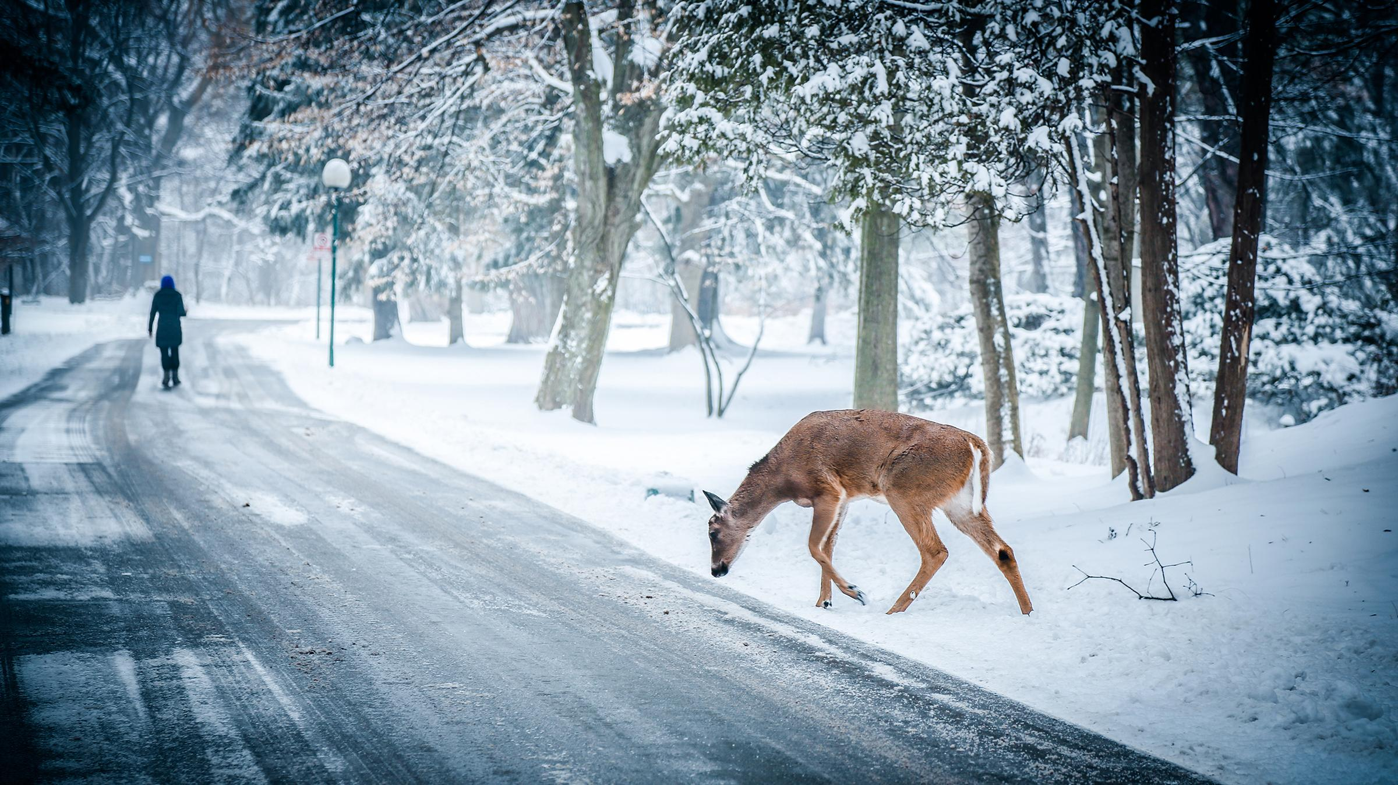
https://www.pexels.com/search/winter/
Someone once said that we should enjoy every season in the way how it passes, for example, lay in the sun in summer, eat many healthy veggies and fruits in fall, admire the greenery of spring and breathe the fresh air in winter. Besides breathing a fresh and cold winter air there are a lot of things to do to make this season interesting and unforgettable. So, here are some fun and useful ideas on how to replace ordinary sitting in front of the TV for other, more variable activities.
- Go in for a Winter Sport

http://www.touchofclasstrailers.com/looking-towards-spring-but-enjoying-the-winter-activities/
Maybe, one of the most popular winter sports we could be engaged in childhood was sledding.
Sledding for adults can also be a great way to spend some time on weekend with pleasure and with use for the health. Another popular winter sports are ice skating and skiing which are a little harder to learn as a grown up and they unfortunately require special equipment need to be bought. They are also more dangerous since it is very easy to get injured by skates or skis, though these sports are worth trying.
2. Go to Some Place Where You Haven’t Been Yet

http://moongardenhomestay.com/en/cttc113a141/airline-tips-for-winter-travel-amp-holiday-travel.html
Look for some adventures in the places you have never been before exploring the world around. It would be very exciting to go to some “winter” countries such as Finland, Sweden, Norway or to Alaska. But in many Euroopean winter is very impressive too. Bring a camera to catch an amazing beauty of winter and memorize the best moments. Optionally, spend your weekend in nature going out to a local park, taking a hike or renting a cabin in the mountains, etc.
3. Plan the Winter Weekend to be Spend with Friends, Relatives and Neighbors
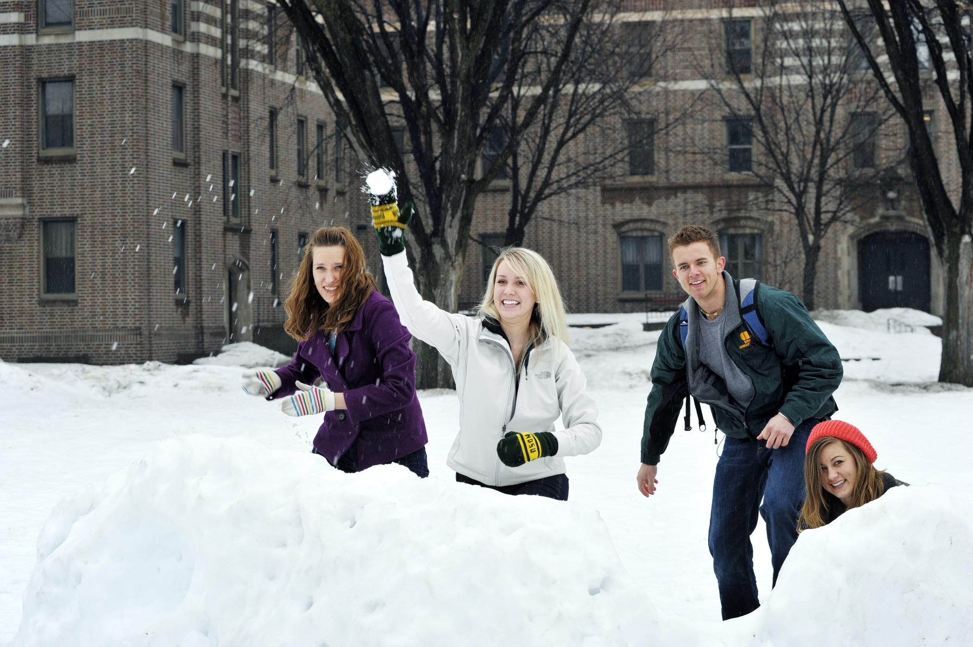

https://www.ndsu.edu/vpur/resources/photo_gallery/people/
For this purpose, arrange some interesting group activities. There are many stunning ideas able to diversify your winter weekend, for example, a potluck dinner, a snowballs fight, different indoor games, dancing in the night disco club, going out to a blues or jazz club or throwing a party at home.

4. Dealing with Arts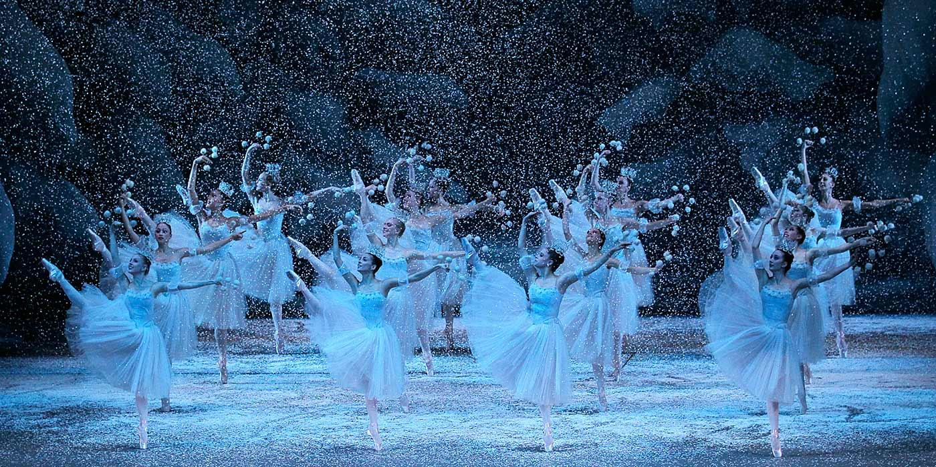
https://www.ndsu.edu/vpur/resources/photo_gallery/people/
Winter is a peak season to buy tickets to The Nutcracker or Swan Lake or to go to the theater, museum, exhibition and other places of cultural interest. If you also like to create art by yourself such as painting, writing poems or a prose. Plan a little cultural infusion on the weekend.

5. Having Meal

http://cte7.com.br/por-que-sentimos-mais-fome-no-frio/

Having meal in winter may be sometimes a little extraordinary. For example, one may go out to a wine tasting dinner or throw it at home, arrange a pajama party brunch inviting friends, cook a pot of soup or whatever dish and see good movie. These are the excellent options to spend a winter weekend indoors with the purpose of having meal.

