The most popular summer flowers for the garden and bouquets

The summer is the best time for flowers. They blossom in the garden and in the field. The beautiful summer flowers fill our lives with bright colors and rich spices. We have only a few months to enjoy this beauty in full.
What flowers do you meet in each garden? And which ones should be chosen for a bouquet? Let's talk about it.

The elegant pioneers of white and pink colors can be found in every garden. You can make a very beautiful bouquet of these flowers. But, unfortunately, petals of peonies fall quickly. It's better to admire them under the windows, but not in the flower vase.
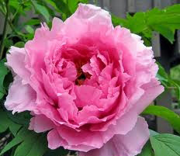

The unpretentious chrysanthemums will create a mood for you on the flowerbed and in a bouquet. A wide range of colors gives you the opportunity to get stuck around. If you have a garden, do not forget to decorate it with chrysanthemums.
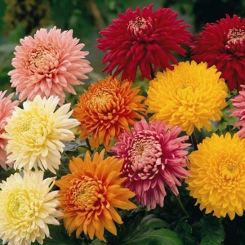

The rose is a queen of the garden. She is a real beauty. With proper care, a bunch of roses will please you for several days. But when you bloom in the garden your first rose is a unique feeling. Like a little prince, about whom Exupery wrote.
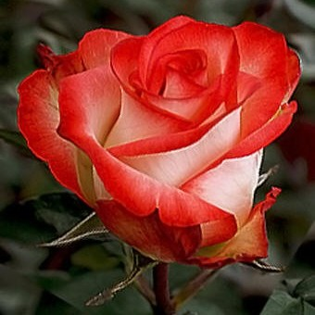
Dahlias will decorate your garden with a variety of colors from light yellow and dark red. You will admire them until the first frost. A bouquet of dahlia looks beautiful and long does not fade in vase.
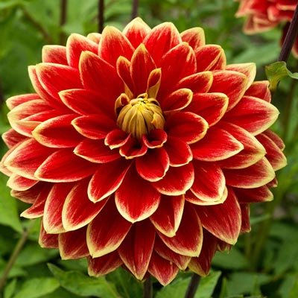

The white, yellow and orange zinnias are very beautiful and unpretentious flowers. They will paint your flower bed until late fall. In bouquets, they are better to combine with other flowers.
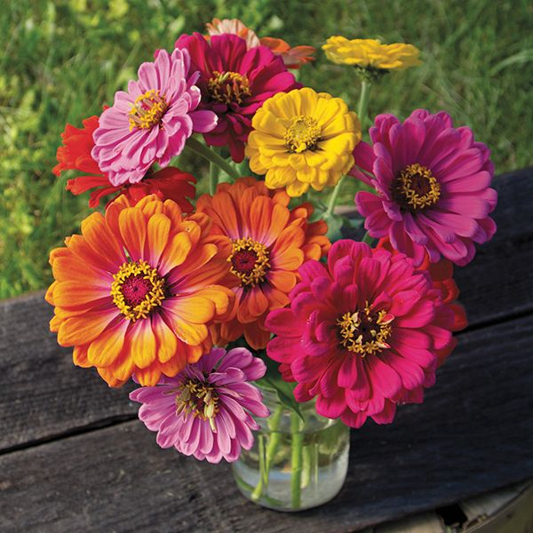

What is summer without poppies, chamomile and cornflower? It is best to enjoy the view of these flowers in the fields. But you will not resist not putting such a bouquet in a vase. These flowers smell like summer.

Beautiful flowers such as lilies and gladiolus will make your garden decorate. But they are very picky in the care. In a bouquet, they need to carefully select the neighbors. They do not get along with everyone.

Do not forget about hydrangeas, phlox and irises. These flowers will diversify and decorate your garden. It will be nice to look around the perimeter of the garden, creating a natural colored enclosure.

Succulents and cacti are becoming more and more popular. After all, from them you can make a garden, even in a small pot. At that, even an inexperienced flower can cope with this task. Create your masterpiece on a flowerbed or in a glass jar. You will have great pleasure in contemplating your own creation.

If the climate allows and you have enough time for gardening, you can plant orchids. This glamorous flower captivated the hearts of the florists around the world. It can also be grown on a window sill or in a closed greenhouse.

Each flower is special. In its own way demanding, in its own way is charming and unique. And summer is a great time to enjoy this beauty. It does not matter in the garden or in a bouquet, but be sure to please your summer flowers. Pick up a piece of heat and beauty while it's available.

