Smart Online Shopping:
Buy and Receive in 1 click!
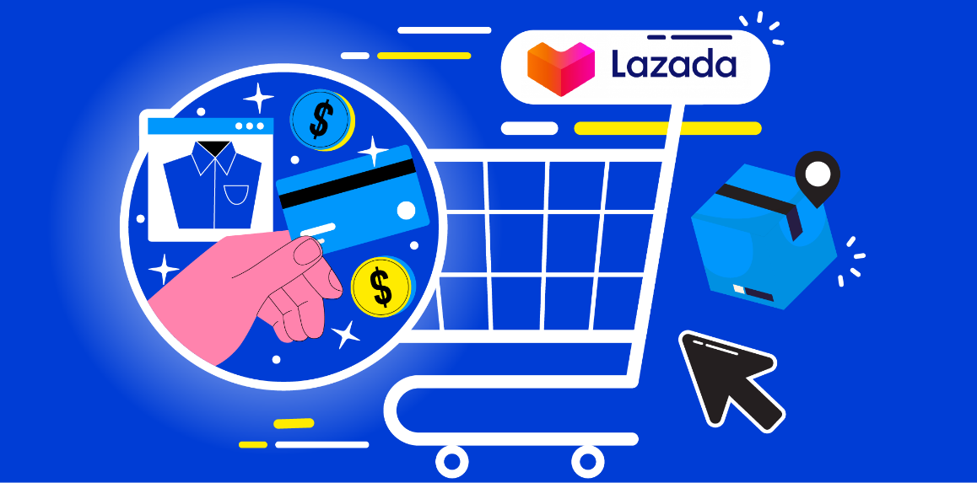
Holidays are about to start, but you have no time to buy gifts for your family? Looking for an online store that is budget-friendly and provides free delivery?
What if I told you that online shopping has become much easier now? Lazada made things possible for you!
Imagine a digital marketplace with everything you could ever wish for! In just one click, you order. And at no additional costs, Lazada gets things delivered for you!
Why Lazada?
Established in 2012, Lazada has proven itself as a top-choice online shopping store, providing excellent customer service for everyone.
With the vast range of products, offering anything from washing machines to make-up specials, there’s no such item that can’t be found in the Lazada marketplace. Thus, it represents the one-stop shop for all your needs.
The platform features a range of local and international brands, encouraging sellers to offer high-quality products with guarantees for buyers. Since the marketplace partners with various retailers, you'll come across different prices and shipping conditions. While a small shipping fee may apply for overseas items, it is shown during the ordering process and is quite reasonable. However, with the extensive variety of options, buyers can easily find free shipping alternatives.
How to start buying from Lazada?
Just download the Lazada App or visit the website to create an account. It won’t take more than 5 minutes.
To get the best shopping experience, you’ll only need:
- Discover a variety of products
- Add to the cart the most attractive ones
- Check their shipping options
- Make your choice
- Order
- Enjoy quick and guaranteed home delivery
What makes their service different from other online stores?
- Easy registration process
- Wide product selection
- Competitive prices, exclusive deals and discounts
- Convenient shopping experience
- Free delivery options
- Flexibility of payment methods
- Buyer protection and free returns

So, with no hidden fees and a guarantee for the receiver, online purchases through the Lazada e-commerce platform are extremely convenient. No more wasting time buying a laptop in one corner of the city and searching for home decor in the other! Either no worries about overpriced shipping fees.
Lazada customers, especially like the convenience of purchases, high-quality products, and free delivery.

“I used to spend so much time shopping because it was so hard to find all the things I needed in one store. Until I found Lazada marketplace. No longer do I spend hours searching for desired lip gloss or warm sweaters! Coz their exceptional assortment and free delivery made my dreams come true! Whenever it’s shopping time, I buy from Lazada! Guys, you are amazing”.
Jessica, Vietnam

How to buy from Lazada?
- Go to the Lazada website and click to register
- Follow the registration steps and set the correct home address
- Confirm your registration by checking your e-mail
- Come back to the website and search for your desired item
- Make your choice
- Choose your preferred payment method and click the Buy button
- Get your item delivered for free and enjoy it

Shop with Lazada now

