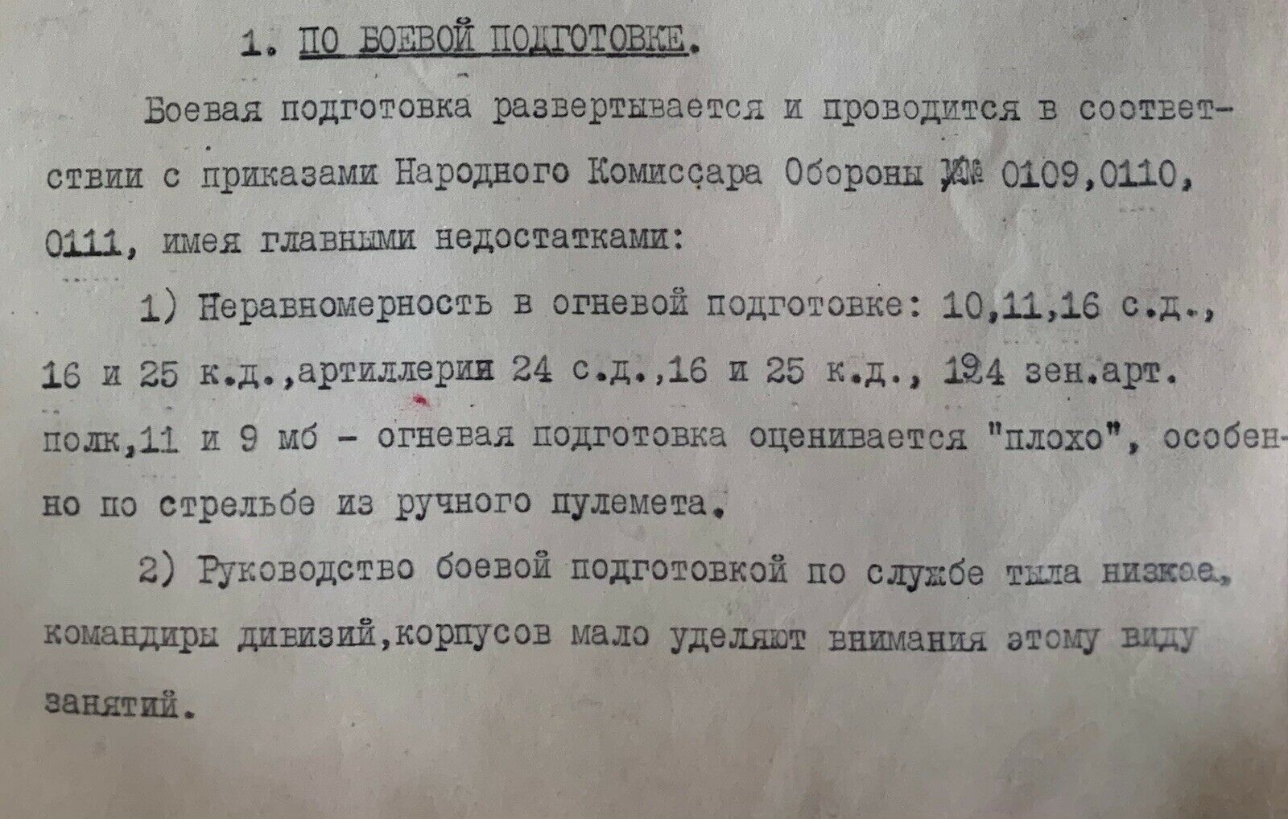
I. COMBAT TRAINING:
Combat training is deployed and conducted in accordance with the orders of the People's Commissar of Defense number 0109, 0110, 0111 with the main disadvantages:
1) The unevenness in fire training of 10th, 11th, 16th cavalry division number and of 16th and 25th rifle division. Artilleries of 24th rifle division, of 16th and 25th cavalry division, 125th anti-aircraft artillery regiment, 11th and 9th mb are rated "bad", especially in shooting with a light machine gun.
2) The management of combat training in the rear service is poor, the commanders of divisions and corps pay little attention to this type of training.
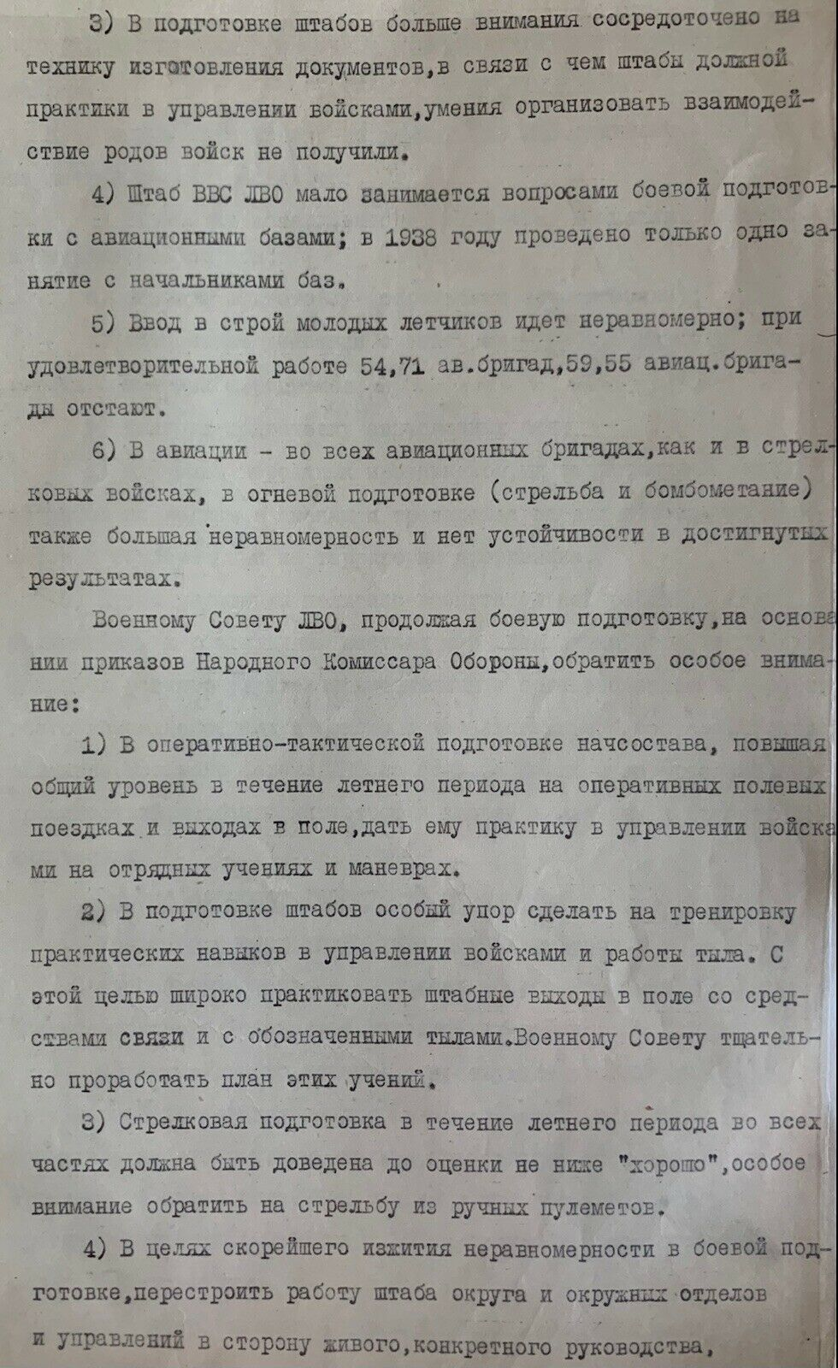
3) Command staff’s attention is mostly focused on preparing of papers, as the result the command staff didn’t receive proper practice in managing troops and didn’t acquire skills in the organization of inter-service cooperation.
4) The Air Force Staff of the Leningrad Military District deals with issues of combat training with air bases. In 1938, only one training session was conducted with the base chiefs.
5) The recruiting of young pilots is uneven. Though the 54th, 71th air brigades work satisfactorily, the 59th and 55th brigades are lagging behind.
6) In aviation - in all aviation brigades, as in rifle troops, so in fire training (shooting and bombing), there is also a large unevenness and there is no stability in the achieved results.
The Military Council of the Leningrad Military District, while continuing its combat training, should pay special attention to the orders of the People's Commissar of Defense:
1) In the operational and tactical training of the commanding stuff, increasing the overall level during the summer period on operational field trips and field trips, the practice in troops management at squad exercises and maneuvers should be provided.
2) In the preparation of staffs, special emphasis should be placed on the training of practical skills in troops the management and the work of the rear. To this end, the staff field exercise with means of communication and with designated rear areas should be widely practiced. The Military Council should carefully work out the plan for these exercises.
3) Rifle training during the summer period in all units should raise the rating to at least "good" and pay special attention to shooting from light machine guns.
4) In order to quickly overcome the unevenness in combat training, the work of the district staff, district departments and district offices should be restructured in the direction of an active concrete leadership, verification of work performance and providing practical assistance to the young stuff.
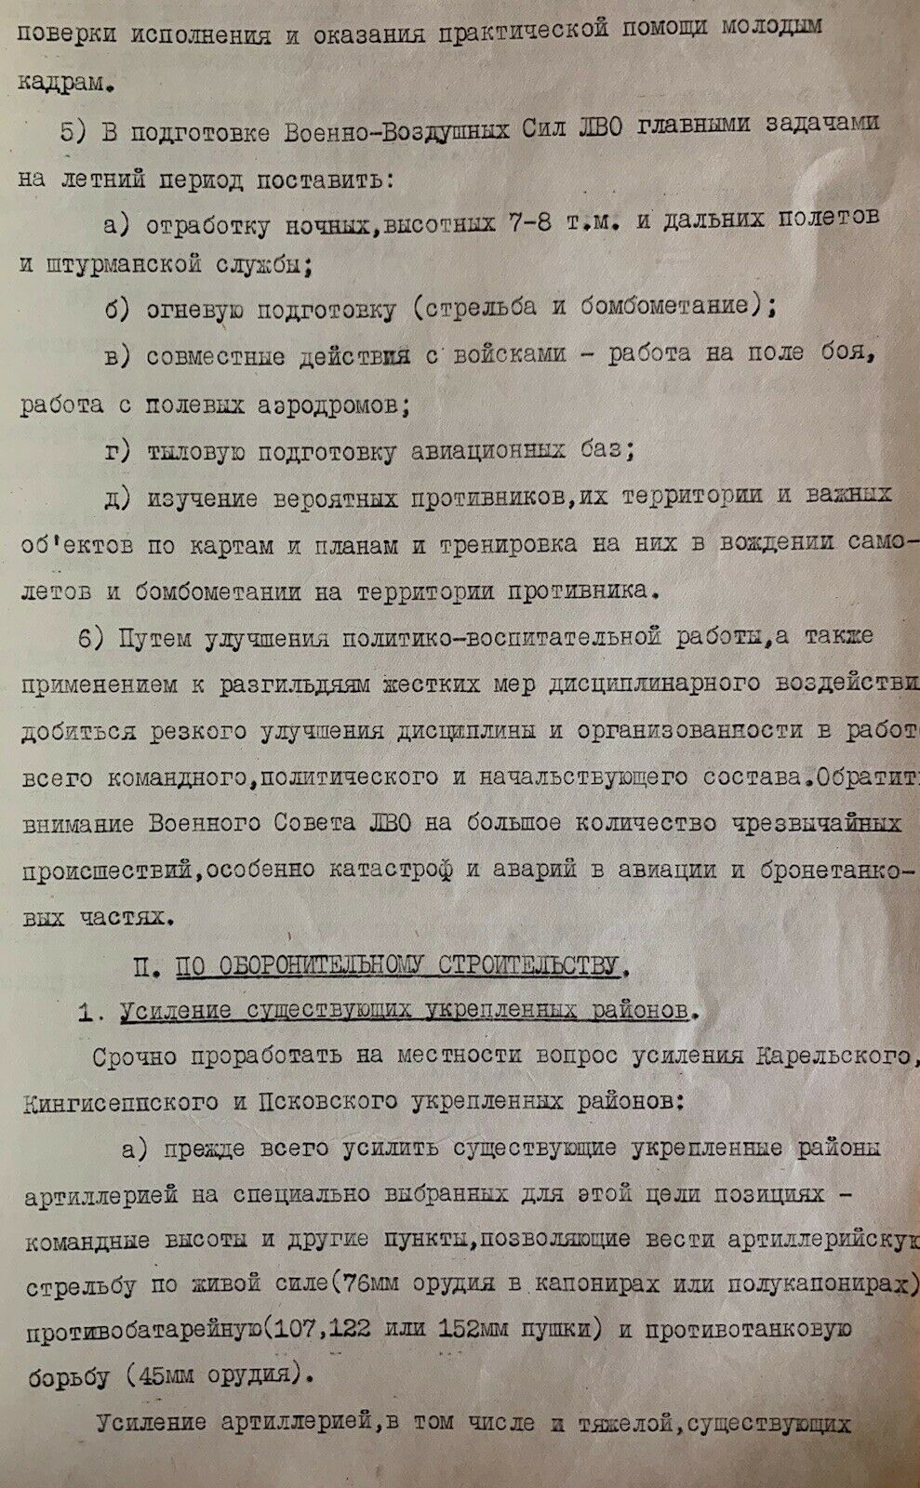
5) During the preparation of the Air Force of the Leningrad Military District, the main tasks for the summer period are to be set:
a) working out the night flying, high-altitude flights (at an altitude of 7-8 tm.) and long-distance flights and navigational service;
b) fire training (shooting and bomb-dropping);
c) joint actions with the troops – working on the battlefield, working at the expeditionary airfield;
d) rear training of air bases;
e) studying of possible contenders, studying of their territory and the important objects on maps and plans, training of aircraft driving and bomb-dropping on the opposing territory.
6) By feat of improving political and educational work, as well as by applying strict disciplinary measures to pudknockers, the discipline and organization in the work of the entire command, political and commanding staff should be dramatically improved. The attention of Military Council of the Leningrad Military District should be paid to the large number of emergency situations, especially disasters and accidents in aviation and armored units.

II. DEFENSIVE CONSTRUCTION:
1. The strengthening of existing fortified regions.
The consideration should be immediately given to the strengthening of Karelia, Pskov, Kingisepp and fortified regions:
а) First of all, the fortified regions of artillery should be reinforced at specially selected positions for this purpose – command heights and other points that allow artillery firing on personnel target (76 mm guns in caponiers or semi-caponiers), anti-battery (107mm, 122mm or 152 mm guns) and anti-tank warfare (45 mm guns).
The artillery augmentation (including heavy artillery) of the existing regions fortified with artillery should be carried out in 1938 and 1939.
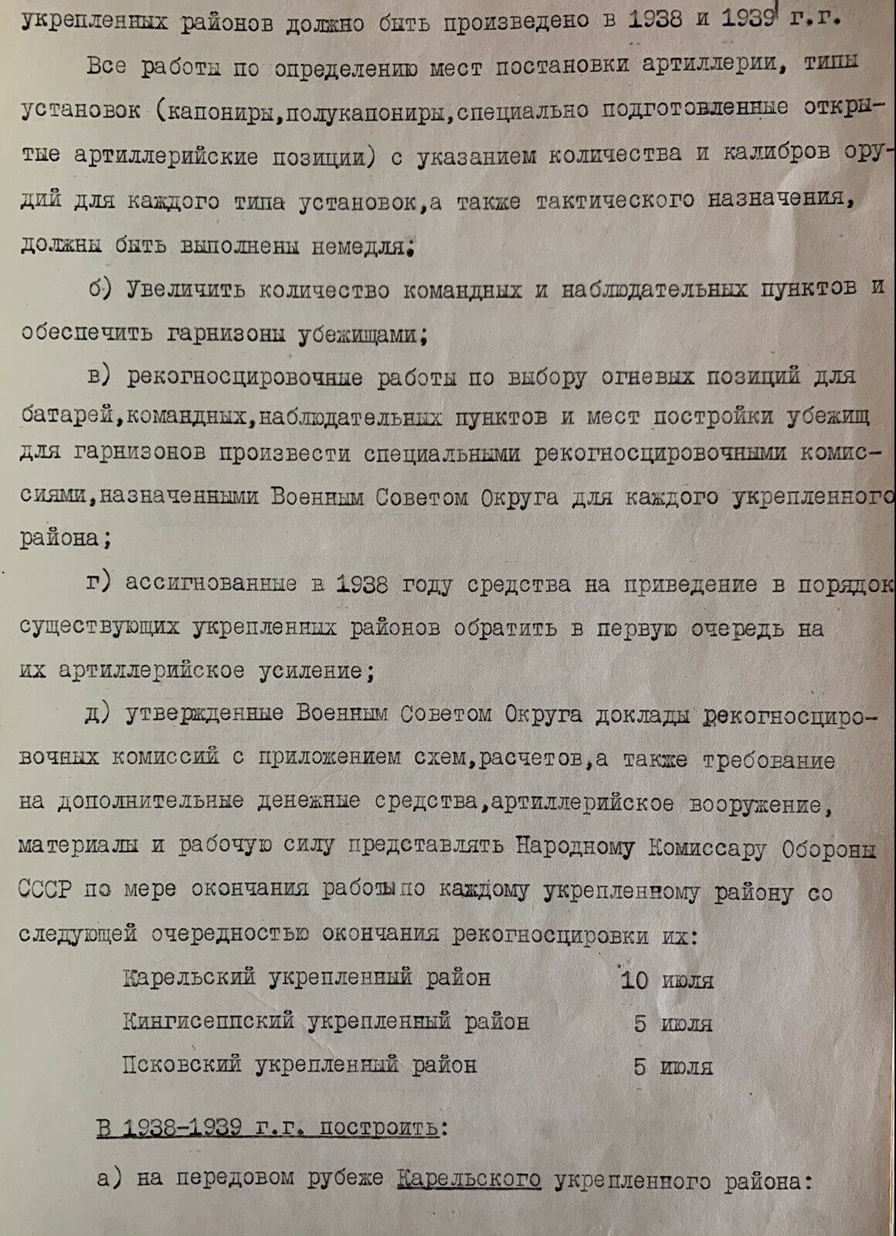

All work on determination of the artillery location, the types of installations (caponiers, semi-caponiers, specially prepared artillery positions), specifying the number and the caliber of rifles for each type of installation, as well as the rifles for tactical purpose, should be performed immediately:
b) The number of command and observation posts should be increased and the garrisons should be provided with shelters.
c) Reconnaissance work on the selection of firing positions for batteries, command posts, observation posts and places of shelters construction for garrisons should be carried out by special reconnaissance commissions appointed by the Military Council of the District for each fortified regions.
d) The funds that were allocated in 1938 to reduce to an orderly arrangement of existing fortified regions, should be used primarily for artillery reinforcement.
e) The reports of the reconnaissance commissions approved by the Military Council of the District with schemes, calculations and the requirement for additional funds, artillery weapons, materials and labor should be submitted to the People's Commissar of Defense of the USSR as soon as the reconnaissance is completed:
Karelian Fortified Region – July, 10th.
Kingisepp fortified Region – July, 5th.
Pskov Fortified Region – July, 5th.
The tools which are to be built from 1938 to 1939:
a) on the front line of the Karelian fortified region:
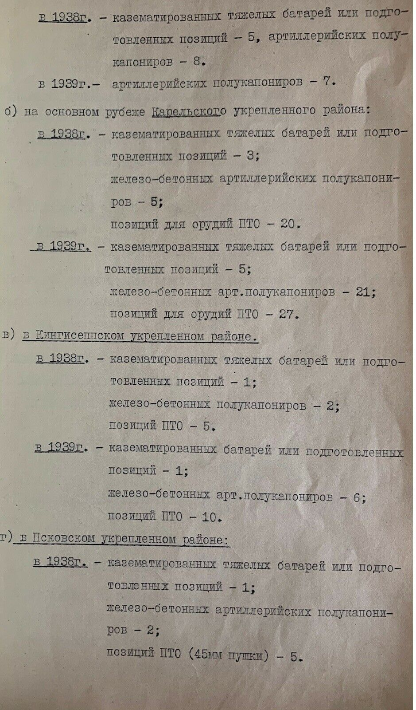
in 1938 – casemated heavy batteries or prepared positions – 5;
artillery semi-caponiers – 8;
in 1939 – artillery semi-caponiers – 7;

b) on the main border of the Karelian fortified region:
in 1938 – casemated heavy batteries or prepared positions – 3;
reinforced concrete artillery semi-caponiers – 5;
positions for AT protection – 20;
in 1939 – casemated heavy batteries or prepared positions – 5;
reinforced concrete artillery semi-caponiers – 21;
positions for AT protection – 27;

c) in the Kingissepp fortified region:
in 1938 – casemated heavy batteries or prepared positions – 1;
reinforced concrete artillery semi-caponiers – 2;
positions for AT protection – 5;
in 1939 – casemated heavy batteries or prepared positions – 1;
reinforced concrete artillery semi-caponiers – 6;
positions for AT protection – 10;

d) in the Pskov fortified region:
in 1938 – casemated heavy batteries or prepared positions – 1;
reinforced concrete artillery semi-caponiers – 2;
positions for AT protection (45 mm) – 5.
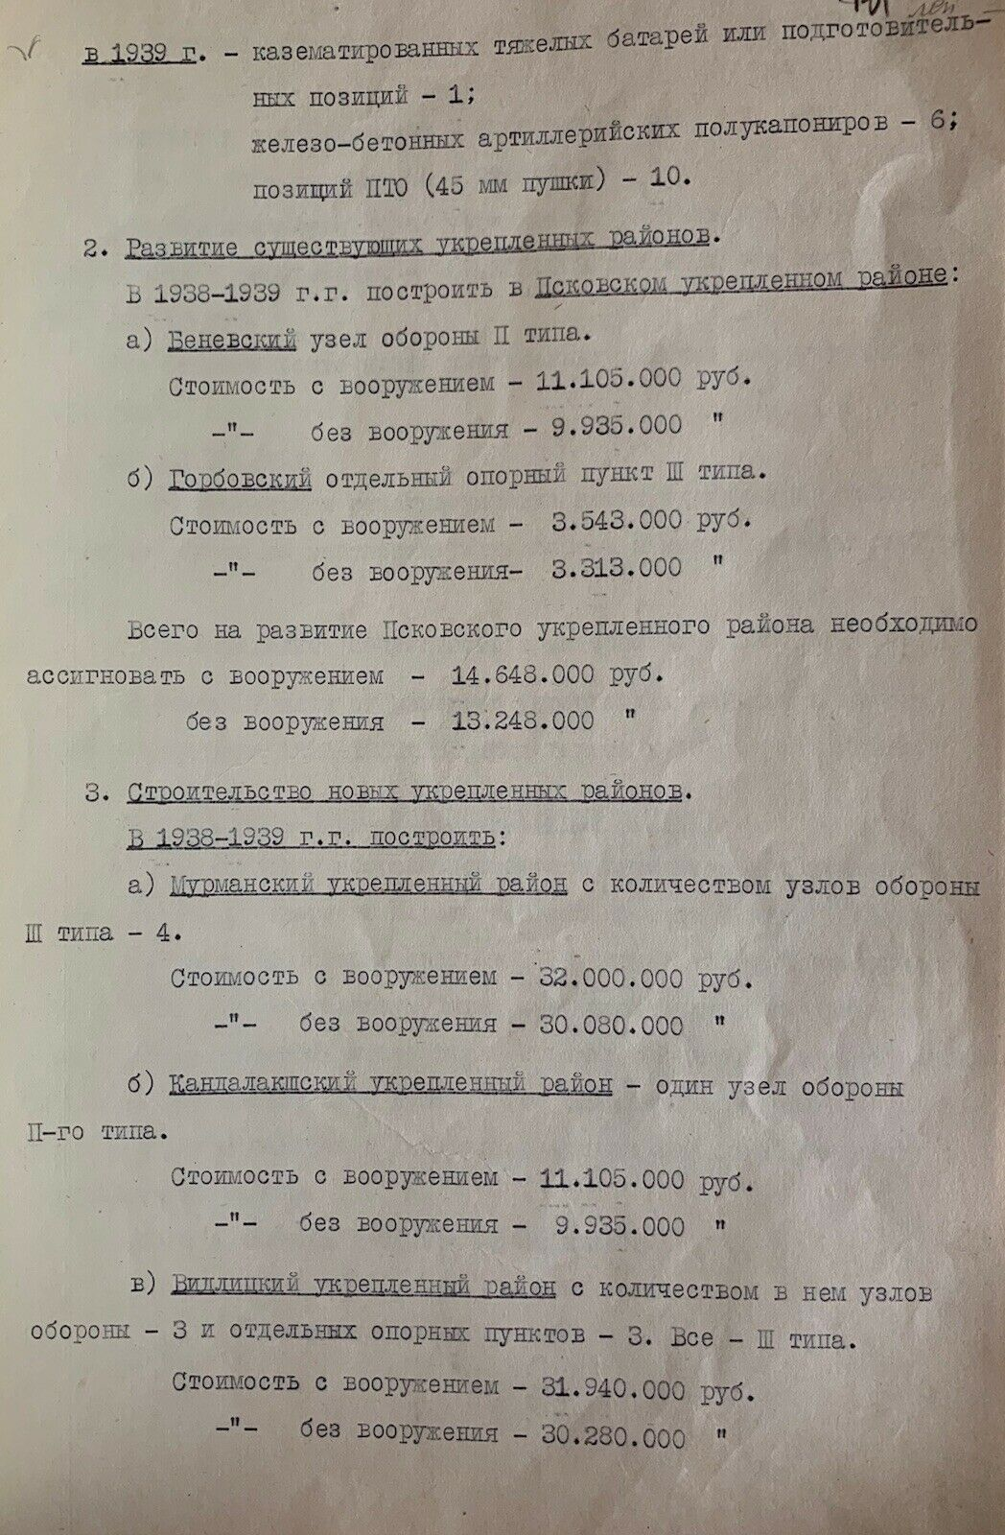

in 1939 – casemated heavy batteries or prepared positions – 1;
reinforced concrete artillery semi-caponiers – 6;
positions for AT protection (45 mm guns) – 10.
2. The development of existing fortified regions.
The fortifications which are to be built in Pskov fortified region from 1938 to 1939:
a) Centre of resistance of II type in Benevsk.
The cost with armament is 11.105.000 rubles.
_ ''_without armament – 9.935.000 rubles ''
b) Gorbov separate strongpoint of III type.
The cost with armament is 3.543.000 rubles.
_ ''_without armament – 3.313.000 rubles. ''
In total, it is necessary to allocate 14.648.000 rubles for the development of Pskov fortified region with armament.
_ ''_ without armament – 13.248.000 rubles. ''
3. The construction of new fortified regions.
The fortifications which are to be built from 1938 to 1939:
a) The number of centers of resistance of III type in Murmansk fortified region is 4.
The cost with armament is 32.000.000 rubles.
_ ''_ without armament – 30.080.000 rubles. ''
b) In Kandalaksha fortified region the is one center of resistance of II type.
The cost with armament is 11.105.000 rubles.
_ ''_ without armament – 9.935.000 rubles. ''
c) The number of centers of resistance in Vidlitsk fortified region is 3. The number of separate strongpoints are 3. They all are of III type.
The cost with armament is 31.940.000 rubles.
_ ''_ without armament – 30.280.000 rubles. ''
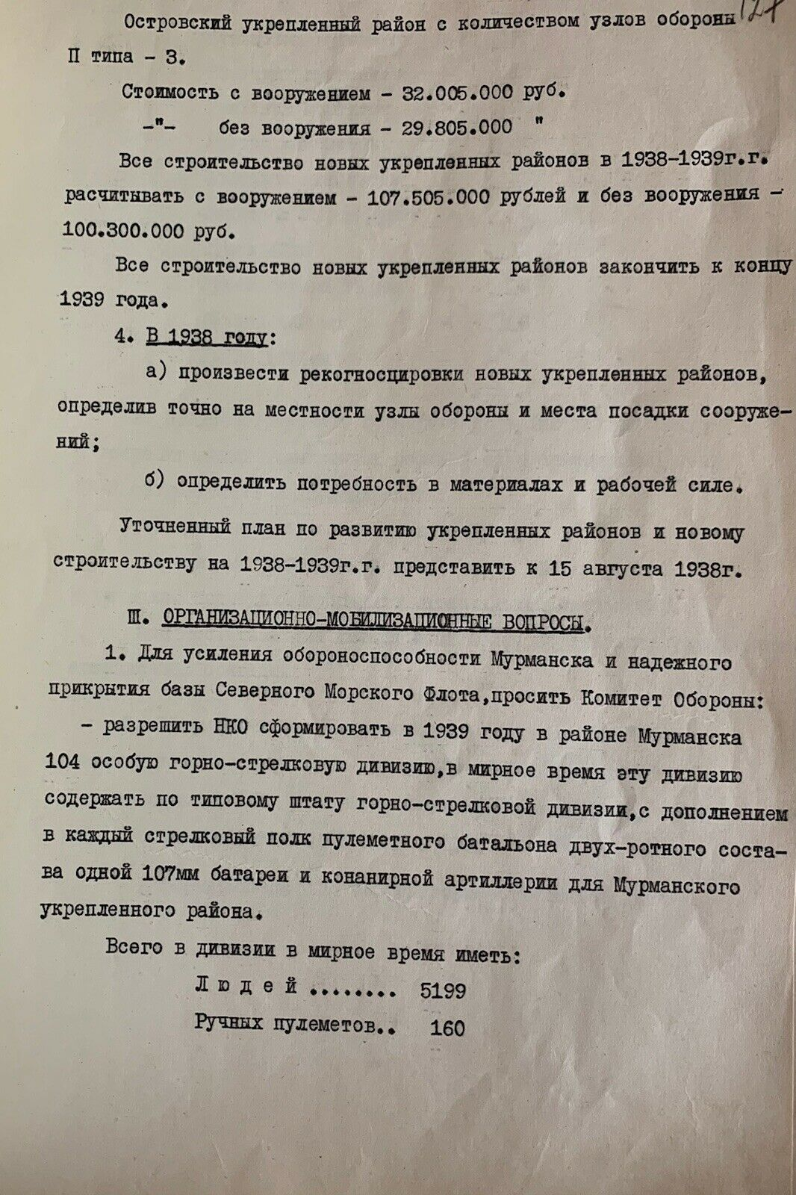

The number of centers of resistance of II type in Ostrov fortified region is 3.
The cost with armament is 32.005.000 rubles.
_ ''_ without armament – 29.805.000 rubles. ''
The cost of all construction of new fortified regions during 1938-1939 – with armament – is 107.505.000 rubles and without weapons – 100.300.000 rubles.
All the construction of the new fortified regions should be completed by the end of 1939.
4. In 1938:
а) The reconnaissance of new fortified regions should be carried out and the site location of centers of resistance of facilities constructions are to be identified.
b) The need for materials and labor is be determined.
The updated plan for the development of fortified regions and new construction in 1938-1939 should be submitted by August 15, 1938.

III. ORGANIZATIONAL AND MOBILIZATION ISSUES.
1. To strengthen the defense capability of Murmansk and to provide the reliable cover for the Northern Sea Fleet base, these requests are sent to the Defense Committee:
- to allow the People's Commissariat of Defenseto form in 1939 in the Murmansk region 104th special mountain rifle division. In peacetime this division should be maintained according to the standard staff of the mountain rifle division. Each rifle division of a two-company machine-gun battalion should be equipped with one 107mm battery and conanir artillery in Murmansk fortified region.
In total, the division should be equipped in peacetime with:
People – 5199
Light automatic machine guns – 160

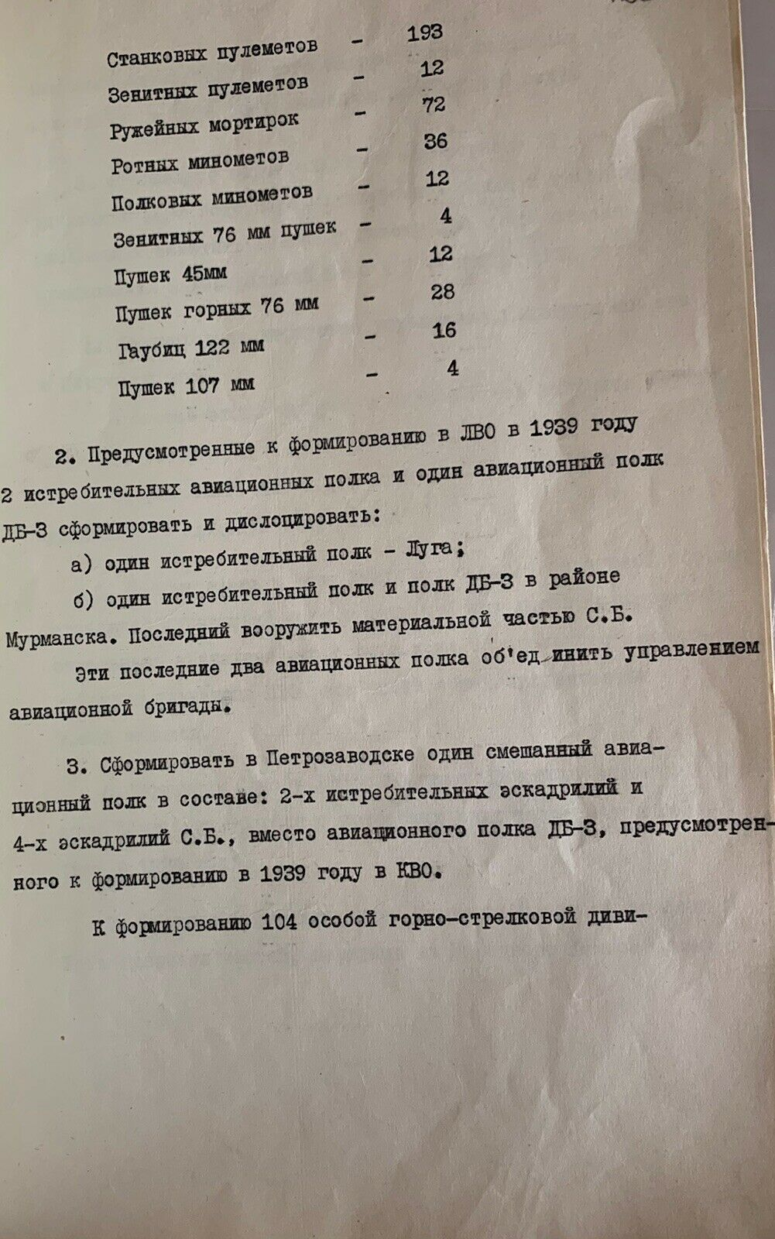
Heavy machine guns – 193
Antiaircraft automatic machine guns – 12
Rifle grenade dischargers – 72
Company mortars – 36
Regimental mortars – 12
Antiaircraft 76 mm guns – 4
45 mm guns – 12
Mountain 76 mm guns – 28
122 mm howitzers – 16
107 mm guns – 4
2. Two fighter aviation regiments and one DB-3 aviation regiment which were provided for the formation in the Leningrad Military District in 1939, should be formed and deployed:
a) one fighter regiment – in Luga;
b) one fighter regiment and a DB-3 regiment in the Murmansk region. The latter should equip the rifle battalion with the material part.
These last two aviation regiments should be united by the control of the aviation brigade.
3. One mixed aviation regiment consisting of: two fighter squadrons and four squadrons of the rifle battalion should be formed, instead of the DB-3 aviation regiment, envisaged to be formed in 1939 in Kiev Military District.
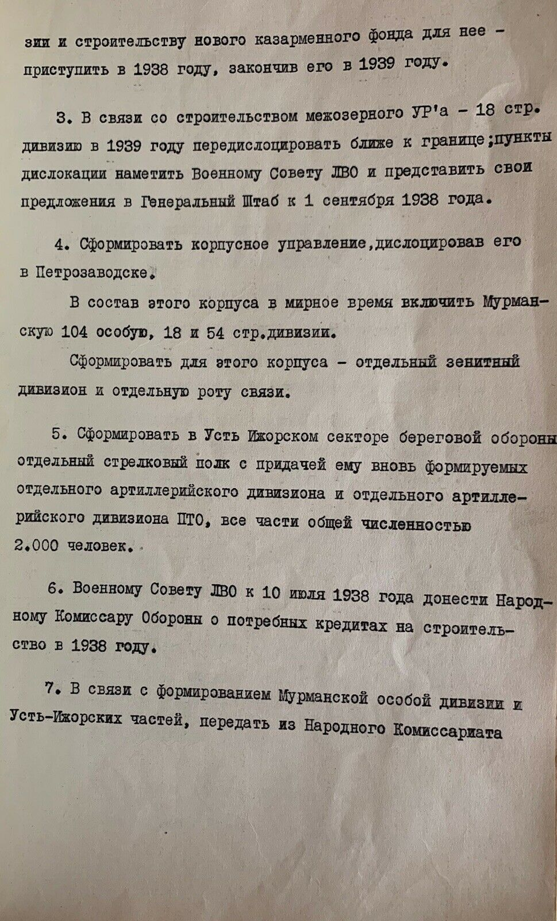
The formation of the 104th special mountain rifle division and the construction of a new barracks fund should start in 1938, and in 1939 it should be completely finished.
3. Because of the construction of the interlake fortified region – the 18th Rifle Division should be relocated closer to the border in 1939; the locations should be identified to the Military Council of the Leningrad Military District and the proposals should be presented to the General Staff by September 1, 1938.
4. The corps administration should be formed and deployed it in Petrozavodsk.
In peaceful time, this corps should include the Murmansk 104th Special Division, 18th and 54th Rifle Divisions.
Separate antiaircraft division and separate signals company should be also formed for this corps.
5. Separate rifle regiment should be formed in the Ust-Izhora sector of the coastal defense with a newly formed separate artillery division of the AT protection. All units have total number of 2,000 people.
6. By July 10, 1938, the Military Council of the Leningrad Military District should inform the People's Commissar of Defense about the required construction loans in 1938.
7. In relation to the formation of the Murmansk Special Division and the Ust-Izhora military forces, 9.000 field rations should be sent from the People's Commissariat of Navy to the People's Commissariat of Defense.
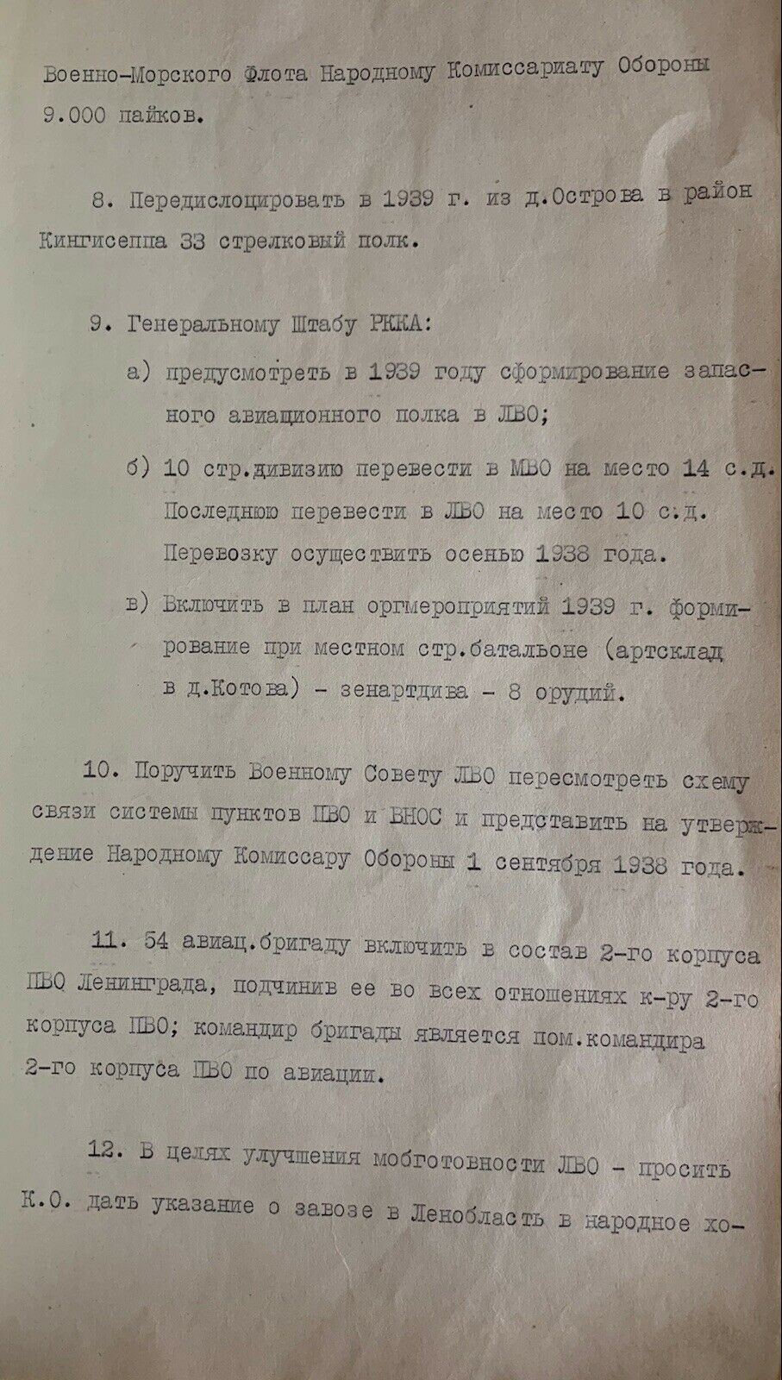
8. 33 Rifle regiments should be relocated from vil. Ostrov to the Kingisepp region in 1939.
9. To the General Staff of the Workers' and Peasants' Red Army:
a) The formation of a reserve aviation regiment should be provided in the Leningrad Military District in 1939;
b) The 10th rifle division to the Moscow Military District should be transferred to the place of 14th rifle division.
The latter is to be transferred to the Leningrad Military District to the place of the 10th rifle division.
The transportation should be carried out in autumn of 1938.
c) The plan of organizational events of 1939 should include the formation of antiaircraft artillery division – 8 guns – at the local rifle battalion (artillery depot in vil. Kotovo).
10. The Military Council of the Leningrad Military District should be instructed to reconsider the scheme of connection of Air Defense Corps and air observation warning and communication services and to submit it for approval to the People's Commissar of Defense on September 1, 1938.
11. The 54th aviation brigade should be assigned to the 2nd Air Defense Corps of Leningrad, attaching it in all respects to the commander of the 2nd Air Defense Corps; the brigade commander is the assistant to the commander of the 2nd Air Defense Corps for aviation.
12. In order to improve the mobile standby of the Leningrad Military District – the commander is to be asked to give instructions about the delivery import of 5,000 cargo vehicles, 1,000 tracked tractors, 1,500 tractors, and 1,500 trailers to the Leningrad region in the national economy in 1938.
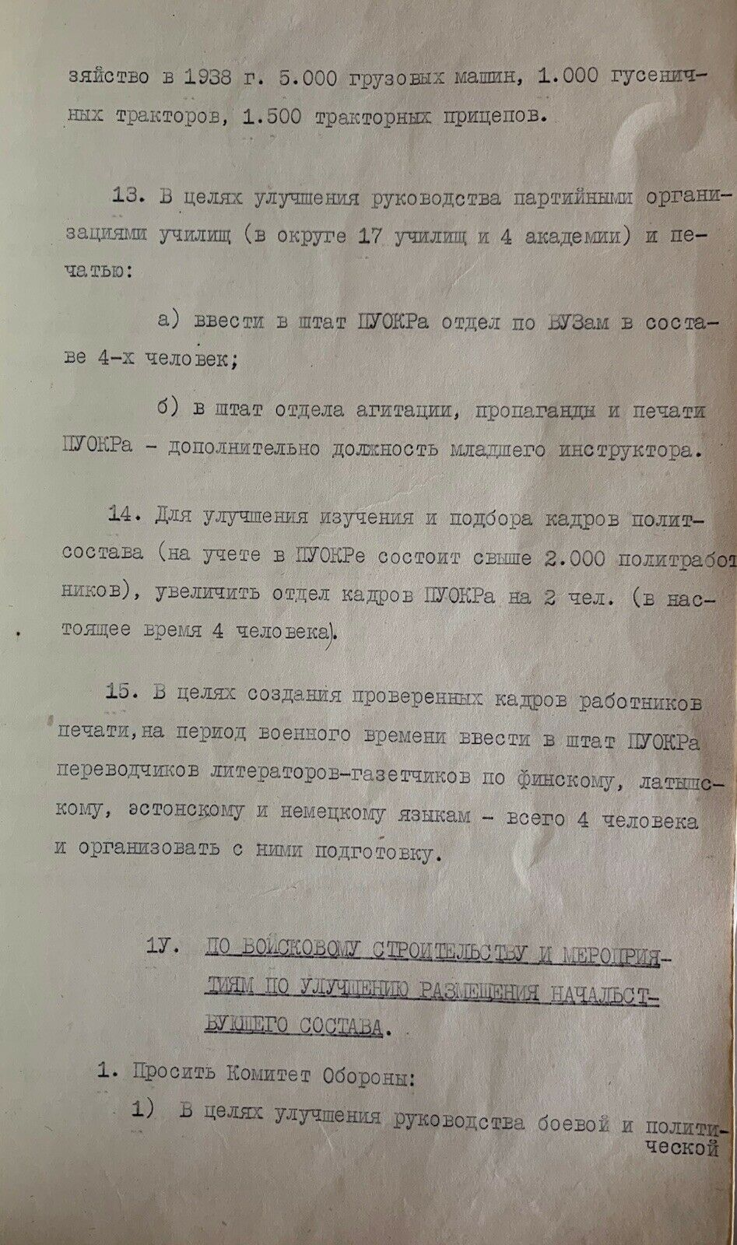
13. In order to improve the management of the party organizations of colleges (there are 17 colleges and 4 academies in the district) and the management of Press Administration:
a) the staffing of Political Department of the military district has to be established within the department for university affairs consisting of four people;
b) in addition, new position of junior instructor is to be established to support the staff of the department of agitation, publicity and Press Administration of the Political Department of the military district.
14. To improve the studying and selection of political personnel (there are more than 2,000 employees registered in Political Department of the military district), the personnel department of Political Department should be increased by 2 people (currently 4 people).
15. In order to create a proven cadre of specialists in the Press, for the period of wartime, the translators, writers and newspapermen of Finnish, Latvian, Estonian and German languages (4 workers, in total) should be established to support the staff of Political Department of the military district and the training with them should be organized.

IV. MILITARY CONSTRUCTION AND MEASURES TO IMPROVE THE PLACEMENT OF THE COMMANDING STAFF.
1. The Defense Committee is requested to the following:
1) In order to improve the management of the combat and political training of the troops, as well as to prepare possible theaters of operations, the Military Councils of the districts should be released from the management by non-defensive construction.
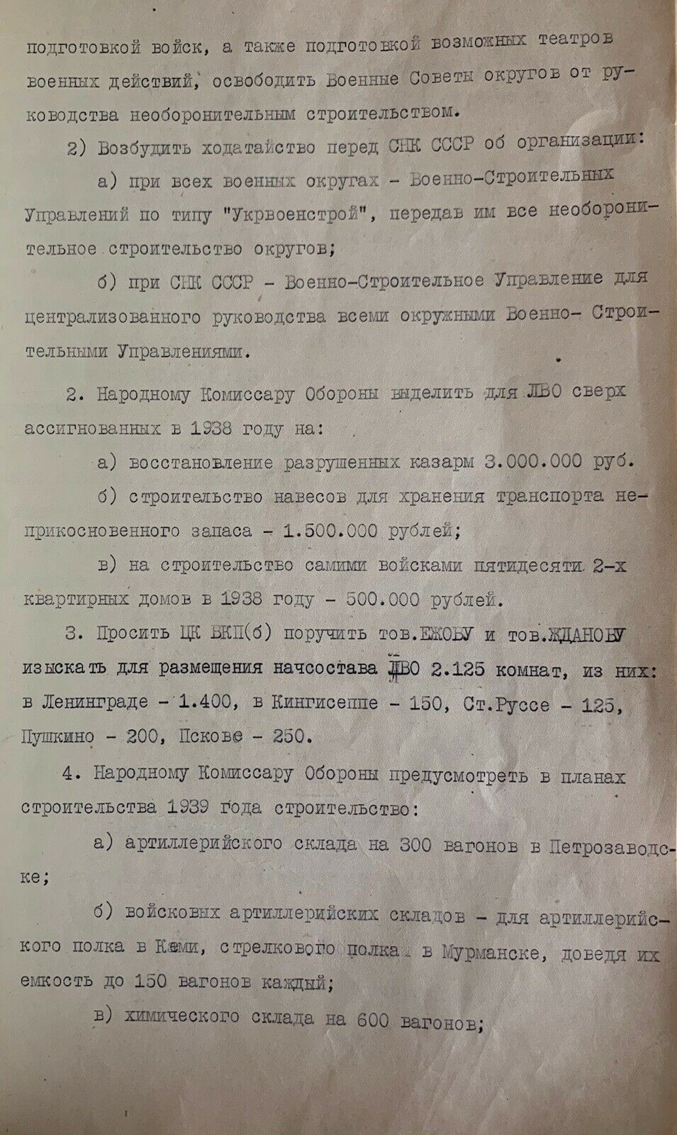
2) The petition should be filed to the Council of People's Commissars of the Soviet Union of the organization of:
a) Military Construction Departments of the type "Ukrvoenstroy", transferring all non-defensive construction of districts to them – at all military districts;
b) the Military Construction Department for the centralized management of all district Military Construction Departments in the Council of People's Commissars of the Soviet Union.
2. To the People's Commissar of Defense to allocate for the Leningrad Military District in excess of the allocated in 1938 for:
a) the restoration of the destroyed barracks – 3.000.000 rubles.
b) the construction of sheds for storage of vehicles of emergency store – 1.500.000 rubles;
c) the construction of fifty 2-apartment buildings by the troops themselves in 1938 – 500.000 rubles.
3. The Communist Party Central Committee is requested to entrust, the Comrade EZHVU and Comrade ZHDANOV, to find 2.125 rooms for accommodation of the head staff of the Leningrad Military District. 1.400 Of these rooms is to be located in Leningrad, 150 rooms – In Kingisepp, 125 rooms – Staraya Russa, 200 rooms – Pushkino and 250 rooms – in Pskov.
4. The People's Commissar of Defense is requested to take into account in its plans of construction for 1939 the building of:
a) artillery depot for 300 wagons in Petrozavodsk;
b) military artillery depots-for an artillery regiment in Kemi, a rifle regiment in Murmansk, bringing their capacity to 150 wagons each;
c) chemical warehouse for 600 cars;
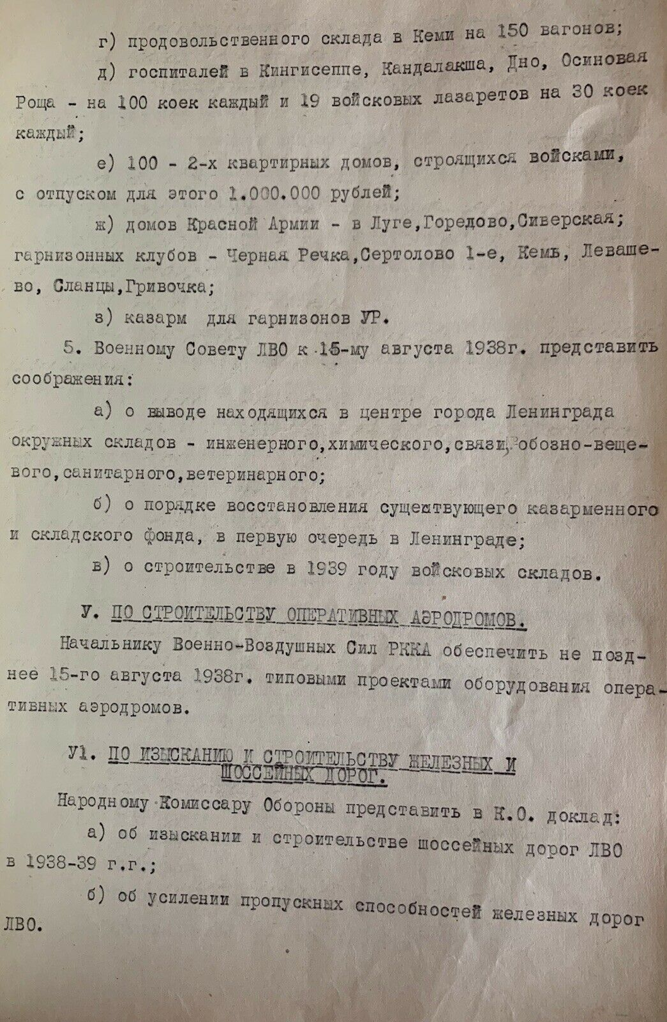
d) food warehouse in Kemi for 150 wagons;
e) hospitals in Kingisepp, Kandalaksha, Dno, Osynovaia Roshcha -for 100 beds each and 19 military infirmaries for 30 beds each;
f) 100 of semi-detached houses which are being built by the troops, providing 1,000,000 rubles for it;
g) houses of the Red Army – in Luga, Goredovo, Siverskaya; garrison clubs – in Chernaya Rechka, Sertolovo 1st, Kem, Levashevo, Slantsy, Grivochka;
h) barracks for guided missile garrisons.
5. Military Council of the Leningrad Military District is requested to provide these views by August 15, 1938:
a) withdrawal of the district warehouses located in the center of Leningrad City, namely: engineering warehouse, chemical warehouse, communications warehouse, survey and clothing warehouse, sanitary ones and veterinary ones;
b) procedure for restoring the existing barracks and storage facilities, primarily in Leningrad;
c) construction of operational storage sites in 1939.

V. CONSTRUCTION OF OPERATIONAL AIRFIELDS.
The Chief of the Red Army Air Force has to provide standard equipment projects for operational airfields no later than August 15, 1938.

VI. RESEARCH AND CONSTRUCTION OF RAILWAYS AND HIGHWAYS.
The People's Commissar of Defense has to report to Kiev Military District:
a) research and construction of the highways of the Leningrad Military District in 1938-1939;
b) strengthening of the railways capacity of the Leningrad Military District.
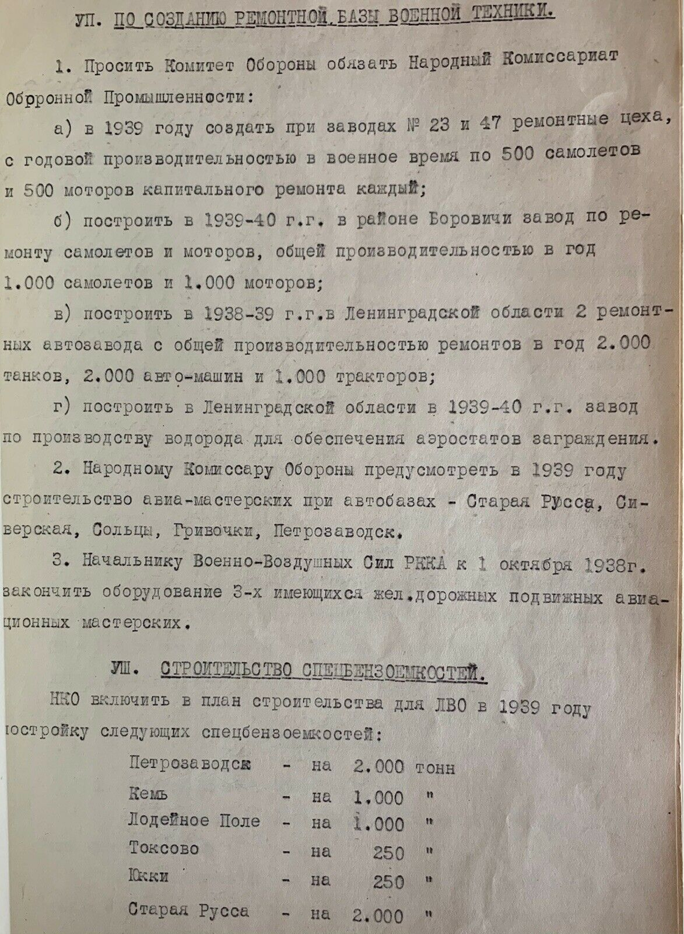
VII. CREATION OF A REPAIR INSTALLATION FOR MILITARY EQUIPMENT.
1. To request the Defense Committee to oblige the People's Commissariat of Defense Industry:
a) to create in 1939 rehabilitation shops at factories number 23 and 47, with an annual production capacity in wartime of 500 aircraft and 500 engines of overhaul repair each;
b) to build in the Borovichi region during 1939-1940 the aircraft and engine repair factory with a total annual capacity of 1.000 aircraft and 1.000 engines;
c) to build in the Leningrad region during 1938-1939 two repair car factories with a total annual repair capacity of 2.000 tanks, 2.000 cars and 1.000 tractors;
d) to build in the Leningrad region during 1939-1940 the factory for production of hydrogen to provide barrage balloons.
2. The People's Commissar of Defense has to provide for the construction of such aircraft workshops at the motor depots as – Staraya Russa, Siverskaya, Soltsy, Grivochki and Petrozavodsk in 1939.
3. To the Chief of the Red Army Air Force has to finish the equipment of 2 existing railway mobile aviation workshops by October 1, 1928.

VIII. THE CONSTRUCTION OF SPECIAL GASOLINE STORAGES.
People's Commissariat of Defense has to include the state construction of the following special gasoline storages to the building plan for the Leningrad Military District in 1939:
Petrozavodsk – the capacity of 2.000 tons ''
Kem – of 1.000 tons ''
Neva – of 1.000 tons ''
Lodeynoye Pole – of 1.000 tons ''
Toksovo – of 250 tons ''
Yukki – of 250 tons ''
Staraya Russa – of 2.000 tons ''
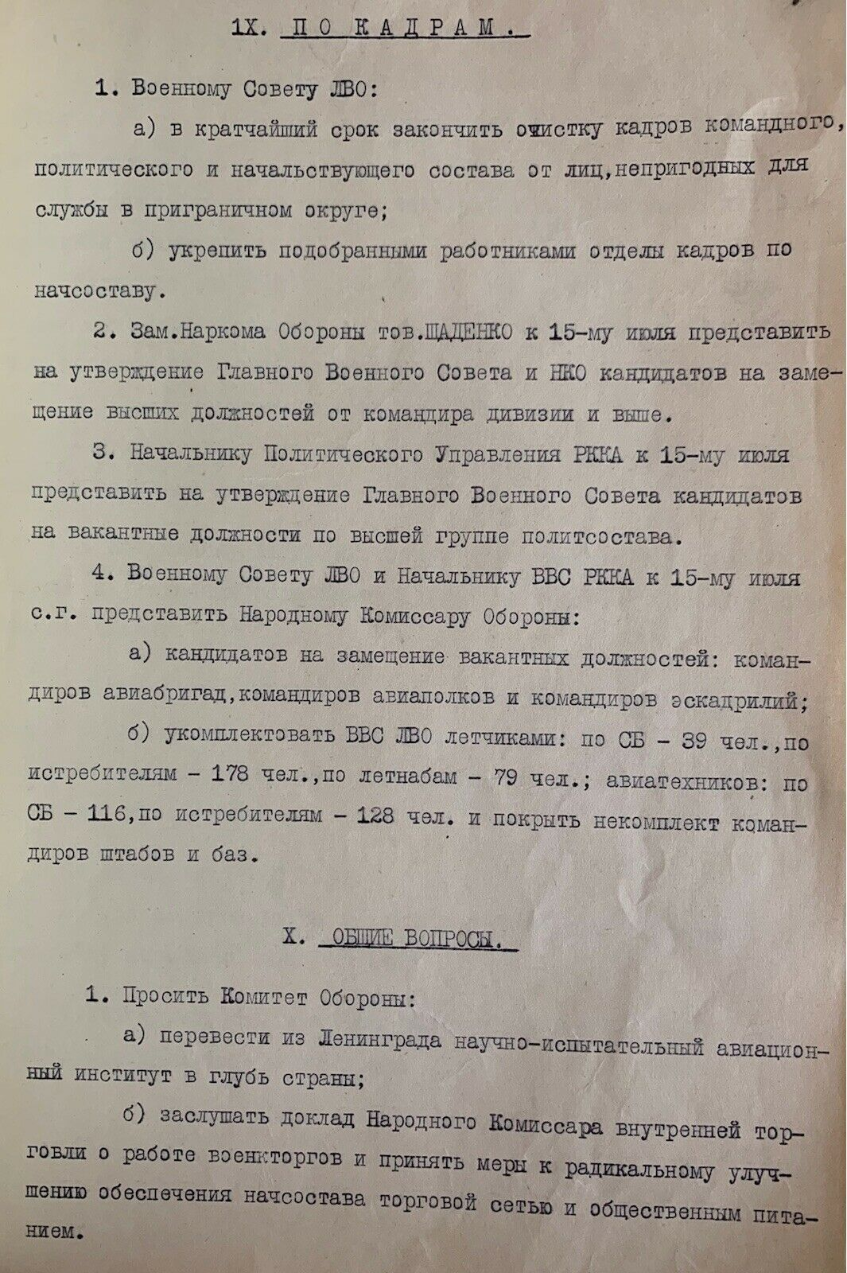

IX. HUMAN RESOURCES.
1. To the Military Council of Leningrad Military District:
a) as soon as possible to complete dismissing of those members of the staff who unfit for service in the border district in the command, political and commanding structure;
b) to strengthen the human resources department of the commanding stuff with the selected employees.

2. The Deputy People's Commissar of Defense, Comrade SHCHADENKO, has to submit for approval of senior positions candidates by the Main Military Council and by the People's Commissariat of Defense from the division commander and higher by July, 15.
3. The Head of the Political Department of the Red Army has to submit for approval of candidates for vacant positions in the top group of political officers by the Main Military Council by July, 15.
4. The Military Council of the Leningrad Military District and the Chief of the Red Army Air Force has to provide to the People's Commissar of Defense by July 15 of this year the following:
a) to accomplish the staffing of candidates for vacant positions: air brigade commanders, air regiment commanders and squadron commanders;
b) to accomplish the staffing of the Leningrad Military District Air Force by appointment of following pilots: for Army Forces – 39 person, for fighter aircraft – 178 person, for air observers – 79 person; with aircraft technicians: for Army Forces – 116 person, for air observers – 128 person; and to accomplish the staffing of the staffing of headquarters and base commanders.

Х. GENERAL ISSUES.
1. To request the Defense Committee:
a) to relocate the Research and Experimental Aviation Institute from Leningrad to the interior of the country;
b) to hear the report of the People's Commissar of Internal Trade about the work of army surplus stores and to take measures to radically improve the provision of commanding stuff by development of distributor network and community nutrition.
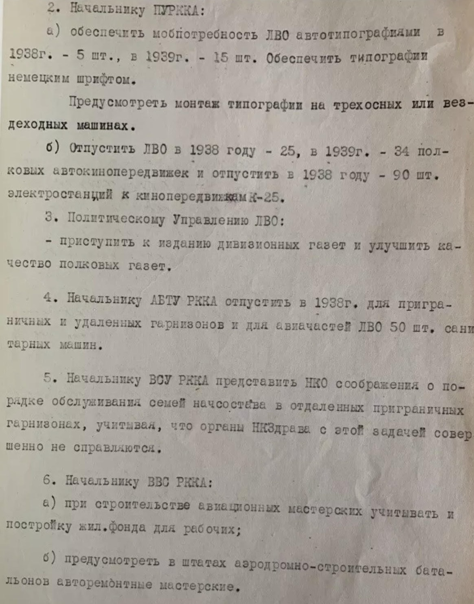
2. To the head of the Political Department of the Red Army:
а) to provide the mobile demand of the Leningrad Military District with automatic printing-offices in 1938 – 5 pcs., in 1939 – 15 pcs. To provide the printing-office s with a German font.
To provide for the installation of the printing-office on three-axle or all-terrain vehicles.
b) To provide the Leningrad Military District in 1938 – for 25 pcs., in 1939 – for 34 regimental moviemobiles and to provide in 1938 – for 90 pcs. of power plants to the moviemobiles (model K-25).
3. Political Management of the Leningrad Military District:
- to start publishing of divisional newspapers and to improve the quality of regimental newspapers.
4. In 1938, the Chief of the Agency of Automobiles and Tanks of the Red Army has to release 50 ambulance cars for border and remote garrisons and for air force units of the Leningrad Military District.
5. The head of the Armed Forces of the Red Army has to provide views to the People's Commissariat of Defense on the procedure for servicing the families of the commanding stuff in remote border garrisons, considering the fact that the People's Commissariat of Health doesn’t cope with this task at all.
6. To the Chief of the Red Army Air Force:
a) during the construction of aviation workshops, the construction of housing stock for workers has to be taken into account;
b) to provide for machinery repair shops in airfield construction battalions.
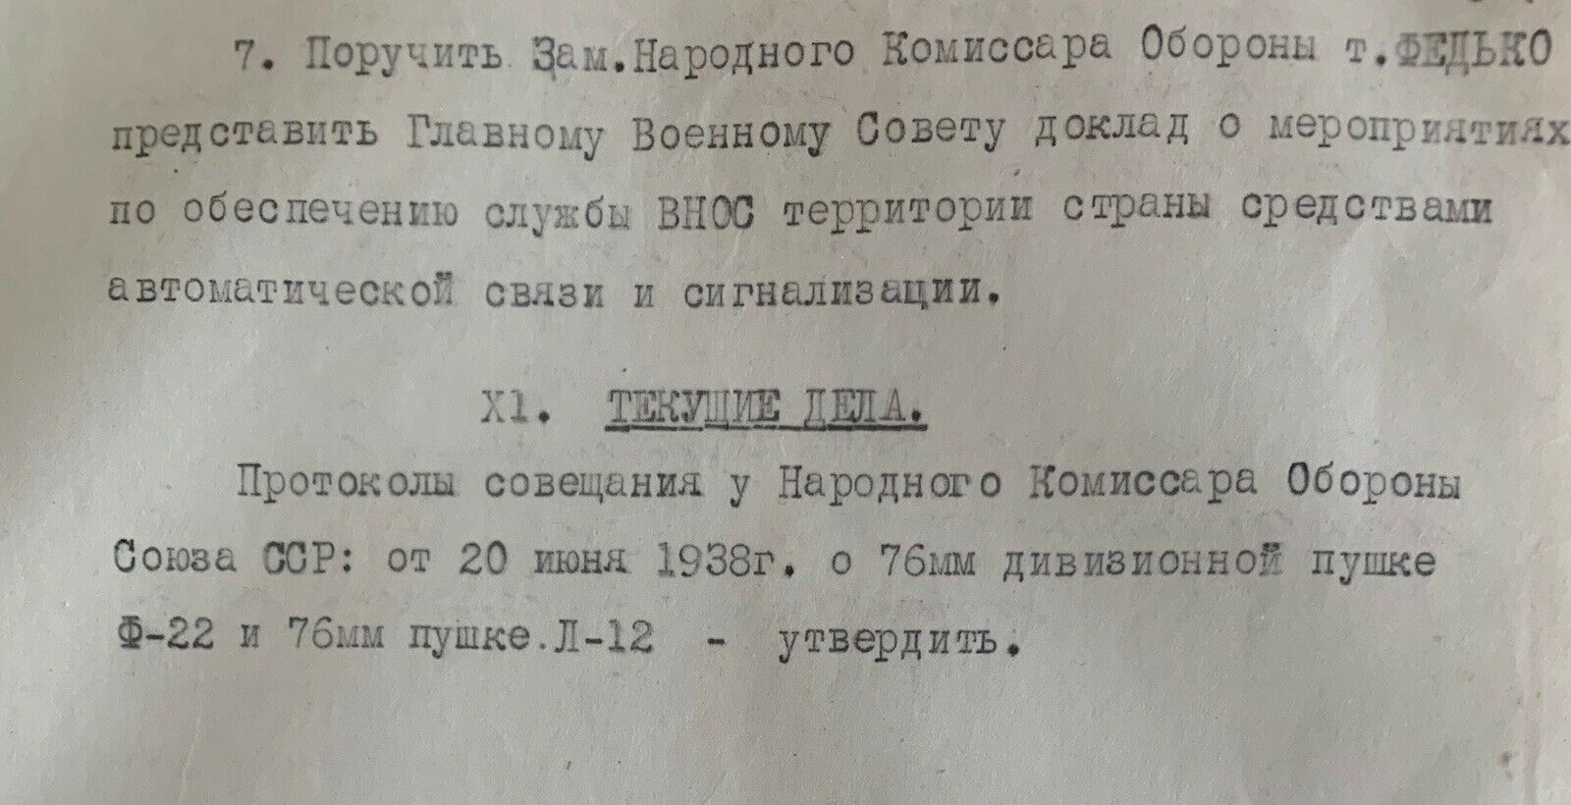
7. To instruct the Deputy People's Commissar of Defense, the Comrade FEDKO, to report to the Main Military Council on activities to ensure the air observation warning and communication services in the territory of the country by means of automatic communication and alarm systems.
XI. CURRENT AFFAIRS.
Minutes of the meeting of the People's Commissar of Defense of the USSR: of June 20 1938, on the 76 mm divisional gun (model F-22) and 76 mm gun (model L-12), – have to be approved.

