National symbols of Ukraine and historical sightings
The state symbols of Ukraine are defined by the Constitution as the flag, coat of arms and anthem. However, it is difficult to disagree with the fact that a nation is made up of many components: our history, traditions, poetry and music, architectural and artistic monuments, landmarks and figures of which we are particularly proud.
On July 28, Ukraine first celebrated a new holiday — Statehood Day.
Blue and yellow flag
During the historical formation of the Ukrainian state, the blue-yellow flag was a symbol of the struggle for the national and social rights of the Ukrainian people. The flag made its way from the flag of the Russian National Guard to the state symbol of an independent country, becoming the State Flag of Ukraine at the time of Independence.
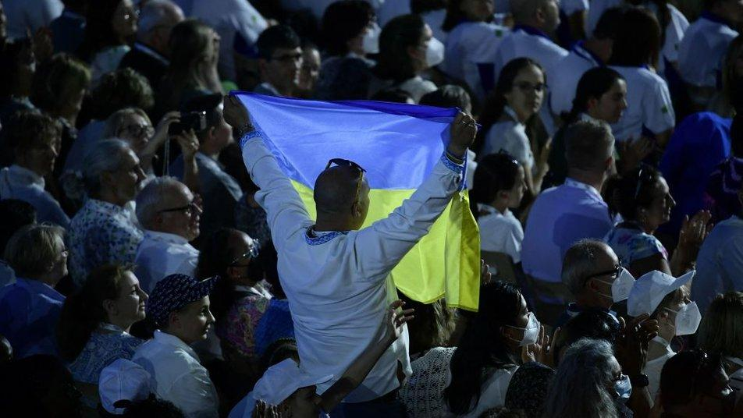
Trident
The trident is a Ukrainian symbol that has been found on our territory since ancient times. The oldest image found by archaeologists dates back to the 10th century. It is assumed that at that time it was a magical sign of the family, a talisman.
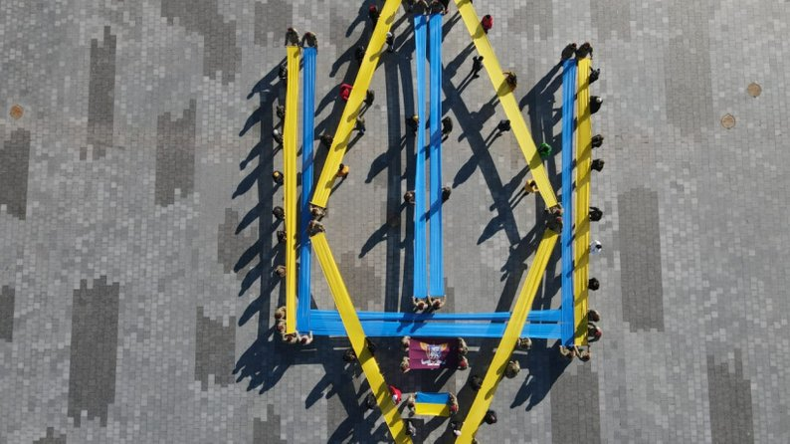
Anthem of Ukraine
In the autumn of 1862, at one of the patriotic parties in Kyiv, the poet Pavlo Chubynskyi wrote a poem that began with the words "Neither the glory nor the will of Ukraine has died yet!". For these poetic lines, 23-year-old Chubynskyi was exiled to the Arkhangelsk province for "pernicious influence on the minds of the common people." But Pavel Chubynskyi's poem was still printed in the Lviv magazine "Meta". This text was liked by the composer Mykhailo Verbytskyi, who wrote a musical accompaniment to it. The first recording of the song "Ukraine is not dead yet" took place in October 1910 in Cologne at the Gramophone company. Ukrainian opera singer Modest Mentsynsky became the soloist. This record has survived to this day.
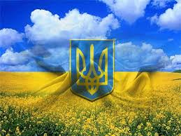
Let's talk about architecture:
Khotyn Fortress
A medieval fortified fortification in the Chernivtsi region, built at the turn of the XIII-XIV centuries. The Khotyn War took place under the walls of the fortress, one of the largest battles in Europe.
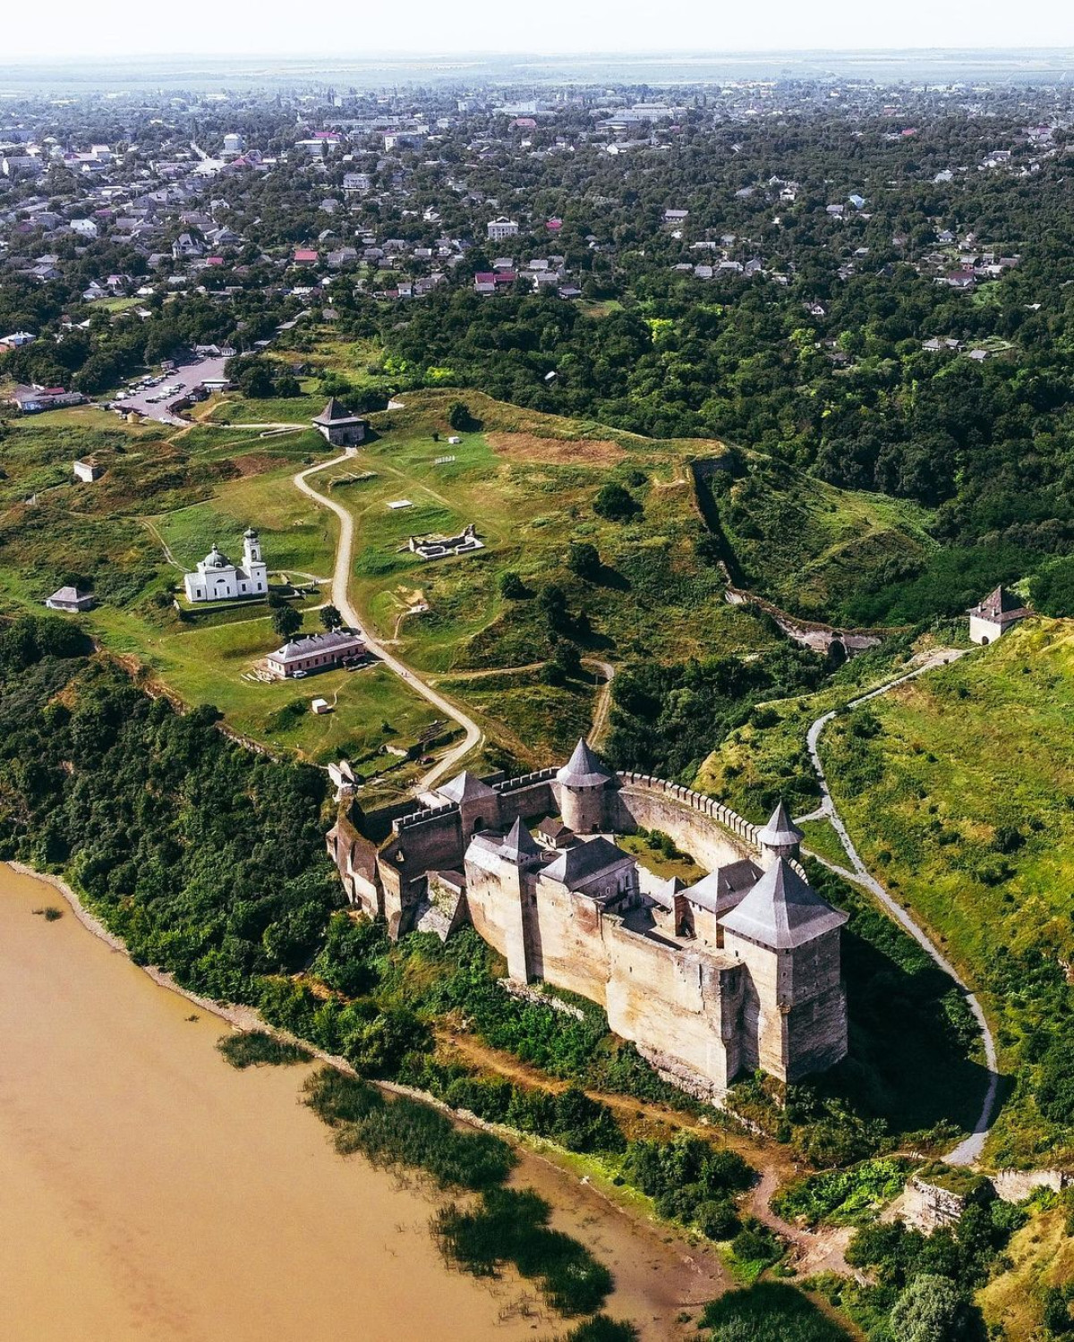
Kyivo-Pecherska Lavra
Orthodox monastery in Kyiv, founded in the 11th century by the monks Anthony and Theodosius. It became the center of the spread and establishment of Christianity in Kyivan Rus. Later, the monastery received the status of a lavra.
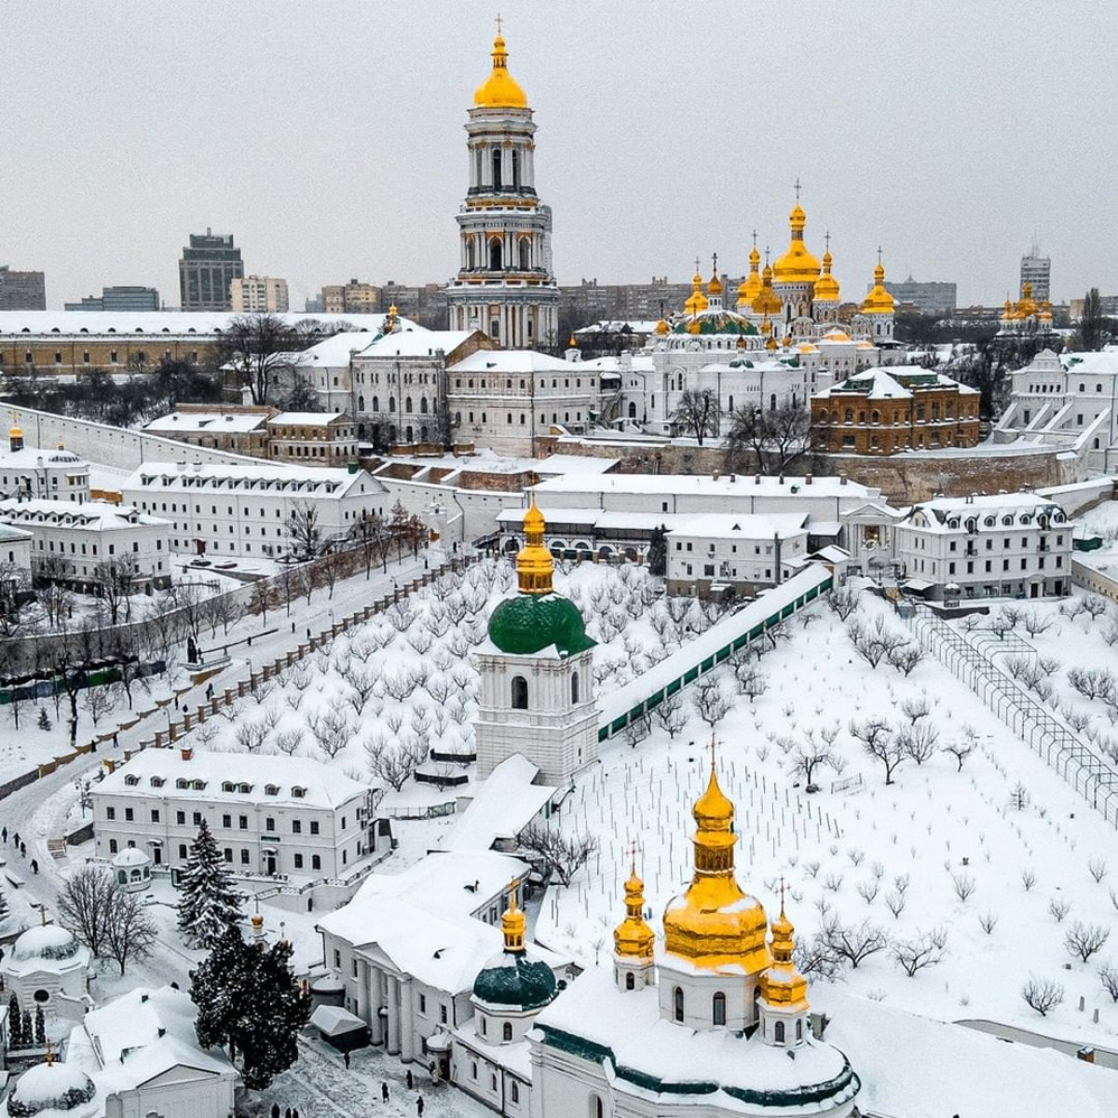
Saint Sophia Cathedral
The cathedral was built in 1011-1018 by Prince Yaroslav the Wise in Kyiv. Until the 13th century, the architectural monument was the main temple of Russia, after its decline it was restored by Metropolitan Peter Mohyla and Hetman Ivan Mazepa.
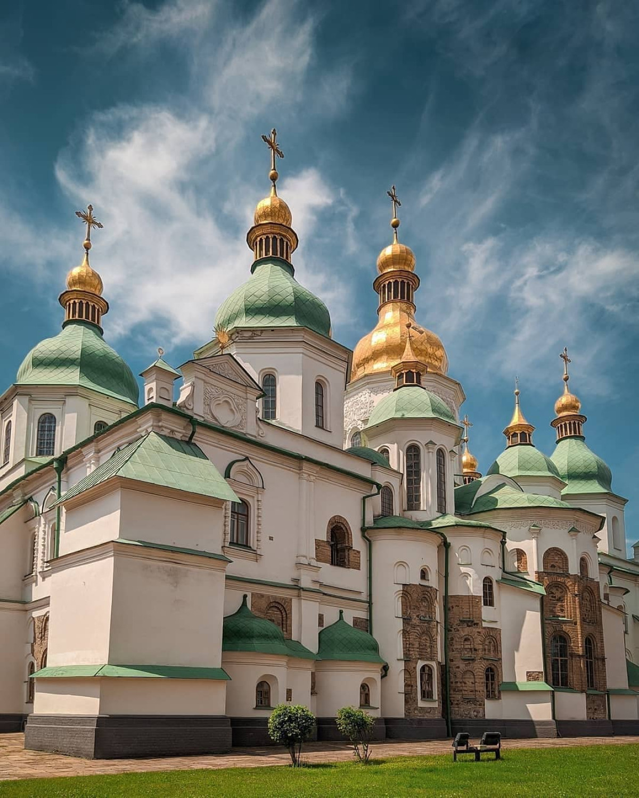
Khortytsia National Reserve
The national reserve is located on the island of Khortytsia and adjacent territories. Founded in 1965, it perpetuates the history of the Zaporozhye Cossacks.
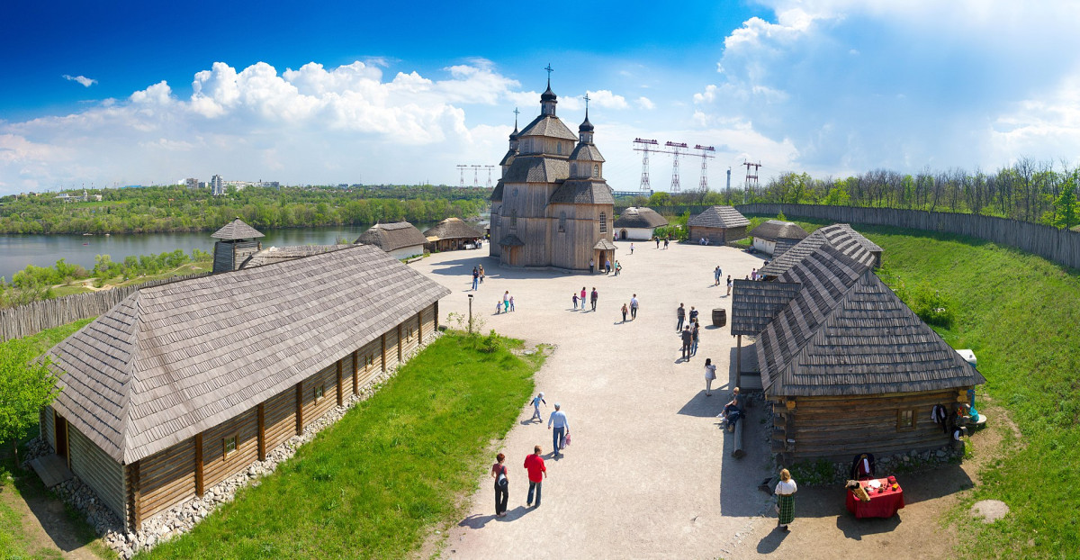
There is also national clothing:
Embroidered Shirt
A national shrine that symbolizes and carries spiritual wealth, high wisdom and the traditional connection of many generations, which is not interrupted by the ages.
