The article describes the production of intelligent polymeric composite materials. This question is multidisciplinary. It includes aspects of chemical engineering, microelectronics and non-destructive testing. Using mathematical models created previously, simulation was carried out. Based on the simulation, designs of processing equipment were developed.
Keywords — intelligent polymers, flow simulation, polymer processing

Introduction
One of the types of polymeric composite materials (PCM) is the materials that are capable of remote transmitting data on their properties, in particular the stressed-strained state, for conducting online monitoring. This is achieved by the introduction into PCM of intelligent sensors that are miniature measuring devices. They have the form of a structural totality of one or more measuring transformers of the magnitude that is measured and controlled. Intelligent sensor produces an output signal suitable for the remote transmission, storage and usage in control systems, and possesses normalized characteristics [1].
The application of intelligent PCM is appropriate in such areas as [2, 3]:
- Aerospace industry, to control the stressed-strained state of aerial vehicles elements.
- Medicine (to control elements of artificial heart valves, etc.).
- Shipbuilding (to control wear on the most critical elements of submarines).
- Automotive and machine building (to control stresses arising in responsible locations during operation).
A problem of obtaining data from the intelligent sensors in PCM is a multidisciplinary one. On one hand, the issue of technologies and equipment for the introduction of sensors into PCM, interpretation of data on stressed-strained state and other properties, received from sensors, is related to polymer machine engineering. On the other hand, the question of obtaining signals from intelligent sensors and their further processing is related to nondestructive testing. At the same time, the creation of intelligent sensor refers to microelectronics [4].
In terms of polymer machine engineering important decision on the introduction of intelligent sensors in polymer material with high precision for different processes.

Modelling and production of intelligent polymeric composite materials
Use of such a method is proposed for the manufacture by injection molding. Injection molding machine performs of polymer melt injection in form until it is at a predetermined filling pressure. Thereafter intelligent sensor probe is introduced to a predetermined thickness and coordinate the product width is output probe from the mold cavity and the pressure is reduced to a predetermined value in the process and regulation is maintained a certain time, and then cooled without pressure, open form and the product removed (Fig. 1).

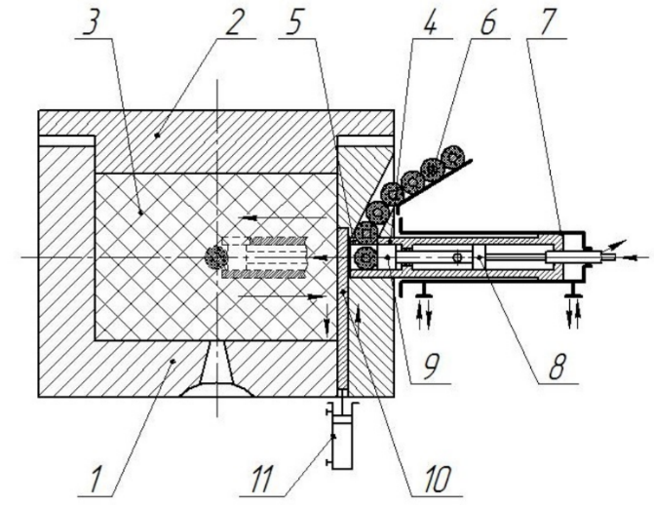
- Introduction of intelligent sensor by process of injection molding:
1 – die; 2 – punch; 3 – cavity; 4 – pusher; 5 – nozzle; 6 – intelligent sensor; 7, 8, 11 – drives; 9 – pusher; 10 – gate valve

For the formation of products offered by pressing the mold design, equipped with a dosing device of intelligent sensors in the set point volume products (Fig. 2).
- Introduction of intelligent sensor by process of pressing:
1 – die; 2 – punch; 3 – cavity; 4 – nozzle; 5 – pusher; 6 – feed device; 7 – intelligent sensor; 8 – drive
The article describes intelligent polymeric composite materials production. Surely, this is multidisciplinary question. It includes chemical engineering, microelectronics and non-destructive testing aspects. We conducted simulation, using mathematical models that were previously created. Based on this simulation, processing equipment designs were also developed.
Keywords: intelligent polymers, flow simulation, polymer processing

Introduction
Types of polymeric composite materials (PCM) include materials that are able to transfer their data characteristics remotely, especially in the stress-strain state to conduct online monitoring. This is achieved by intelligent sensors’ introduction into PCM (i.e. small-scale measuring devices). They have structural totality form of one or more measuring size transformers that is calculated and controlled. Intelligent sensor produces an output signal, suitable for the remote transmission, storage and usage in control systems, and it also has normalized characteristics [1].
The application of intelligent PCM is appropriate in such areas [2, 3]:
- Aerospace industry (to control the stress-strain state of aerial vehicles elements).
- Medicine (to control artificial heart valves elements, etc.).
- Shipbuilding (to control the most critical elements run-out of submarines).
- Automobile and machine building (to control stresses, arising in responsible locations during different procedures).
A problem of obtaining data from the intelligent sensors in PCM is a multidisciplinary one. On the one hand, the issue of technologies and equipment for the sensors launching into PCM, data interpretation on stress-strain state and other characteristics, received from these sensors, is related to polymer machine engineering. On the other hand, the obtaining signals issue from intelligent sensors and their further processing is related to nondestructive testing. At the same time, intelligent sensor development refers to microelectronics [4].
In terms of polymer machine engineering the decision to launch intelligent sensors with high accuracy for different operations in polymer material is very important.

Modelling and production of intelligent polymeric composite materials
Use of such method is proposed for the manufacture by injection molding. Injection molding machine performs the polymer melting injection in particular shape up to fixed filling pressure. Afterwards, intelligent sensor probe is established to preset thickness and coordinated the product width, then it is output by probe from the mold cavity, after this the pressure is reduced to predetermined size, regulation is kept going to a certain period of time, and finally it is cooled without pressure, open form and the item can be removed (Fig. 1).

- Intelligent sensor launching by process of injection molding:
1 – die (matrix); 2 – punch; 3 – cavity; 4 – pusher; 5 – nozzle; 6 – intelligent sensor; 7, 8, 11 – drives; 9 – pusher; 10 – gate valve

For the products formation we offer pressing the mold design. It is equipped with a dosing device of intelligent sensors in the set volume products (Fig. 2).
- Intelligent sensor launching by pressing process:
1 – die(matrix); 2 – punch; 3 – cavity; 4 – nozzle; 5 – pusher; 6 – feed device; 7 – intelligent sensor; 8 – drive

