Text Content Writing Assignment: Full List of Social Casinos

Purpose for the author (content creator): Objective for the author (content creator): To write content on the topic above, with a word count of at least 6306, following the requirements and structure below.
Do not use any generative artificial intelligence services or programs to write content.
Write text in the first person - the content creator.
Please write in neutral English targeting an international audience. The content should be suitable for US-based users, but without any mention of the USA, Europe, or other geographic references.

Header h1 and meta title and description tags

Header h1: Full List of Social Casinos for Jule 2025
Title: Best New Online Social Casinos 2025 with Real Money Prizes
Description: The new online social casinos in July 2025 ✅ Find out what the 🥇 best social casino is from our personal experience.

✅ 1. Content requirements

Purpose of this text: To provide international users with an accurate, trustworthy, and up-to-date guide to all active social casinos, with detailed comparisons, legal insights, and expert recommendations to help them enjoy free-to-play casino-style gaming responsibly, while understanding sweepstakes redemption rules.
User Intent:

Visitors to this page expect:

- Find a complete and up-to-date list of all international social casinos.

- Compare features: bonus offers, game variety, platform convenience and sweepstakes rules.
- Understand the difference between social casinos and sweepstakes casinos.
- Learn how to redeem sweepstakes coins for prizes or money.
- Evaluate which social casinos are safe, legal and fun to use.
- Get direct access to bonus codes, free coin offers and app download links.

Level of topic disclosure and credibility: In-depth and expert presentation of information is needed to make the page stand out among competitors and be unique.

During and after writing, ask yourself these questions that Google recommends for evaluating content and its quality

Content and quality questions
- Does the content provide original information, reporting, research, or analysis?
- Does the content provide a substantial, complete, or comprehensive description of the topic?
- Does the content provide insightful analysis or interesting information that is beyond the obvious?
- If the content draws on other sources, does it avoid simply copying or rewriting those sources, and instead provide substantial additional value and originality?
- Does the main heading or page title provide a descriptive, helpful summary of the content?
- Does the main heading or page title avoid exaggerating or being shocking in nature?
- Is this the sort of page you'd want to bookmark, share with a friend, or recommend?
- Would you expect to see this content in or referenced by a printed magazine, encyclopedia, or book?
- Does the content provide substantial value when compared to other pages in search results?
- Does the content have any spelling or stylistic issues?
- Is the content produced well, or does it appear sloppy or hastily produced?
- Is the content mass-produced by or outsourced to a large number of creators, or spread across a large network of sites, so that individual pages or sites don't get as much attention or care?

Expertise questions
- Does the content present information in a way that makes you want to trust it, such as clear sourcing, evidence of the expertise involved, background about the author or the site that publishes it, such as through links to an author page or a site's About page?
- If someone researched the site producing the content, would they come away with an impression that it is well-trusted or widely-recognized as an authority on its topic?
- Is this content written or reviewed by an expert or enthusiast who demonstrably knows the topic well?
- Does the content have any easily-verified factual errors?

Focus on people-first content
People-first content means content that's created primarily for people, and not to manipulate search engine rankings. How can you evaluate if you're creating people-first content? Answering yes to the questions below means you're probably on the right track with a people-first approach:
- Do you have an existing or intended audience for your business or site that would find the content useful if they came directly to you?
- Does your content clearly demonstrate first-hand expertise and a depth of knowledge (for example, expertise that comes from having actually used a product or service, or visiting a place)?
- Does your site have a primary purpose or focus?
- After reading your content, will someone leave feeling they've learned enough about a topic to help achieve their goal?
- Will someone reading your content leave feeling like they've had a satisfying experience.

Additional requirements

- The article should be understandable to the reader with any level of training. If the text contains terms, professionalisms, abbreviations and other words that may be unclear, they should be explained.
- The text should not contain sentences longer than 35-40 words and long paragraphs: the volume of the recommended paragraph is 3-5 sentences.
- The article should interest the reader and (ideally) encourage him to read to the end. To do this, it is necessary to repeat the topic of the material in the lead and provide attractive information (unique way, quick registration, etc.).
- The material should be logically constructed: divided into semantic blocks, each of which should begin with the designation of the topic of a particular block and end with a conclusion to it. (e.g., therefore, however, etc.).
- The material should be divided into subheadings. Subheadings must observe hierarchy: higher level subheadings include lower levels, not the opposite.
- The text should contain at least one numbered or bulleted list. If it is a sequence of actions (instructions), it is necessary to choose a numbered list, if the usual list without order - a bulleted list. All items in the list should be equally organized. At the end of each item put a semicolon, for the possibility of getting the list on the zero position or to list items in the meta description tag.
- Visual information should be placed in the article, especially if it concerns instructions. Screenshots should be prepared for them. Schemes, videos and other such materials can be requested from specialists. The article should contain at least one relevant image on the topic with a relevant filled alt attribute.
- The article should have at least 3 different (!) links to internal materials of the site that complement the topic of the article.
- The definition is better formalized in a separate paragraph starting with the definition itself, a dash and the word "it".
- Water content should be avoided - general phrases, information off-topic, etc. (water content should be no more than 15%).
- The text should be unique (uniqueness from 90%).
- Tautology (repetition of the same words within one or two neighboring sentences) and frequent use of the same words in the text should be avoided.
- The text should be written competently: do not contain grammatical, linguistic and stylistic errors.
- The use of clericalisms, obsolete vocabulary should be excluded.
- Each statement should be supported by facts. For example, a large selection of sports is better to supplement the specification - more than a dozen or the exact number.
- Rhetorical questions should be used in the text to attract the reader's attention (for example: "How to get a bookmaker's bonus?"). However, it is always necessary to give detailed answers to them.
- When describing the text, add the following phrases that can describe the author's competence and experience. For example, these are the following phrases:
  - Based on my experience
  - As my tests have shown
  - During my review of {casino name} I found that
  - After I put it to the test
  - When I tested the {casino name} website
  - After conducting experiments with
  - Thanks to my knowledge
  - My review of {casino name} showed that
  - I came to the conclusion that
  - As a result of using the …, I noticed

✅ 2. Keywords
These are the keywords you need to use in your text. First, a table of keywords with their search volume is given. And below that, these keywords with the text areas where they should be used and how many times they should be used in the text.

Keywords | Search volume
social casino | 18000
social casinos | 11000
social casino games | 3900
new social casino | 3600
online social casino | 2900
best social casino | 2600
list of social casinos | 1800
social casinos real money | 1700
best social casinos | 1600
social casino sign up bonus | 1500
new social casinos | 1200
social casino real money | 1100
live social casino | 1100
best social casino real money | 1000
social casino no deposit bonus | 800
social casino real money no deposit | 800
online social casinos | 800
slots social casino | 700
top social casinos | 700
social casino online real money | 500
new social casino 2025 | 500
social gaming casino | 500
free social casino | 450
social casino login | 450
social casino list | 450
best online social casinos | 400
social casinos that pay real money | 400
new online social casinos | 350
newest social casino | 350
new social casino no deposit bonus | 300
top social casino | 250
newest social casinos | 200
new social casino real money | 200
new social casino list | 200
new social casinos 2025 | 200
social casino games real money free play | 150
social casino sites | 150
new social sweeps casino | 150
ultra social casino | 150
new social casino sites | 150
new online social casino | 150
brand new social casinos | 150
list of all social casinos | 150
social casino bonus | 150
social casinos list | 100
social casino welcome bonus | 100
social casino win real money | 100
free social casino games | 100
best social casino sign up bonus | 100
instant redemption social casino | 100
social casino with sign up bonus | 100
social casinos 2025 | 100
social casino 2025 | 90
social coin casino | 90
best social casino no deposit bonus | 90
top 10 social casinos | 90
social casinos free sc | 90
social casinos with daily bonus | 90
online social casinos that pay real money | 90
social casino free play | 80
social casino games free play | 80
best new social casinos | 80
social media casinos | 70
legit social casinos | 70
social casino daily bonus | 70
best social casinos real money | 70
new social casinos real money | 70
free social casino real money | 70
social casino reviews | 70
best social casino welcome bonus | 70
social casino instant payout | 70
social gambling sites | 70
best social casino games | 60
social casinos online real money | 60
social casino sign up bonus no deposit bonus | 60
online social casino games | 60
best casino social slots | 60
social casinos with sign up bonus | 60
best social casinos 2025 | 60
top online social casinos | 60
real money social casino no deposit bonus | 60
online social casino no deposit bonus | 60
social casino no deposit bonus codes | 50
online social casino login | 50
social casino blackjack | 50
top 10 social casino games | 50
slots social casino real money | 50
social casinos win real money | 50
free social casinos | 50
free spins social casino | 50
top social casino games | 50
best social casino games for group play with friends | 50
fastest paying social casino | 50
real money social casino free play | 50
best social casino 2025 | 40
top 20 social casinos | 40
best online social casino real money | 40
live social casino real money | 40
top social casino apps | 40
social casino platform | 40
social coins casino | 40
fastest payout social casino | 40
best us social casinos | 40
full list of social casinos | 30
best social casino sites | 30
new online social casinos 2025 | 30
instant withdrawal social casino | 30
free to play social casino | 30
online social casino sign up bonus | 30
social casino free sign up bonus | 30
list of new social casinos | 30
newest social casino 2025 | 30
new social casinos no deposit bonus | 30
social casino site | 20
what social casino pays out the fastest | 20
live social casino online | 20
list of online social casinos | 20
best social casinos that pay real money | 20
real social casino | 20
social casino games no deposit bonus | 20
fastest redemption social casino | 20
top rated social casinos | 20
newest social casinos 2025 | 20
social casino websites | 20
best paying social casino | 20
best new social casino | 20
free social casino no deposit bonus | 20
what social casino pays out the most | 20
social casino bonuses | 20
top social casinos no deposit bonuses | 20
social coin casino real money | 20
social casino companies | 20
best social casinos no deposit bonus | 20
ultra social casino login | 20
instant cashout social casino | 20
social casinos real money no deposit bonus | 20
social media casino | 20
top social casino real money | 10
live social casino no deposit bonus | 10
social slots casinos | 10
instant cash out social casino | 10
social casino platforms | 10
free to play social casino games | 10
social casinos that pay out instantly | 10
free to play online social casino | 10
newest online social casinos | 10
social casino real money no deposit bonus codes | 10
social casino deposit bonus | 10
online social casinos no deposit bonus | 10
top social casino gaming companies | 10
do social casinos pay real money | 10
best free social casino | 10
newest online social casino | 10
ultra social casino real money | 10
social casino daily rewards comparison | 10
social casino promo | 10
social casinos with instant payout | 10
online social casino free play | 10
social casino real money no deposit free play | 10
spin social casino | 10
daily rewards social casino platforms 2025 | 10
what is the best social casino | 10
social casinos that pay real money no deposit | 10
newest social casino no deposit bonus | 10
best social casino bonus | 10
free online social casino | 10
new online social casino sites | 10
social casino games real prizes no real money gambling | 10
live social casino promo code no deposit bonus | 10
no deposit social casinos | 10
instant redeem social casino | 10
new social casino sign up bonus | 10
which social casino pays out the fastest | 10
top social casinos 2025 | 10
new social casinos may 2025 | 10
best social casino to win real money | 10
social casino platforms win real rewards 2025 | 10

The author can increase the number of occurrences of words, but only in proportion to the amount of new text written (more than the minimum number of words specified at the beginning of this assignment).

So, for example, if you write 1/2 as many words of text as the minimum recommended, you must also add 1/2 as many new occurrences as the number of occurrences listed below.

Since the more words of text, the more occurrences you can and should use in it!

Below is the minimum number of occurrences based on the best target competitor.
- social casino
  - 1 time in the first paragraph
  - 2 times in headings h2-h3
  - 25 times in any part of the text except headings
- social casinos
  - 1 time in the second paragraph
  - 6 times in headings h2-h3
  - 49 times in any part of the text except headings
- social casino games
  - 1 time in the first heading h2
  - 6 time in any part of the text except headings
- new social casino 2025 (or new social casinos)
  - 1 time in the first heading h2
  - 6 time in any part of the text except headings
- online social casino (or online social casino)
  - 1 time in the first heading h2 (online social casino)
  - 4 time in any part of the text except headings
- best social casino (or best social casinos)
  - 1 time in the first heading h2
  - 3 time in any part of the text except headings

- real money
  - 1 time in the first heading h2
  - 4 time in any part of the text except headings
- sign up bonus
  - 1 time in any part of the text except headings
- live
  - 22 time in any part of the text except headings

- no deposit bonus
  - 1 time in any part of the text except headings

- slots
  - 48 time in any part of the text except headings

- top social casinos
  - 1 time in the first heading h2
  - 1 time in any part of the text except headings

- social gaming casino
  - 1 time in any part of the text except headings

- free
  - 53 time in any part of the text except headings
- login
  - 6 time in any part of the text except headings
- newest
  - 1 time in any part of the text except headings

- free play
  - 1 time in any part of the text except headings
- sites
  - 11 time in any part of the text except headings
- sweets
  - 35 time in any part of the text except headings
- sweepstakes
  - 65 time in any part of the text except headings

- ultra
  - 1 time in any part of the text except headings

- brand (or brands, brand’s)
  - 30 time in any part of the text except headings
- list of all
  - 1 time in any part of the text except headings

- welcome bonus
  - 15 time in any part of the text except headings

- welcome bonus
  - 2 time in the first heading h2
  - 2 time in any part of the text except headings

- games
  - 91 time in any part of the text except headings

- instant redemption
  - 1 time in any part of the text except headings

- coin (or coins)
  - 157 time in any part of the text except headings
- top 10
  - 1 time in any part of the text except headings
- free SC
  - 6 time in any part of the text except headings
- with daily bonus
  - 1 time in any part of the text except headings
- that pay real money
  - 1 time in any part of the text except headings
- legit
  - 1 time in any part of the text except headings
- instant payout
  - 1 time in any part of the text except headings
- blackjack
  - 4 time in any part of the text except headings
- free spins
  - 1 time in any part of the text except headings

- for group play with friends
  - 1 time in any part of the text except headings

- apps
  - 2 time in any part of the text except headings

- platform
  - 4 time in any part of the text except headings

- fastest payout
  - 1 time in any part of the text except headings

- instant withdrawal
  - 1 time in any part of the text except headings

- top rated
  - 1 time in any part of the text except headings

- best paying
  - 1 time in any part of the text except headings

- pays out the most
  - 1 time in any part of the text except headings

- instant cashout
  - 1 time in any part of the text except headings

- social media
  - 1 time in any part of the text except headings
- gambling sites
  - 2 time in any part of the text except headings

✅ 3. Competitors
Target competitor URLs for the collected search queries are highlighted in green in the summary table below. You can, if necessary, see what and how competitors write about on their pages, when writing content, if, for example, there are difficulties with the description of a certain section.
But do not copy their content!
Competitors | ranked by the number of occurrences in the top 10 | ranked by query frequency
https://www.gamingtoday.com/social-casinos/ | 160 | 64970
https://next.io/sweepstakes-casinos-us/social-casinos/ | 125 | 63980
https://deadspin.com/sweepstakes-casinos/social-casinos/new/ | 67 | 52170
https://www.hellomillions.com/ | 58 | 48580
https://www.chumbacasino.com/ | 38 | 42050
https://www.mcluck.com/ | 64 | 40960
https://www.reddit.com/r/sidehustle/comments/1eveook/daily_bonus_social_casinos/ | 26 | 38550

4. Content structure

✅ This structure is intended to help create informative and competent content that is as useful as possible to the user, easy to understand, and stands out from other competing pages on this topic.

The content structure below is a guideline and a skeleton for the author who will be creating textual content on this topic.

You may adjust/remove certain sections as long as the quality of the content, its purpose and usefulness to users, and especially its completeness, are not compromised.

✅ At the beginning of the text content, state the purpose of this page. When describing the purpose of the page, include the following information:
- What is this social casino review and what type of players is it for?
- In it I review all the main features of these casinos, their features, pros and cons, security details, bonuses, games and other useful information for players.
- The review is based on my personal experience with these casinos with a rating of the best casinos so that you can make an informed decision about playing at them.

Header 2 - What is a social casino and how does it work?
In describing this section, disclose the following information:
- Give a definition in the format: Social casino is
- How social casinos work

Header 2 - What’s the difference between a social casino and a real money casino?
In describing this section, disclose the following information:
- Legal differences between social casinos and real money casinos (describe the differences in text and make a comparison table)
- Here's an example of a table. But not for copying. And not to point to countries, nor states, nor cities!
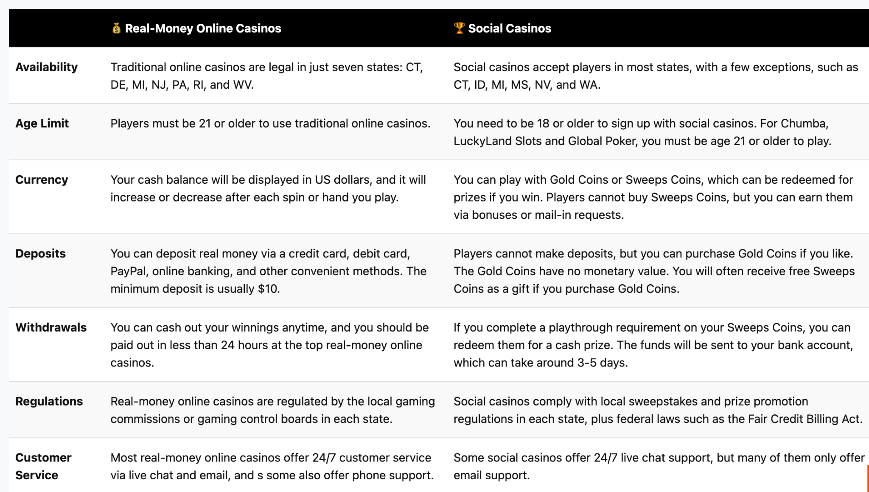

Header 2 - What’s the difference between a social casino and a sweepstakes casino?
In describing this section, disclose the following information:
- Legal differences between social casinos and real sweepstakes casino (describe the differences in text and make a comparison table)
- In the table, do not point to countries, states, or cities!

Header 2 - Full List of (specify the number) Social Casinos Accepting International Players

In describing this section, disclose the following information.

Make a short text summary of one, maximum two paragraphs, stating what I have tested and ranked all social casinos for international players. Indicate what these sites offer (what are their unique features).

Add a table with such casinos. Here is an example, but not for copying! In the table, indicate the following columns:

Casino name

Bonus offer

Promocode (make in the form of a referral link)
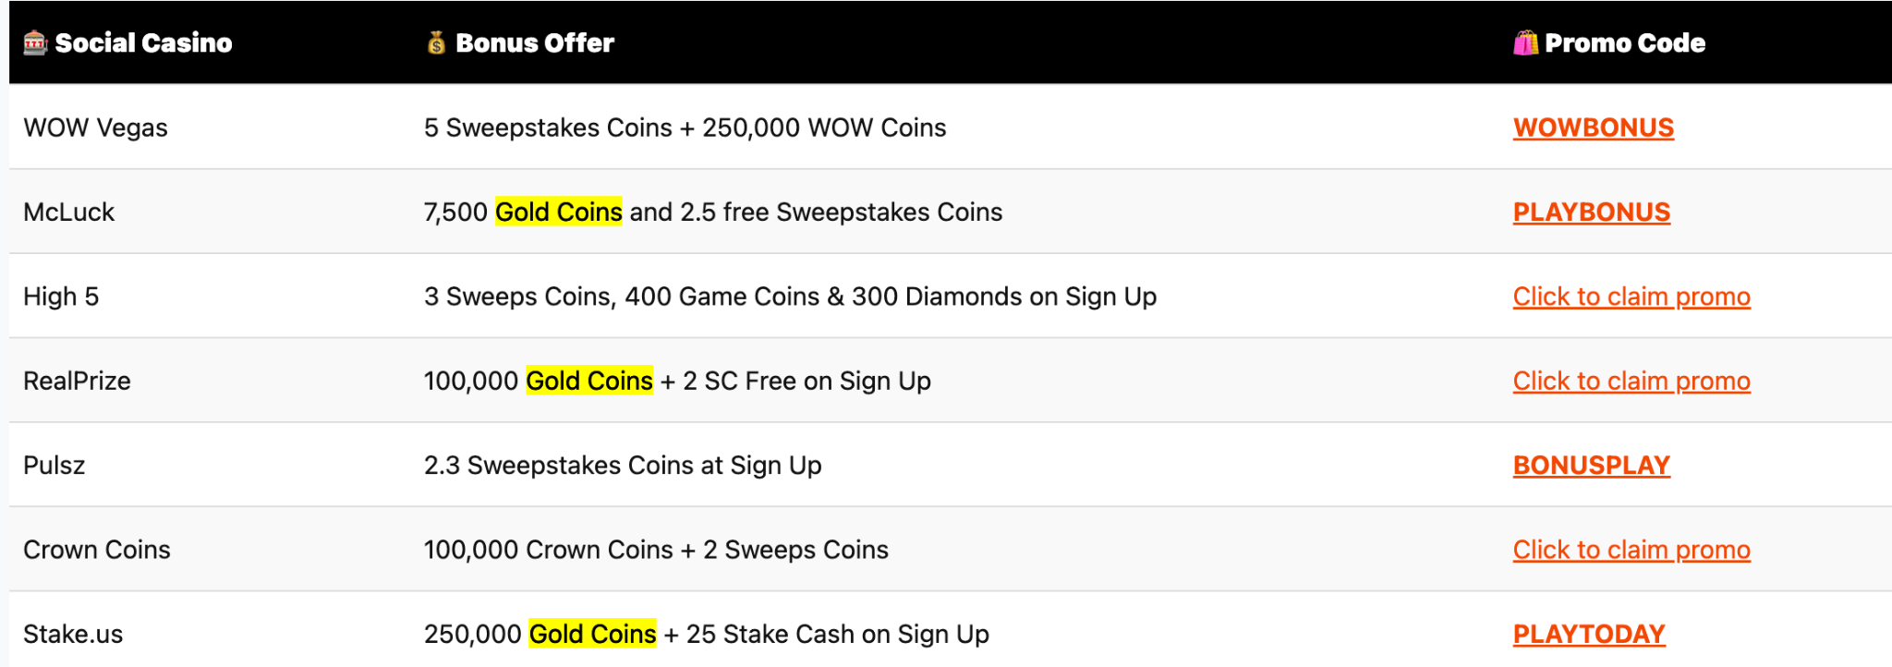
Header 2 - My Picks for TOP 10 Best Social Casinos in July 2025

In describing this section, disclose the following information.

- Make a short text summary of one, maximum two paragraphs, in which I state what I have tested and ranked the top 10 best social casinos for international players.
- Specify what these sites offer (why I chose these particular casinos from the general list of all casinos, on what criteria).
Header 3 - #1. Enter the casino name
Describe 9 other best casinos using the same example
Include the following information when describing the casino:

- In the first paragraph, state the main differences between this casino and others, what year it was founded and whether it has an international license.
- Specify a screenshot with a general view of this casino (preferably from a mobile device)
- What number of slots and from what number of providers are presented (specify approximately the number)

- What popular games (specify categories and the name of these games) can be played in this casino

- What is the size of the welcome bonus offered by the casino and what is its uniqueness
- Fill in the following information about the casino in a table format with the following columns:

  - Best for:
  - Number of Slots:
  - Additional Games:
  - No-Purchase Welcome Bonus:
  - First Purchase Bonus:
  - App:
  - Redemption speed and limits:
- Add a table with the pros and cons of this casino
- At the end of the description of the review of each casino to make a short conclusion about what you liked and what you did not like when interacting with the casino, what could be improved, what problems you encountered (if any) during registration, login, selection of games, activation of the welcome bonus, the game itself, deposit and withdrawal, how they were solved and whether they were solved at all, how quickly and who helped with their solution.
- What final score would you give this best casino from 1 to 5 points.
Header 2 - How To Purchase Coins To Begin Playing At Social Casinos

In describing this section, disclose the following information.
- In the form of what social casinos offer coins.
- How many (on average) free coins are given when you buy paid coins
- Instructions for buying coins in a social casino (to make a numbered list)

Header 2 - How To Redeem Cash Prizes

In describing this section, disclose the following information.
- What conditions must be met to win a cash prize. For example, you could specify the following (be sure to paraphrase), in this format:
  - Sweeps Coin Playthrough Requirement - detailed description
  - Minimum Redemption Requirement - detailed description
  - Sweeps Coin Expiry Info - detailed description
  - Verification Procedures - detailed description
  - It is obligatory to add other conditions and describe them according to the above scheme.
- What steps must be completed in order to receive the cash prize (indicate by numbered list)

Header 2 - Social Casino Purchase Options and Redemption Speeds

In describing this section, disclose the following information.
- Specify a table for the best social casinos in this format. Not for copying!
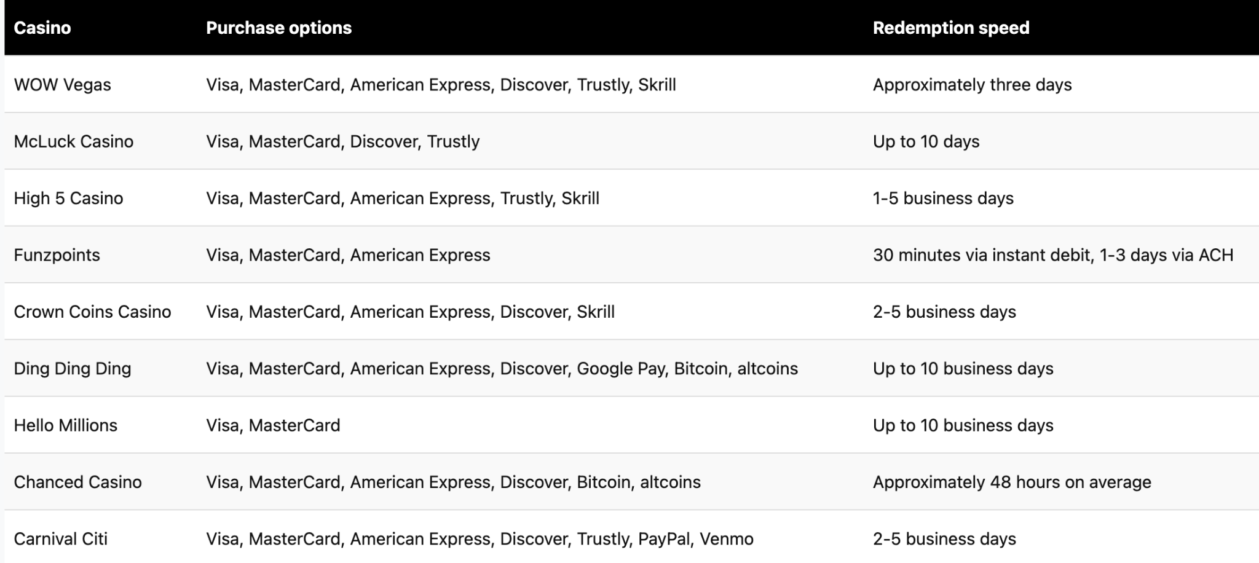

Header 2 - What I liked and didn't like about Social Casinos?
Make in a bulleted list format.
Header 2 - Do I recommend playing at Social Casinos?
Indicate a fair and objective conclusion in the form of a summary of this category of casinos. Do you recommend playing in this type of casino, what games and to whom (you can make a division into beginners and experienced players), what you recommend to pay attention to when playing in these casinos, starting from creating an account, making a deposit, the game itself and withdrawal.
What final grade put this type of casino according to the results of your review from 1 to 5 points.

Header 2 - Things To Know: Terms and Conditions
Describe what are the mandatory rules and conditions that need to be followed in this type of casino. Here's an example of a competitor's description. No copying! Add more terms and conditions than the competitor!
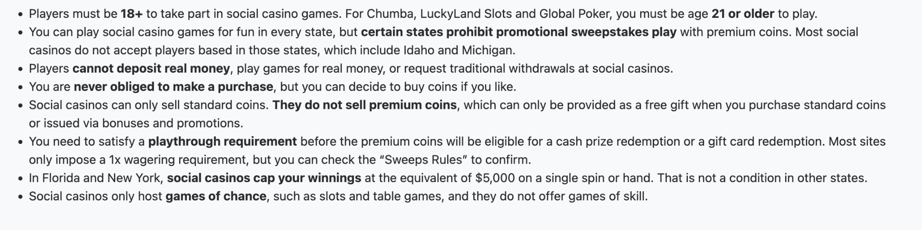

Header 2 - Frequently Asked Questions
The answer should be no more than 30 words. Less and only the most important information is better.

- Can I win real money at a social casino?

- What do SC and GC mean in a social casino?

- Do I need to deposit money to play at a social casino?

- What’s the best social casino for slots, blackjack, or new players?

