GDP trends of United Arab Emirates from 2020 to 2025 with a seperation of Oil and Non-Oil
1.1 Oil
OPEC, even though sanctions and economic distress have wiped out 2.5 mb/d of production from Iran and Venezuela since 2017, effective crude oil capacity rises by 1.2 mb/d to 34.1 mb/d.
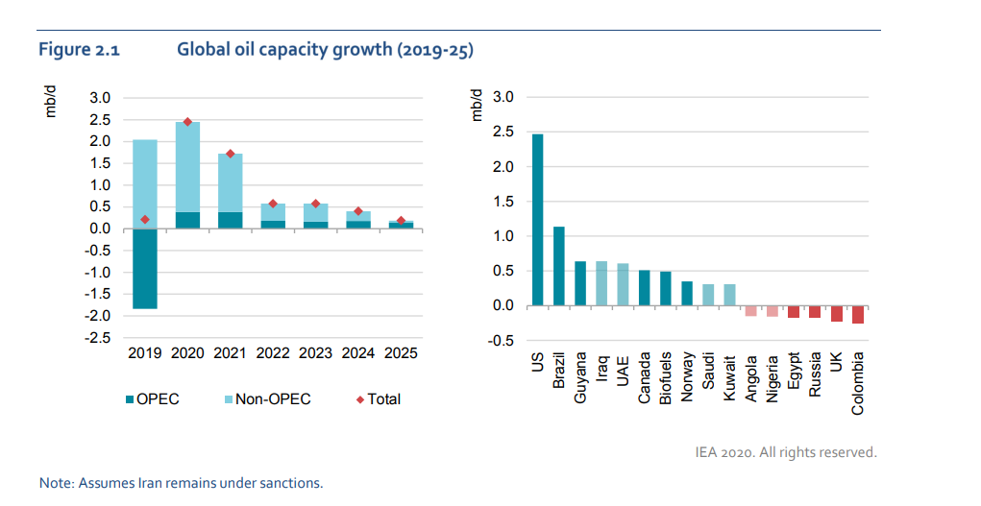
In this forecast, we have assumed that Iran remains under sanctions. If sanctions were to be eased, OPEC’s effective crude oil capacity could rise by an additional 1.7 mb/d in short order.
Iraq and the UAE are poised to build capacity to fresh record highs and Saudi Arabia and Kuwait will benefit from the resumption of flows from the Neutral Zone.
Saudi Arabia and the UAE have plans to stimulate other parts of the economy. They intend to invest in the generation of electricity from natural gas, renewables and nuclear to reduce carbon emissions.
The UAE continue to lead the gains in capacity and should remain comfortably in OPEC’s number two and three slots, respectively, through 2025. Annual record highs in 2019 for the UAE were at 3.2 mb/d.

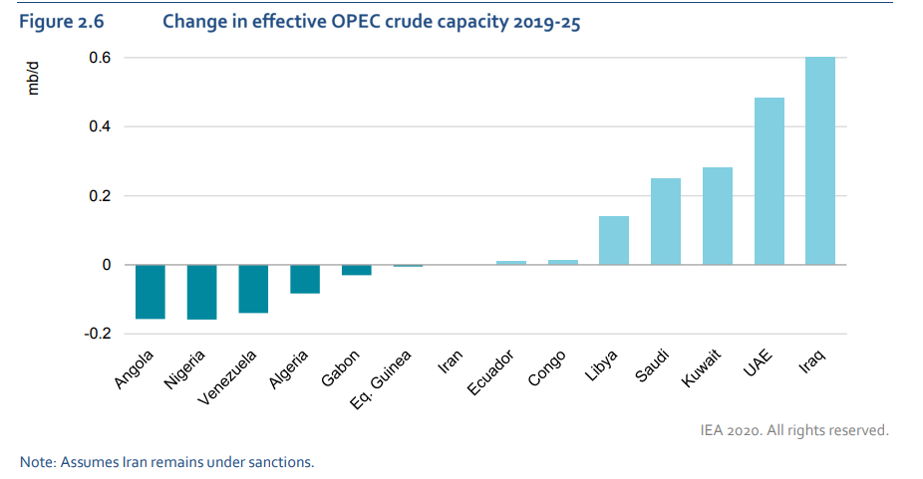
The UAE is expected to deliver a substantial production capacity increase thanks to its secure operating environment and relatively low-cost resource base. Growth of 480 kb/d is forecast by 2025, with capacity rising to 4 mb/d, higher than Iran’s. In 2019, the UAE’s crude supply rose to a record 3.2 mb/d, up 180 kb/d year-on-year (y-o-y), making it OPEC’s third-largest producer after Saudi Arabia and Iraq.
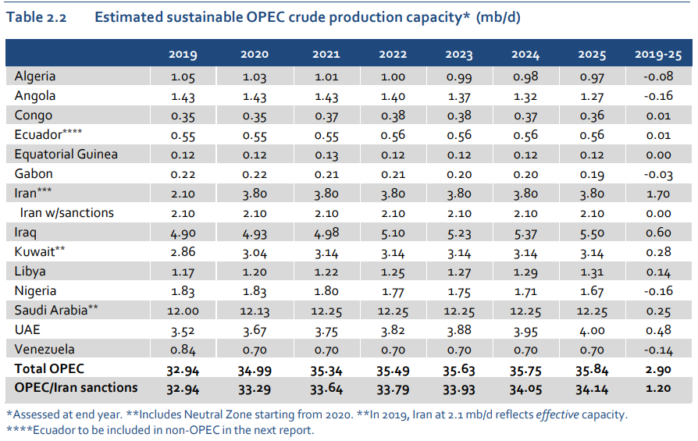
The UAE will drive the growth as it presses on with an integrated gas strategy that aims to achieve self-sufficiency by 2030. It is due to add 118 kb/d of condensates and NGLs by 2025. The offshore Ghasha ultra-sour gas scheme, requiring investment of over USD 20 billion, is expected to pump more than 100 kb/d of oil and condensates when it starts up in the mid-2020s.
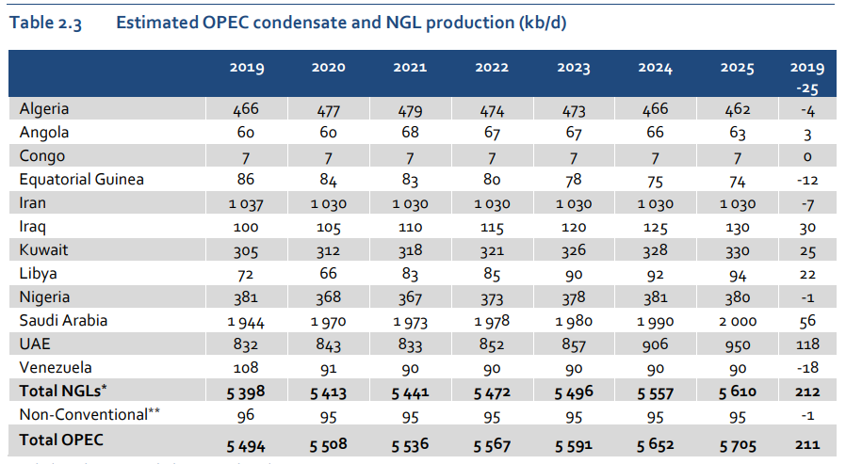
A large-scale refinery construction and modernisation programme is ongoing in the Middle East, though increasingly concentrated in a smaller number of countries. The forecast for gross additions to capacity is essentially unchanged from our last report, at 2.3 mb/d. However, shutdowns are higher at 0.7 mb/d, as they now include an 85 kb/d refinery in the United Arab Emirates (hereafter “UAE”).
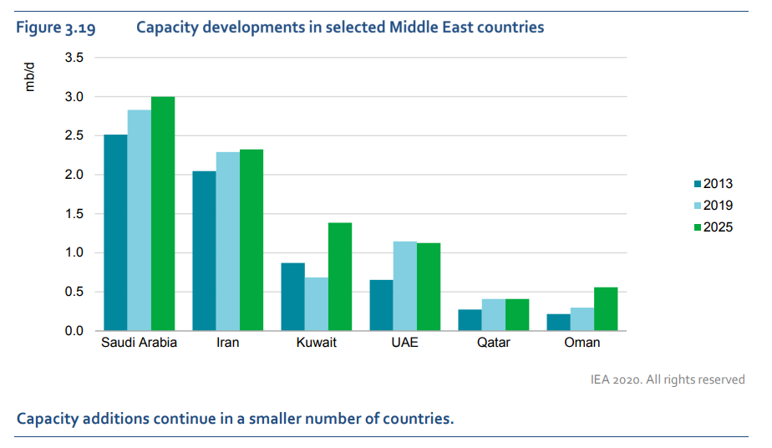
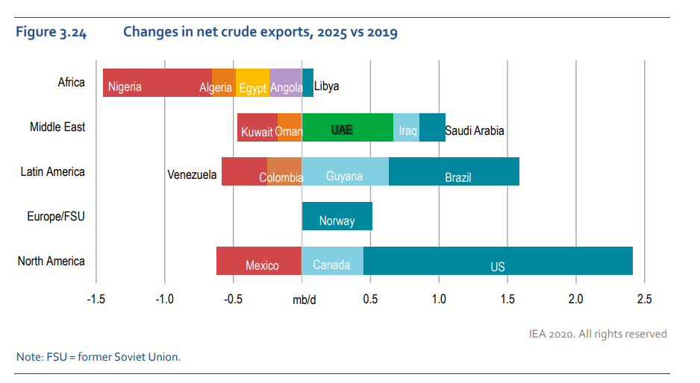
  - Non-Oil
The pandemic in 2020 resulted in large GDP losses and increased risks of long-lasting effects on growth.2 Possible lasting damage to UAE potential growth could materialize through multiple channels that affect productivity, labor, and capital:
- TFP (total factor productivity) losses and spillovers. The accommodation and food service activities, wholesale and retail trade, and construction sectors all saw double-digit growth declines in 2020.
- Loss of human capital and labor force. The crisis has had uneven effects on labor markets. Employment declines have been significant among lower-skilled workers. The pandemic has also likely had a long-lasting effect on future economic opportunities for women and youth, risking inferior reemployment prospects and a persistent drop in income.
The UAE’s macroeconomic policy support and relatively high level of digitalization are helping to mitigate some risks of long-lasting crisis effects, including relative to other Emerging Markets and Developing Economies (EMDEs). Macroeconomic stimulus measures in 2020-21 to hard-hit sectors and structural reforms under the UAE 2050 Strategy will help to alleviate some of the medium-term output and employment losses, while a transformation of the workplace through further digitalization, fintech, and e-commerce are likely helping to offset some of the adverse productivity shocks. However, achieving higher medium-term growth hinges on sustained reform efforts. Non-oil growth is expected to accelerate, boosted by Expo 2020 and reform momentum, and to improve further over the medium-term with increased foreign investment and the benefit of announced structural reforms. Nevertheless, uncertainty about the outlook remains, which could make it difficult to attract sufficient foreign labor, particularly in highskilled areas, to meet future economic needs despite recent significant government efforts to modernize visa and work permits regulations.
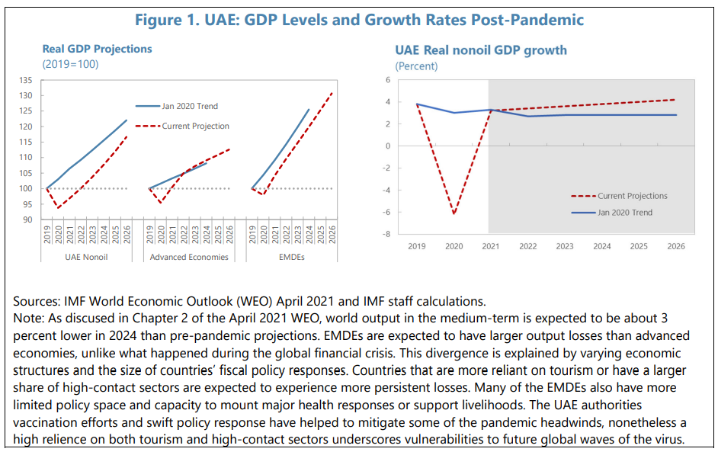
A detailed analysis of factors of production point to significant challenges to future productivity growth in the UAE. Potential non-oil growth in the UAE has been on a downward trend over the past twenty years (Figure 2). This has largely been driven by declining contribution of TFP in the run-up to the Global Financial Crisis, followed by increasingly lower contributions from labor in the subsequent years. The UAE’s capital stock has also exhibited a steady decline over the entire period.
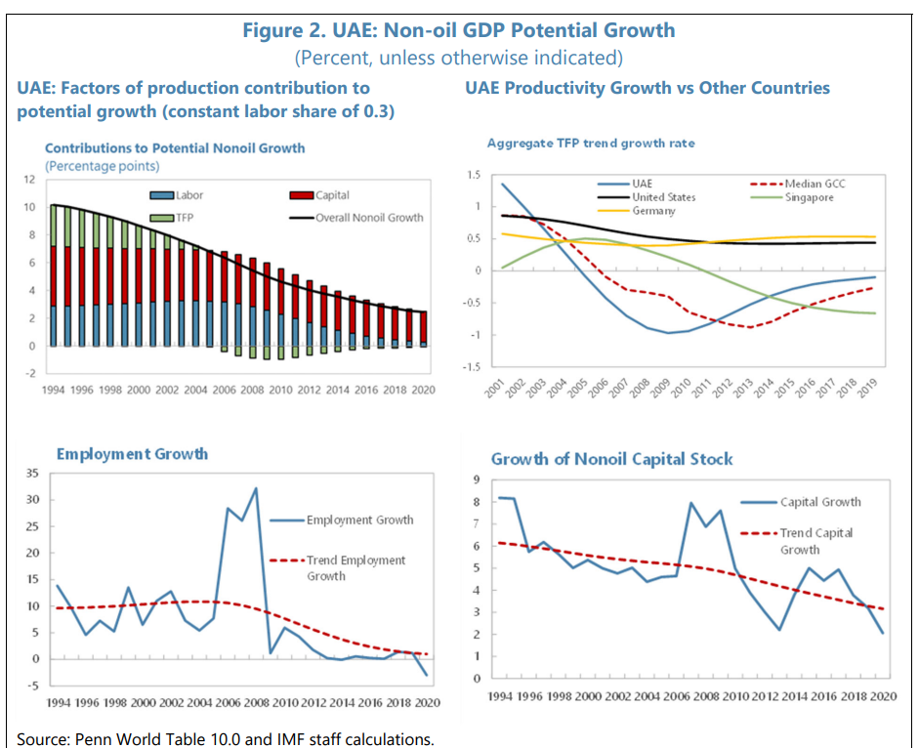

- GDP trends of United Arab Emirates from 2020 to 2025 city wise, with a seperation of Oil and Non-Oil
2.1 Oil

Recent growth was supported by spending on the offshore Umm Lulu and Satah al-Razboot (Sarb) fields, which are expected to produce 200 kb/d by 2023. The climb towards 4 mb/d will require the expansion of the Exxon-operated Upper Zakum offshore field, one of the world’s largest. Output is around 750 kb/d and is expected to reach 1 mb/d by 2024. ExxonMobil has invested around USD 6.5 billion in Upper Zakum since it took a share in 2006. More near-term supply will come from offshore oil fields Ghasha, Dalma and Hail. As for the onshore, the Haliba field started up in 3Q19 and output is expected to reach 40 kb/d. Located along the Abu Dhabi-Oman border, it is operated by Al-Dhafra Petroleum, a joint venture between the Abu Dhabi National Oil Co (ADNOC), Korea National Oil Corp and GS Energy. 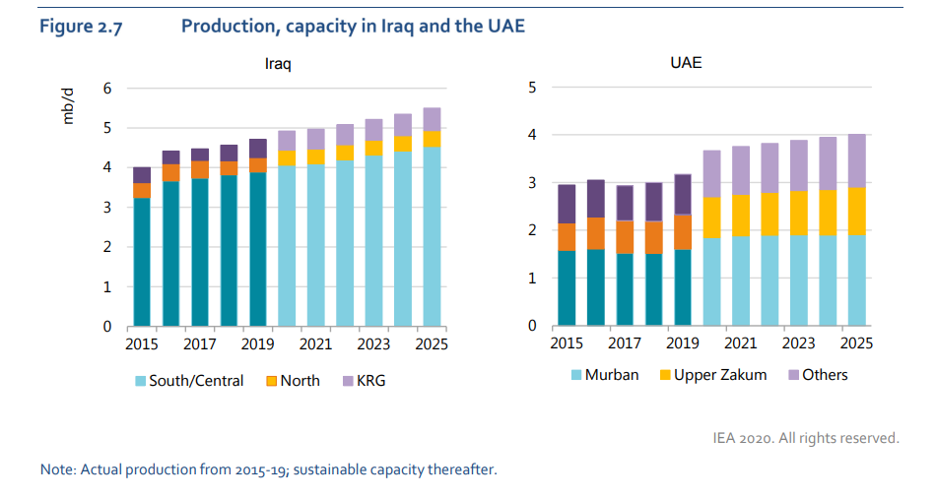
Apart from Upper Zakum, ADNOC split its 700 kb/d offshore oil concession into three separate ventures: Lower Zakum, Umm Shaif and Nasr, and Sarb and Umm Lulu. Total secured a 5% stake in Lower Zakum and 20% in Umm Shaif/Nasr; while OMV acquired the final 20% stake in Sarb and Umm Lulu. ADNOC will retain a 60% stake in each. For its onshore sector, which pumps around 1.8 mb/d of flagship Murban crude, ADNOC has secured foreign partners for a 40% share of the concession. The official aim is to boost Murban output beyond 1.8 mb/d and, to that end, ADNOC plans to lift production from the Bab field to 485 kb/d from around 420 kb/d currently. Total and BP both hold 10% of ADNOC Onshore, with GS, Inpex, CNPC and Zhenhua Oil securing minority stakes.
  - Non-Oil

Business confidence is set to increase in the United Arabian States as forecasted growth exceeds historical trends. Increased private consumption, investment activity and above trend-tourism sector output will also contribute in bringing positivity to businesses’ sentiment. An increase in the confidence of businesses will in turn positively affect the office real estate sub-sector.
Abu Dhabi’s office market is primarily reliant on government-related entities and Small and Medium Enterprises (SMEs). Demand for space in the city’s Aby Dhabi Global Market is expected to be sustained. Rental rates in Abu Dhabi are now seeing an increase as demand increases and supply remains moderate.
In Dhubai, the office market is experiencing growth due to demand being bigger than supply. The growing demand is especially towards larger office areas leading to a forecasted 5.1% rise in average rental rates for 2023. Meanwhile, in Sharjah rental rates for office property has become stable due to moderate supply and demand. As the city has a relatively small market size, only limited activity is seen.
Activity in Sharjah is mainly comprised of SMEs and the city has a relatively small market size, significant market supply in the nearest term. Moreover, the retail real estate market is also expected to go through growth in arrivals of international tourists. However, the rise in e-commerce presents a growing risk on the retail market companies are trying to increase their online presence. This in turn prompts retailers to divert investment towards warehousing and logistics supply chains instead of physical stores, as per FitchSolutions.

Consumer spending baskets of United Arab Emirates

Consumer Spending in the United Arab Emirates decreased to 483057.20 AED Million in 2020 from 569166.38 AED Million in 2019
pr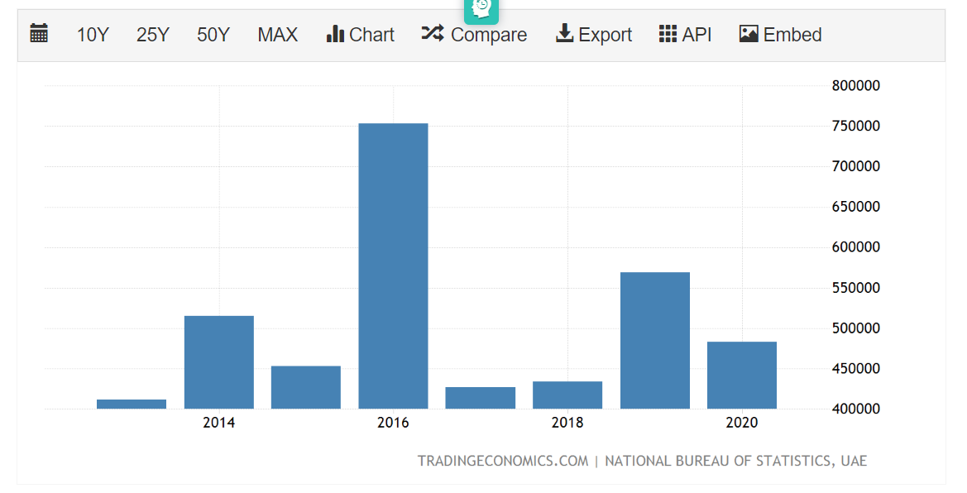

Consumer Spending in the United Arab Emirates is expected to reach 504795.00 AED Million by the end of 2023, according to Trading Economics global macro models and analysts expectations. In the long-term, the United Arab Emirates Consumer Spending is projected to trend around 524482.00 AED Million in 2024 and 543888.00 AED Million in 2025, according to our econometric models.

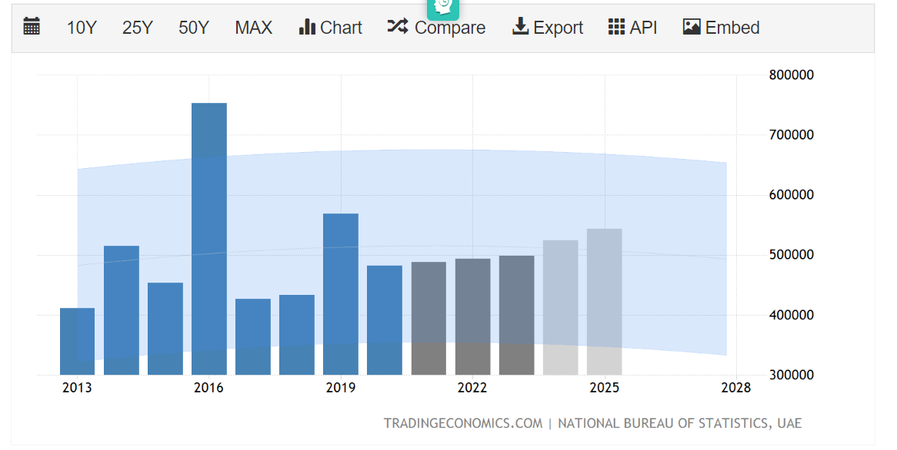

Consumer Price Index CPI in the United Arab Emirates increased to 106.29 points in the second quarter of 2022 from 102.77 points in the first quarter of 2022.

source: National Bureau of Statistics, UAE

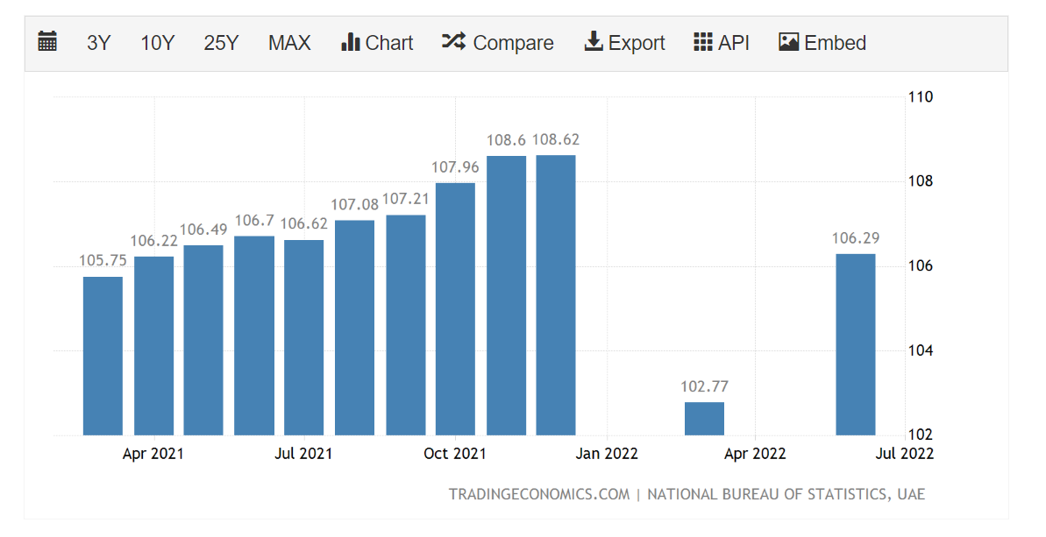

Consumer Price Index CPI in the United Arab Emirates is expected to be 107.91 points by the end of this quarter, according to Trading Economics global macro models and analysts expectations.

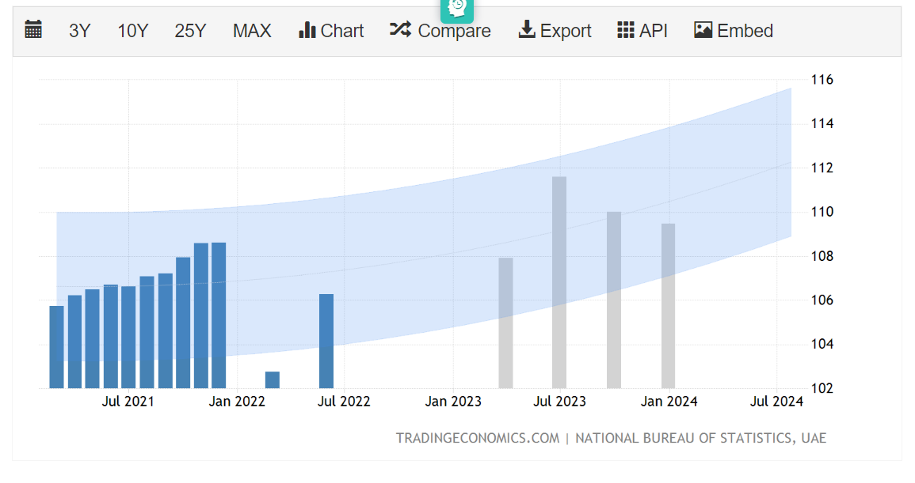

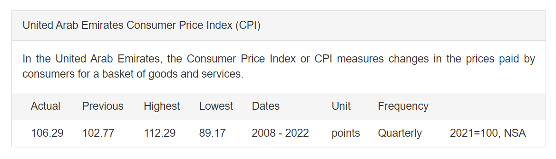

Resources:
- https://tradingeconomics.com/united-arab-emirates/consumer-spending
- https://tradingeconomics.com/united-arab-emirates/consumer-price-index-cpi
- UAE Economic Report: https://pwstg02.blob.core.windows.net/pwfiles/ContentFiles/10868PublicationFile.pdf
- United Arab Emirates: file:///C:/Users/Admin/Downloads/1UAEEA2022002.pdf

