NATIONAL AVIATION UNIVERSITY
Department of Aircraft Design

COURSE PROJECT
Part 1

Theme: «The use of modern energy-saving technologies in the
maintenance of the power plant of aircraft with a turbojet two-
circuit engine.»

Performed by: Burdun Bogdan

Supervisor: PhD, associate professor Karuskevich M.V

Kyiv 2020
Table of the statistic data of prototypes

 | TU-144 | Concorde | SU-27
General data
Cockpit crew | 4 | 3 | 1
Maximum number of passengers | 80 | 100 | 0
Geometrical parameters of aircraft
Length, [m] | 59,40 | 61,66 | 21,935
Wing span, [m] | 27,65 | 25,60 | 14,698
Wing area [m²] | 438 | 358,6 | 62,04
Wing aspect ratio* | 1.66 | 1.7 | 3.5
Wingsweep, [degree] | Fwd LE Sweep = 76°  Main LE Sweep = 57° | Fwd LE Sweep =80°  Main LE Sweep = 60° | Fwd LE Sweep =42°  Main LE Sweep = 15°
Mass data
Maximum Takeoff Mass (MTOM), [kg] | 180 000 | 185 000 | 30 000
Max payload, [kg] | 12 000 | 13,380 | 6000
Power plant data
Number of engines and their type | 4 x NK-144 | 4 x Olympus 593 | 2 x AL-31
Take off thrust, [kN]  or  Take off power, [k kWt/] | 4x171,6 | 4x170,0 | 2x74,53  (non afterburner)  2 х 122,58 (afterburner)
Thrust/weight ratio [kN/kg]**  or  Power/weight ratio [kWt/kg]*** | 0,0038 | 0,0036 | 0,0049
* Wing aspect ratio = (Wing span)²/ (Wing area)
** Thrust/weight ratio = (number of engines)*(Take-off thrust of single engine) / (Maximum Takeoff Weight)
*** Power/weight ratio = (number of engines)*(Take-off power of single engine) / (Maximum Takeoff Weight)

The Tupolev Tu-144 (Fig.1) (Ukrainian: Tyполев Ту-144; NATO reporting name: Charger) is a Soviet supersonic passenger airliner designed by Tupolev in operation from 1968 to 1999.
The Tu-144 was the world's first commercial supersonic transport aircraft with its prototype's maiden flight from Zhukovsky Airport on 31 December 1968, two months before the British-French Concorde. The Tu-144 was a product of the Tupolev Design Bureau, an OKB headed by aeronautics pioneer Aleksey Tupolev, and 16 aircraft were manufactured by the Voronezh Aircraft Production Association in Voronezh. The Tu-144 conducted 102 commercial flights, of which only 55 carried passengers, at an average service altitude of 16,000 metres (52,000 ft) and cruised at a speed of around 2,200 kilometres per hour (1,400 mph) (Mach 2). The Tu-144 first went supersonic on 5 June 1969, four months before Concorde, and on 26 May 1970 became the world's first commercial transport to exceed Mach 2.
The Tu-144 suffered from reliability and developmental issues, and with the 1973 Paris Air Show Tu-144 crash, restricted the viability for regular use. The Tu-144 was introduced into passenger service with Aeroflot between Moscow and Almaty on 26 December 1975, but withdrawn less than three years later after a second Tu-144 crashed and retired on 1 June 1978. The Tu-144 remained in commercial service as a cargo aircraft until cancellation of the Tu-144 program in 1983. The Tu-144 was later used by the Soviet space program to train pilots of the Buran spacecraft, and by NASA for supersonic research until 1999. The Tu-144 made its final flight on 26 June 1999 and surviving aircraft were put on display across the world or into storage.
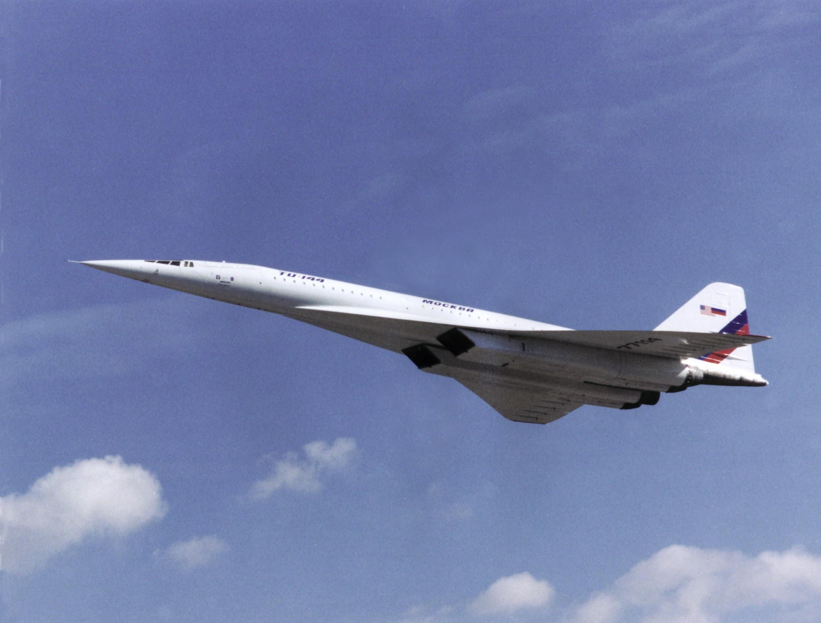
Fig.1 | TU-144 on flight

Glider
A total of 9 series were built, including one prototype of the zero series, one prototype of the first series, and four airframes for static and load tests. A total of 21 gliders, of which 17 are aircraft, the latter was not completed and never flew (that is, in fact - 16 flying machines).
The Tu-144 airframe is made of AK4-1 heat-resistant aluminum alloy and, in part, of VAD-23 and OTCH-1 alloys. The window glazing is made of heat-resistant fluoroacrylate plexiglass of the E-2 type.
Fuselage
The fuselage of a circular cross-section is structurally divided into three parts: nose, center and tail unit. Power set - from frames, beams and stringers. The nose of the fuselage by means of an electric drive (double electric motor) is deflected by 11 ° during takeoff and by 17 ° during landing, while freeing the front glazing of the cockpit, which provided a normal forward view. There is also a backup drive of the nose from an emergency nitrogen cylinder under a pressure of 150 kg / cm2.
In the central part there is a passenger cabin, which, together with the bow, forms a single pressurized compartment. The passenger compartment is divided into three passenger compartments. The right row had blocks of three seats each, the left one - two, in the aft section of the third cabin, several rows had blocks of two seats on the left and right. In the first saloon, double luxury seats were installed. On the left side of the fuselage, two service doors were installed for access to the saloons. There were also service doors: two in the aft fuselage on the left and right, and one each on the right in the middle and in front. For an emergency exit to the wing, there was a hatch on the right and left, also on some vehicles there was an emergency escape hatch for the crew on the bottom left, made like a blind tunnel through the front cargo compartment. There was no such tunnel in the Moninsky instance, and a hatch opening from below gives free access to the front cargo compartment (however, in many respects filled with a non-standard centering tank for aviation kerosene).
The tail section of the fuselage is occupied by a fuel caisson tank and a brake parachute compartment.
Cockpit
The cockpit on the experimental machines is made for four members of the flight crew: the commander, co-pilot, flight engineer and experimental engineer. A crew of three was planned for production vehicles, but due to technical problems with the navigation and aerobatic complex, a navigator was additionally introduced. All crew members can be regularly equipped with VKK-6M high-altitude compensating suits. When flying at altitudes up to 12 km, VKK may not be used, but a KM-32 oxygen mask is provided for each crew member.
The wing of the multi-spar structure was formed from symmetrical profiles and had a complex twist in two directions: longitudinal and transverse. Originally it was a delta wing of an ogival shape with a sweep angle along the leading edge of 78 ° for the front flush part and 55 ° for the rear base part. There were four-section elevons along the entire trailing edge. The central part of the wing and the elevons were made of titanium alloys, the rest of the wing skin was made of solid all-milled plates made of aluminum alloys. Later, according to the test results of the "044" machine, the wing was completely redone, its profile and area changed, the sweep of the flowing part along the leading edge was reduced to 76 degrees, and the base was increased to 57 degrees, and the conical twist of the tips was increased. Now the wing provided self-balancing in cruising flight mode with minimal loss of quality, taking into account the optimization of the wing's flight deformations.
The wing area is 503 m2, the span is 28 m. The pitch angles of the elevons are ± 22 °, and the roll is ± 19 °.
According to the test results of the first vehicle, the fuselage diameter was increased by 50 mm (up to 3300 mm), two inserts were added to the fuselage - 2610 mm in front, and 870 mm in the rear. At the front of the fuselage, a multi-slot retractable wing was installed, designed to increase the overall lift during takeoff and landing.
Tail assembly with two-piece rudder. The keel caisson was used as a balancing fuel tank. The keel area excluding the forquil is 49.24 m2.

Propulsion System
A two-circuit turbojet engine with an afterburner NK-144 KB ND Kuznetsov was specially developed for the aircraft. The engine was created on the basis of the NK-8 gas generator and the NK-6 developments. A further development of the NK-144 was the NK-22, NK-25 and NK-32 engines, and to this day, the Tu-22M3 and Tu-160 aircraft that lift into the air. The NK-144 turned out to be the only in the history of aviation with a bypass engine with an afterburner, normally used on a serial passenger aircraft. The afterburner is made adjustable and made it possible to change the maximum engine power by moving the throttle.
Four NK-144 engines on the first aircraft were installed in a "package" in the lower rear fuselage. The nozzles of the engines protruded beyond the trailing edge of the wing, since it was originally planned to install a reverse device on the external engines. Later, from the development of the reverse came to refuse, and to reduce the mileage they installed a parachute braking system.
Later, the engines were modified to modify the NK-144A (Tu-144S aircraft). However, they did not satisfy, primarily in terms of fuel consumption, which limited the flight range. It was decided to resume work on a powerful non-afterburner engine. At OKB-36, under the leadership of P.A. RD-36-51 went simultaneously with the design of another powerful single-circuit turbojet engine RD-Z6-41 for the long-range supersonic attack aircraft T-4 OKB P.O. Sukhoi)
On the aircraft under construction in the series, the engine nacelles were blown apart, their air intakes, power frames and systems were modified to be able to install one of two types of engines during production - NK-144 or RD-36-51A. Subsequently, the aircraft with RD-36-51A engines received the Tu-144D code.
Each engine has its own adjustable rectangular air intake with an upper horizontal movable wedge panel, three side feed flaps and a lower bypass flap. At a speed of M = 2.2, the air compression ratio in the air intake is 10: 1, while the air temperature in the b / intake duct is + 135 ° C, at an outside temperature at the flight level - 57 ° C.
Operational limitations for NK-144A engines. On the ground, the maximum afterburner mode of the engines is limited in operating time - 5 minutes. On takeoff: outboard engines (No. 1 and No. 4) - 30 minutes, inboard engines (No. 2 and No. 3) - 10 minutes (due to temperature limitations of the fuselage tail section + 120 ° C). In level flight: cruising afterburner - no more than 3 hours, maximum afterburner: external engines - no more than 20 minutes, internal engines - no more than 10 minutes.

Auxiliary power unit.
An auxiliary power unit TA-6A is installed between the engines in the engine nacelle block 3 and 4, which provides the aircraft with energy on the ground and in emergency cases in flight, up to an altitude of 3000 m.

Aircraft fuel system
The first aircraft in the wing had 18 tanks with a filling capacity of about 70,000 kg.
On the serial Tu-144 (in accordance with the Operation Manual book. 4) eight groups of tanks: 1st lion. and right., 2nd lion. and right., 3rd lion., middle. and right., 4th lion. and right, 5th lion and right., 6th, 7th, 8th; supply tanks - RB No. 1, RB No. 2, RB No. 3 and RB No. 4. Balancing tanks No. 1 and 2 (front) and No. 8 in the stern. Balancing tanks were used when changing the flight mode (switching to supersonic and vice versa). The fuel system is controlled by the SUIT1-2B electronic fuel control and metering system. There are also four RT-31 flow meters installed. Centrifugal fuel pumps ETSN-321M and jet pumps SN-3F are installed as transfer pumps.
Aviation kerosene T-6 or T-8 with nitriding was used as fuel.

Hydraulic system
Four hydraulic systems operating in parallel with a normal discharge pressure of 210 kg / cm². Hydraulic tanks 1-2 and 3-4 are combined. The first tank contains 75 liters of hydraulic oil, the second 71 liters. As a reserve, two turbopump units HPU for 2 and 4 g / systems are used, operating on the air taken from the APU. If necessary, 2 and 4 g / s can be looped back from 1 and 3.

Landing Gear
Front support with two twin wheels KN-17 950 × 300 mm. The rack was retracted into a niche against the stream. Turning the wheels from the directional control pedals. Angles of rotation of the front wheels: when taxiing - ± 60 °, during take-off and run - ± 8 °, when towing the aircraft - free orientation mode.

The main struts were built in two versions: initially, each main support had three four-wheeled carts (twelve wheels), while the struts were retracted into the wing. Then the bogies were converted into two-axle eight-wheeled bogies, with cleaning into the chassis niches between the intake / intake channels, and the bogies are rotated in the transverse plane by 90 °. Wheels - KT-160 950 × 400 mm. The landing gears track is 6.05 meters.

Anti-icing system
Includes heating of the VNA engine cocks, electric heating of the edges of the air intakes, pressure receivers PPD-5, PPD-1, PVD-19-1, the DUA angle of attack sensor from the AUASP-21kr system, electric heating of the pilot's windshields. Aircraft icing sensor - radioisotope RIO-4, engine icing sensors - DO-206-2 type (installed only on engines 3 and 4).

Equipment
It consists of a power supply system, instrumentation, recorders, electronic equipment, an automatic control system ABSU-144, a navigation and flight complex NPK-144, an electronic engine control system and fuel automation.
The primary alternating current network of a stable frequency, four generators of 200 volts 400 Hz on the engines and an APU generator, the PO-500 electric machine converter is in reserve. Alternators are connected to constant speed hydraulic drives (except for the APU generator). The DC network is powered through four rectifiers, four onboard batteries are used as a backup. The secondary network of 36 volts is powered by three-phase transformers - the main ones No. 1 and No. 2, two more transformers are in reserve; the electrical machine converter PT-1000TSS (PT-500TU) is also used. All supply networks are divided into left and right.

The automatic on-board control system, originally ABSU-004, then - ABSU-144, was quite revolutionary for that time. It provided automatic flight with stabilization of angular positions, altitude and speed, as well as control from the navigation complex. Trim mechanisms and flight loaders were installed in the control wiring. There was an automatic balancing system. A novelty was the built-in system of automatic control of serviceability and pre-flight check of the ABSU. To increase the reliability, the system is made with four-fold redundancy. On the ABSU-004, a flight restriction was introduced on the use of all automatic modes (disabled), except for the stabilization mode of the indicated speed.

The NK (NPK) -144 complex is built on the basis of the Orbita-10 onboard computer. The set also includes a VNPK-D calculator, a gyroinertial system "Rainbow" (GIS-1 and GIS-2), a backup course system, consoles and blocks. The complex was installed for testing, starting with the aircraft of the second series (tests at site No. 10021), then on all subsequent aircraft. NPK is designed for constant calculation of flight and navigation information and its issuance to consumers, as well as indication of the current location of the aircraft to the pilots on the projection indicator of the navigation situation (PINO block), later replaced with an automatic navigation tablet PA-3 (as on Tu-22M).

Instrumentation equipment
Air signal system SVS-30-3; automatic angle of attack and overload AUASP-21kr; IA-16 equipment (braking temperature thermometer), tacho-signal equipment of the APU TSA-6M, etc.

