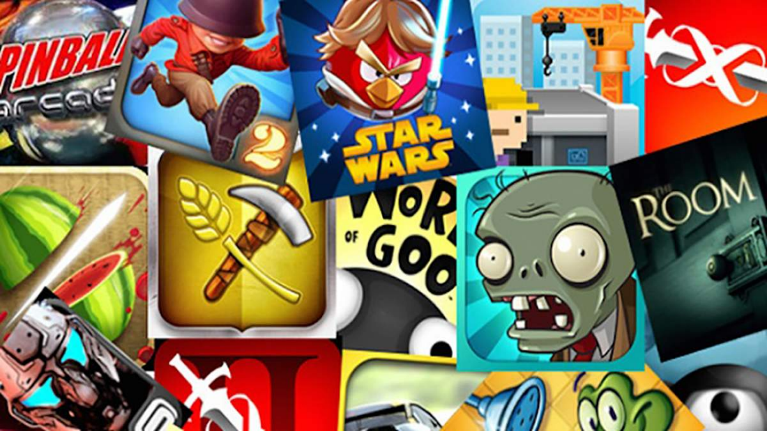
Marketing creatives or how to attract players

Let's start from the very beginning and tell you what an advertising creative is. This is a short video of 10-15 seconds, which, most often unusually, conveys the idea of the main features of your game. Creatives are promoted on major advertising platforms, so you have probably come across such videos on websites or inside applications.
Unlike full-fledged trailers, creatives aim to give the impression that the game is already on your device: something cool is happening right now, and all you have to do is press a button to break into the process and get your portion of pleasure.
For visual persuasiveness, creatives often use not real gameplay, but its reconstruction with a special emphasis on engagement elements - large buttons and interface details that arouse the desire to click on them.
As a result, creatives fully reflect the meaning of their name: nothing limits the freedom of creativity when creating them. At the same time, marketing tools allow you to curb the flow of ideas and direct them in the right direction so that the creative fulfills its main task and brings loyal players.

The beginning of all beginnings
To create a high-quality creative, it is enough to play games and watch ads. This is very important for your viewing library and for keeping up with game trends.
You can often notice that the offered ads in games are very similar, it looks strange and raises questions. But the answer is very simple - it means that today this type of creativity is at the top. But you need to remember that trends change very quickly, so you should always keep an eye on the market.
The main advice for those who want to make a quality product is to show real gameplay, without embellishments, effects, and even color correction - this is always a good start, especially in hyper-casual.

Competitor analysis
Mobile game creatives are extremely diverse, with several mainstreams emerging recently. Whether to follow them or not is an open question, but it is not superfluous to be aware.
Existing creatives often rely on:
Demonstration of game progression, whether it's a character, your farm, or estate - whatever. The inner message here is: “Download our game and become cool, rich, great…”
Gameplay variability is a chance to show your skills. “Download the game and prove that you are not a fool and you know how to make the right decisions.”
Process efficiency. “Look what kind of meat we have, what graphics and endless frenzy! ”
Humor. “Look, we came up with a funny video for you! And by the way, our game is also cool! ”
But this is a theory, and we need facts, we need data. To do this, we use parsers - services for collecting open data. There are many similar solutions on the market, and you are free to choose the one that suits you best. In the context of creating creatives, we are interested in the top videos and their performance: the number of installations and the overall financial success of the project. This is enough to weed out the unnecessary and pay attention to really working creatives.
We continue our analytical work. We are breaking down the videos into components: general plot and idea, intro, use of UI elements, CGI quality, dynamics, and editing. Based on this, we build hypotheses and think about how to apply them to our project.

What about misleads?
Often creatives use misleading videos. These are fake gameplay videos. But if you look at the issue more closely, then in the current realities we are rarely talking about outright deception. Modern misleads often play with real game mechanics or ideas, but present them in an exaggerated form.
The reason for the effectiveness of misleads is their catchy addictiveness. They easily awaken curiosity, the desire to immediately download the application and try to do something yourself. The strength of misleads is that they very distinctly and create the feeling of a certain problem, an unbalanced situation, which, it seems, can be solved here and now. This is what pushes a person to click, download the game, and linger in it.
And they want this path to be ethically flawed, it works and brings people into the game. If the video brings the desired business results, that is, it brings people into the game who stay in it for a long time, and then the ad has worked effectively.
For example, if the growth at the top of the funnel (CTR - video clicks) does not contribute to the growth of retention, but at the same time the necessary part of the people still stay and play. From an economic point of view, the creative turned out to be profitable.
A separate issue with misleads is tied to the genre of a particular game. For example, shooters, having dynamic gameplay and a variety of situations, may well get by with gameplay creatives. Finally, different types of videos appeal to different audience segments. That is why different creative concepts can work in parallel: both independently of each other and complementing.
Perhaps the main secret here is not to fixate on one idea or one video - you need to launch a pack of options (from 10 or more) into production and testing at once, and then you can quickly figure out that we are working for you.


Search for ideas
Having dealt with competitors, we begin to think about what we need. We answer the following questions:
Who is our audience and who do we need to reach?
-Based on the first question: how can we help our audience, what task to solve?
-Where to look for such people?
-What is the utilitarian goal when creating creatives? Specifically for us and at the current stage: installs, brand awareness, conversion to payments, etc.
For us, the main goal is to improve the purchase of traffic to maximize ROAS (return on ad spend - advertising profitability). At the same time, we want to attract the audience at the lowest possible cost, while maintaining active gaming and financial behavior of users. Simply put, we want a lot of players to come, and make purchases for a long time and with enthusiasm.
Globally, this task can be decomposed into 2 components:
1. Improve the top of the acquisition funnel. That is, the user must click on the video and get to the game page in the store.
2. Make sure that the creative increases retention (retention) and ROAS. That is, the user should see something in the video that will make him not only download the game but also stay in it for a long time by making purchases.
The first component requires pure creativity: we are looking for an idea to make the video catchy. The second component is simpler - it can be based on simple logic. If we want the player to linger, then we show the gameplay, its capabilities, and prospects.
In the search for ideas, it also helps that we already have experience working with creatives, and, as a result, metrics by which we can evaluate their effectiveness. As a result, we form three equivalent flows and start working on them:
-Improving our ideas that worked well before.
-Adaptation of competitors' ideas to our game.
-Pure experiments within reasonable limits. Feel free to do something weird and crazy, look for something new, and try.

The influence of creativity on the world of gameplay
Sometimes working with creatives leads to the fact that they migrate to the game.
A great example is the story of the Slingshot developers. They collected a level at which hitting a specific point led to the destruction of the entire location. Spending has doubled - the video worked and continues to work to this day, we only change the location, colors, and so on. It was impossible not to use such success, and it was decided to add the level to the game. And so there are a lot of examples when creatives were subsequently transferred from a successful video to a game.

