Barça vs. Real: Why is El Clásico losing its magic?
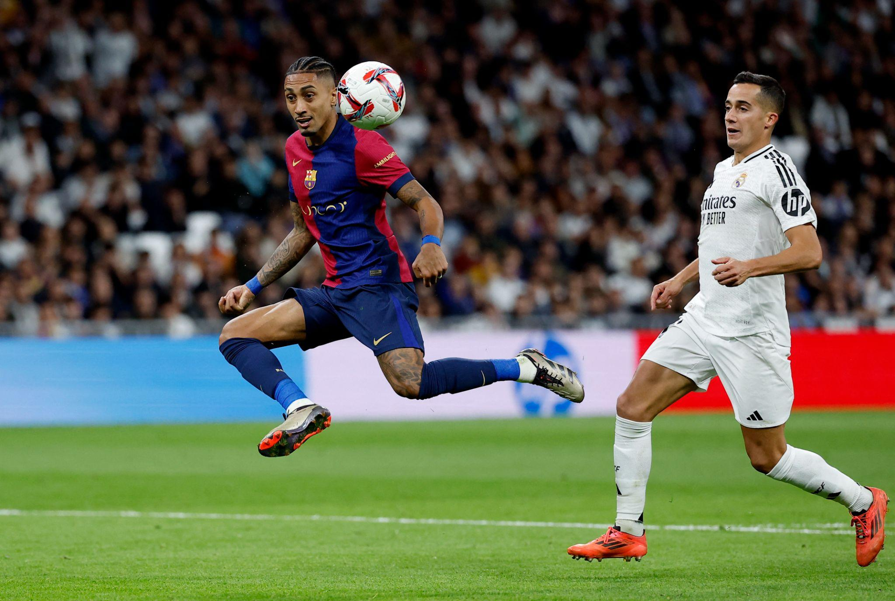
The main rivalry of Spanish football has lasted for over 100 years and has become iconic. Political, geographical and purely football reasons have made this derby important beyond the Iberian Peninsula. In La Liga, the standings before the meeting of Madridians and Catalans do not matter – these rivals are always motivated. But in recent years, many fans have complained that El Clásico has faded. Is this true, and if so, why?

The Main Derby of Spain
Usually, the hottest matches are held between clubs from the same city, but everything is more complicated in this case. Historically, Real Madrid and FC Barcelona have become the most titled and successful in local football and always claim success in Europe and the world. In addition, since the 1930s, the confrontation between the capitals of Spain and the separatist-minded Catalonia, which is part of it, has acquired a special political connotation. That has also manifested itself in football stadiums.
It is difficult to directly measure the decline in interest in El Clásico since it is almost impossible to accurately assess even the TV audience, let alone immeasurable things like the fascination or magic of the contest. However, many have begun to talk about losing a certain charm. The reasons may be the following:
- the departure of legendary football players and coaches;
- economic difficulties of clubs;
- the strengthening of other top European clubs and the emergence of new rivalries;
- the long-term negative effects of the coronavirus pandemic.
Of course, these factors primarily affected the interest of neutral fans. Local true fans still support their favourites on both sides.

Changes in players and coaches
This reason is apparent. In previous years, the rivalry between Lionel Messi and Cristiano Ronaldo heated up interest in El Clásico to the max. The Portuguese was the first to leave, having changed Real Madrid for Juventus in 2018. In 2021, the even more iconic Messi left Barcelona, ​​ending an era for the Catalans.
In addition to the players, the duels of coaches are also crucial in the confrontation between top clubs. The geniuses of Josep Guardiola and José Mourinho (as well as Zinedine Zidane) gave the rivals' games a special charm, as they professed different approaches to football. The change of personalities at the helm and sometimes unsuccessful experiments of new coaches, according to Eurosport experts, became the main reason for the loss of popularity of the matches between Real and Barça.

Financial woes
As the Spanish league deteriorates (against the EPL and beyond), the Spanish giants lack the funds to support their ambitions. It is not for nothing that they have started promoting the Super League, wanting to accumulate more profits. It is not so much a matter of greed but of the need to compete for the best players in the world with other fat cats in Europe. Many talents come to Madrid and Barcelona, ​​but players like Ronaldo and Messi are not obtained this way.
The two rivals will have to rely more on their academies in the long term. In addition, their graduates also need to be retained. Journalists complain that previously, players from the benches of Real and Barça went to play in England, and now their first team players are willing to sit on the bench of the Premier League giants.

Competitors Abroad
In addition to the battle for the best players and the rivalry on the football field, Spanish clubs also compete for the attention of a global fan base. Recently there has been much to see, not only in football, cause the younger generation easily finds alternatives.
The growth of other European giants is undeniable: in addition to the EPL, the Italian and German championships are becoming more spectacular again, where the hegemony of Juventus and Bayern Munich, respectively, has finally passed. This distracts attention from the main matches of La Liga, especially since modern media platforms make it possible to choose from a huge number of broadcasts.
In general, it is not only too early but also wrong to talk about the decline of El Clásico. The Real – Barcelona poster remains spectacular even in friendly matches, and no one needs to specify which Real is being mentioned. But it is unlikely that it will soon again become as exclusive in European football as it has become usual in past decades.

