Meta title: How to buy Bitcoin?
Meta Description: Previously you purchase Bitcoin, you should to load a Bitcoin purse by going to a website, like a Blockchain.info, or to a mobile application such as Bitcoin Wallet for Android or Blockchain Bitcoin Wallet for iOS
Исходники статей (с которой делался рерайт):
https://buy.bitcoin.com/
https://www.coinbase.com/buy-bitcoin
https://www.coindesk.com/information/how-can-i-buy-bitcoins
https://www.investopedia.com/tech/how-to-buy-bitcoin/
Pictures:
https://pixabay.com/photos/euro-coins-currency-money-yellow-1353420/
https://pixabay.com/photos/bitcoin-cryptocurrency-digital-2007769/
Уникальность: 88,19 %
Символов:5429
Ссылка на проверку:
https://text.ru/spelling/5cabbe239d3aa
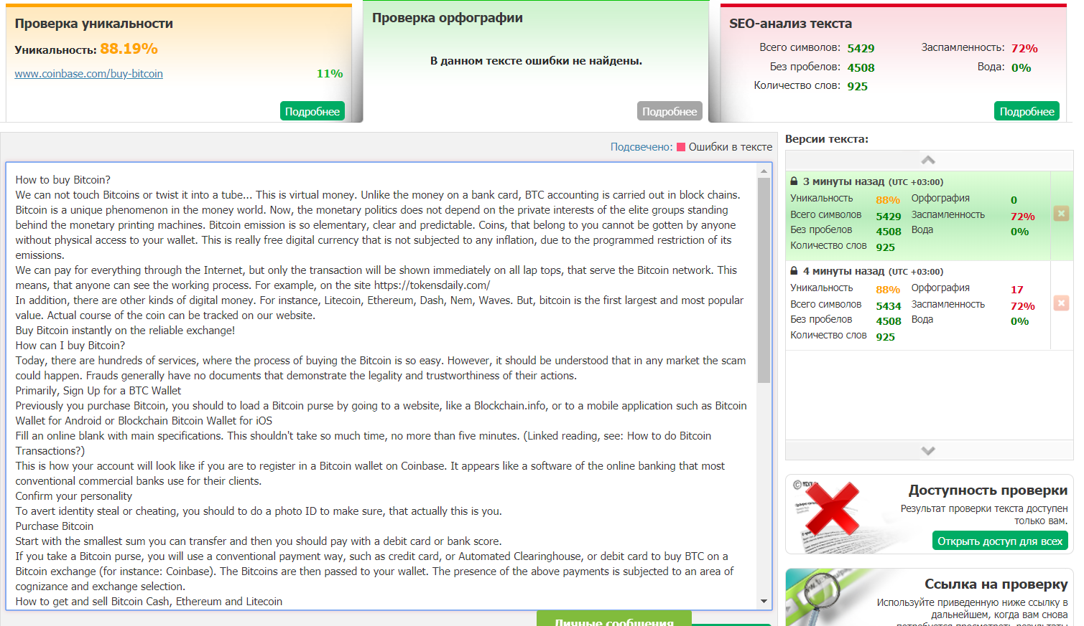
How to buy Bitcoin?
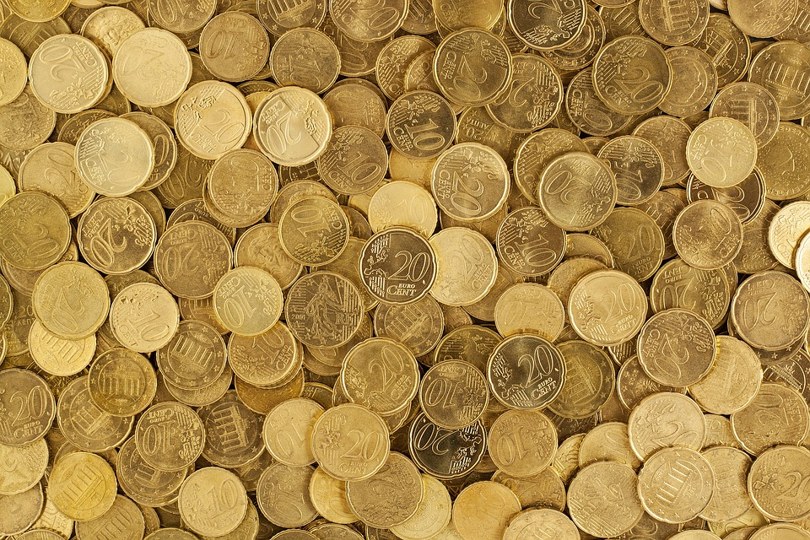
We can not touch Bitcoins or twist it into a tube... This is virtual money. Unlike the money on a bank card, BTC accounting is carried out in block chains.
Bitcoin is a unique phenomenon in the money world. Now, the monetary politics does not depend on the private interests of the elite groups standing behind the monetary printing machines. Bitcoin emission is so elementary, clear and predictable. Coins, that belong to you cannot be gotten by anyone without physical access to your wallet. This is really free digital currency that is not subjected to any inflation, due to the programmed restriction of its emissions.
We can pay for everything through the Internet, but only the transaction will be shown immediately on all lap tops, that serve the Bitcoin network. This means, that anyone can see the working process. For example, on the site https://tokensdaily.com/
In addition, there are other kinds of digital money. For instance, Litecoin, Ethereum, Dash, Nem, Waves. But, bitcoin is the first largest and most popular value. Actual course of the coin can be tracked on our website.
Buy Bitcoin instantly on the reliable exchange!
How can I buy Bitcoin?
Today, there are hundreds of services, where the process of buying the Bitcoin is so easy. However, it should be understood that in any market the scam could happen. Frauds generally have no documents that demonstrate the legality and trustworthiness of their actions.
Primarily, Sign Up for a BTC Wallet
Previously you purchase Bitcoin, you should to load a Bitcoin purse by going to a website, like a Blockchain.info, or to a mobile application such as Bitcoin Wallet for Android or Blockchain Bitcoin Wallet for iOS

Fill an online blank with main specifications.
This shouldn't take so much time, no more than five minutes. (Linked reading, see: How to do Bitcoin Transactions?)
This is how your account will look like if you are to register in a Bitcoin wallet on Coinbase. It appears like a software of the online banking that most conventional commercial banks use for their clients.

Confirm your personality
To avert identity steal or cheating, you should to do a photo ID to make sure, that actually this is you.
Purchase Bitcoin
Start with the smallest sum you can transfer and then you should pay with a debit card or bank score.
If you take a Bitcoin purse, you will use a conventional payment way, such as credit card, or Automated Clearinghouse, or debit card to buy BTC on a Bitcoin exchange (for instance: Coinbase). The Bitcoins are then passed to your wallet. The presence of the above payments is subjected to an area of cognizance and exchange selection.
How to get and sell Bitcoin Cash, Ethereum and Litecoin
They are other popular virtual money. It's as plain as snapping on the “Buy” button, if you want to buy something, or “Sell” tab if you want to do of the same name action. You choose which valute you are buying or selling and which remittance way to use (your bank account or credit card).
Remember that “Bitcoin swap” and “Bitcoin purse” should not be the idem. BTC exchanges are form of the foreign swap markets — sites where you can commerce BTC for a fiat currency, saying BTC for USD and contrariwise (in United States, for example). While exchanges proposal purse capabilities to clients, it’s not their principal business. Since the wallets need to be conserved in safety and reliable, exchanges do not promote storing of coins for supreme numbers or long periods of time. Hence, it is the best to broadcast your Bitcoins to a secure wallet. Safeness must be your top precedency while choosing for a Bitcoin wallet; at any time, pick for the one with multi-signature object.
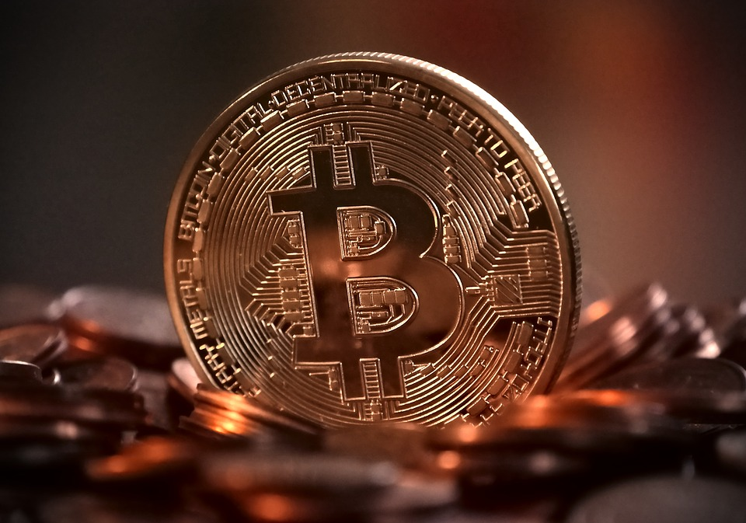
There are many good-established exchanges, that act as a one-stop decision by suggesting high protection standards and accounting.

Due conscientiousness and painstakingness must be manifested while choosing a coin exchange or wallet. (See also: How do Bitcoin Transactions Work?)
How to risk freely with Virtual Cash?
Put your commercial skills to the trial with our free of charge serve simulator! Compete with the mass of traders and retail your way to the top! Accept deals in a virtual surrounding, before you start taking risks your proper money. Practise all the trading strategies on our website! Thus, when you're ready to input to the live market, you have had the best praxis you ever need.
What can you do with your BTC?
Keep
A lot of lients hold into their coin hoping, that its cost goes up. You can accumulate your coins in the Coinbase account or broadcast it to an individual wallet. Control the price of BTC!
Sell out
Selling digital money on Coinbase is so easy. You can exclude your earnings to your bank or PayPal account.
Convert
Do you want to have an other crypto valute? Convert any piece of your Bitcoin residue to another digital currency.
Spend your BTC
Use your coins to pay for journeys, buy present cards, eat in cafes and at restaurants, use more and more opportunities. The ammount of places that admit Bitcoin is increasing every day.
Transfer
In contradistinction to sending money abroad, you can set off Bitcoin to anyone in the world virtually forthwith.
Donate
Give Bitcoin to people in need on websites such as GiveCrypto.org, which spreads digital currency to individuals, living in total poverty.
Read more details in the next article “ Why Use a Blockchain?”.
Faithfully yours, BTC reporter.

