B2B/B2C SaaS, Live Proxies

Category: B2C/B2B SaaS, commercial proxies
Website: liveproxies.io
Country: US
Budget: $3,500 / mo

1. Challenges
- highly competitive market;
- new unknown brand - no paid ads previously;
- can only track paid subscriptions (via offline conversions upload).

2. Objective
Maximize subscriptions within the current budget.

3. Review
- US competitors research (manually and with dedicated tools);
- Website audit, UI/UX adjustments recommendations.

4. Work done
- Semantic core creation: target search queries, close ones and more with interest intent to form the funnel;
- Campaigns split based on the level of market intent and devices;
- DSAs, Pmax, video campaign for broader brand awareness;
- Brand and competitors campaigns;
- Budgets were selected according to devices demand and срс;
  - After first crucial month of management, we had enough of data to adjust budgets and bidding strategies according to the account performance;
- Always unique ad copies for every ad group with maximum symbols usage and dynamic insertions;

5. Results July ‘23 vs June ‘23
- Subscriptions 714 vs 122
  - Conversions grew by 485%
  - СРА was $4.25 vs $12.58

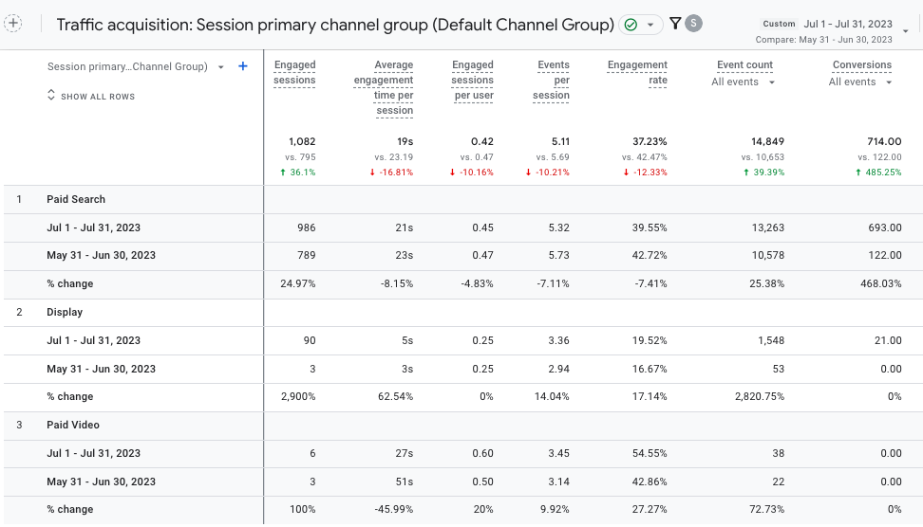

6. Results October ‘23 - December ‘23 vs July ‘23 - September ‘23
- Subscription 7,020 vs 4,216
  - Conversions grew by 66.5%
  - СРА was $1.34 vs $2.14

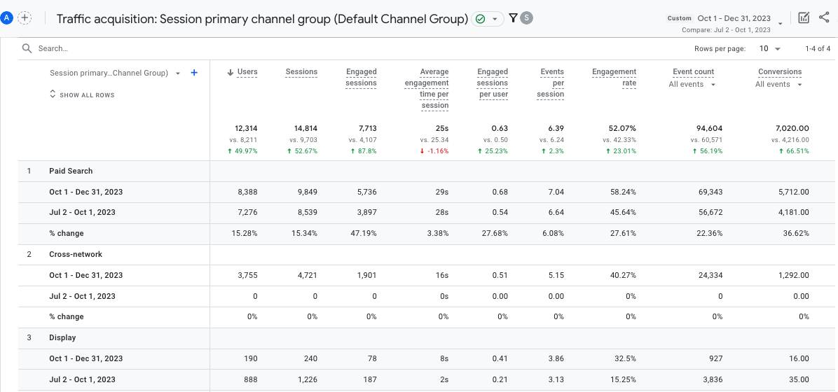

Conversions grew even in the winter period of decreased demand. All the ongoing jobs and account expansion were focused on conversion growth within the given and only slightly increased budget.

