The Life of a 10/10 Male (Tinder Case Study)(Pics)
By Marcus | June 6, 2015
163 Comments

An interesting Tinder experiment was carried out to answer one question: What’s Tinder like for a male model compared to the rest of us? Here are the results.

The Case Study – Background
A user of the misc named GermanLifter decided to do a Tinder experiment.
The premise was simple, saying he “made a tinder troll account just to see how well a male model compares to the rest of us.”
The results of his thread (which you can find here) were interesting to say the least.

The Model Profile
Here’s the Tinder profile that GermanLifter used:

In case you didn’t recognize who he is – it’s Holden Nowell, the guy from the “Call me maybe” music video.
As you’d expect, a model would do very well on Tinder… but just how well?

The Results
“The results are unbelievable (srs). Every single girl I swipe yes to has been an instant match. There hasn’t been a SINGLE time where I have swiped yes and there was no match.” said GermanLifter.
The matches were great, but the interesting part of all of this experiment turned out to be the conversations that he had with the girls he matched with.
“…I can literally say ANYTHING and still get their #.”
Here are those conversations:
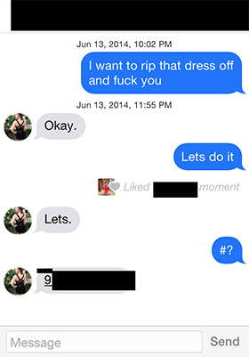

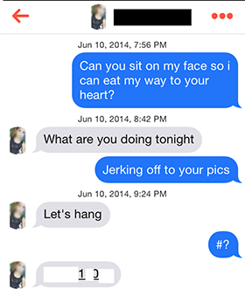

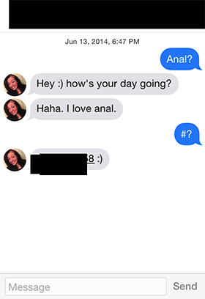The easy conversations kept on coming…
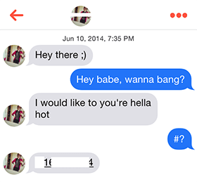

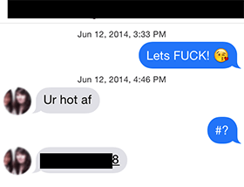

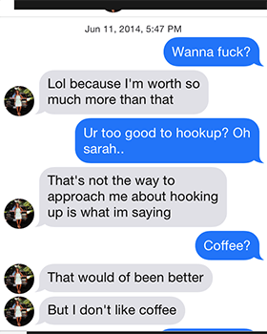
Occasionally girls would show some resistance to the extremely direct approach…
But a simple change-up from sex to coffee was all that was needed to win them over:
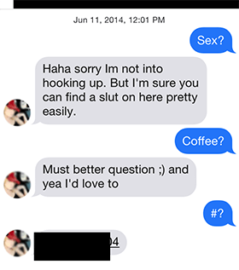
Note: a solid conversation routine can be an incredibly powerful seduction tool, even if you’re not a model.

Testing
An interesting point was noted by users on the forum – even though this guy was a model, women were still giving him the same “tests” (known as “shit-tests”) that normal guys get:
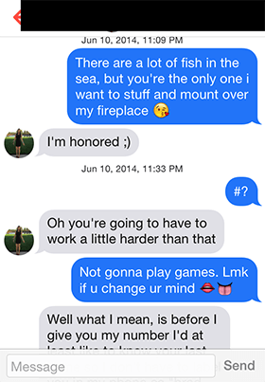
“You’re going to have to work a little harder than that” is a classic.
A lot of guys would comply with her request and “work harder” for her attention, but not GermanLifter. And the change in tone as a result is interesting:
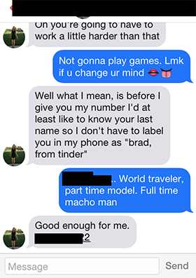As user Everglide123 pointed out:


Do women have double standards when it comes to looks?
Another topic of discussion was around double standards:
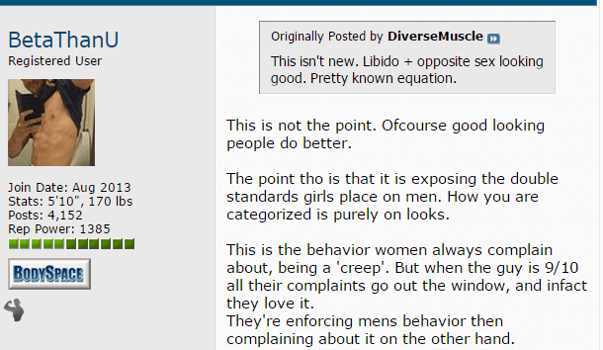
“What is being exposed here is how the standards on what is and isn’t ‘creepy’, or ‘entitled’, etc. actually has almost nothing to do with a guy’s behavior, and is instead a function of his facial aesthetics.” said supersystem3.
He used openers that would destroy the chances of a normal guy… but not for a male model.
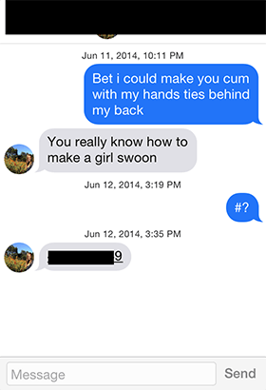

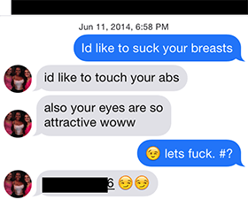

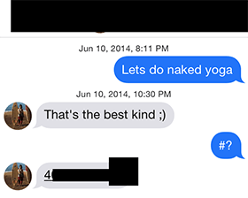
Even girls who you’d think would be reserved based off their profile, accepted and enjoyed anything this guy said:
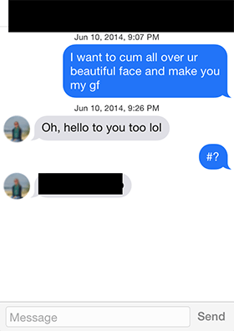

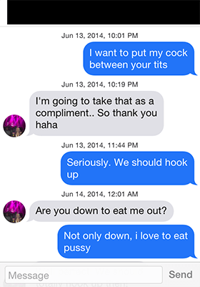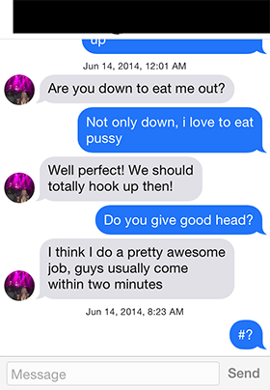

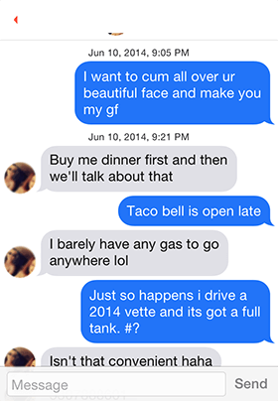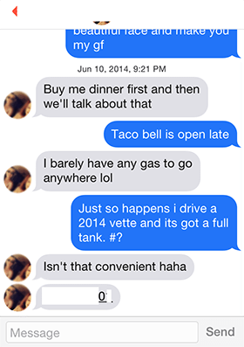

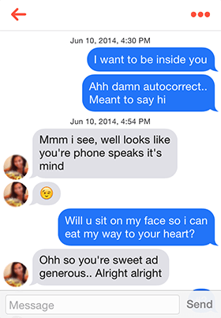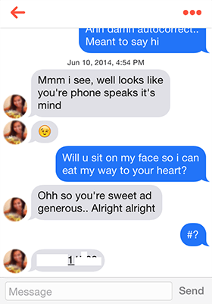Nothing seemed to be out of the question:


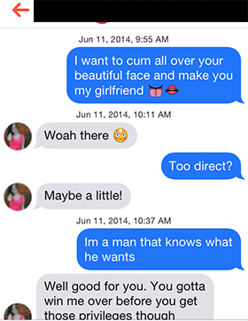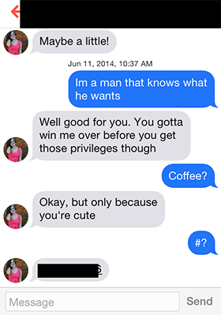

Those feels
Witnessing how easy it was for the model motivated a few of the readers:

But there were a lot more readers who felt discouraged by it all:
“I think I have given up all hope with women srs” – Freuddcoco


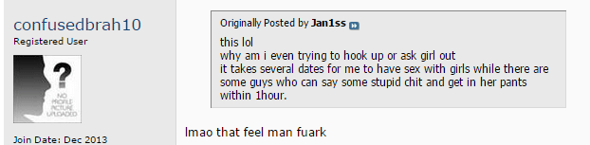


Conclusion
There’s no doubt that all things being equal, a male model will get better results than most guys on Tinder. Everyone accepts that.
But this experiment by GermanLifter might also show that the difference is bigger than most would believe.
Another interesting discussion point from this experiment, as raised by a number of people, was that women complain about the things (average) guys say on Tinder and classify them as creeps. But when those same words come from an attractive guy, they aren’t as creepy… in fact, apparently most women seemed to respond positively to it.
It’s a prime example of how attractive people are treated differently.
There’s no doubt about it, being a male model definitely makes Tinder easier.
So what if you’re not a male model? What then?
Do you give up on Tinder? Do you resign yourself to a life of loneliness, accepting that it’s only the really attractive guys who get the girls?
Definitely not.
Why shouldn’t you give up?… Because there are countless ordinary guys out there who are hooking-up and dating gorgeous women off Tinder. They don’t get the same coverage as these types of forum threads, and they may not do it as easily as a male model, but they do it.
Know that there are conversation methods and techniques available that allow any guy to hook-up and date attractive women on Tinder.
So if you’re an average guy who’s on Tinder and what you’ve been doing in the past hasn’t worked, it’s probably time to try a new approach.
What do you think when you see conversations go down like this?

