Medical Marijuana Card in Riverside, CA 2020

Beginning January 1, 2018, the sale of cannabis in California is allowed to persons aged 21 and older. This is the sixth American state where the drug is legalized. But how we got there, let's go a little deeper into history.
California is the first state in the United States of America to publicly speak about the need to legalize medical marijuana when it was found that the CBD and THC it contained helped not only relieve boredom, but also treat pain, stress, and even insomnia. It is worth noting that a special piece of legislation has been created to regulate the use of marijuana in accordance with the guidelines that are spelled out in maximum detail in the Medical Marijuana Program Authorization Act.
Riverside city has completely legalized the use of marijuana for recreational and medical purposes. To purchase medical cannabis within the city, you must have official permission from your doctor or a special plastic MMJ ID card. To issue one, you need to contact special medical state institutions or use the services of licensed online services.
The most convenient and fastest of related online services is the Dr.Weedy platform. We will tell you about the norms of legislation in the city regarding cannabis and about the advantages of issuing an appropriate MMJ card in this article. We are by no means positioning ourselves as a complete guide to MMJ, but our article will definitely give you a good informative foundation to understand MMJ and how you can take advantage of it in Riverside, California.
- State and Local Laws Regarding Medical Weed in Riverside, CA
- How to Apply for 420 Med Evaluations in Riverside?
- Traveling with medical marijuana in Riverside, CA
- Recommendations for using medicinal marijuana in Riverside, CA
- Most Popular Strains of Medical Cannabis in Riverside
- Popular Activities in Riverside, CA To Do During 420 Therapy Sessions
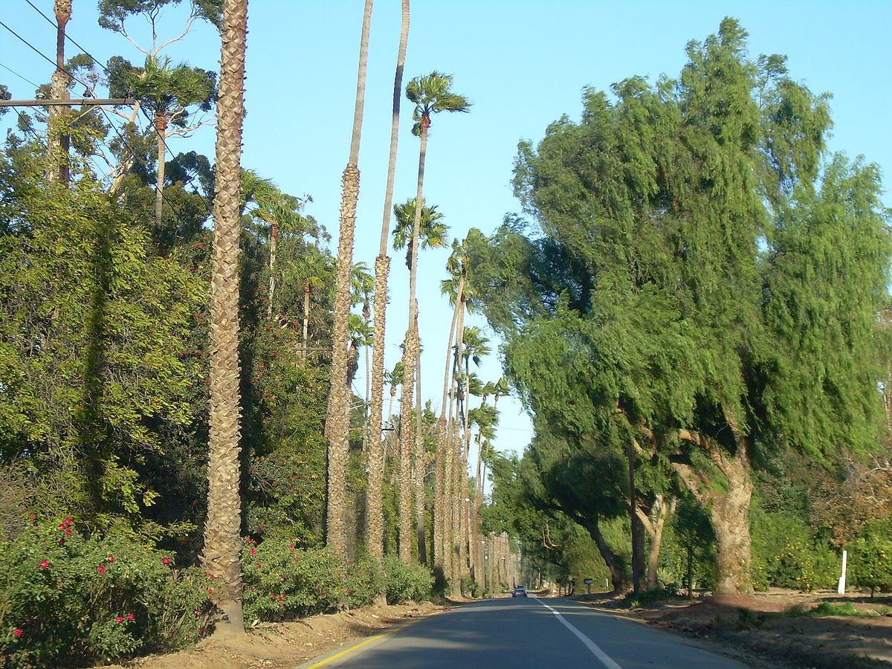
State and Local Laws Regarding Medical Weed in Riverside, CA
Certain rules and laws govern the process of obtaining a medical marijuana card (which may vary depending on government policy), as well as the position of the cannabis plant in principle. Each state has its own unique legal regulations, so you should carefully read the state of affairs in Riverside.

Medical Marijuana Weed Use Laws in California
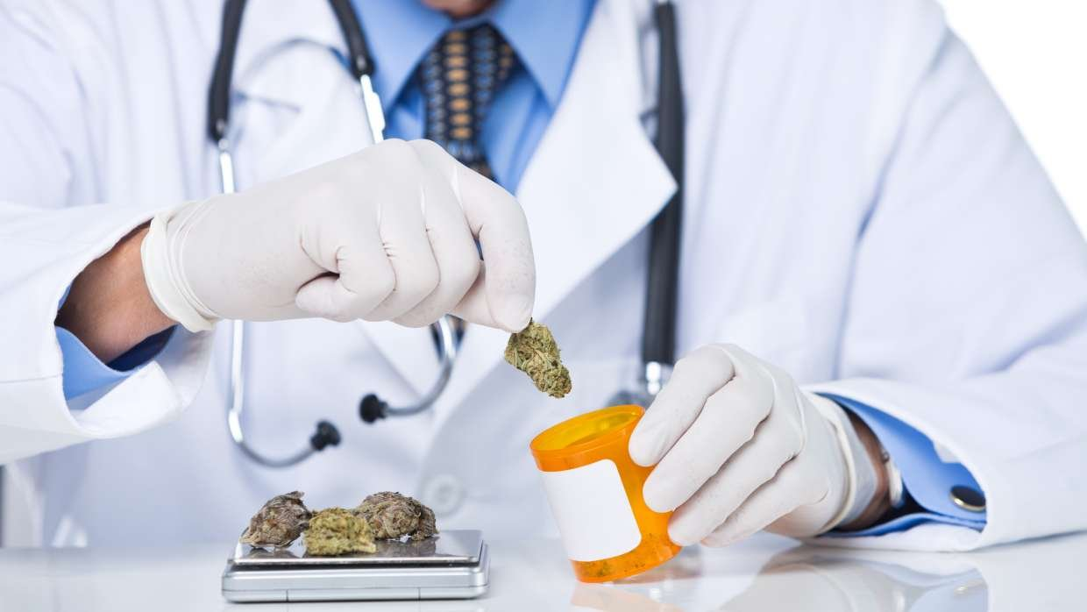
Unsurprisingly, from the very moment that medical marijuana became legalized, marijuana has become a popular form of treatment in Riverside, California. And with all the benefits that come with it, there are certain rules and regulations that must be followed.
The laws of the state of California, equally applicable to the city of Riverside, are free to purchase not only medicinal varieties of cannabis, but also completely normalized the use and carrying of a certain amount of marijuana. We can clearly highlight the following legal provisions that are directly related to SB420:
- Permit to grow cannabis plants on a private property / legal entity or company, as well as permit for co-cultivation and cultivation associations of medical and psychoactive marijuana;
- Banning smoking marijuana in places that are three hundred meters from public places (schools/playgrounds/park areas, etc.);
- Banning the use of cannabis while driving in land and water vehicles;
- Individuals who are on parole can receive a medical record only by submitting an application to special organizations that issue a prescription and appropriate permission. Otherwise, they may be refused;
- Individuals who have been seen forging regulatory documents or plastic cards permitting the purchase of marijuana will be prosecuted by law enforcement agencies.
- Flying with hemp is not legal everywhere. But Los Angeles airport can carry up to 28.5 grams of cannabis.
Features of medicinal cannabis laws at Riverside
- Medicinal functions. Medical marijuana has proven to be effective in treating a wide variety of diseases, ranging from physical disabilities, epilepsy and chronic pain. Marijuana can help manage mental conditions such as anxiety and depression.
- Financial affordability. With a medical marijuana card at their disposal, a person with some degree of disability can easily get a significant discount on the purchase of medical marijuana in the nearest state. This was made possible by a tax cut on MMJ products.
- High quality product. The use of marijuana for adults was officially legalized in 2016 and became fully available after two years. But there are certain restrictions for simple entertainment lovers. Thus, a medical user can access more powerful MMJ products than someone who uses marijuana just like that.
- Storage limits. It is important to know that a recreational user can only have an ounce of cannabis per day, whereas a medical user can only have 8 ounces. For violation of these rules, the person will be prosecuted.
- Purchasing marijuana in dispensaries. With a Riverside marijuana medical card, anyone can easily purchase their preferred strains at dispensaries. In fact, there are far more medical marijuana dispensaries than recreational facilities.
- Low age limit. Cannabis is legally available to individuals over the age of 21. On the other hand, the age restrictions are slightly more relaxed in the case of medical cannabis, for patients who need it. Even if you are under 18, you can easily get full access to cannabis.

How to Apply for 420 Med Evaluations in Riverside?
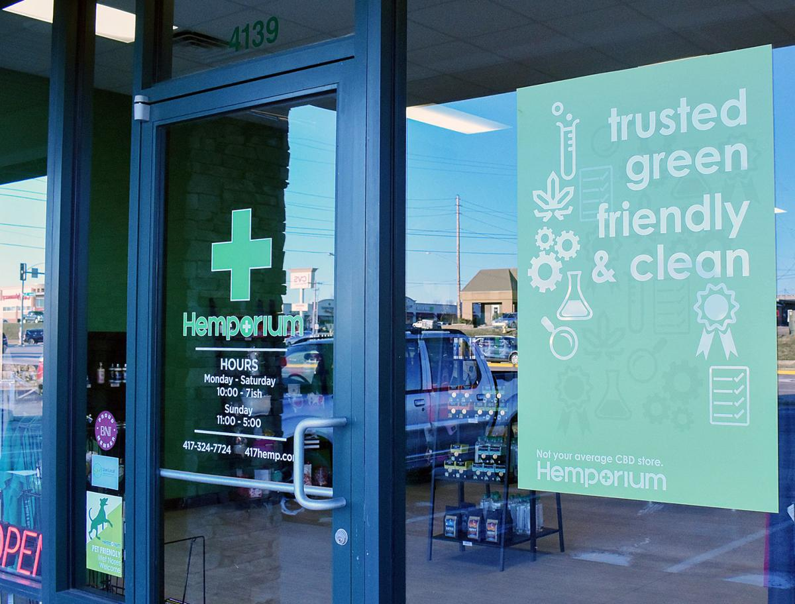
- Step one. We authorize our personal account and fill out a simple application form.
- Step two. Select from the list the required variant of the marijuana card.
      - New Patient Option: $ 59.99
      - New Patient Option + Photo ID: $ 79.99
      - Medical record renewal: $ 45
- Step three. Communication with a specialist doctor
- After approval, a recommendation will be sent to you by mail. All this will take no more than a few minutes.
A doctor may recommend medical marijuana for any conditions they think will be improved by using medical marijuana. Some common conditions for medical marijuana patients include:
- Anxiety;
- Depression;
- Insomnia;
- Loss of appetite;
- Muscle pain;
- Body aches;
- Migraine;
- Nausea.
- inflammation
Remark: This process is only available to patients 18 years of age and older. For Riverside residents under the age of 18 who are seeking medical marijuana, there is a separate process that includes obtaining a second recommendation from a doctor and additional information from a parent / guardian.
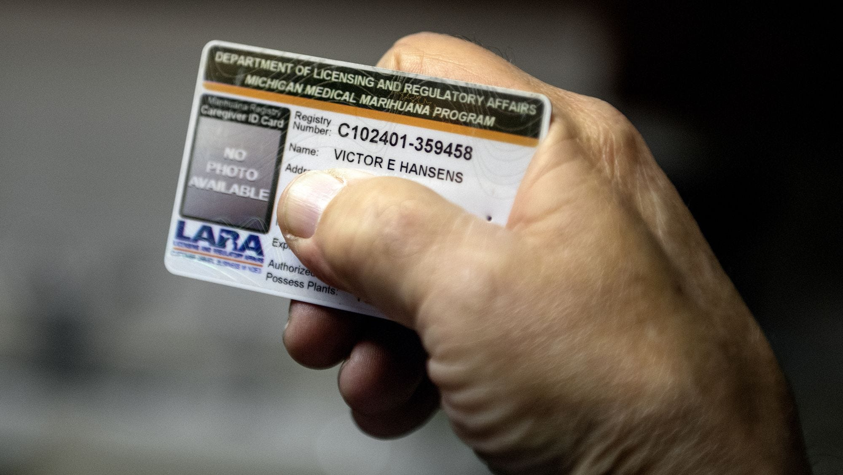

Recommendations for using medicinal marijuana in Riverside, CA
Most often, trained professionals prescribe medicinal marijuana to alleviate the symptoms of the following conditions:
- Effective in the treatment of affective disorders and various mental health disorders - depression, post-traumatic stress disorder, clinical depression, obsessive-compulsive, panic and bipolar disorder, panic disorder.
- Relief of common symptoms when prescribed as an adjunct in the treatment of serious medical conditions, including AIDS, cancer, tuberculosis, and opioid withdrawal symptoms.
- Cannabinoids can be used in the treatment of premenstrual syndrome, arterial hypertension, insomnia. They are also reported to be effective in treating constipation and alcohol hangovers.
- Cannabinoids can be used in the treatment of opiate-induced drug addiction, in particular heroin.
Of course, the question of the advisability of using marijuana for medical purposes can only be decided by a doctor and the initiative of the patient himself is, at best, not welcome here.

Most Popular Strains of Medical Cannabis in Riverside
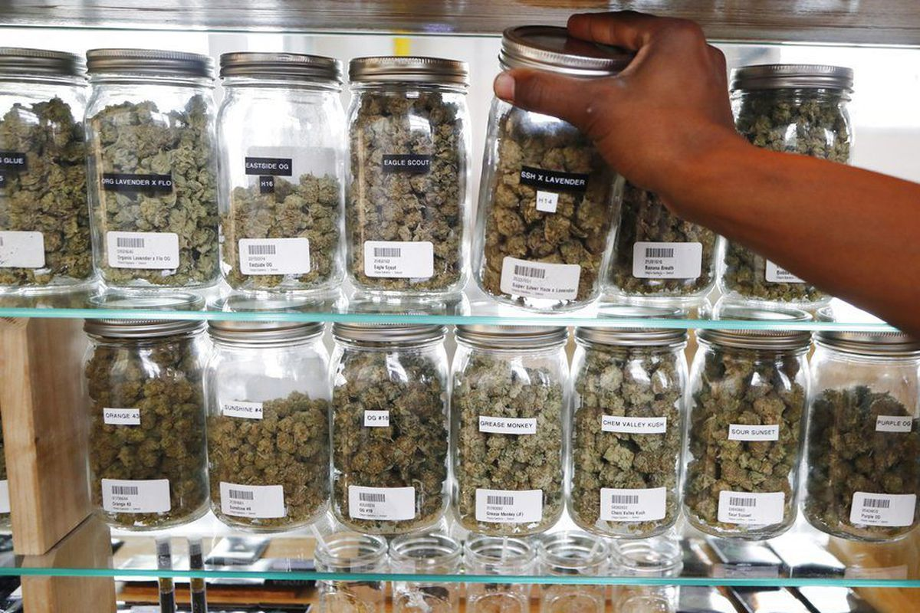
Cannabis is most commonly referred to as a very common drug by qualified doctors. To obtain a particular type of medicinal plant, you need to contact specialized specialists. The online service Dr.vidi provides additional services in the form of the possibility of obtaining advice from specialized specialists - they will help you choose a strain based on the amount of CBD and in relation to the diversification of the pronounced characteristics of various types of medical marijuana. Let’s take a look at two of the most popular strains in the Riverside area.

Runtz variety
Cookies' Runtz has made a splash across the United States. Runtz searches hit a record high in May 2020, according to Google. This popular sweet marijuana strain is grown by Compound Genetics, a Californian company known for creating new strains for the Cookies brand. More than 112 thousand people have subscribed to their Instagram, stop by and you will admire many exotic varieties of cannabis.

Wedding Pie variety
Wedding cake and Grape Pie gave birth to a super sweet Wedding Pie. It can be found at Los Angeles Farmers dispensary, produced by the talented Jungle boys breeders. You can admire the impressive photos on the Instagram accounts of both companies. Prices for Wedding Pie for medical purposes are lower than for recreational ones - $ 46 and $ 60, respectively.

Blueberry Cruffin variety
This is something very special from Oakland, California. This variety is ideal for those who like sweet taste. Its producers - the guys from cannatique farms - have created a huge selection of strains, each of which looks more amazing than the next. The Blueberry Cruffin is a premium product with a premium price tag, but worth it.
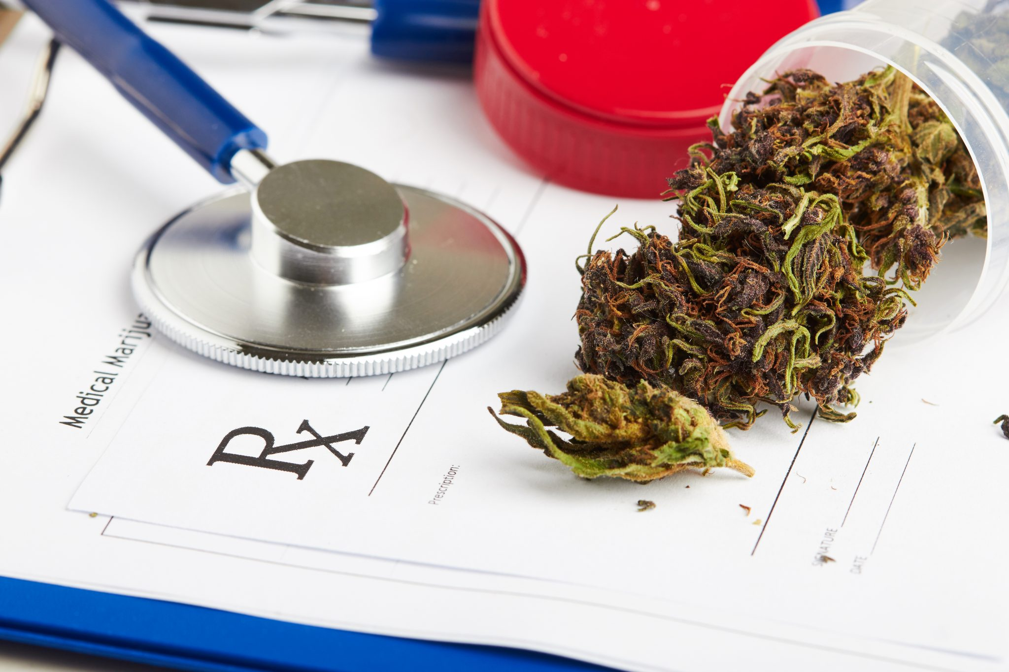

Popular Activities in Riverside, CA To Do During 420 Therapy Sessions
Riverside is a picturesque city nestled on green hills amid the endlessly beautiful sunrises of the heart of the American Dream. The city has many cozy and beautiful places where you can spend an interesting evening and get to know the local history and sights. Locals recommend the following locations, which tourists have chosen so much:

Mount Field National Park
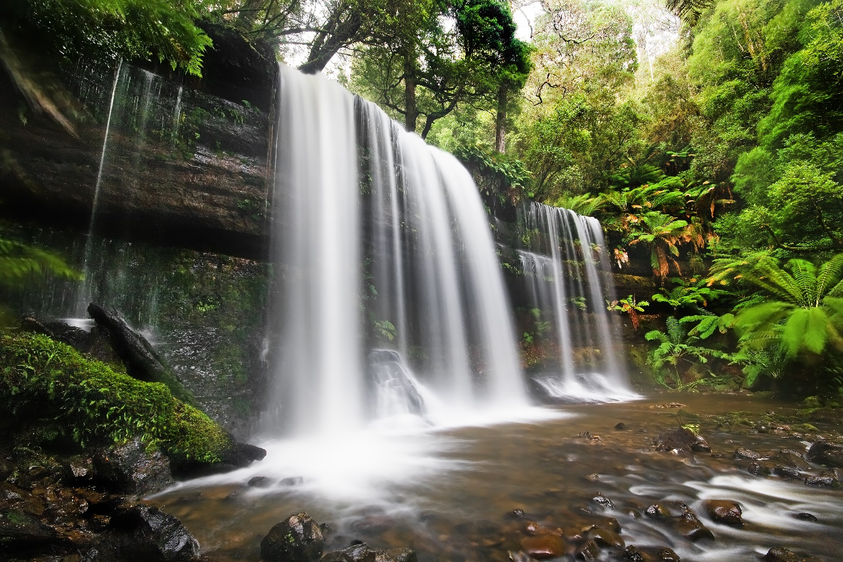
The landmark of the city, Mount Rubidu is home to one of the most popular hikes for residents and tourists alike. Various paved routes take visitors to the top of the mountain, and it takes three to four miles from any starting trail to the summit. The trail is dotted with cacti and wildflowers, as well as many historical markers that represent the city's past.
Above Rubidou passes the symbolic tower of peace, and a large American flag proudly flies in the air. Also on the Rubida is a massive cross overlooking the city, and stone steps are available for seating. This cross is the site of the nation's oldest open-air Easter service, a cherished tradition in Riverside since 1909. The entire Inland Empire is also showcased on Rubida with a 360-degree viewing angle, providing a great place to pack lunch and enjoy the view.

Mission Inn
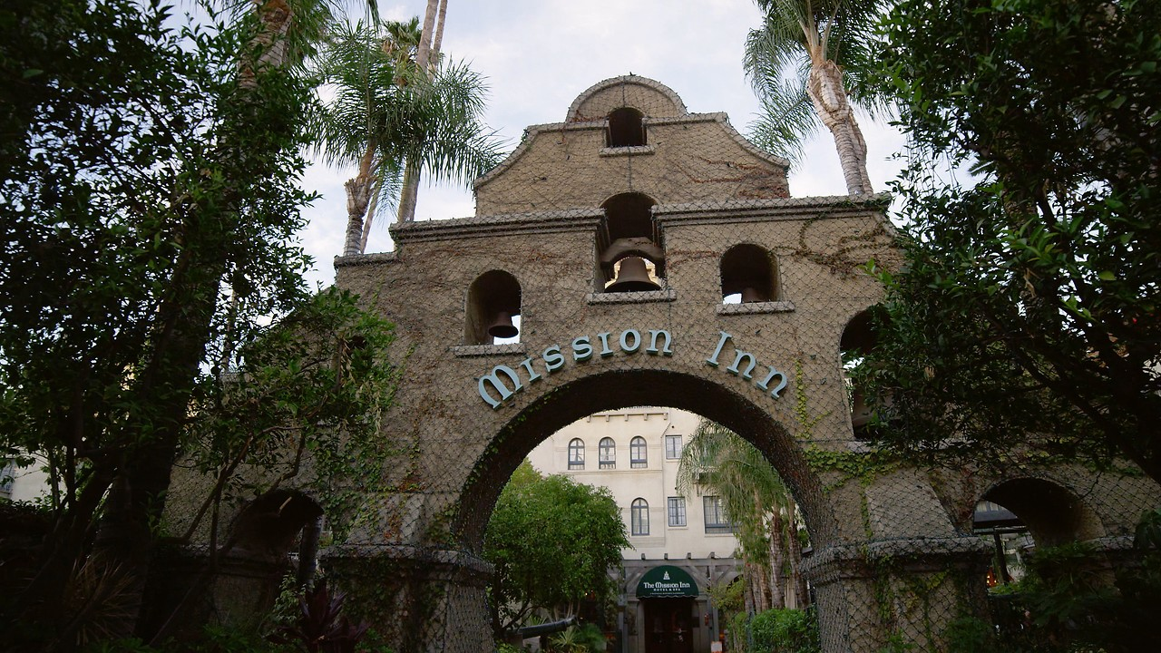
The historic Mission Inn, a piece of Spanish Mission architecture that sets the tone for the rest of the city center, spans an entire block with a castle presence. From this guesthouse to bankruptcy and more than one renovation, this unique hotel has a history spanning more than a century, with walls and stylish décor. The Mission Inn Museum offers 75-minute guided tours of this Mission Revival mansion throughout the week, and the public can visit the elegant lobby on their own.
As one of the finest hotels in Riverside, Mission Inn & Spa allows guests to continue their sleepover heritage. Along with admission to other areas of the Mission Inn that are not visited on public tours, guests are accommodated in uniquely decorated rooms that have been preserved to maintain their historic character. Mission Inn is also home to numerous award-winning restaurants including Prime Steaks Duane's and Seafood.
For relaxation, the Mission Inn hosts the Festival of Lights for six weeks at the end of each year. Starting with a spectacular Turn On Ceremony, Mission Inn is lit up with over five million holiday lights in an instant, followed by fireworks. Along with the lights, tourists encounter animatronic displays, horse-drawn carriages, and even some fresh snow.

