Jive dance classes
Jive dance is a Latin American dance that is popular all over the world, it is:
- very energetic;
- cheerful;
- cheerful;
- beautiful;
- practical;
- international;
- stylistic;
- shakes everyone to the depths of their soul.

History of occurrence

The dance has its fast rhythm, the dance itself is carried out with fast movements in general, the jive dance classes is a modern style that almost everyone likes.
All the movements will be very relaxed and you should try this kind of dance for the soul and physical exertion on your body.
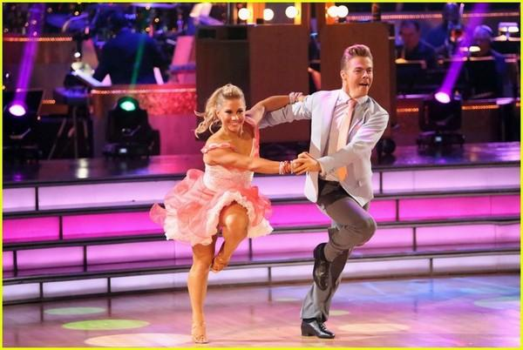
<alt>One of the most popular dances in the world</alt>

The history of jive dance introduces the events that influenced the formation of modern jive meaning.
Like any dance, jive has its predecessors — these African-American styles originated a couple of centuries ago. The version of the dance that is closest to the one that we see now in the program of Latin American ballroom dancing appeared in the United States of America in the 1940s.
Jive classes are often associated with swing, highlighting the features of the first — a more dynamic character, a bright rhythm, and free movements. Some of the figures and movements of the jive are borrowed from swing, but the modern version is very different, and the difference between these two dances is very significant.
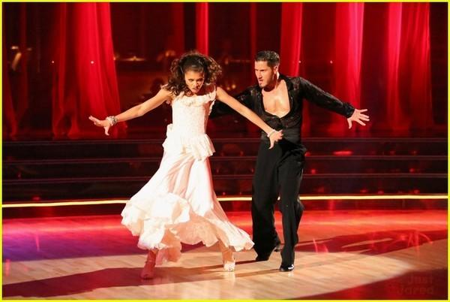
<alt>The dance comes from the 1930s</alt>

Modern history dance

The modern history of dance is closely connected with the competitive program of ballroom dancing. Today, jive classes in Dubai are danced at sports ballroom dancing tournaments that are held all over the world.
As a rule, the jive is placed fifth in a row, and it looks like the apotheosis of the performance of couples. With incredible freedom of movement, bright facial expressions, emotions over the edge, incendiary music couples often go into a real break on the floor. This is an impressive spectacle for the public, which is why the audience is so fond of ballroom dancing competitions, and especially the Latin American dance program.
The jive dancers show their unique skills, talent, and true professionalism.
They demonstrate skill in performing tricks, plasticity, as well as special physical training.
The history of the origin of the jive does not define it as a descendant of African-American styles for nothing — this dance can be safely called the freest, charismatic, bullying, teasing.
It calls for fun, joy, positive, bright emotions, lifts the mood, excites, and makes you look at the world differently. As many centuries ago, African Americans moved to the rhythm of music, forgetting about worries and problems, so today, jive dancers with drive and a positive attitude go out on the floor and are transported to a carefree and bright world.
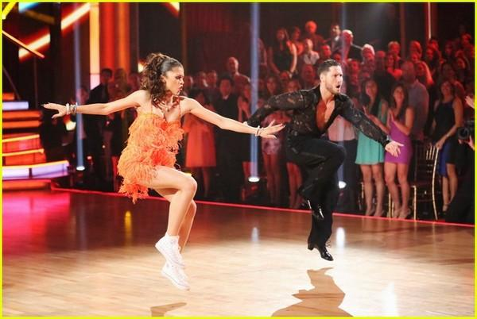
<alt>Modern Jive</alt>

Movements in jive dance

In jive, movements that are characterized by a syncopated rhythm are very interesting.
The transfer of body weight is carried out from one foot to the other, and thus an expressive movement is created, which is very well known in this dance. Modern jive cost can not be confused with any other dance jive lessons in Dubai. It involves a complex technique and to perform it beautifully and accurately, you need a special passion and desire to learn. It is easy to understand the principles of jive dance performance, but it takes months of training to feel at ease and ease on the floor.
However, the result is worth the time spent — you will be able to conquer the audience with the beauty of the dance, and you will get real pleasure yourself.
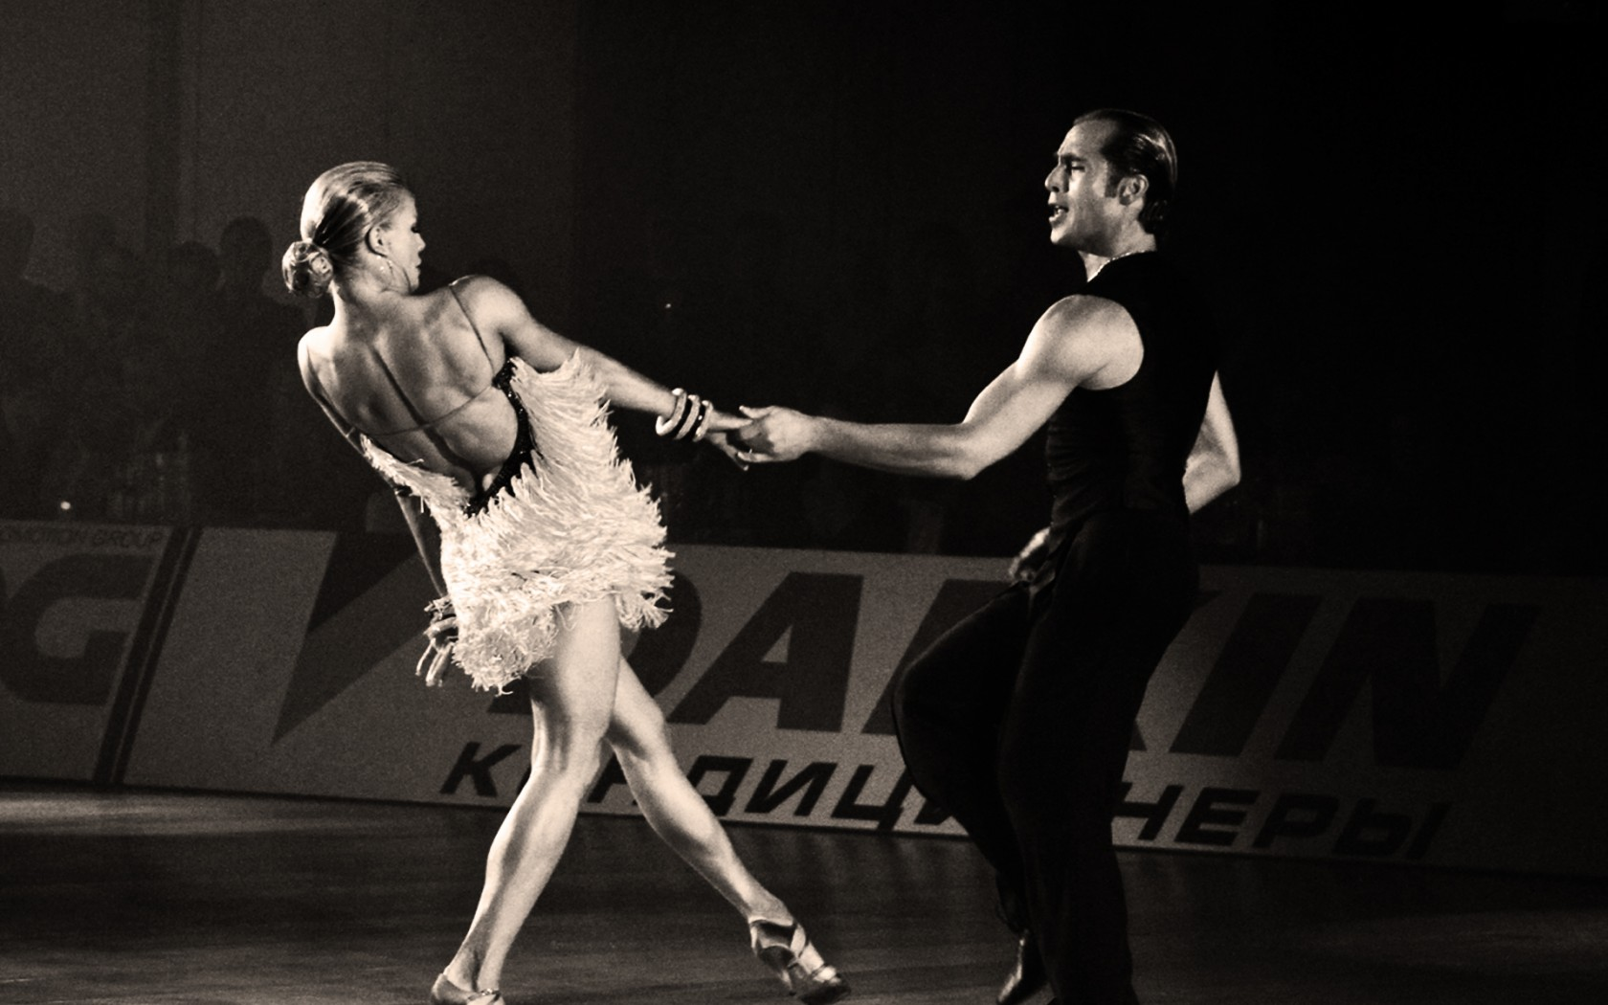
<alt>Position in the dance</alt>

Position in jive dance

In a closed position, the partners stand at some distance from each other.
The partners right hand lies clasping the partner's left shoulder blade, and her left hand is freely placed on top of the partner's right hand on the edge of his right shoulder.
The bend of the partner's hand then repeats the bend of the partner's hand.
Keeping the left elbow at the same height as the right elbow, the partner raises his left hand so that his palm is at eye level, and takes the partner's right hand in it. The partner's left arm should be slightly bent, jive meaning. The partner should offer his left hand to the partner with a gesture similar to the gesture of a policeman stopping traffic at an intersection. The thumb is naturally set aside to learn to jive dance.
The partner puts the middle finger of her right hand between the thumb and the other fingers of the partner, palm to palm. Then she lowers her index and ring fingers, and only after that — the little finger. He wraps his thumb around the base of the partner's thumb, after which the partner wraps his fingers around the partner's hand, slightly squeezing them. The partner's right-hand repeats the curve of the partner's left hand.
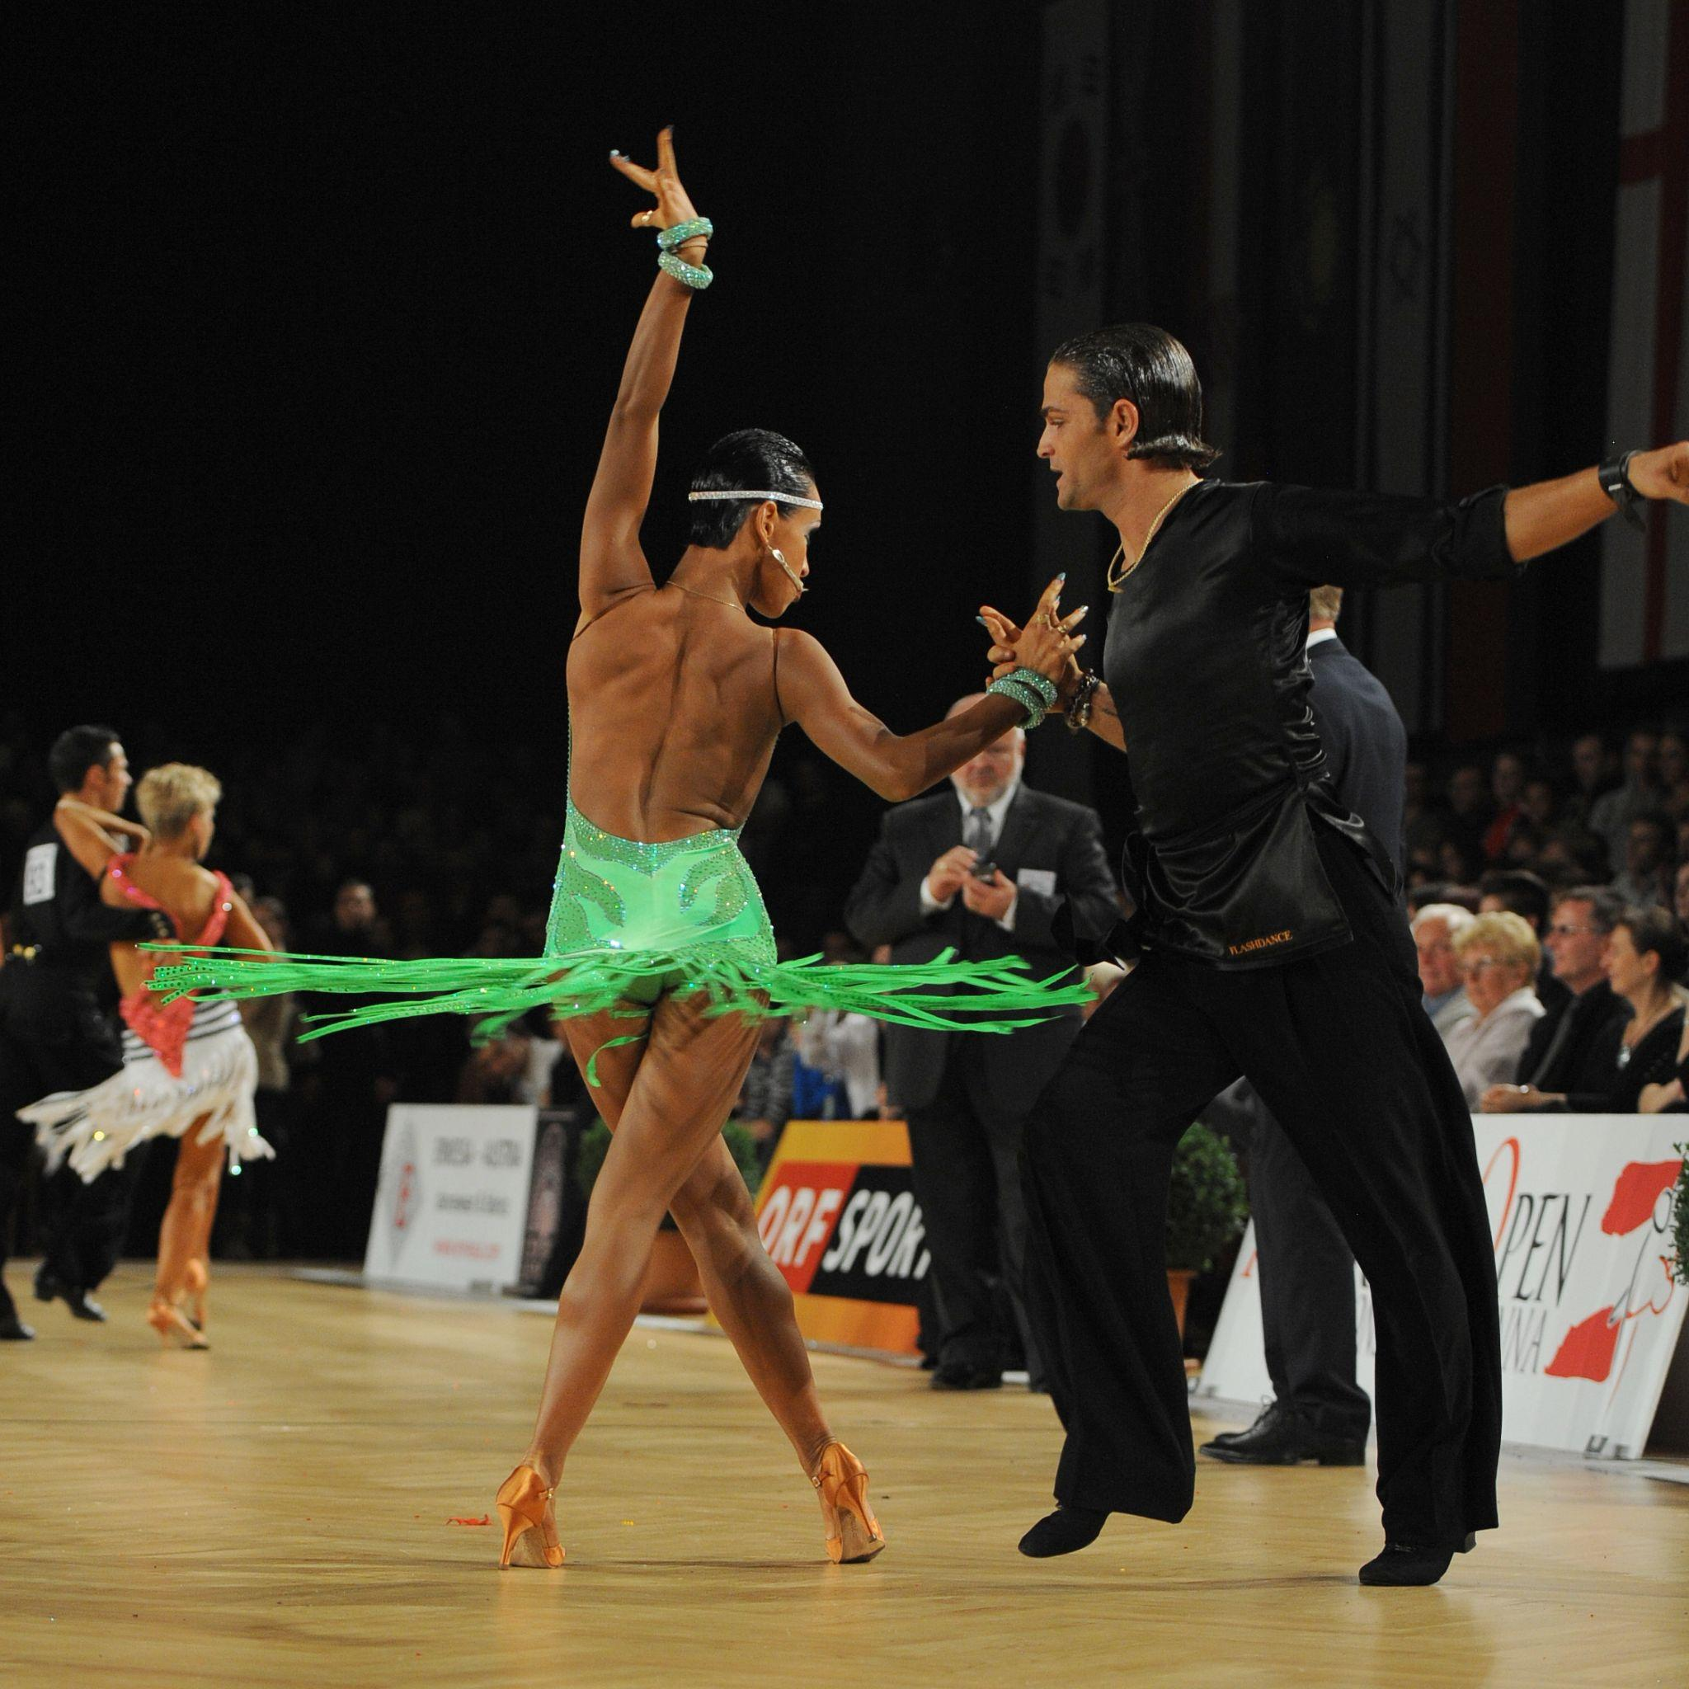
<alt>Basic steps</alt>

The basic steps consist of a fast syncopated chasse (step, prefix, step) to the left and right, along with a slower step back and a return forward. The hips are displayed on the account of "and" jive competition.
After each step, the weight is in front, and all steps are taken from the sock.
Different lengths of steps on the highway will help with the bills.
On the highway, we step through the inner part of the foot, rib down knee up.
Hands are valued for isolation (you can exercise with a filled glass of water).
At the top, there should be no reaction to dancing below.
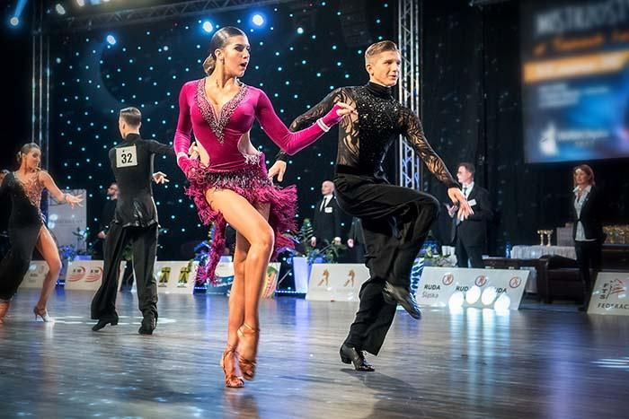
<alt>Exercises in dance</alt>

Exercise in the dance classes

The exercise we raise the knees alternately jive dance classes Dubai:
- the body is tilted, hangs over the pads, it is allowed to slip a little on the supporting leg;
- exercise rolling in the hips, legs at shoulder width, working out the work of the hips in the chasse. Roll from hip to hip with the legs in place and with lifting and bending the opposite leg;
- testing of all types of highways: highway to the side, compact highway, highway forward and backward, highway with rotation;
- kiki forward-turned heel, at one point, the body with a Latin slope. The kick ball changes exercise jive dance classes in Dubai;
- dance heel to buttock 4 kicks each jive lessons Dubai;
- kiki through flick movement you can dance you can jive;
- shuffle steps ("steps of drunken sailors" triple step). The main thing is to separate the first step (tighten 3/4, quarter, whole), swing in the hips and upper part;
- push and pool interaction;
- kickball change-actions-jump, knee lift, kick, return of the leg in the knee, jump.
- Pull in the stomach (you can take it from behind and pull the belt to show the principle of operation);

Clothing for men

Vests, hats, shoes with white inserts, shirts that have sleeve holders above the elbow look good on men who practice ballroom jive events in Dubai dancing. This not only looks very extravagant but also corresponds to the time when the jive was experiencing its dawn. Special attention should be paid to costumes designed for sports jive in Dubai. Here, the trend phenomena include asymmetry, the use of materials that imitate the naked body, sequins, rhinestones, feathers. Women's dresses often have an open back and hips, and sometimes a stomach. Men's suits are also distinguished by their brightness best jive dance. Here, shirts with ornaments and a cutout on the chest, and partially tight trousers are popular.

