7 Countries To Travel On a Student Budget?

Who doesn’t like to travel? I am confident that you do. Adventures in new cities are touting insistently while you are visiting travel sites to find star travel discounts for star travel flights. Are you dreaming of conquering the whole world, but you don't have enough funds? Then, you are a lucky beggar! There are some countries which welcome you even if your wallet or purse is not full of versatile currencies. Just do not forget about star travel insurance.

Please meet the list of 7 countries where is cheap travel is possible. Most of them are from my own experience so that you can rely on the following information from scholarship essay writing service. Here you are.

- The first country on our list is Morocco. It is in the first place as this undiscovered well country can propose plenty of natural adventures. Are you familiar with many sites which consist of the ocean, the sea, the desert and the mountains at the same time? The Atlantic Ocean on the west impresses with its most extensive beaches where you can see the local boys playing football. Tender waves of the Mediterranean Sea on the north and warm sands of Sahara desert will charm you forever. The road to the mountains surprises you with its quality and bends. The view on them is worth to enjoy.

Thanks to the developed net of hostels, street cafes and public transport, you are in safety from a waste of extra money. Low level of local currency lets you to enjoy all places plus to buy the famous products like argan oil and rose water or other local souvenirs.

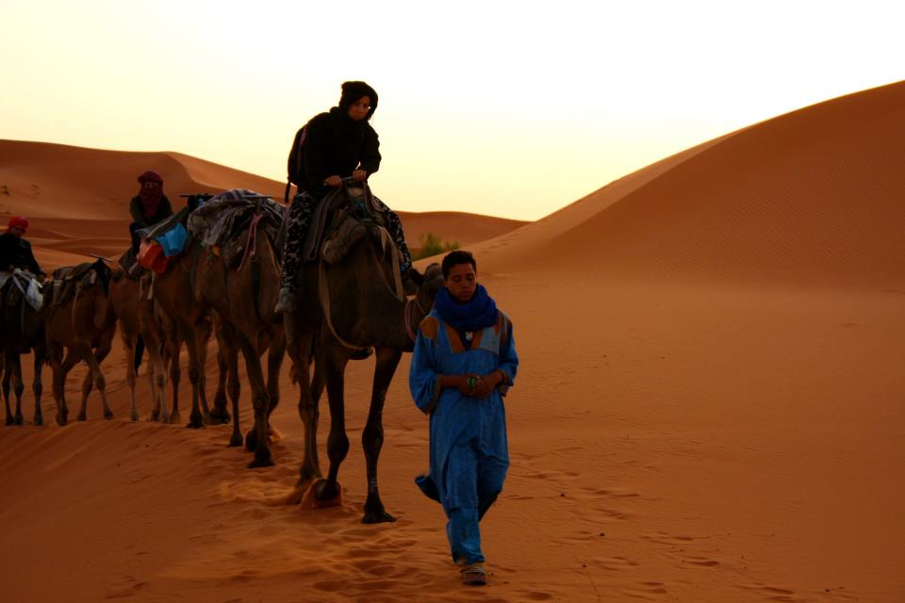

- Next country - Egypt - is situated in North Africa too. This fascinating civilization has incredibly long and full of events history. Cairo and Alexandria are able to open their hearts to those who adore historical artifacts of ancient civilization. There are a lot of American hostels btw.

Last but not least, please follow your heart to the south if you prefer to take part in diving in an incredibly overwhelming and unique Red Sea. Flora and fauna there impress your mind. This one and other beach activities are waiting for you for the ridiculous price (for example, $10 for each one if you travel in low season). Please do not worry about accommodation, five starts hotels in low season can suggest you attractive discounts. Last minute vacation deals save your budget fundamentally.

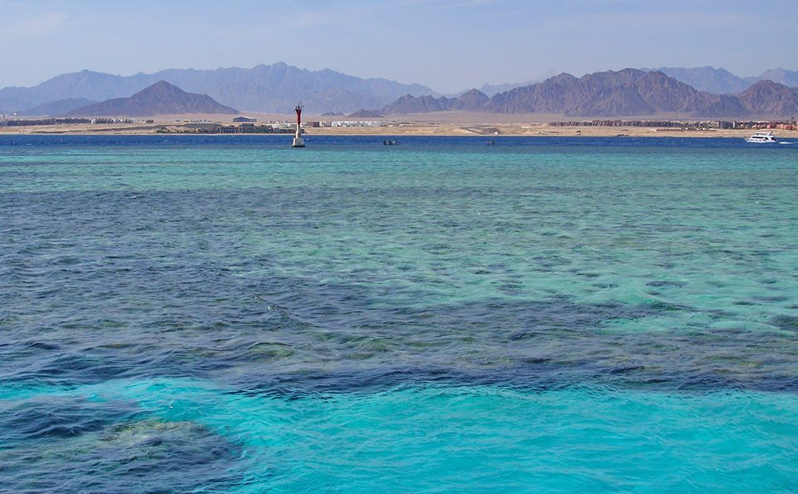

- Hungary is located in Europe. At the same time, this nation is unique with its language, fascinating landscapes and old architecture. Budapest charms you from the first minute with canals and bridges over the Danube, particularly, if you decide to catch the picturesque view from Fisherman Bastion. Mouth-filling dishes for affordable price satisfy your meager budget. Please do not hesitate to visit Széchenyi bathing establishment if you have an extra day for relax rest of course. Street food will cost you from 400 till 600 HUF; fast food can be a little bit higher – till 1500 HUF for a whole lunch. The cheapest food is a Chinese one. Yes, such big cities as Budapest have varied cuisines from different nations.

- Albania can be one of an exciting alternative to beaches in Italy or Greece. Waves of the Mediterranean Sea are tender to you at the same way in Dhermi and Jala. Hostels attract you with their affordable prices, prices on the food and transport are less high than in other European countries. Albania pleasantly astonishes you with its heritage and history comparing with well-known Empires. Tirana is the capital of the country and may offer you a lot from colorful Ottoman, German and Soviet architecture. You are free to visit Skanderbeg square, National Museum of History and Efem Bey Mosque.

- Colombia is one of the South America countries which has not a good reputation because of drugs. If you are not going to deal with illegal business there, I suggest you look closer to developing the infrastructure of the travel industry (hotels, restaurants, etc.). The capital suggests you plenty of activities. At the same time, the pure heart of Colombia is in Cartagena. Charming Spanish architecture in colonial style and the most popular in the country The "Cartagena International Music Festival" and significant heritage of the world - the most extensive fortifications in South America attract the vast quantity of people around the globe.

A trip to amazing Colombia will costs not so much, especially in case of selecting the eco-friendly farm as an accommodation.

- China becomes more and more popular thanks to external policy directed toward tourism development. The country is so big and different and ready to propose you a historical heritage combined with modern metropolises like Beijing and Shanghai. The bigger city, the more opportunities to find the cheapest accommodation till 10 dollars per night. Street food is part of Chinese traditions and costs you about 1 dollar only. Restaurants are not expensive too – till 5 dollars for one dish.

Most of the touristic attractions and landmarks are free for visitors. History and culture are in every step, so you can enjoy the way and take a lot of picturesque photos. Even if you are going to land in such famous sights as Great Wall, you will be pleasantly astonished by inexpensive price.

- Indonesia is one the most affordable countries for any budget. Thousands of small and tiny islands appeal with its pristine wilderness of beaches and rainforests. Volcanoes and tropical fruit are the raisins of your trip as well a surfing, snorkeling, rafting and other activities. All of them are in enough quantity in one of the islands – Bali. It offers you affordable accommodation in such regions as tropical Ubud or vivacious Kuta.

Ubud located in rainforest proposes you to visit monkey's park and watch for traditional religious dances at sunset. The most delicious and not expensive seafood is waiting for you in Jimbaran. Colorful trekking thanks to bird watching impresses you in West Bali National Park. You can drop in coffee planting if you are the coffee addict or just like experiments.

Please welcome Sandra Larson. She is an academic writer who likes to try something new and fascinating. She couldn’t find proper scholarly writing services, that’s why she decided to create her website where she can share this precious knowledge.
She has been working for EduBirdie for five years. Satisfied customers inspire her to develop this service, and she does it with a big pleasure. The team offers the prompt and flawless writing service. You are free to ask any questions and write them to the email.

