Process Optimization of DME Production Plant Using Aspen HYSYS Simulation Model
Noor J. Alreyahi ⁽¹⁾
⁽¹⁾ AL Balqa Applied University, Faculty of Engineering Technology, Amman-Jordan

Abstract
The natural gas to dimethyl ether (DME) process via direct route has great yield, selectivity and efficiency in comparison with other routes. DME has been widely utilized in clean compression engines as alternative fuel; due to its significant characteristics. In this paper, process optimization is conducted to DME plant in Aspen HYSYS simulation model. A comparison of the process before and after pinch analysis is realized in term of energy saving, cost and carbon emissions.

Knowledge
R
ecently, the global world consumption is highly enhanced due to the chemical industries and transportation growth. Most chemical production industries have used coal and crude oil as energy sources. These sources consume energy of approximately 5.7 million tonnes per year, besides to their prices are increased over time (Laiwatthanaphaisarn & Anantpinijwatna, 2018). From another point of view, these sources reflect negatively on the environment and human’s safety if the strategic precautionary measure is not considered. For instance, the crude oil source is responsible for around 45% of the total global carbon emissions in the United State US in 2020 (Alshbuki & Bey, 2020). Current studies have been focused on alternative energies and fuel sources that can be used in several applications to be studied and abled to design a suitable plant with minimum energy waste using process optimization simulated in Aspen HYSYS software (Laiwatthanaphaisarn & Anantpinijwatna, 2018). Dimethyl ether (DME) is an organic and hydrocarbon substance; it is highly recommended and got a numerous attention as an alternative energy source, fossil fuel and liquified petroleum gas (LPG); due to its large-scale properties. DME is an ether of two methyl groups with one oxygen molecule in the middle of its structure (Chen, et al., 2013). Thus, its structure provides low by-products emissions through combustion; due to there is no carbon-carbon bonding and moderate oxygen content. Dimethyl ether is a safe, and non-toxic component; it can be easily transported and liquified at a low pressure of around 1.5 MPa. It is considered a significant fossil fuel source from its thermal, physical and chemical properties, including high cetane number, low heating value, low density, molecular weight and other properties shown in Table 1 (Arcoumanis, et al., 2008).
Table 1: Properties of DME (Makoś, et al., 2019)
Properties | DME
Chemical Formula | CH₃-O-CH₃
Molecular Weight (g/mol) | 46
Cetane Number | 55-66
Auto-Ignition Temperature (K) | 508
Carbon to Hydrogen Ratio | 0.337
Density (kg/m³) | 660
Viscosity (cP) | 0.15
Oxygen Content (% w/w) | 34.8
Calorific Number (MJ/kg) | 27.6
The DME is produced from synthesis gas (carbon monoxide and hydrogen) obtained from different and several feedstocks. Its formation has a large scale of options, including distillation columns and simple reactors. Despite the properties of DME, there are operations included through the production plant require high temperature consuming significant energy waste; therefore, the process optimization can be a suitable solution. It develops the energy supply approaches, the operating conditions of the processes and their heat recovery, helping for efficient use of energy to reduce the waste and pollutants (Natural Resources , 2003). The paper comprises the DME production plant with and without the process optimization using the Aspen HYSYS simulation model.

Methodology
In this paper, the Aspen HYSYS software is selected to design a conventional plant for dimethyl ether production and apply the process integration to achieve the study goal at 100 kmol/hr of inlet raw material. Aspen HYSYS is one of the energy leading simulation models. It is highly used by gas and oil refineries and producers. It is selected; due to its high modelling and optimization performance, process design and dynamic solution (Alshbuki & Bey, 2020).
Dimethyl ether is formed from methanol dehydration by direct or indirect synthesis route. In this paper, the direct route is selected, known as one-step method, where the methanol and the DME are formed simultaneously in a single reactor over a bi-functional catalyst, unlike the indirect route in two separate reactors (Khandan & Kazemeyni, 2009). The direct synthesis route is preferred and chosen according to many studies investigations. These investigations are based on many terms, including the thermodynamic information, economics, environment, safety and the operation conditions applied. Starting with thermodynamic data, yield, purity, and conversion that are better, around 99%, 99.9%, and 90%, respectively for the direct route (Otalvaro, et al., 2021). In addition to the environmental and economic terms being more suitable in comparison with the other paths according to (Azizi, et al., 2014).

HYSYS Simulation
The first step before DME plant simulation is raw material selection and identifying the primary operations involved. The suitable raw material to start the plant is natural gas; its high availability and flexibility can be used as both an energy source and raw material. Finally, natural gas is applicable in many chemical manufacturing industries, and the dimethyl ether plant is one of them (G.Speight, 2019). Secondly, the main steps of the DME production plant should take into account before simulation. DME production needs conversion of the selected raw material into synthesis gas by steam methane reformer at extreme operating conditions. This is followed by methanol production from synthesis gas hydrogenation combined with DME formation in a single reactor. Besides, several separation processes are operated to remove the undesired components from the main mixture through the process plant and purify the DME at the end, as shown in Figure 1.
Figure 1: Block Diagram for Main Steps of DME Plant
These main processes in Figure 1 are applied on HYSYS with necessary auxiliaries between them to achieve the desired goal for each unit. The fluid package during HYSYS is conducted based on the nature of the components included in the whole plant. BWRS fluid package is selected because it is highly applicable for the hydrocarbon components and is suitable for extreme temperature and pressure operations.

Steam Methane Reformer Reactors Modelling
The simulation for the dimethyl ether process starts with synthesis gas (carbon monoxide and hydrogen) production from the selected raw material using a steam methane reformer reactor. Reformer reactor operated and applied to convert the natural gas mainly of methane into carbon monoxide and hydrogen using steam at high operation conditions as shown in Eq.1.
$CH_{4}+H_{2}O→CO+3H_{2 }$ (1)
The reaction is added at methane conversion of 92% at a temperature of 700 $℃$ and pressure of 3 MPa (G.Speight, 2019). Therefore, the reactor needs steam to be fed as another stream to the reactor to be converged. However, the inlet streams are added at their storage operation conditions, $25 ℃, 1 atm$. Thus, several auxiliaries are needed, pumps and heaters, to increase their pressure and temperature to the desired operating conditions, as shown in Figure 2.
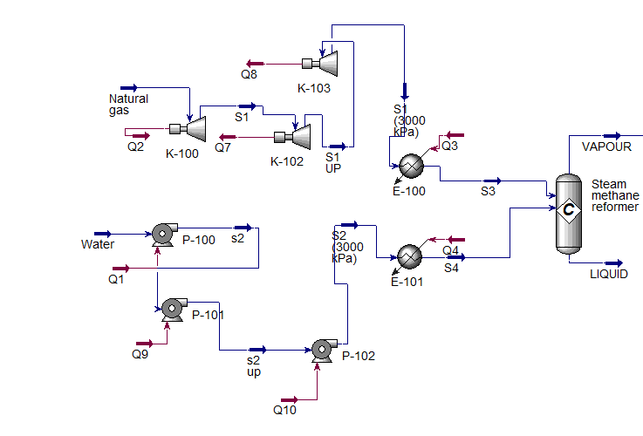
Figure 2: Steam Methane Reformer Simulation

DME Synthesis Reactor
After the synthesis gas is formed, the methanol is produced to be dehydrated for DME production, as shown in Eq.2, 3, 4, and 5.
$CO+2H_{2}→CH_{3}OH$ (2)
$CO+H_{2}O→CO_{2}+H_{2}$ (3)
$CO_{2}+3H_{2}→CH_{3}OH+H_{2}O$ (4)
$2CH_{3}OH→CH_{3}OCH_{3}+H_{2}O$ (5)
Eq. 1, 2 and 3 describe the methanol production from synthesis gas hydrogenation with a water gas shift reactor. The final equation is the dimethyl ether production from methanol dehydration. The conversion reactor is selected for simulation at a temperature and pressure of $340 ℃ and 5 MPa$ (Azizi, et al., 2014), respectively as shown in Figure 3.
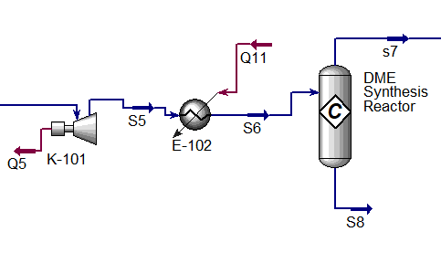
Figure 3: DME Synthesis Reactor Simulation
The auxiliaries are added due to the conditions that differs between the units.

Separation Units Simulation
The final step is DME purification done by three separation units. Firstly, the syngas is removed from methanol, water and half of the DME amount at the top stream of the distillation column, assuming the efficiency is 100%. The first distillation column is operated at $-54.27 ℃$ and 101.3 kPa. The top stream is fed into the absorption column with MEA as a solvent to purify the DME from the syngas at $T=40℃$ and P= 1 atm. The bottom stream is fed into a second distillation column to purify the DME from water and methanol at 100% assumed efficiency to be then combined, forming pure DME as shown in Figure 4.
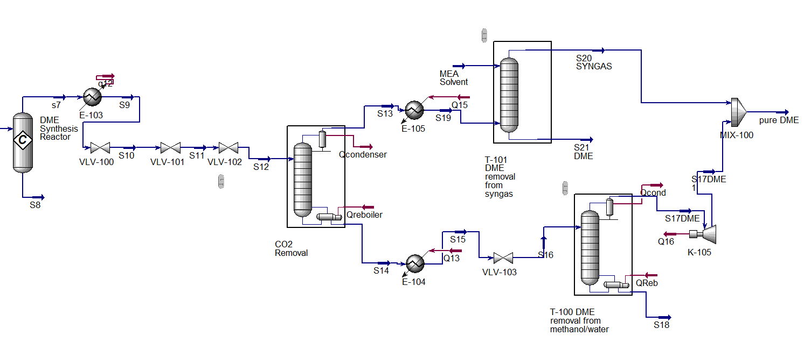
Figure 4: Separation Unites Simulation
The final conventional process for DME production is shown in Figure 5, describing each stream's operation conditions, mole flowrate and compositions.

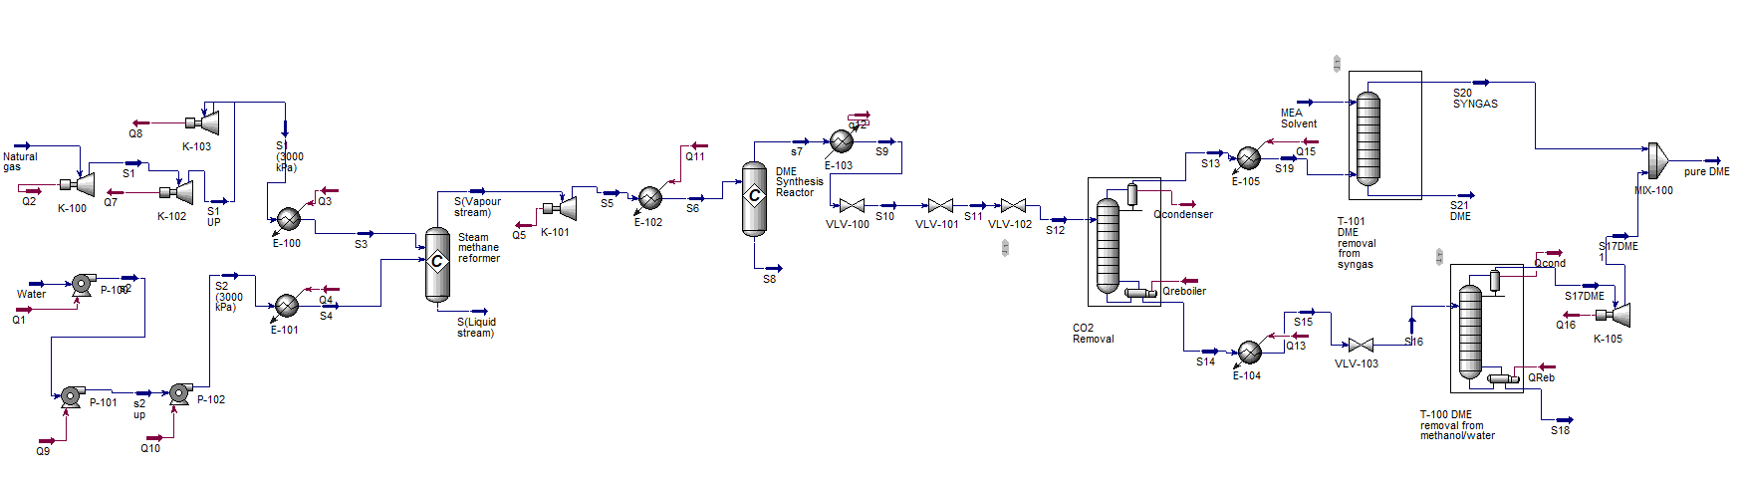
Figure 5: DME Simulation Process Without Heat Integration
Table 2: Material Streams and Operation Conditions
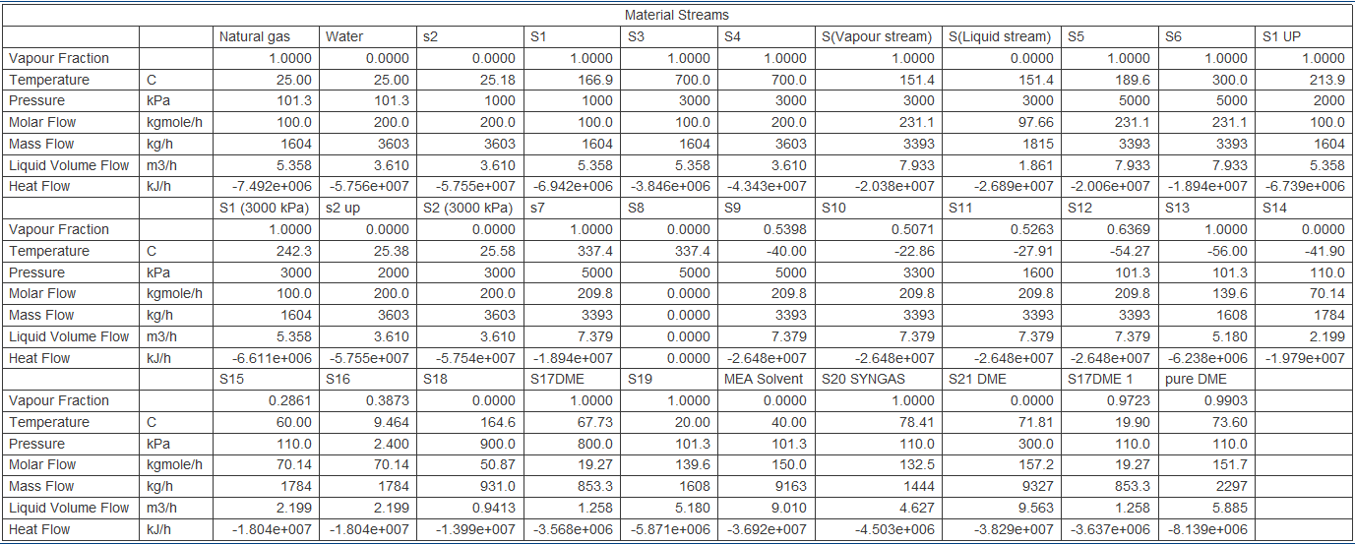

During the main process plant of dimethyl ether shown in Figure 5, around 5 heaters are causing large energy waste. Therefore, in this paper, a process optimization methodology is obtained to investigate the energy-efficient and the comparison between the processes.

Process Optimization of DME Plant
The process optimization methodology used in this paper is pinch analysis. It is an applicable method that can achieve the minimum waste energy to a feasible target by optimizing the energy supply method, heat recovery systems and the operating conditions. This paper applies the pinch analysis to the simulated DME plant by replacing the heaters with heat exchangers and reusing the hot waste streams for heating purposes. The pinch analysis starts with E-105 used as a heater for stream S13 from ($-65 to 20 ℃$). The top outlet stream of T-101 (S20 Syngas) is used as shell side inlet to heat the required cold stream into the desired value as shown in Figure 7.
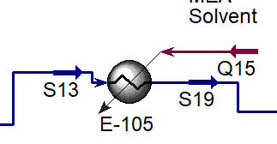
Figure 6: Heater E-105 Simulation Before Pinch Analysis
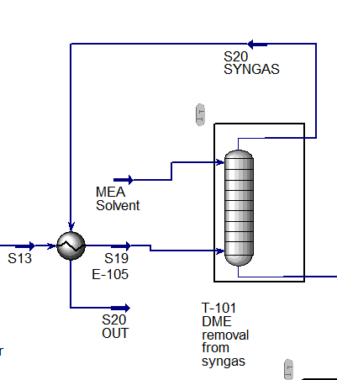
Figure 7: Heat Exchanger E-105 Simulation using Pinch Analysis
Figures 6, and 7 show the simulation of E-105 with and without pinch analysis and the difference between them by duty presence. The duty Q15 in Figure 6 has been replaced by a hot waste stream (S20 Syngas) in Figure 7 for heating purposes.
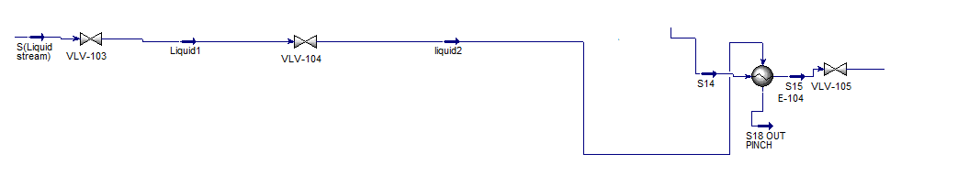
Figure 8: E-104 Heat exchanger Simulation using Pinch Analysis
As shown in Figure 8, S(liquid stream) of stream reformer is used to heat the required cold stream as shell side inlet in heat exchanger E-104.
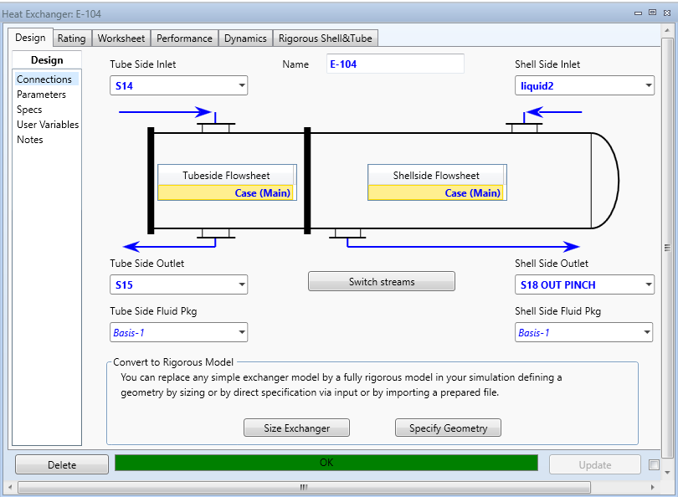
Figure 9: E-104 Heat exchanger Simulation
Only one waste hot stream remains through the DME simulation plant, that is, the bottom outlet stream of the final distillation column S18 in Figure 5. However, this stream does not apply to the remainder of heat exchangers, where it causes cross temperature during simulation. For instance, heater E-102 cannot be optimized by S18 leading to temperature cross. That means that outlet temperature of the hot waste stream is less than the outlet temperature of cold stream as shown in Figure 10.
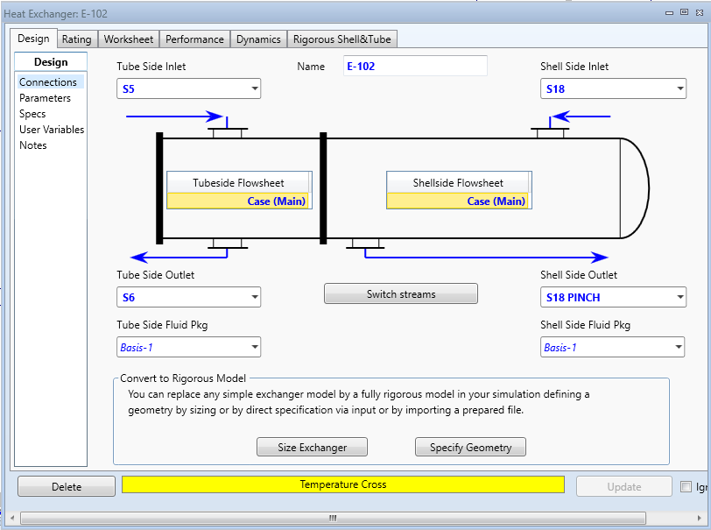
Figure 10: E-102 Simulation using S18

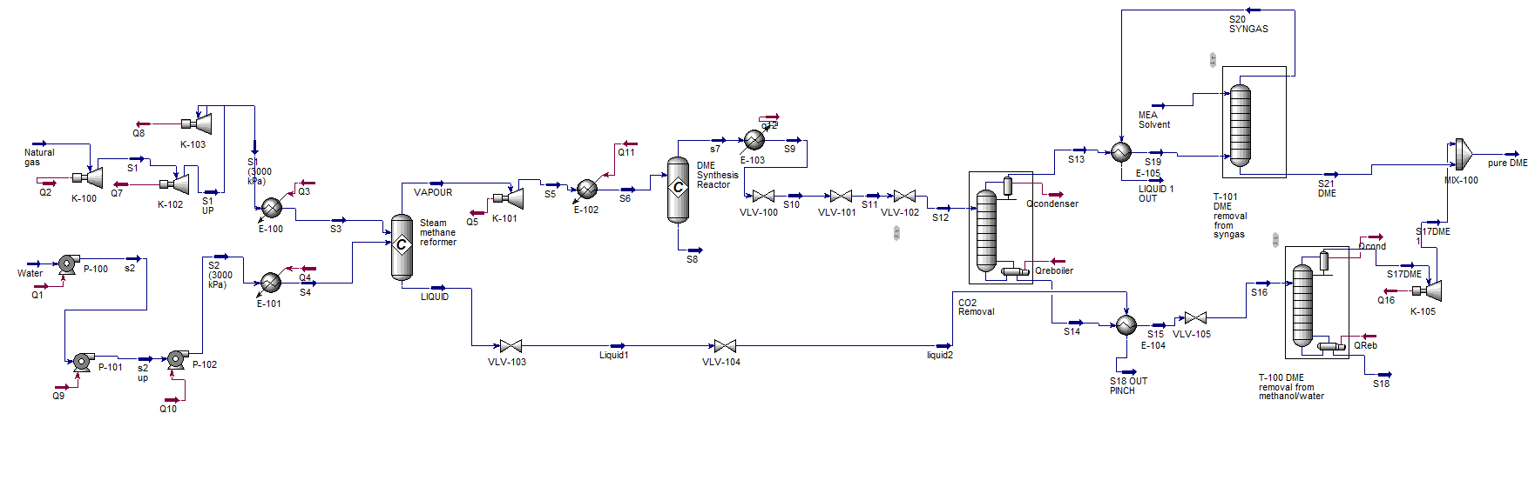
Figure 11: Simulation of DME Plant with Process Optimization

Figure 11 shows the process optimization done on the simulation plant of DME; the operation conditions, duty and the material streams are shown in Table 3.

Table 3: Operation Conditions and Material Streams of Modified Process Plant
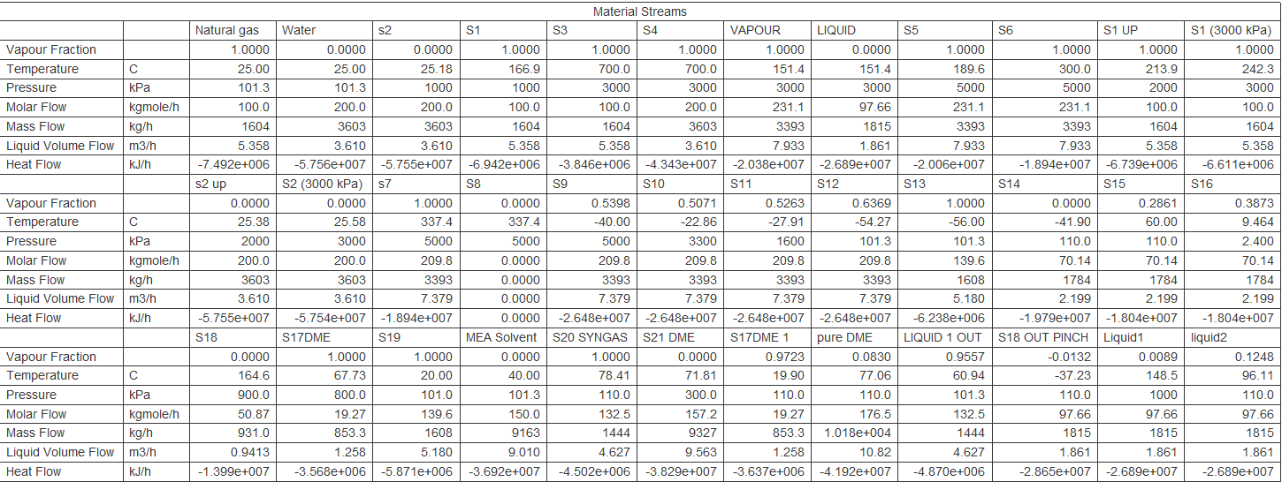

Data Analysis and Results
Process optimization has been accomplished for the dimethyl ether production plant using pinch design analysis. Significant energy and economic saving are realized from the pinch analysis in comparison with the conventional plant. It is found that the energy saving has been increased from $1.393×{10}^{7} kJ/h$ for the conventional plant to $8.5×{10}^{6}\frac{kK}{h}$ in the optimized plant. That equalizes 37.74% waste energy percentage for the conventional plant and 25% energy waste for the modified plant using pinch analysis.
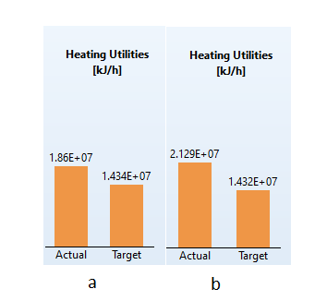
Figure 12: Heating Utility Saving (kJ/h) (a) after Pinch Analysis, (B) Before Pinch Analysis
Figure 12 indicates the actual heating utilities demand for whole process, which shows modified plant (a) is closer to the process target for heating utility than the traditional process.
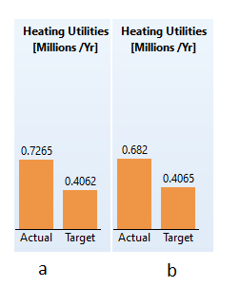
Figure 13: Heating Utility Cost Saving in (million/yr) (a) Before Pinch Analysis (B) after Pinch Analysis
From another point of view, a significant cost saving in heating utilities from pinch analysis is obtained compared to the traditional plant as shown in Figure 13. The results investigate that the optimized plant is closer to the cost saving target for the DME plant around 0.682 (million/yr) to 0.4065 (million/yr) target than the traditional plant. Furthermore, reusing the hot waste streams for heating purposes during pinch analysis made a positive reflection on the environment. It reduces the by-product emissions mainly of carbon content as shown in Figure 14.
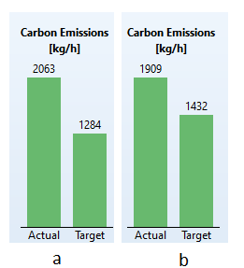
Figure 14: Carbon Emissions (kg/h) (a) Before Pinch Analysis (B) after Pinch Analysis
The different between the actual carbon emissions formed and the process target is lower by pinch analysis compared to the traditional one as shown in Figure 14. Therefore, the actual to the target ratio is lower of around 25%. Table 1, and 2 shows the data analysis of DME plant before and after pinch analysis obtained from Aspen HYSYS.
Table 4: Available Saving for Plant Before Pinch Analysis
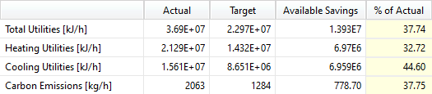
Table 5: Available Saving for Plant After Pinch Analysis
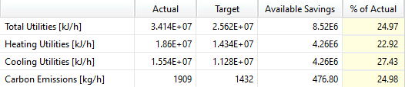
Tables 4, and 5 demonstrate the inversely proportional relationship between the saving amount and the actual percentage. The saving amount in terms of flow has been realized by many factors, heating and cooling utilities besides the carbon emissions. By the pinch analysis, the saving value has been enhanced as well as the carbon emissions have reduced. However, the actual percentage that describes how close the current value obtained in HYSYS to the target value is lower than traditional plant.

Conclusion
Direct synthesis of DME is performed to be designed in this paper considering promising chemical molecule and fuel, whose direct production from natural gas has become of significant interest in these recent years due to its high efficiency and low cost. Aspen HYSYS V.12 has been utilized in this paper to produce a DME production plant at basic feed value to be optimized by pinch analysis as a powerful tool providing highly efficient data analysis. A comparison of DME plant before and after pinch analysis has been investigated at 100 kmol/h feed natural gas. Results and data analysis showed that the introduction of pinch analysis reduces the operating cost, energy waste, cooling and heating utilities. Besides its ability to quantify and conduct the saving amount and process development. Thus, high energy efficient is achieved.

References
Alshbuki, E. & Bey, M., 2020. Simulation Production of Dimethylether (DME) from Dehydration of, Dubai, United Arab Emirates : Scholars Middle East Publishers.
Arcoumanis, C., Bae, C. & Crookes, R., 2008. The potential of di-methyl ether (DME) as an alternative fuel for compression-ignition engines: A review. Fuel, 87(7), pp. 1014-1030.
Azizi, Z., Rezaeimanesh, M. & Tohidiana, . T., 2014. Dimethyl Ether: A Review of Technologies and Production Challenges. chemical Engineering and Processing: Process Intensificatio, 82(1), pp. 150-172.
Azizi, Z., Rezaeimanesh, M. & Tohidian, T., 2014. Dimethyl ether: A review of technologies and production challenges. Chemical Engineering and Processing: Process Intensification, 82(1), pp. 150-172.
Chen, H.-J., Yu, C.-S. & Fan, C.-W., 2013. Analysis, synthesis, and design of a one-step dimethyl ether production via a thermodynamic approach. Applied Energy, 101(1), pp. 449-456.
G.Speight, J., 2019. Natural Gas. 1 edition ed. New York: Elsevier .
Khandan, N. & Kazemeyni, M., 2009. Dehydration of methanol to dimethyl ether employing modified h-zsm-5 catalysts.. Iranian Journal of Chemical Engineering, 6(1), pp. 1-9.
Laiwatthanaphaisarn, T. & Anantpinijwatna, A., 2018. Optimization of dimethyl ether production process synthesis using superstructure analysis. Bangkok, Thailand, EDP Sciences.
Makoś, P., Słupek, E. & Sobczak, J., 2019. Dimethyl ether (DME) as potential environmental friendly fuel. Gdansk, Poland, published by EDP Sciences.
Natural Resources , 2003. Pinch Analysis: For the Efficient Use. 1st edition ed. canada: Natural Resources in Canada.
Otalvaro, N., Sogne, G. & Delgado, K., 2021. Kinetics of the direct DME synthesis from CO2 rich syngas under variation of the CZA-to-γ-Al2O3 ratio of a mixed catalyst bed, Leopoldshafen, Germany: RSC Adv..

