Summary | No contact information in the basement of the site.
Component
Version | v.23.67 2009-2020
Severity | Tweek
Priority | High.
Status | New
Environment
Steps to Reproduce | 1. Go to the site  2. Pay attention to the lack of contact information in the basement of the site.
Actual Result | When going down to the basement of the site there is no contact information for communication.
Expected Result | When going down to the basement of the site there is information for communication, mail or contact number.
 | 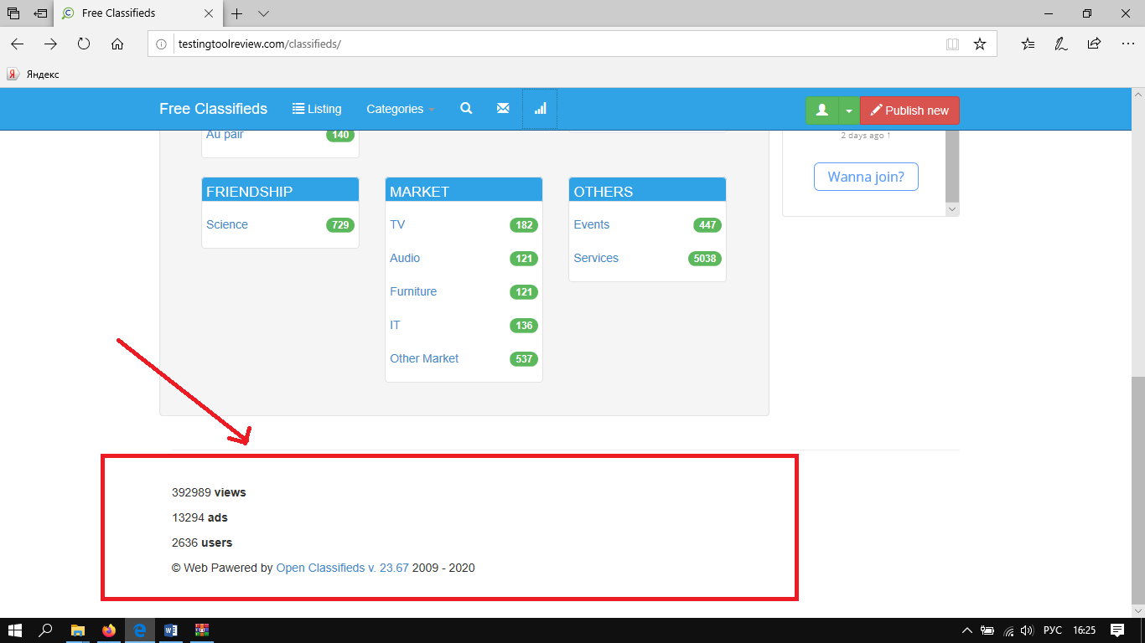

Zinchenko Polina

Summary | The inscription climbed under the icon of the user in the chat when entering the site.
Component

Version | v.23.67 2009-2020
Severity | Tweek
Priority | Not critical
Status | New
Environment | IE
Steps to Reproduce | 1. Go to the site http://testingtoolreview.com/classifieds/  2. Pay attention to user chat rooms
Actual Result | The text is hidden under the icon of the user in the chat.
Expected Result | The text is not hidden under the icon of the user in the chat.
Attachment | 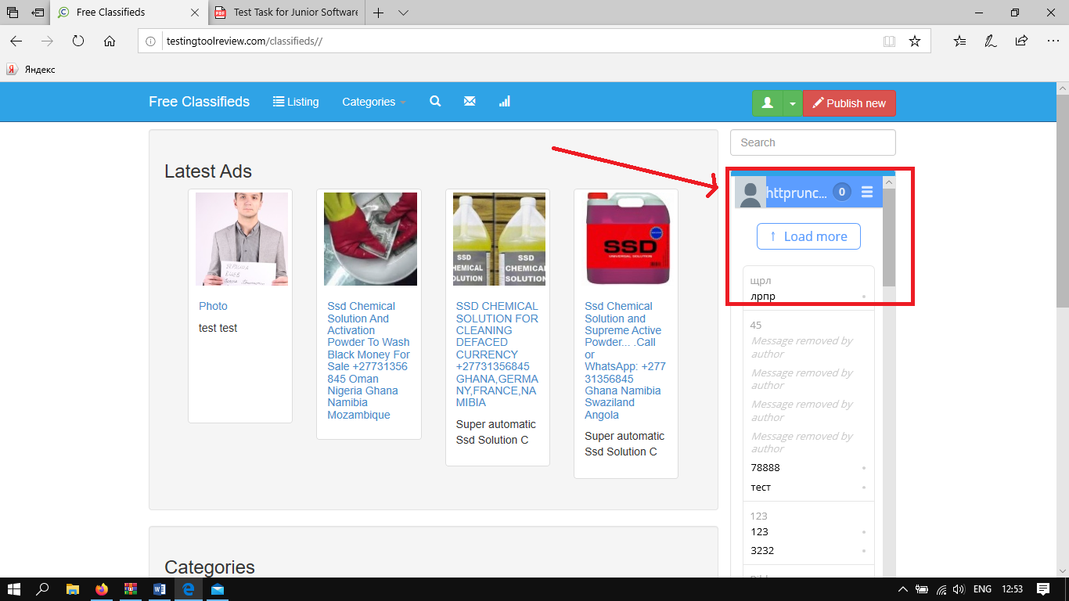
Zinchenko Polina

Summary | The selection illumination is out of range in the category department when the cursor is moved.
Component

Version | v.23.67 2009-2020
Severity | Tweek
Priority | Not critical
Status | New
Environment | IE
Steps to Reproduce | 1. Go to the site http://testingtoolreview.com/classifieds/  2. Point the cursor at any category
Actual Result | When the cursor is over the selection of content in the categories, the backlighting of the selection goes beyond
Expected Result | When the cursor is over the selection of content in categories, the backlighting of the selection does not go beyond
Attachment | 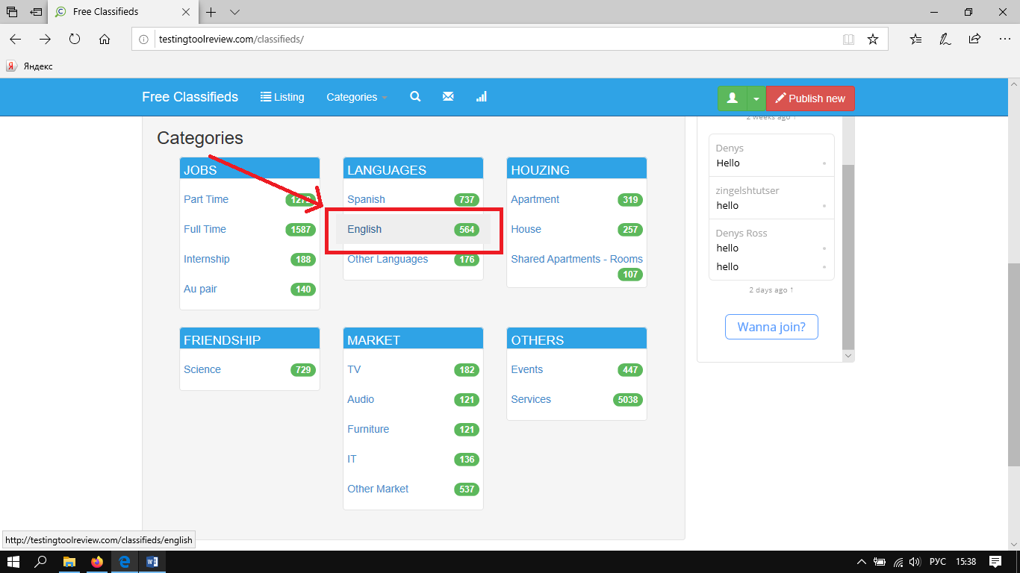

Summary | No contact information in the basement of the site.
Component

Version | v.23.67 2009-2020
Severity | Tweek
Priority | Not critical
Status | New
Environment | IE
Steps to Reproduce | - Go to the site http://testingtoolreview.com/classifieds/  - Check out the basement of the site  - Pay attention to the lack of information
Actual Result | There is no contact information when you go down to the basement.
Expected Result | When going down to the basement of the site, there is contact information
Attachment

Summary | The color of the name and user comments are different in the chat room.
Component
Version | v.23.67 2009-2020
Severity | Tweek
Priority | high
Status | New
Environment | IE
Steps to Reproduce | 1. Open the site http://testingtoolreview.com/classifieds/  2. Pay attention to user chat and color scheme
Actual Result | Color in the users' chat room will be cured in three shades.
Expected Result | Color in user chat rooms does not change randomly in three shades.
Attachment | 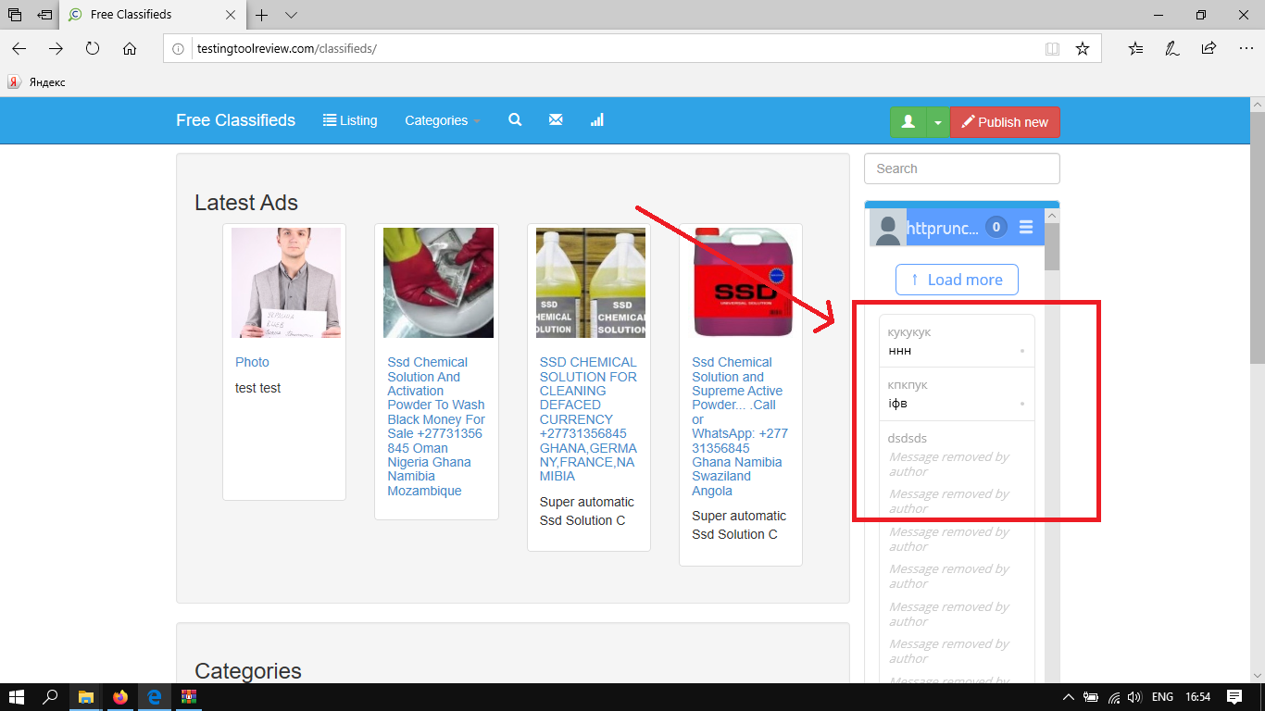

Zinchenko Polina

Summary | The logo of the site is not in the header of the site on the main page of the site.
Component
Version | v.23.67 2009-2020
Severity | Tweek
Priority | high
Status | New
Environment | IE
Steps to Reproduce | 1. Open the site http://testingtoolreview.com/classifieds/  2. pay attention to the header of the site
Actual Result | No website logo
Expected Result | The site logo is present
Attachment | 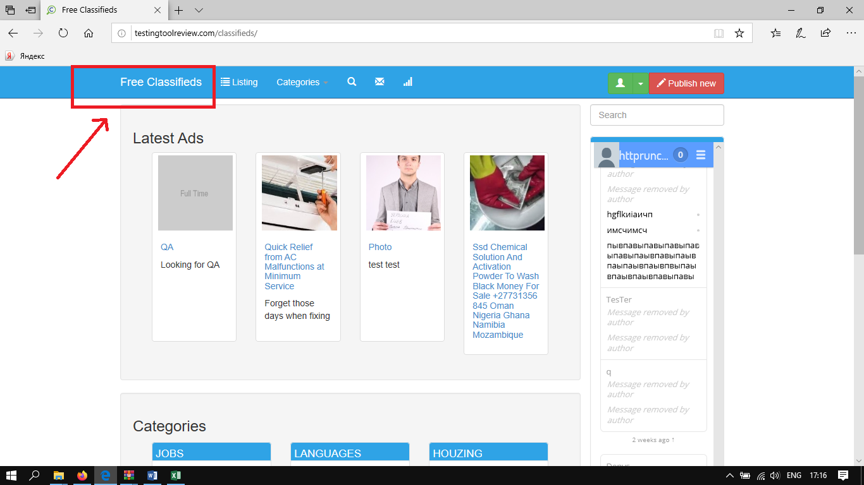

Zinchenko Polina

Summary | The text goes beyond the product description when scrolling through product pages.
Component
Version | v.23.67 2009-2020
Severity | Tweek
Priority | high
Status | New
Environment | IE
Steps to Reproduce | 1. Open the site  2. Select a product category Full Time  3. Go to the lower ads  4. pay attention to the product description
Actual Result | The description of the product goes beyond
Expected Result | The description of the product does not go beyond
Attachment | 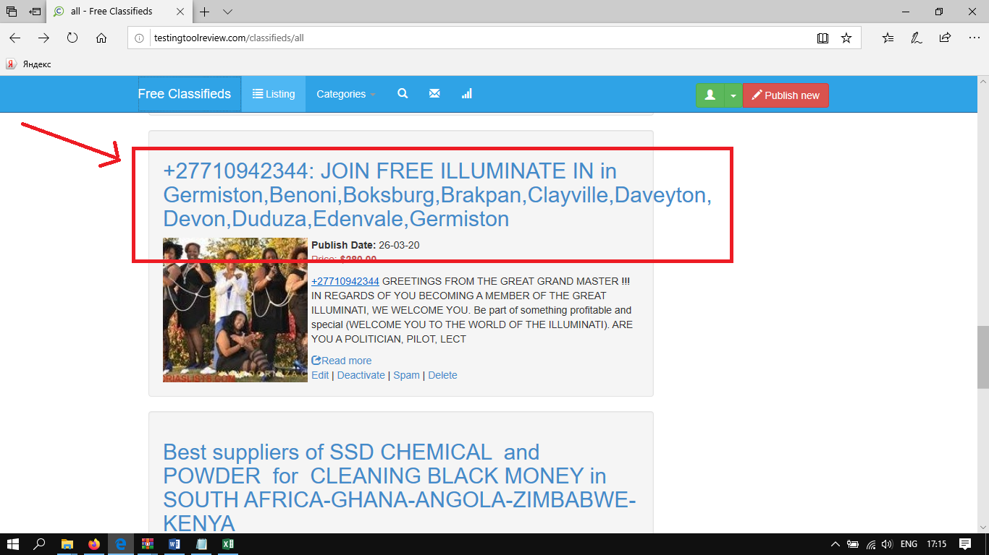

Zinchenko Polina

Summary | Content does not match the selected category on the site when selecting content.
Component
Version | v.23.67 2009-2020
Severity | Tweek
Priority | high
Status | New
Environment | IE
Steps to Reproduce | 1. Open the site  2. Choose a category  3. Pay attention to the proposed content
Actual Result | Content does not match the selected category
Expected Result | Content corresponds to the selected category
Attachment | 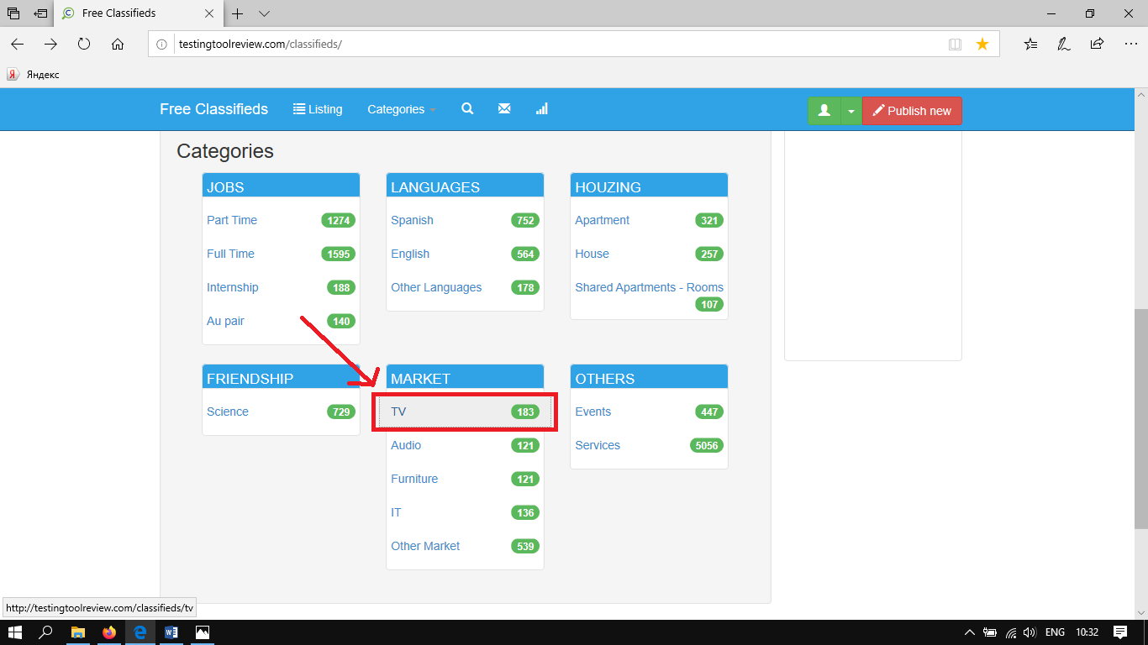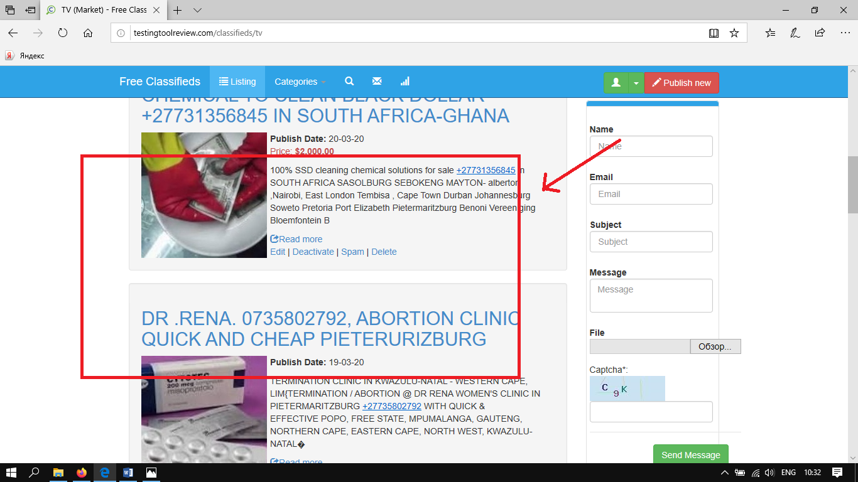

Zinchenko Polina
Summary | An error has been made in the proposed section of the house category.
Component
Version | v.23.67 2009-2020
Severity | Text
Priority | Not high
Status | New
Environment | IE
Steps to Reproduce | 1. Go to the site  2. to review the proposed houzing category  3. Pay attention to the correct spelling of this category
Actual Result | Category of the house is written with errors
Expected Result | Category of the house is written without errors.
Attachment | 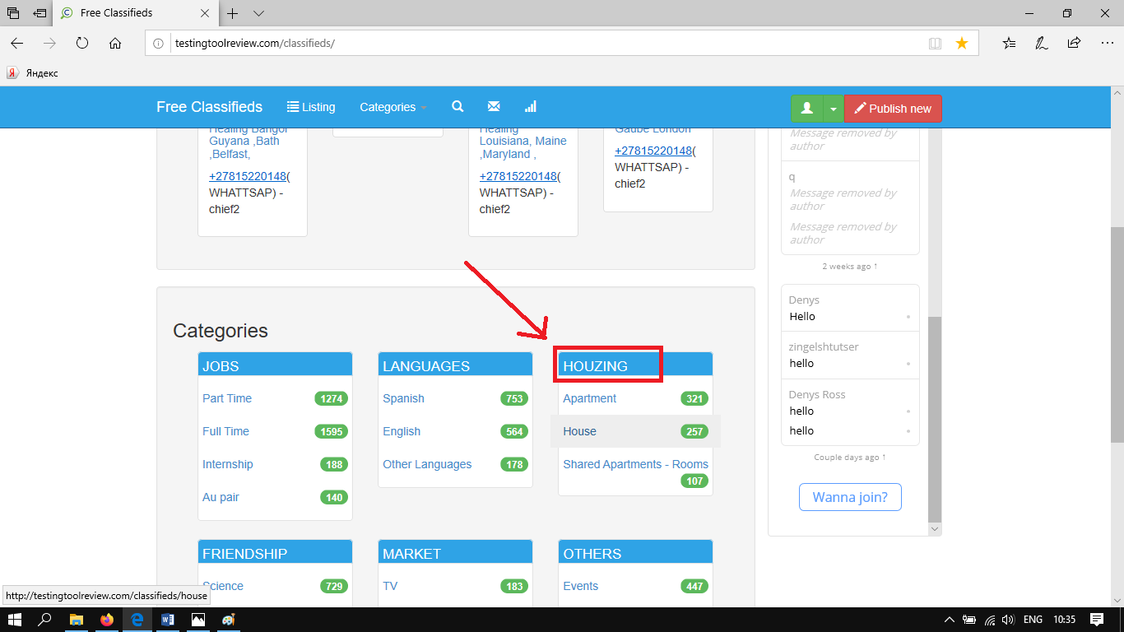

Zinchenko Polina

Summary | Сontent is repeated when selecting a category regardless of category selection.
Component
Version | v.23.67 2009-2020
Severity | Tweek
Priority | high
Status | New
Environment | IE
Steps to Reproduce | 1. Open the site  2. Choose a category  3. Review the content that produces
Actual Result | Content is repeated regardless of the selected category
Expected Result | When a certain category is selected, certain content will appear
Attachment | 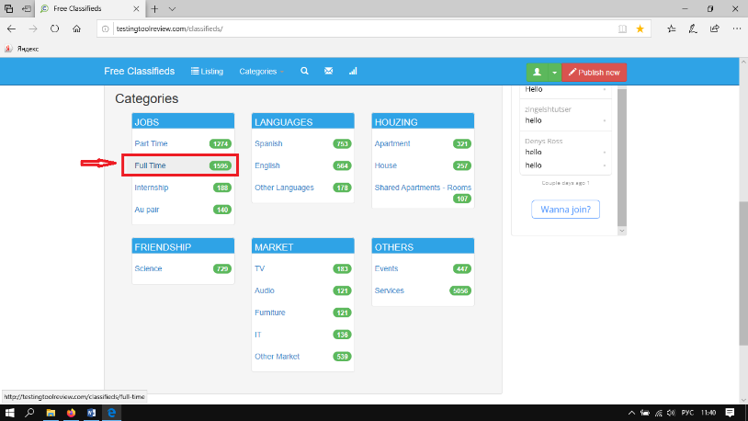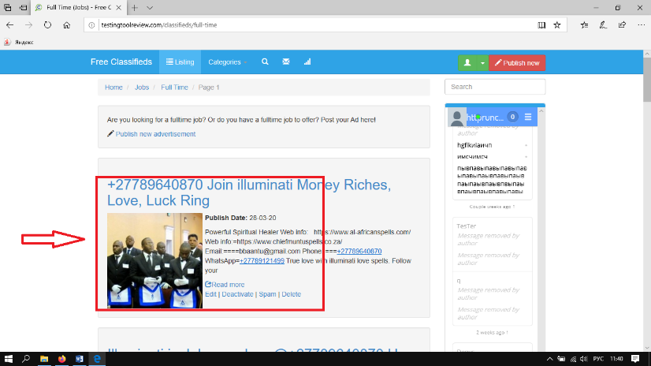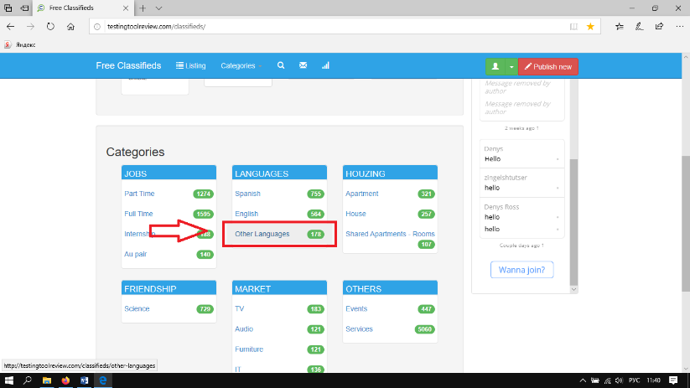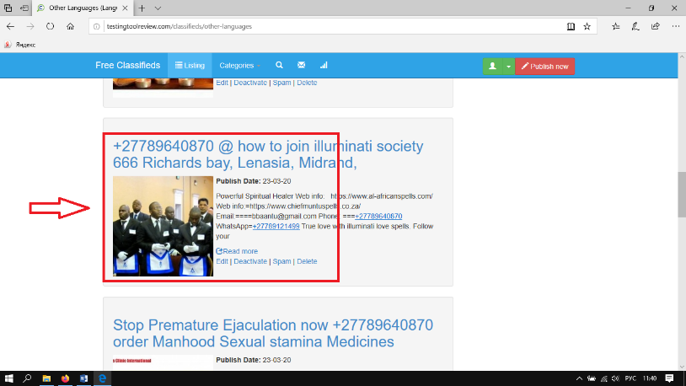

Zinchenko Polina

Summary | Does not remember re-entering the user when reloading the page after the agreement to remember the user.
Component
Version | v.23.67 2009-2020
Severity | Tweek
Priority | high
Status | New
Environment | IE
Steps to Reproduce | 1. Open the site http://testingtoolreview.com/classifieds/oc-panel/auth/login  2. Register, agree to save data for re-entry.  3. Reboot page.  4. Note that no data has been saved.
Actual Result | After filling in the data with the data storage agreement, the data is not saved when the page restarts.
Expected Result | Once the data have been filled in with the data storage agreement, the data are saved when the page is restarted.
Attachment | 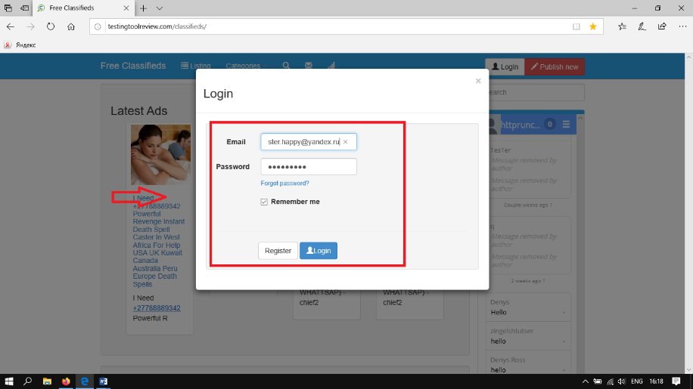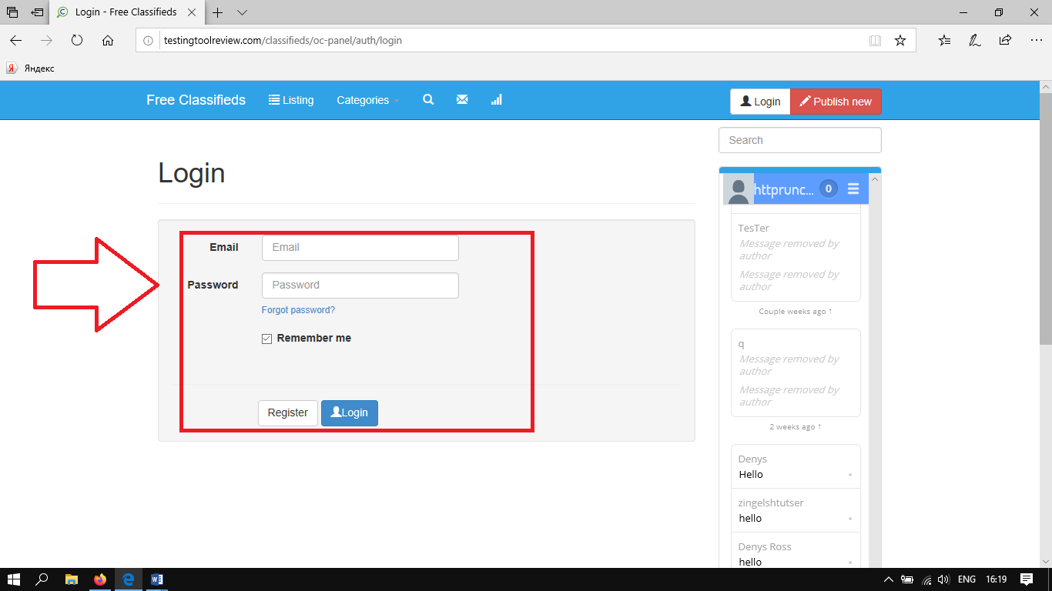

Zinchenko Polina

Summary | The icon of adding an image is out of scope in the Add news department when adding a news item.
Component
Version | v.23.67 2009-2020
Severity | Tweek
Priority | high
Status | New
Environment | IE
Steps to Reproduce | 1. Open the site  2. open the filling in form add news  3. Pay attention to the icon of adding an image
Actual Result | Icon of adding an image goes beyond.
Expected Result | Icon of adding an image does not leave a frame.
Attachment | 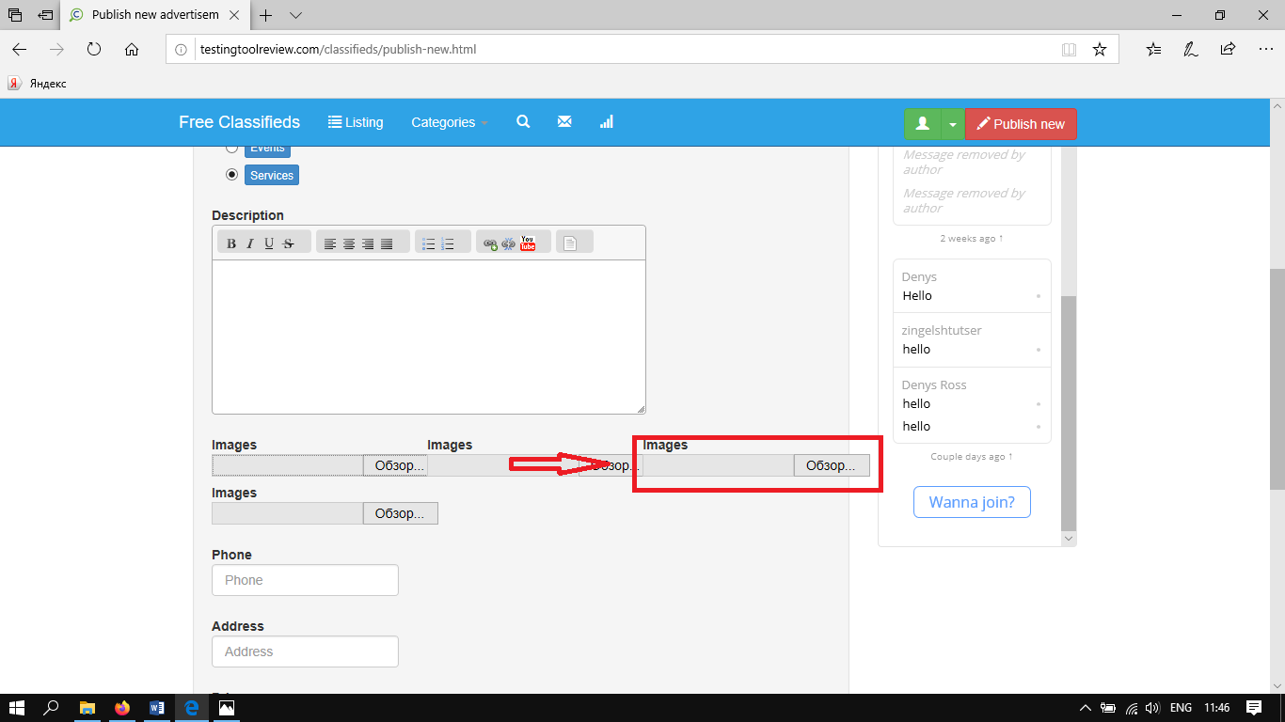

Zinchenko Polina

Summary | The login prompt hides under the browser panel when pointing the cursor at the login. Always .
Component
Version | v.23.67 2009-2020
Severity | Tweek
Priority | high
Status | New
Environment | IE
Steps to Reproduce | 1. Open the site  2. Point the cursor at the login.  3. Pay attention to hiding a clue.
Actual Result | The login prompt hides under the browser panel.
Expected Result | The login hint is not hidden under the browser panel.
Attachment | 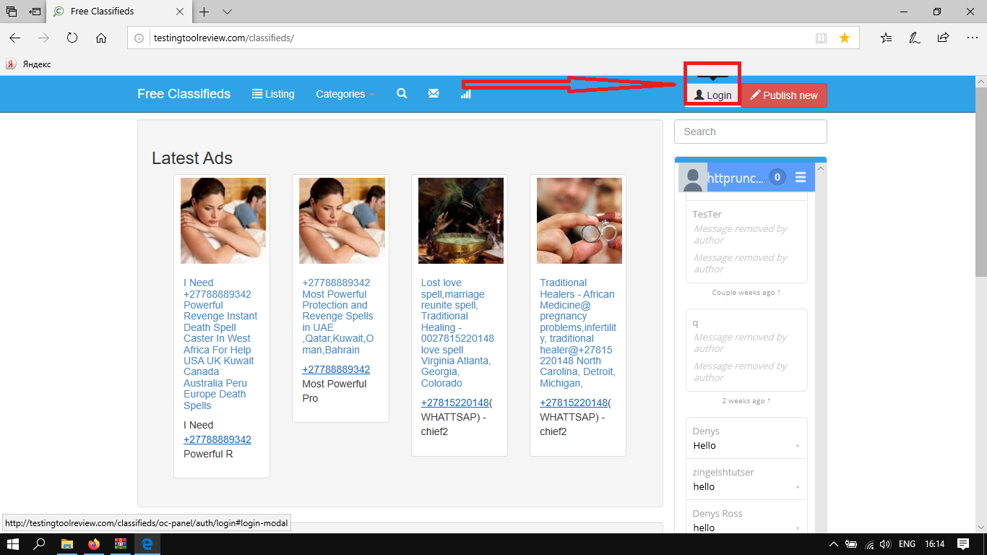

Zinchenko Polina

