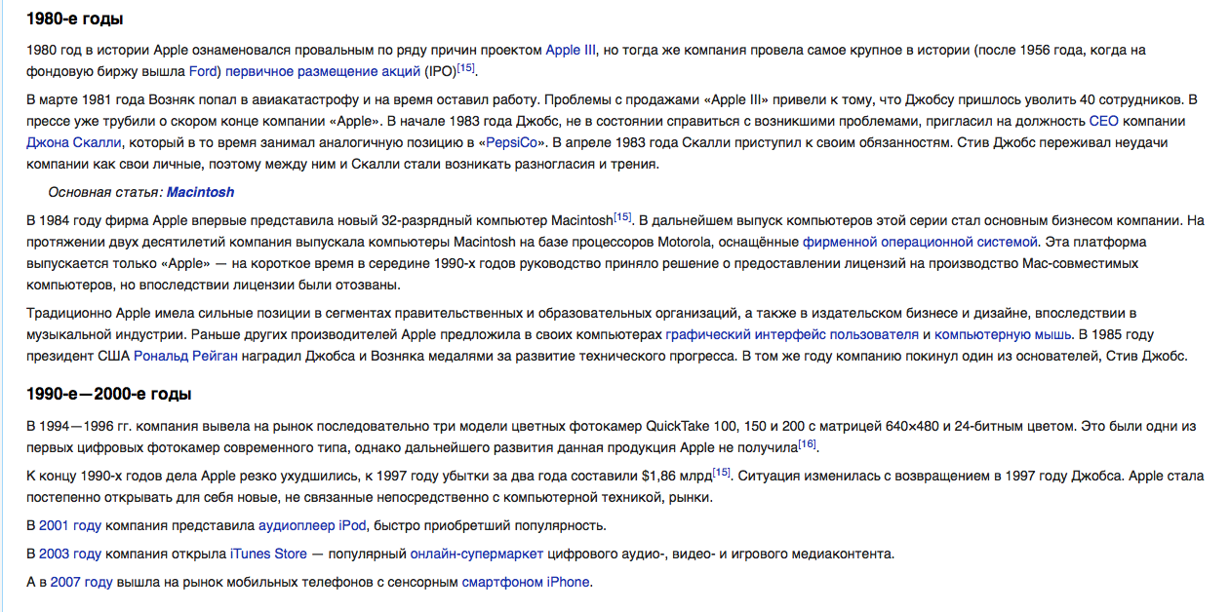
1980s
1980 in the history of Apple was marked by the failure of the project Apple 3 for several reasons, but at the same time the team conducted the largest in history initial public offering.(IPO)
In March 1981 Wozniak got in a plane crash and stopped working for a while. Jobs had to fire 40 workers because of the problems with “Apple3” selling. The press had already been yelling about the imminent end of the “Apple” company. At the beginning of 1983 Jobs wasn’t able to deal with all of the problems, so he invited John Scully on a CEO position in the company, who at that time held an analogical position at “PepsiCo”. In April 1983 Scully got started with his duties. Steve Jobs worried about company’s problems the same way as he did for his private ones, therefore some disagreements started to arise between him and Scully.
In 1984 Apple released new 32-bit computer Macintosh for the first time. Production of this computer series subsequently became the main business of the company. Apple was producing Mac computers based on Motorola processor, equipped with proprietary operating system for two millennia. This platform is produced by Apple only – for a short time, in the middle of 1990s, management decided to require licenses for the production of Mac-compatible computers, but eventually the licenses were revoked.
Traditionally, the company had a strong position in the segments of government and educational organizations, as well as in publishing business and design, later in the music industry. Before other manufacturers, Apple offered a graphical interface and a computer mouse in their computers. In 1985 USA president, Ronald Reagan awarded Jobs and Wozniak with medals for the development of technical progress. In the same year Steve Jobs, one of the founders, left the company.
1990s-2000s
In 1994-1996, the company introduced to the market three models of colour cameras QuickTake 100, 150 and 200 with a 640x480 matrixes and 24-bit colour. These were one of the first digital cameras of the modern type, however this Apple product didn’t get the further development. The company’s business sharply got worse by the end of the 1990s and by 1997 the losses for two years amounted to 1.86 billion dollars. The situation changed with Jobs’ return in 1997. Apple gradually started to reveal new markets, which weren’t directly connected to computer technics.
In 2001 the company released iPod audio player, which quickly became popular.
In 2003 the company opened iTunes Store, popular online supermarket of audio, video and gaming media content.
And in 2007, “Apple” entered the mobile phone market with an iPhone touchscreen smartphone.

