
7 Effective Ways to Increase User Engagement
There are many ways to attract potential customers to your mobile app. However, this is not enough. A well-built sales strategy includes ways to keep users' attention. In this article, you will learn 7 effective strategies to keep your audience interested in your product. They will help increase user engagement and fuel their interest in your services.
How to Improve User Engagement: 7 Proven Strategies to Follow
According to statistics, people devote third of waking time to mobile apps. The average user uses apps for about four hours a day. Despite this, keeping the attention of the target audience is not an easy task for developers and marketers. Even if you have created a unique and interesting product, you risk losing up to 60% of users in the first month. To avoid this, you need to carefully consider how you interact with the client. Then you will receive not only his loyalty but also positive recommendations that will lead to new subscriptions. Developing a mobile or web application is a constant struggle with competitors. And engagement strategies will help you win.
What are the stages of implementation of engagement strategies? Competent developers of mobile and web applications think over the mechanisms for the best involvement of users already at the development stage. Then the marketing department continues to work on audience engagement. And only with the interaction of developers and marketers can you get a good result. So, let's take a closer look at the best engagement strategies.
1. Simplify Registration Process
This issue should be considered at the design stage. The task of the developer is to make the procedure for getting to know a web or mobile application simple and understandable. Creating a username or login should not be difficult for the user. Here we advise you to consider authorization options through:
- Google email
- using an Apple ID
- through social networks (Facebook, Twitter, Instagram)
The user wants to start using the application as soon as possible. Therefore, at the registration stage, exclude all additional fields.
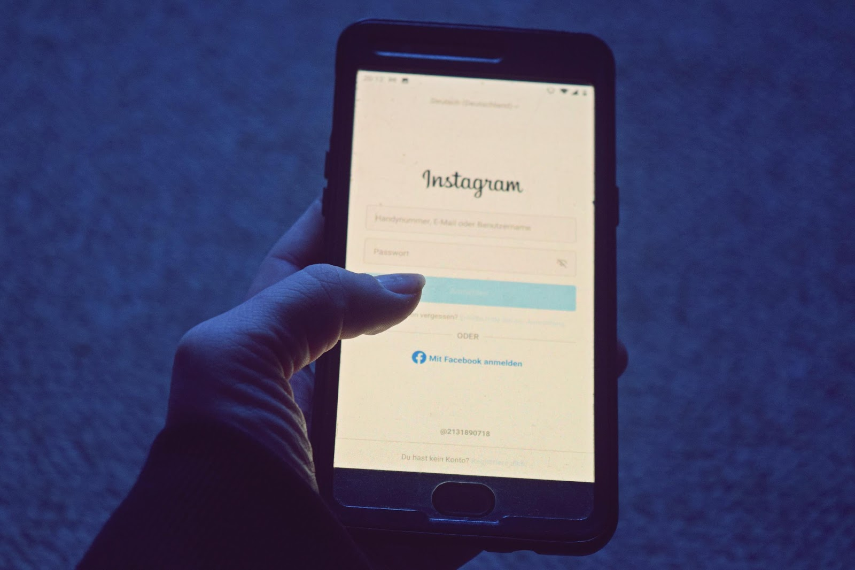
Consideration should be given to staying logged in when the app is closed, using, for example, Face ID or a short PIN for quick access to the app. Your main task is to give the user access to the maximum number of useful features of your product already at the initial stage. And the authorization process should not interfere with it.
2. Improve User Experience
Onboarding is an instruction that teaches the user to work with the program. This is an important factor to increase user engagement in app. Remember that the average user cannot figure out the interface on their own. Therefore, he needs the most detailed instructions. With it, he will immediately evaluate the capabilities of the product and make a decision to leave or stay.
For onboarding to be effective, follow these rules:
1. Create high-quality visual slides, without unnecessary information. Quickly get the person up to speed - give them a quick guide that can be flipped through in a couple of seconds. This will show your respect for the user's comfort and time.
2. Choose the key features of your product and focus on them. On the slides, show only the basic features, and let the client figure out the additional ones on their own.
3. Don't forget the "Skip" feature. Part of your audience has already used similar applications. Therefore, allow experienced users to skip onboarding in part or whole.
It is very good if onboarding takes place in an unobtrusive game form. This should be facilitated by both the design of the application and text instructions.
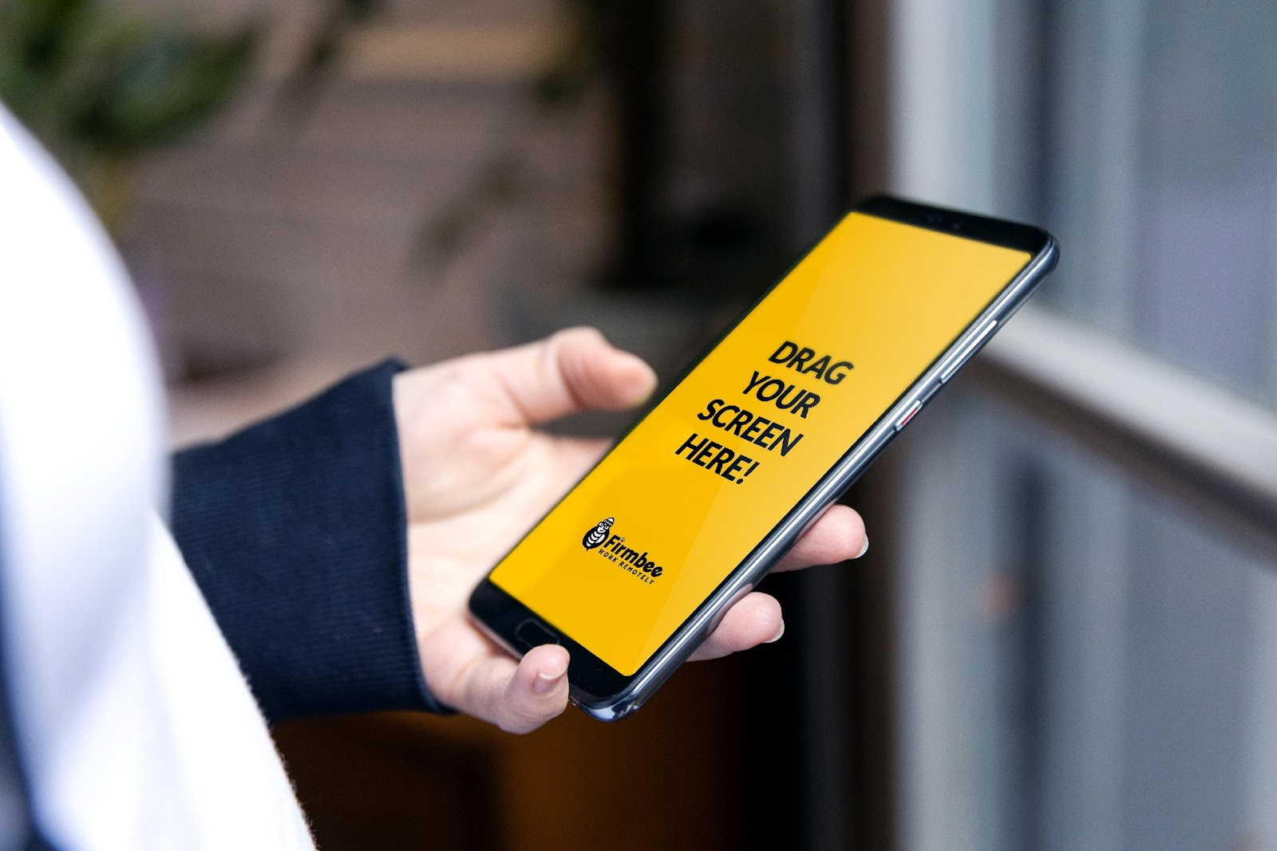
3. Add Gamification Elements
Gamification is the backbone of modern marketing. Game elements have increased the popularity of applications from various categories. Vivid examples are the Duolingo language learning platform, the MyFitnessPal sports motivator, the Todoist task management service, and others.
Popular gamification methods:
- reward systems with points or bonuses;
- daily game tasks;
- badges of achievements;
- quizzes with prizes;
- countdown to an important event, etc.
It is also important to combine virtual and material rewards, then you will be able to achieve high customer engagement.
4. Use Personalized Push Notifications
By using push notifications, you invite the user to a dialog. In order for this dialog to interest the client and not be intrusive, use them only in cases where he has not appeared in the application for a long time, has an unfinished target action, or wants to ask a question. Push notifications should be personalized. Address the client by name, remind him of his preferences, offer a product that he was interested in, etc.
5. Create Engaging Content
Useful content in mobile and web applications is very important. An additional method of involvement can be e-mail marketing. It can include a welcome letter, a description of the uniqueness of the product, user success stories, onboarding, etc.
In the application, be sure to enter a section with positive reviews. They should be a truthful and understandable concentration of the benefits that each user will receive through your program.

6. Develop Reward System
Reward programs are an effective engagement tool that comes from network marketing. It may include bonuses for new registrations through affiliate links. The principle of such a program is: bring a friend - get a reward for it. The incentive can also be a rank-up system. Thus, you will not only stimulate the interest of already active users but also attract new customers.
7. Integrate Additional Features Gradually
Do not try to implement all your ideas at once. Even the most perfect application requires an upgrade. Therefore, implement improvements gradually, regularly informing users about it. It is good to blog on this topic, filling it with expert content. Also, include updated topics in the email newsletter and push notification system. But this information should not be much for the user. And it should be as practical as possible. For example, in gaming applications, it is important to communicate about updates and what functional changes they bring.
Final Thoughts
User engagement can be measured in different ways. For a given period, it is necessary to determine how many users downloaded the application and how many of them regularly accessed it. And even better - performed a targeted action. It is also important to look at the duration of the session and the intervals between visits for individual users. For each application, engagement calculations will be individual. The same goes for audience engagement.
The choice of methods depends on the specifics and subject matter of the application and its target audience. It is not necessary to use all the methods described in this article at once. But it is important to analyze together with specialists which of the techniques are suitable specifically for your project, and implement them at any stage of work on your product.

