
PARTNERSHIP
END OF YEAR REPORT

І. GENERAL INFORMATION
1. Name of Project: New Life Rehabilitation Center - for drug addicts, alcohol addicts, people in difficult life circumstances, men released from prisons, alcohol and drug addicted veterans of Anti-terrorist operation, Environmental Defense
2. Year 2020
3. Name of Director Kozhukhar Mykhailo Valeriievych
4. History of cooperation with SMU: Since 2005, the Samaritan Mission has handed over a house and an adjoining area with outbuildings to the Victory Christian Church for the rehabilitation and further resocialization of men with various addictions.
5. Mission Statement: Proverbs 24:11 “Save those who are put to death, and those who are about to be put to death, will you not support them?
ІІ. FINANCIAL REPORT
The amount of the grant received 2640$
How it was used:
№ | category | amount | Short description
1 | Stipends for assistant | 720$ | Artem Kalinichenko will receive $ 60 a month as a livestock assistant.
2 | Mentors | 720$ | Assistant mentors receive $ 60 a month. Distributed according to their needs (payment for energy, food, medicine and other needs)
3 | Repairs | 500$ | Used to repair the resocialization center
4 | New heating | 700$ | Used part of the funds from the Foundation for new heating in order to make repairs in the shower room and purchase equipment
possible categories: transport, medicines, food, salary, office, etc.
Comment:_________________________________________________________
ІІІ. NARRATIVE INFORMATION
- Please comment on the current state of the project and how it is proceeding.
At present, 28 people have applied to us for help, 5 of them have completed the rehabilitation course, 2 people have graduated from the resocialization center, and 5 people are undergoing the resocialization course. The center is also engaged in the development of subsidiary farming in the field of animal husbandry (cows, goats, pigs), poultry farming (chickens, Hindus). We produce cheese and cottage cheese with their subsequent sale in Zhytomyr.
Next year we plan to raise the center's team to 7 (seven) people for each day of the week, the leader of the resocialization center, the leader of the chaplaincy service at the center. We also plan to sign memoranda with the social services, the Ministry of Veterans, the purpose of which will be to send people with various addictions for rehabilitation at our center
- Please attach at least two testimonies with corresponding photos.
A) This year we were approached by our graduate brother, who is a member of the Baptist Church in Kyiv, so that we could take Maxim, an orphan with a complex form of cerebral palsy (we don`t know the diagnosis), who found himself on the street after the disbandment of the specialized center for such people, at the moment Maxim has already begun to speak a little, read the Bible, serve himself and this is a miracle from God. We plan to make a group on disability.
B) My former acquaintance, who was very skeptical about our ministry and repeatedly stated this, turned to us for help because his son abuses drugs and has a pharmaceutical addiction. His son Oleg underwent a 6-month rehabilitation course, is now undergoing resocialization, serves as an assistant mentor, cooks cheese from the milk of our cows.
C) At this stage we have one adult and two young cows, we plan to buy another by the end of the year. Due to this, the center is provided with milk, cheese and cottage cheese are produced, part of the funds from their sale goes to provide the center

3. Please add 2 photos giving an overview of the project.
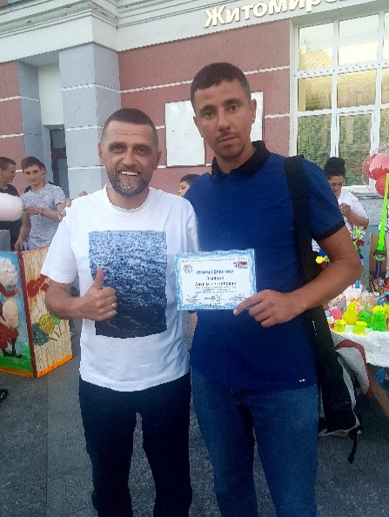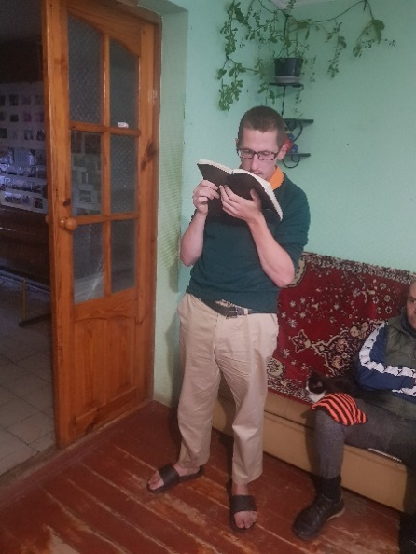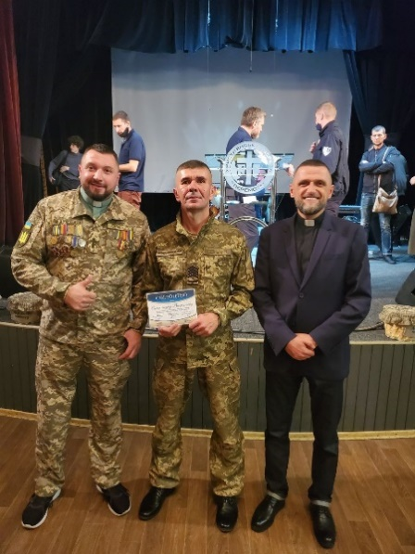
4. Please describe the spiritual idea of ​​your project.
The spiritual idea of ​​our project is the freedom from the destructive power of dependence in the lives of Ukrainian men given by Jesus Christ, their further resocialization in society and entering into a vocation from God.
Jn 8:36 "So if the Son sets you free, you will truly be free"
1Pet 2:21 "For to this you were called, because Christ also suffered for us, leaving us an example, that we should follow in His footsteps."
5. Please provide any other information you consider valuable to us.
Your help and support is very valuable to us, given the rather difficult economic situation in Ukraine, we look forward to the close cooperation of the ICF in the service of rehabilitation. According to UN forecasts, next year Ukraine will have a major recession in 10 years, 9 million citizens will remain below the poverty line.

Signature
Date

