Unique: 96,46%. https://1text.com/plagiarismchecker/65b39880d161c.
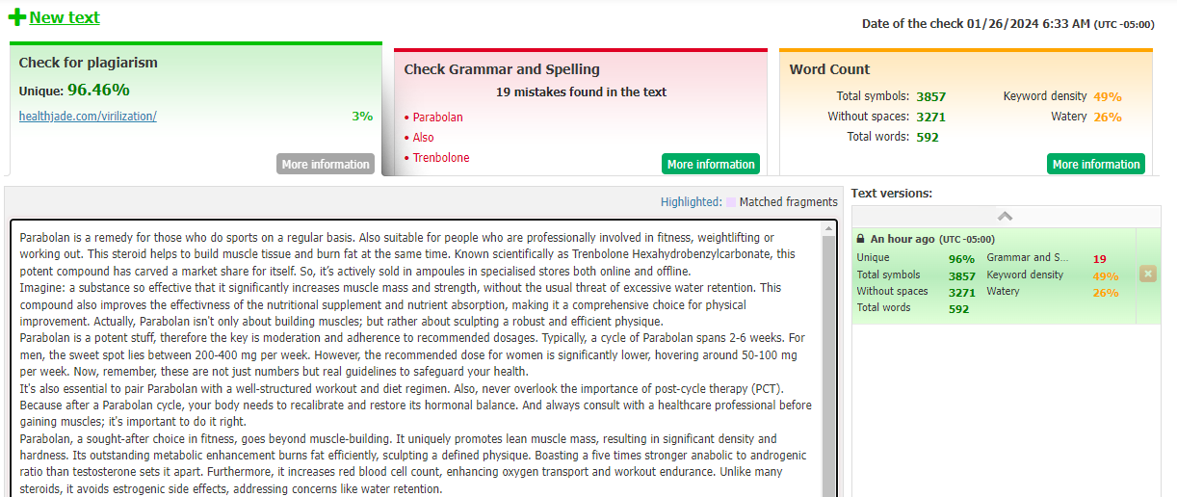
AI-generated: 0%.
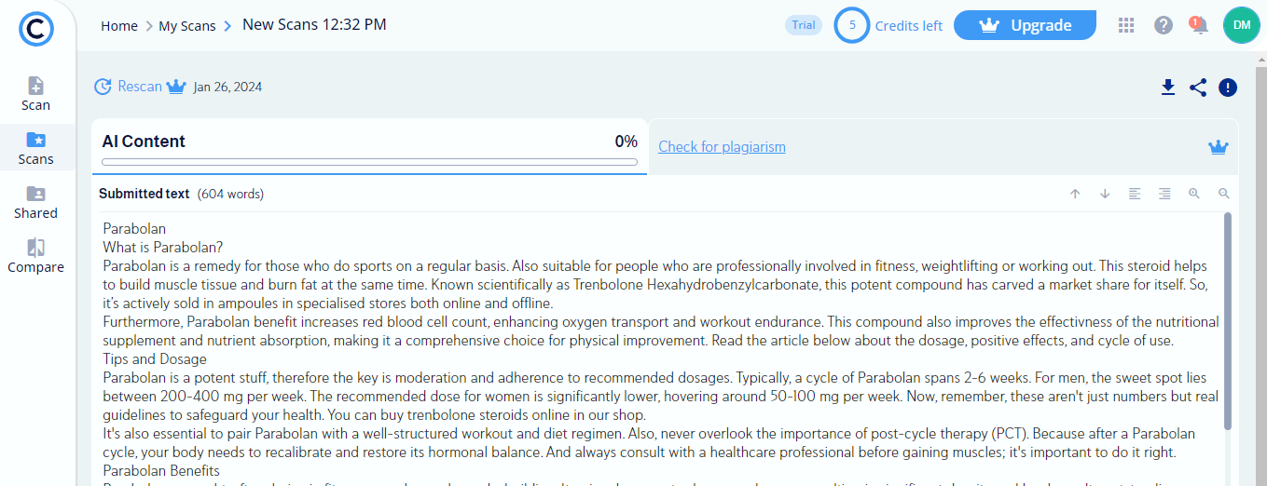
Keywords:
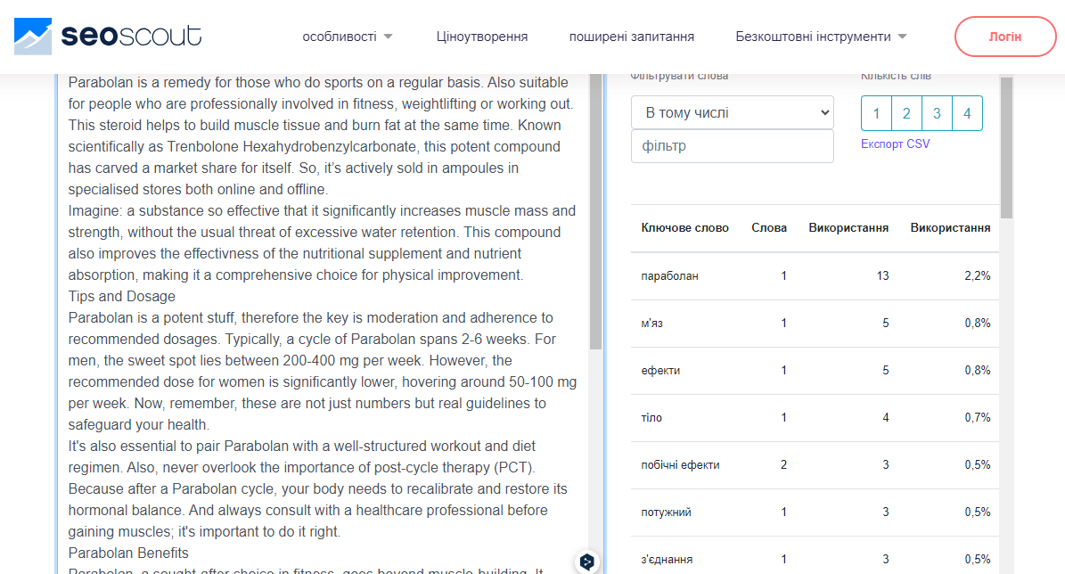

Parabolan

What is Parabolan?
Parabolan is a remedy for those who do sports on a regular basis. Also suitable for people who are professionally involved in fitness, weightlifting, or working out. This steroid helps to build muscle tissue and burn fat at the same time. Known scientifically as Trenbolone Hexahydrobenzylcarbonate, this potent compound has carved a market share for itself. So, it’s actively sold in ampoules in specialized stores both online and offline.
Furthermore, Parabolan benefit increases red blood cell count, enhancing oxygen transport and workout endurance. This compound also improves the effectiveness of the nutritional supplement and nutrient absorption, making it a comprehensive choice for physical improvement. Read the article below about the dosage, positive effects, and cycle of use.

Tips and Dosage
Parabolan is a potent stuff, therefore the key is moderation and adherence to recommended dosages. Typically, a cycle of Parabolan spans 2-6 weeks. For men, the sweet spot lies between 200-400 mg per week. The recommended dose for women is significantly lower, hovering around 50-100 mg per week. Now, remember, these aren't just numbers but real guidelines to safeguard your health. You can choose Parabolan for sale or buy trenbolone steroids online in our shop.
It's also essential to pair Parabolan with a well-structured workout and diet regimen. Also, never overlook the importance of post-cycle therapy (PCT). Because after a Parabolan cycle, your body needs to recalibrate and restore its hormonal balance. Always consult with a healthcare professional before gaining muscles; it's important to do it right.

Parabolan Benefits
Parabolan, a sought-after choice in fitness, goes beyond muscle-building. It uniquely promotes lean muscle mass, resulting in significant density and hardness. Its outstanding metabolic enhancement burns fat efficiently, sculpting a defined physique. Boasting a five times stronger anabolic-to-androgenic ratio than testosterone sets it apart. Unlike many steroids, it avoids estrogenic side effects, addressing concerns like water retention.
Interestingly, if you test your blood for the presence of this drug, it won’t be detected. It's not merely a derivative of nandrolone. Parabolan's impact on muscle endurance and recovery benefits athletes in rigorous training. The compound's role in nitrogen retention amplifies muscle growth, solidifying its desirability. Imagine: a substance so effective that it significantly increases muscle mass and strength, without the usual threat of excessive water retention.

Side Effects
However, it's essential to address the side effects of Parabolan. The most notable is its potent androgenic effects, which can lead to:
- acne,
- hair loss in those predisposed to male pattern baldness,
- body hair growth.
Women might experience virilization symptoms like deepening of the voice and increased body hair.
Remark: virilization is a condition in which a woman develops signs associated with male hormones.
Parabolan can significantly impact cholesterol levels, which could potentially lead to cardiovascular issues. It suppresses the natural production of testosterone, making post-cycle therapy necessary to help the body restore hormonal balance.
When used in high doses and/or for a long time, there is a risk of toxic effects on the liver. Compared to other nutritional supplements of this type, the risk is lower, but it cannot be ruled out completely.

Conclusion
Quality supplements can be bought in our store. We provide fast and reliable delivery of the best injectable steroids for sale. You can use the augments you need according to your training plan and in consultation with your doctor. But this should not be the only thing that helps you reach your goal: eat right, take breaks between workouts, and do not take any supplements without consulting a professional. Actually, if you buy Parabolan, you're not only building muscles; but rather sculpting a robust and efficient physique.

