Test Case

Test Case № 1 Authorization
Negative
Action : 1) Open page login
2) Input email and password
3) Button login is not pressed
Expected results: 1) Opens the login / password entry window with the appropriate fields for input, the "Login" button
2) Login to the system was successfully completed.
Test results: failed (screenshot № 1)

Test Case № 2 Loading
Positive
Action : 1) Run the game
Expected results: 1) The game will start
Test results: Passed

Test case № 3 Options
Positive
Action : 1) Go to the game
2) Click options
Expected results: 1) The game will start
2) Options will open
Test results: Passed

Test case № 4 Audio check
Positive
Action : 1) Open Options
2) Drag the slider to the left - turn off the music
3) Drag the slider to the right - turn on the music
Expected results: 1) Options are displayed.
2) Music will be on or off
Test results: Passed
Test case № 5 Button Help
Positive
Action : 1) Open Help
2) Drag the slider down
3) We press the button ok
Expected results: 1) The slider will lower
2) The button will click
3) Let's go back to the menu
Test results: Passed
Test case № 6 Player name
Positive
Action : 1) Click to change player
2) Enter a new name
Expected results: 1) The player change menu opens
2) To change the name, enter a new name.
3)Successfully created
Test results: Passed
Test case № 7 Players ( saving data after player change)
Positive
Action : 1) Push the button player change
2) Change to another
3) Go to the game
Expected results: 1) Players menu opens
2) Changed player's name
3) Entering the game, we get to the first level
Test results: Passed

Test case № 8 Cleaning the Hall of Fame
Positive
Action : 1) We go to the Hall of Fame
2) Push clean
Expected results: 1) Entrance to the Hall of Fame
2) Clear successfully
Test results: Passed

Test case № 9 Hall of Fame ( check for saving records)
Negative
Action : 1) We go to the Hall of Fame
Expected results: 1) Entrance to the Hall of Fame
2) Data will be saved
Test results: Failed ( screenshot № 2)

Test case № 10 Authors
Negative
Action : 1) Click on the authors button
Expected results: 1) A window with a description opens
2) List of authors
3) Graph Design does not meet the standards ( text position shifted)
Test results: Failed ( screenshot № 3)

Test case № 11 Spelling mistake ( trivial)
Negative
Action : 1) Click to start the game
2) Read the dialogue
3) Click Next
Expected results: 1) Opens the dialog box
2) The following page is opened
3) No mistakes
Test results: Failed ( screenshot № 4)

Test case № 12 Gameplay ( checking clickability)
Positive
Action : 1) Push start
2) We check the clickability for possible positions
Expected results: 1) Run level
2) All positions are clickable
Test results: Passed

Test case № 13 Gameplay ( time and money)
Positive
Action : Push start the level
Expected results: 1) Level will start up
2) At the end of time and collected money, the level will pass
Test results: Passed

Test case № 14 Statistics
Positive
Action : Let's open the game statistics
Expected results: 1) Statistics will open
2) The data will be displayed
Test results: Passed

Test case № 15 Exit the game
Positive
Action : Push Exit
Expected results: 1) Application closes
2) Everything works fine
3) Data saved
Test results: Passed

Screenshots

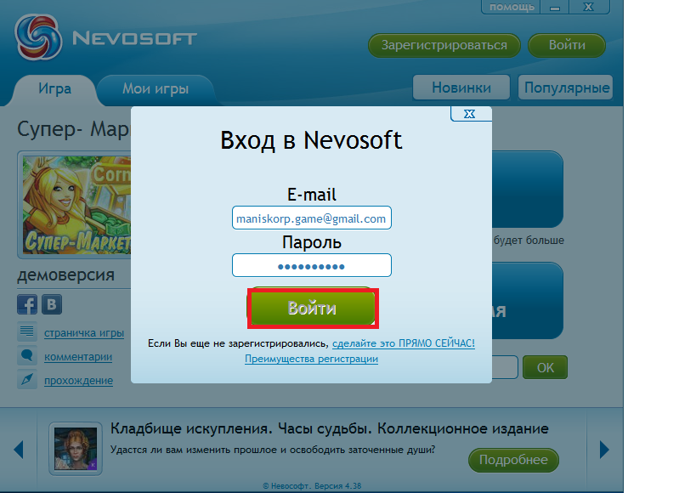
Screenshot № 1

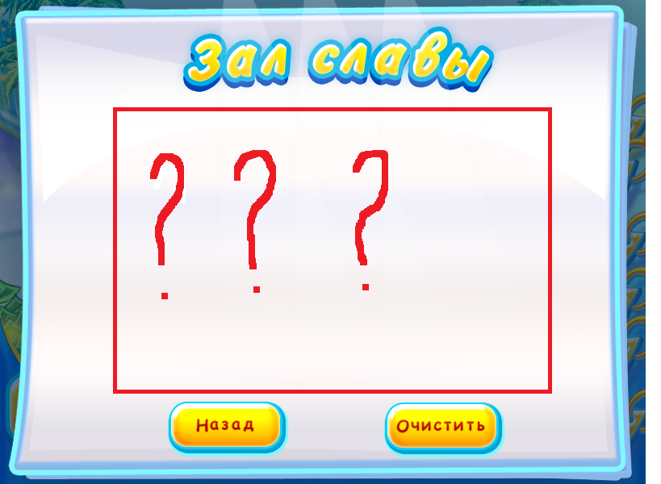
Screenshot № 2

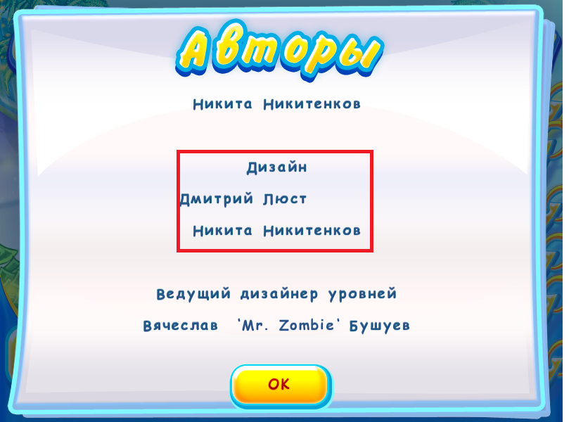
Screenshot № 3

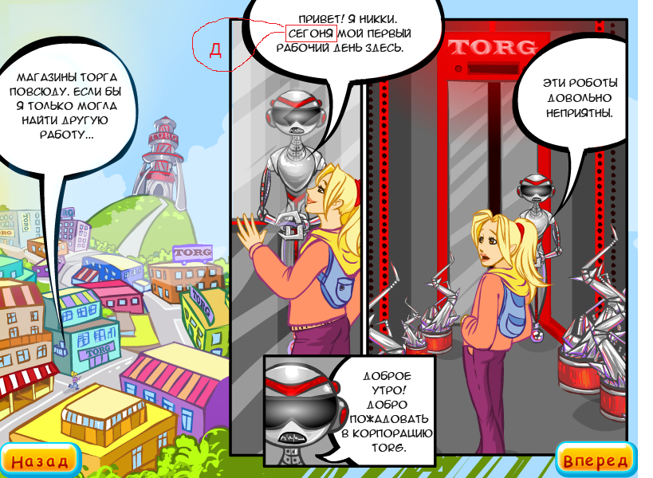
Screenshot № 4

