- The source table for Customers: № of the order, the date of opening of the order, the closing date of the order, order number, customer, subject, type of delivery, the name of the design, the construction area, the number, the stage of the order ...
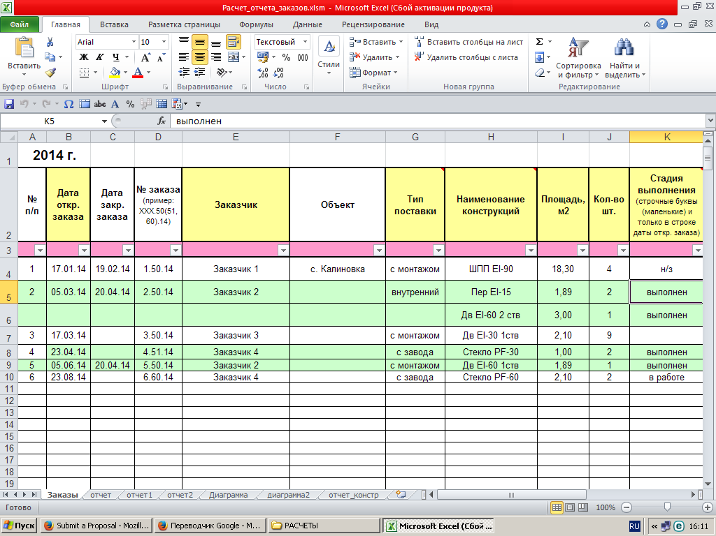

- Quarterly Automated table analysis using Excel formulas and functions and macros VBA. Actuated by pressing in the table
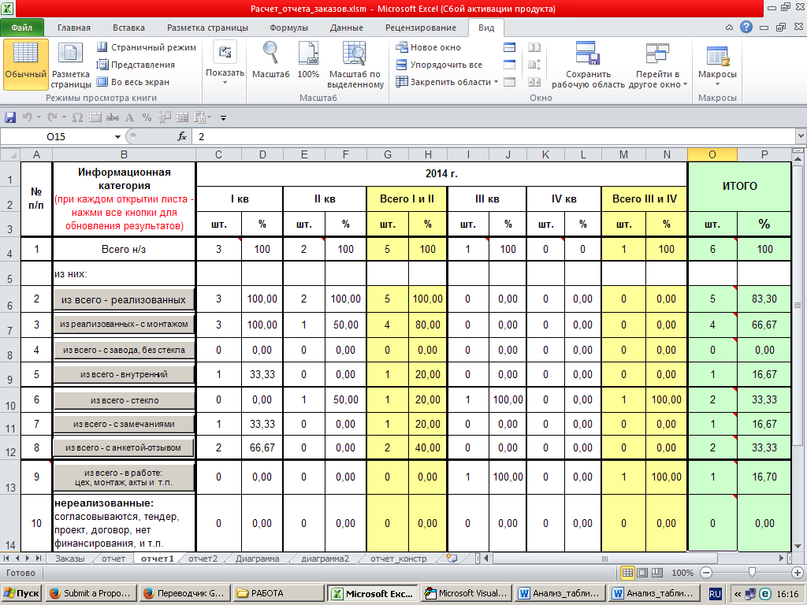

- A portion of one of the many macros
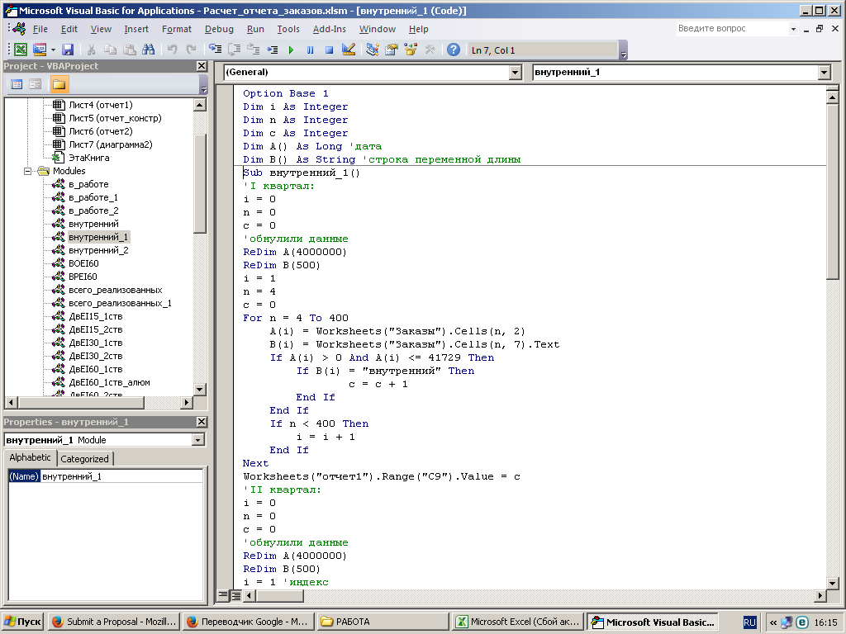
- Figure built automatically on the results of data analysis
