The most unexpected ombre hairstyles
Recently, a special staining technique - Ombre - became very popular among fashionable women. Hair coloring represents two-tone coloring with a border, blurred by the horizontal line. Due to such coloration hairstyle looks quite original: from the roots to the mid-length preserved natural shade, followed by a soft and smooth transition in a different color, and the tips, the color becomes the most intense and saturated. Ombre, where the darker shade is gradually transformed into a light, also called the "solar" coloring, because the result is very similar to natural hair burning.
The more daring girls agree to make a sharp boundary between two colors. Transitions can be quite different - from dark hair to light and vice versa, or from natural colors to bright fashionable shades, in short, Ombre hair coloring can be made to suit all tastes. The tips of the hair of a different color are very refreshing way, make the face younger. Ombre hair also adds volume and splendor will revive the simplest haircut.
- Dark brown ombre.
It looks gorgeous overflowing coffee and cognac, golden brown, caramel, and honey natural shades in combination with a deep dark color of hair. This fashionable coloration is now preferred by many luxurious brunettes in Hollywood and it certainly looks very impressive and glamorous. Depending on how bright an image you want to create, you can choose either a quiet coffee and cognac shades or more juicy and contrast caramel-honey color.
https://www.instagram.com/p/-Lu6iQRYZo/

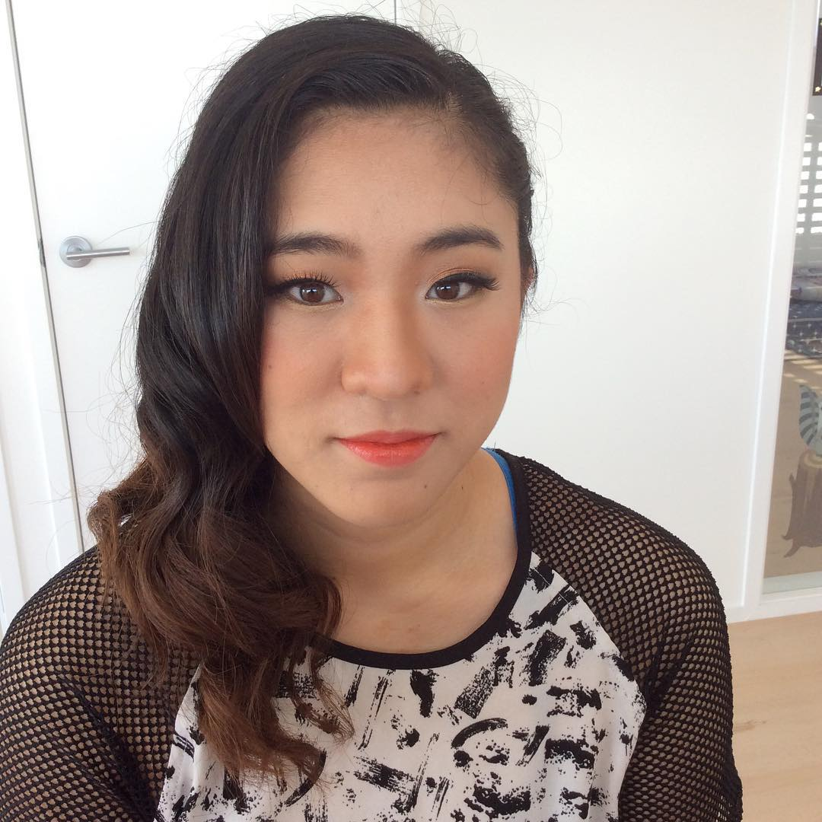
https://www.instagram.com/p/BELfLrkCY1v/

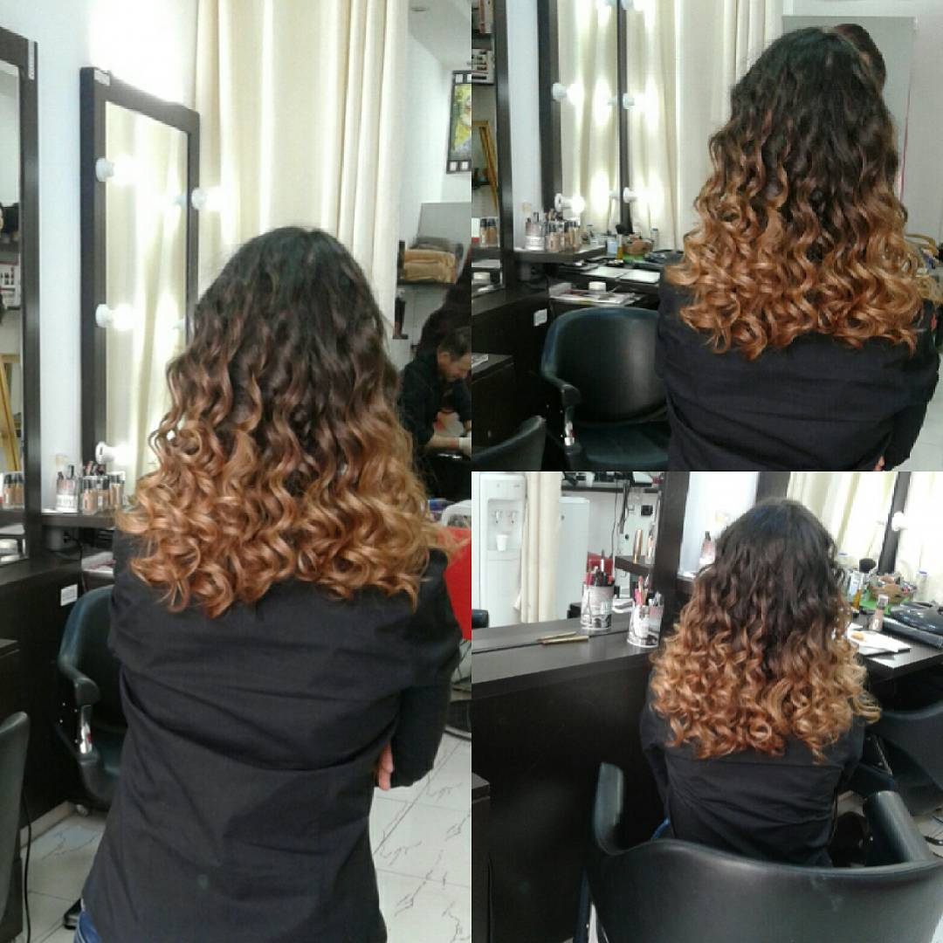
https://www.instagram.com/p/BFXKRtvn4yM/


https://www.instagram.com/p/BFSDjdSAjwh/
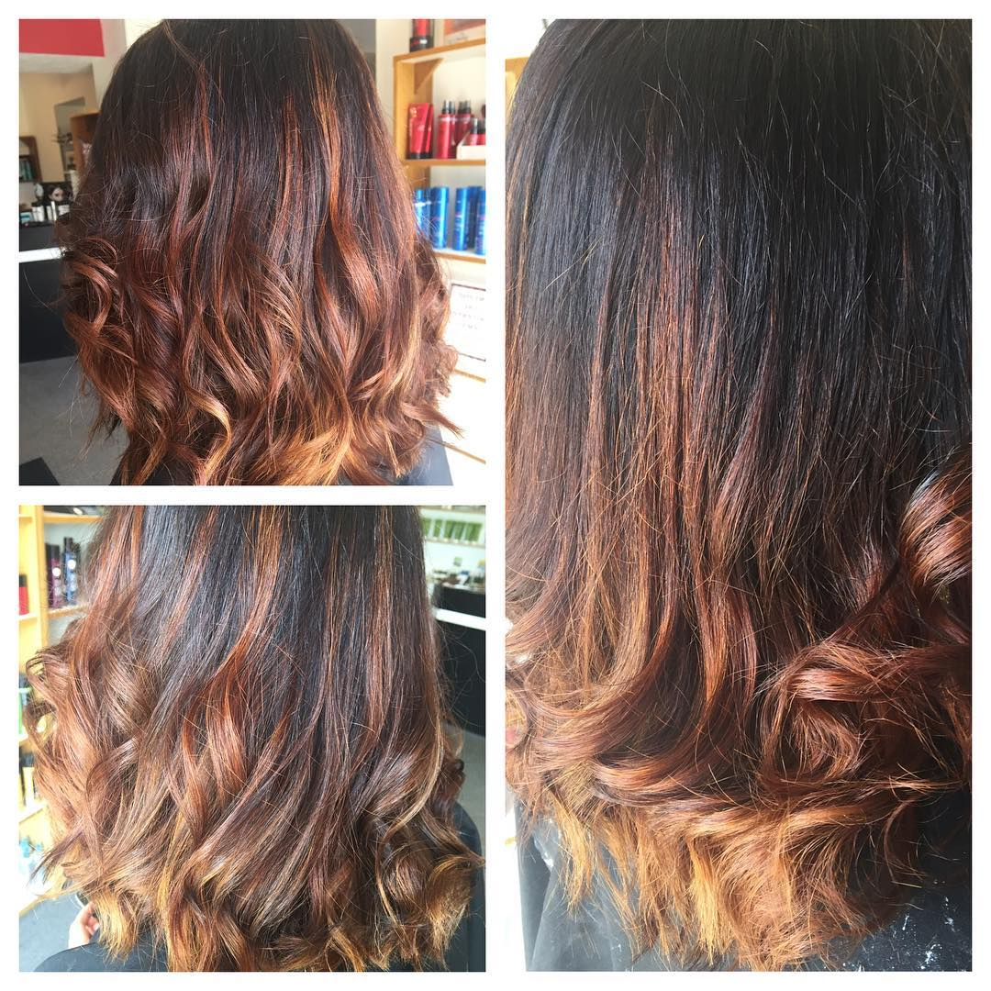
- Blond ombre.
The classic version Ombre, which is considered a two-tone coloring hair with bleached tips and saved darker shade roots. The intermediate zone is made seamlessly and allows getting a maximum natural image.
https://www.instagram.com/p/pBcf-gSU__/

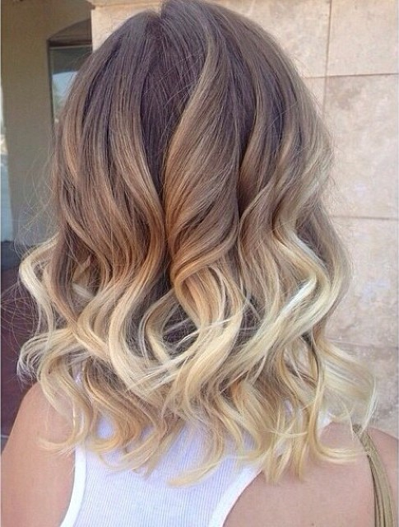
https://www.instagram.com/p/BFlCEYgvmQY/

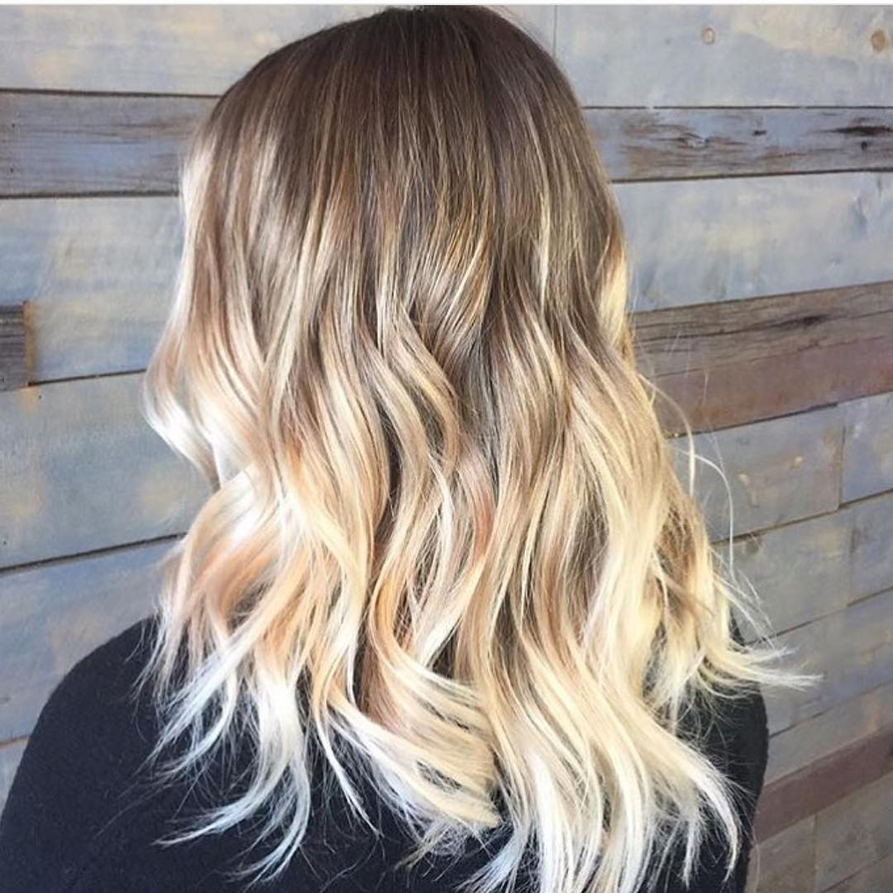
https://www.instagram.com/p/BFUG-M2piTY/
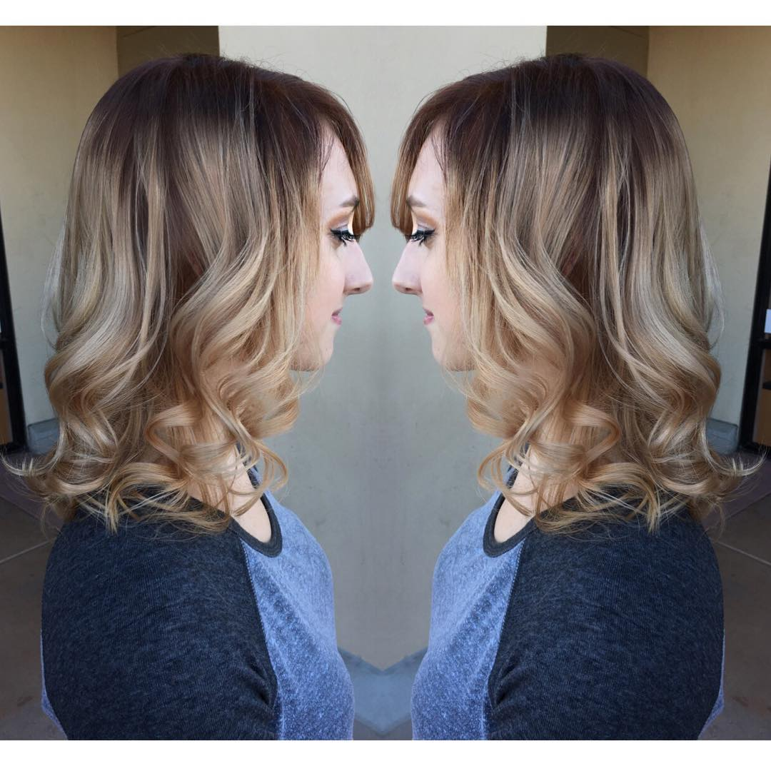
- Red ombre.
Stylish and bright brunettes are sure to attract extravagant Ombre with a luxurious effect "the flames". Its essence is that the tips of dark or black hair make shades of red, gold, copper and honey or red - orange. Styling curls give hair movement and emphasize the beauty of this fantastic Ombre.
https://www.instagram.com/p/cSNQ1rG1Jm/

https://www.instagram.com/p/BFZNnWFG_N1/

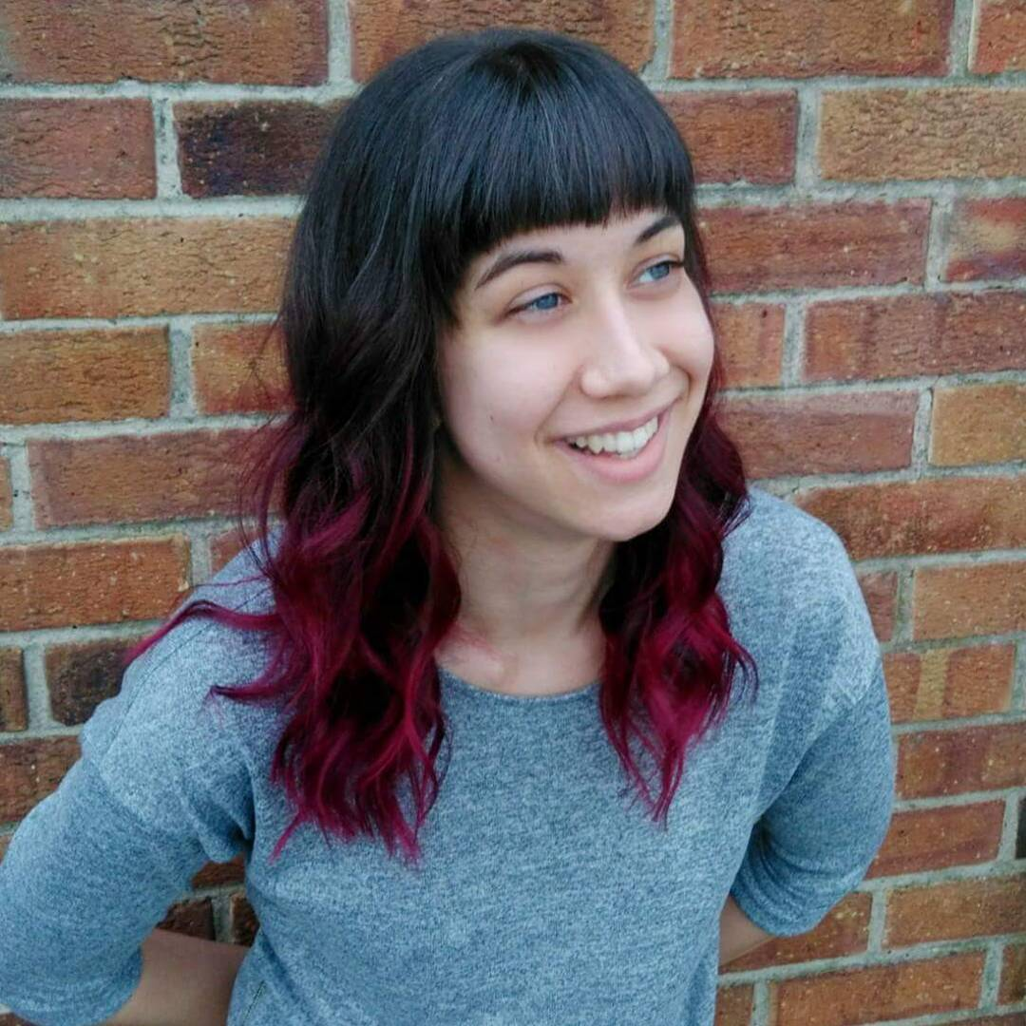
https://www.instagram.com/p/BAlQigIlarv/
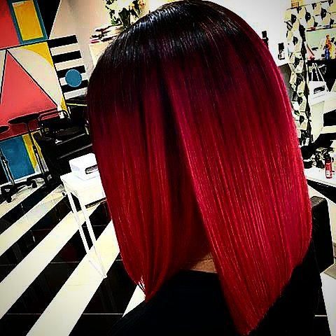
- Light brown ombre.
Gentle color reflections make this coloration a fresh and elegant instead of bright accents. Hairs with a warm shade quicken with wheat, caramel, golden sand or light honey color of Ombre.
https://www.instagram.com/p/BA7wMtyrRiK/

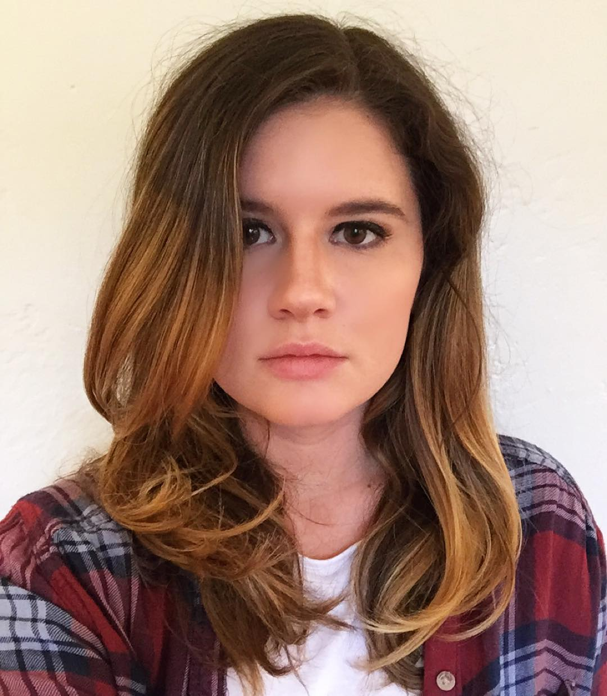
https://www.instagram.com/p/BE6dOPgtB5A/
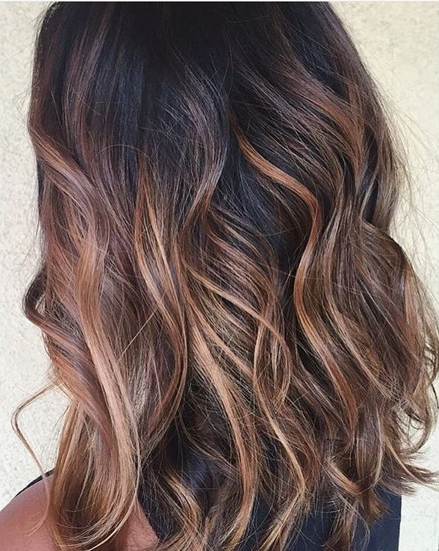
https://www.instagram.com/p/-gpqeBpsRk/

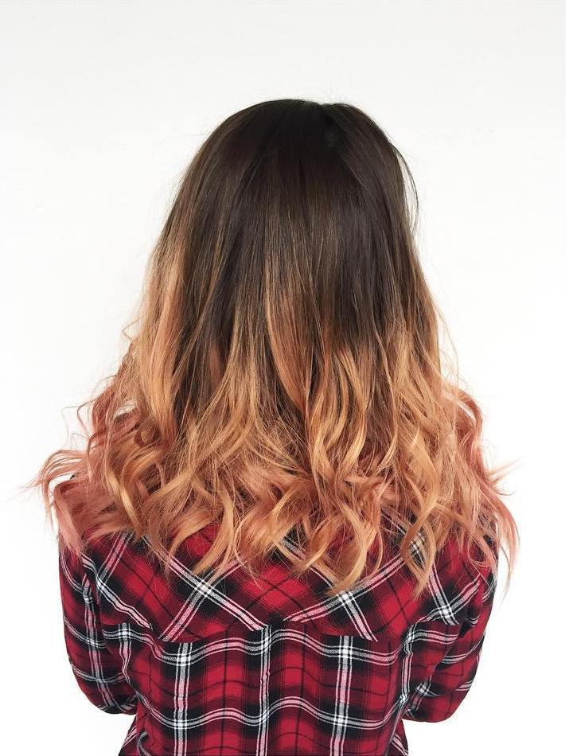
https://www.instagram.com/p/9_879NQY_T/
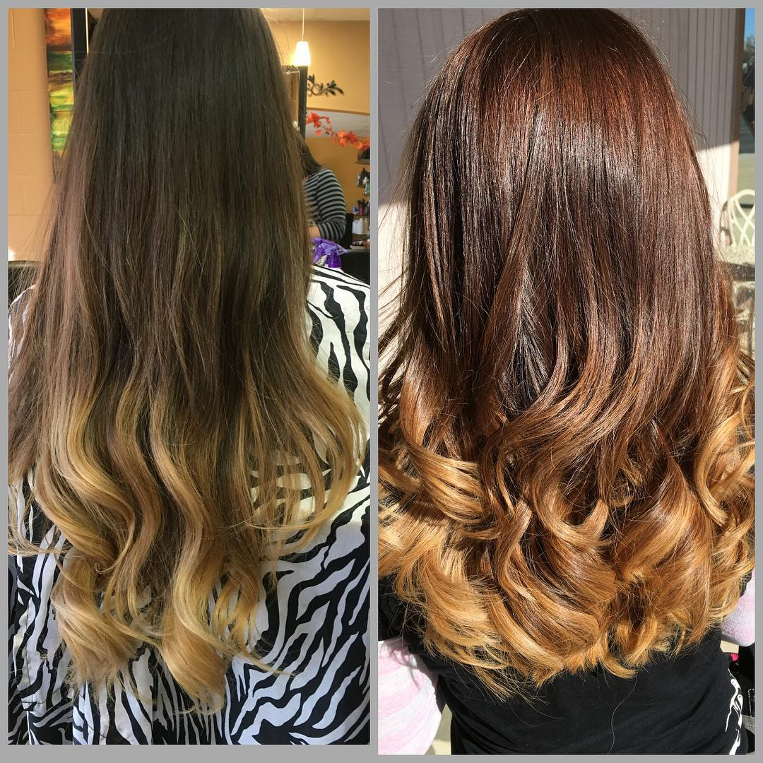

- Light blue ombre.

Thanks to the technique of color Ombre, on the dark or light hair, you can create real works of art. The favorite become cold images, it is assumed luxurious flowing play several tones of light blue on the tips of the hair.
https://www.instagram.com/p/mOFGxjSU9G/

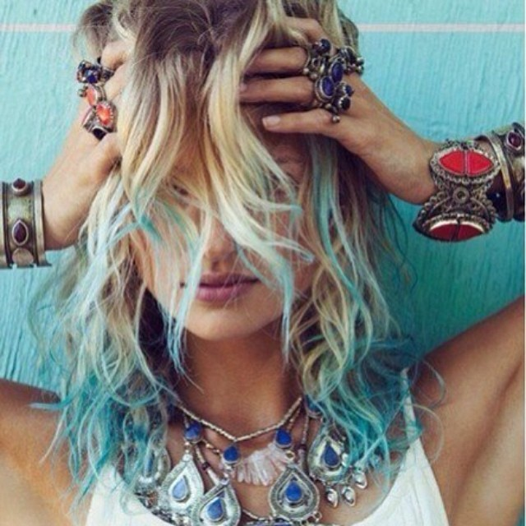
https://www.instagram.com/p/BEva7bPMerC/
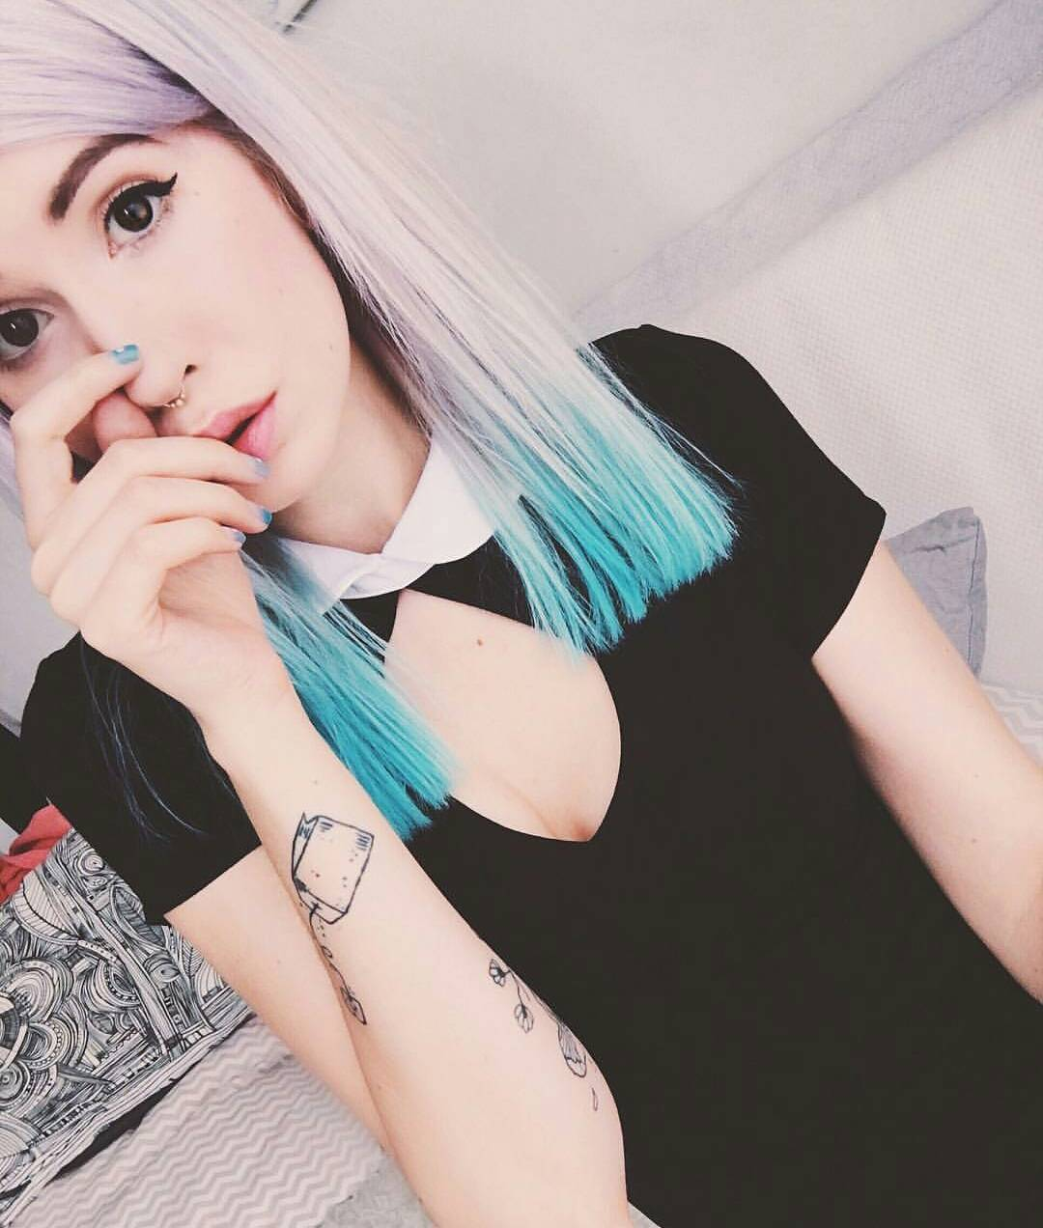
https://www.instagram.com/p/BFIP9jCnP7y/
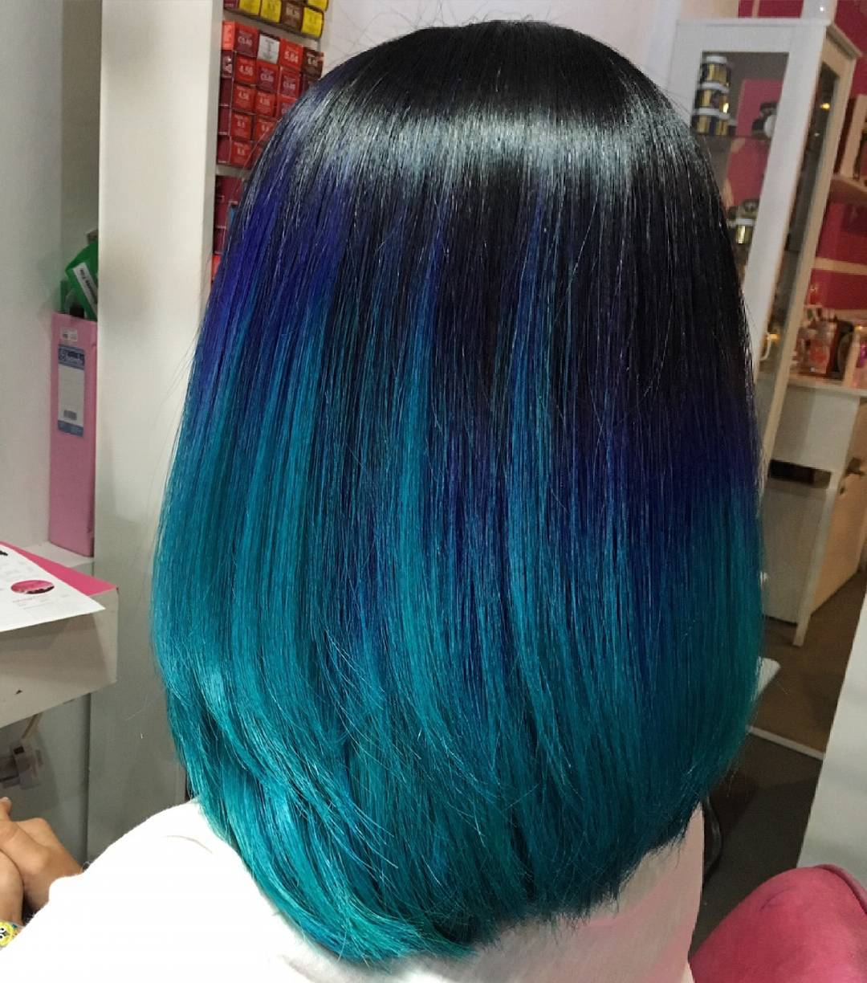
- Purple ombre.
For bright and extravagant girls, there are also striking two-color variants Ombre. This kind of hair coloring executed as well as classic, but with bold enchanting colors. Here is where to turn fantasy, you can use all shades of purple.
https://www.instagram.com/p/pV-Gp-SU1p/
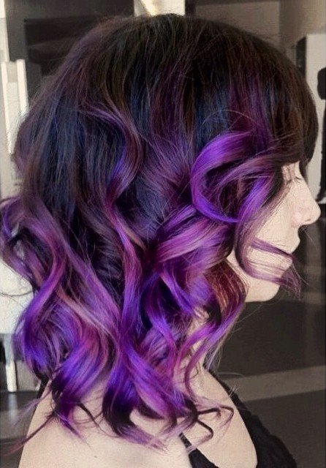

https://www.instagram.com/p/6E2eGIHP2W/

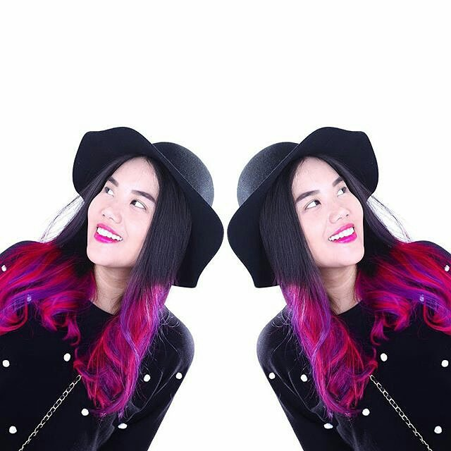
https://www.instagram.com/p/BDbe6ZeycdI/
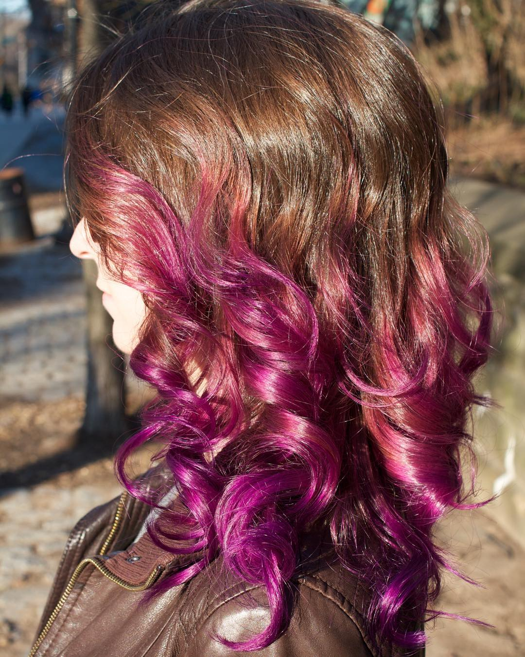
https://www.instagram.com/p/BC2yEe8picJ/
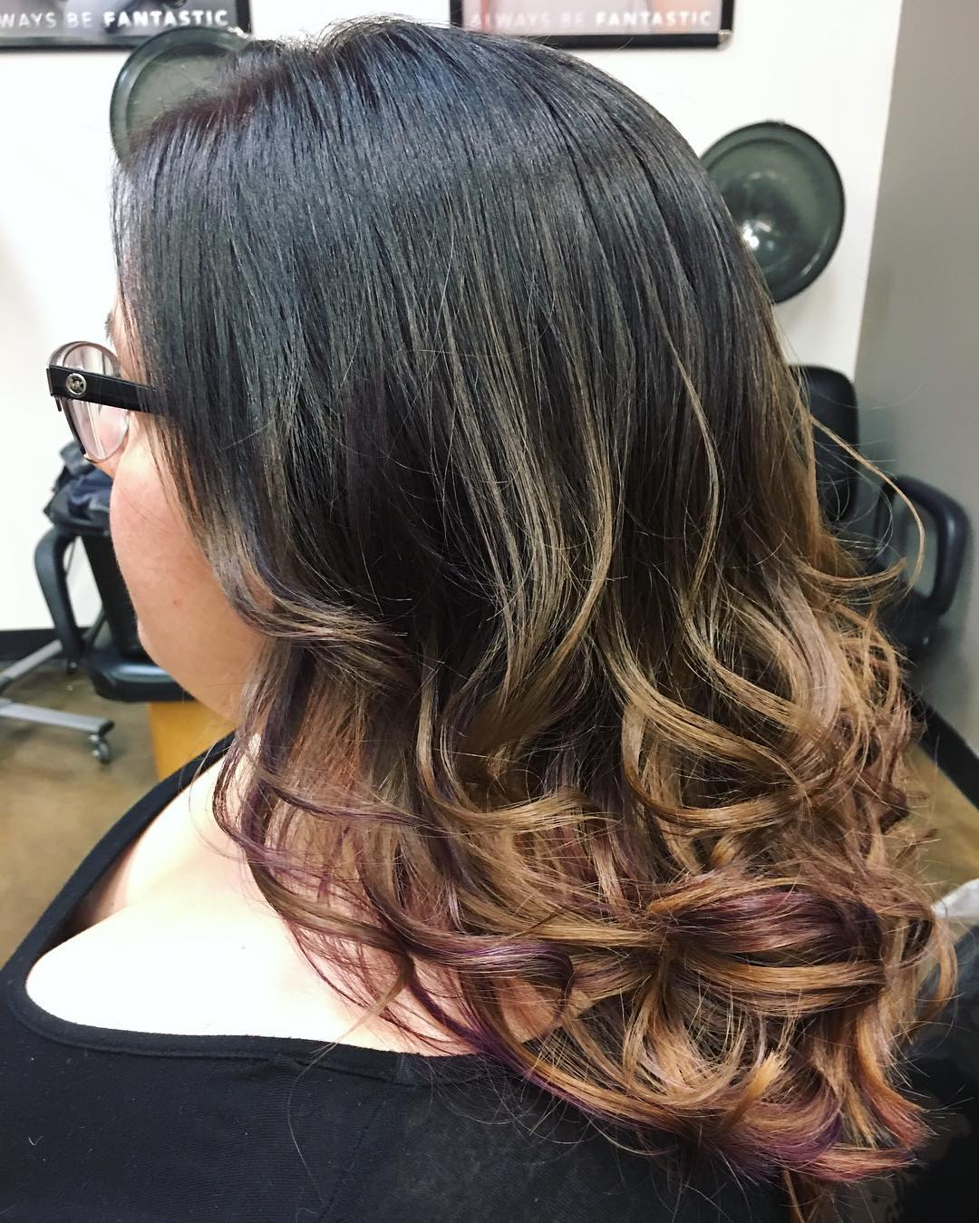
- Black ombre.
An incredibly interesting inverse variant where light roots are transferred to the dark ends. Laconic and stylish black Ombre represents a bright and contrasting combination of rich black with a lighter hair color. The boundaries of coloring can be both clear and blurred horizontally.
https://www.instagram.com/p/9r8Yj7R84W/

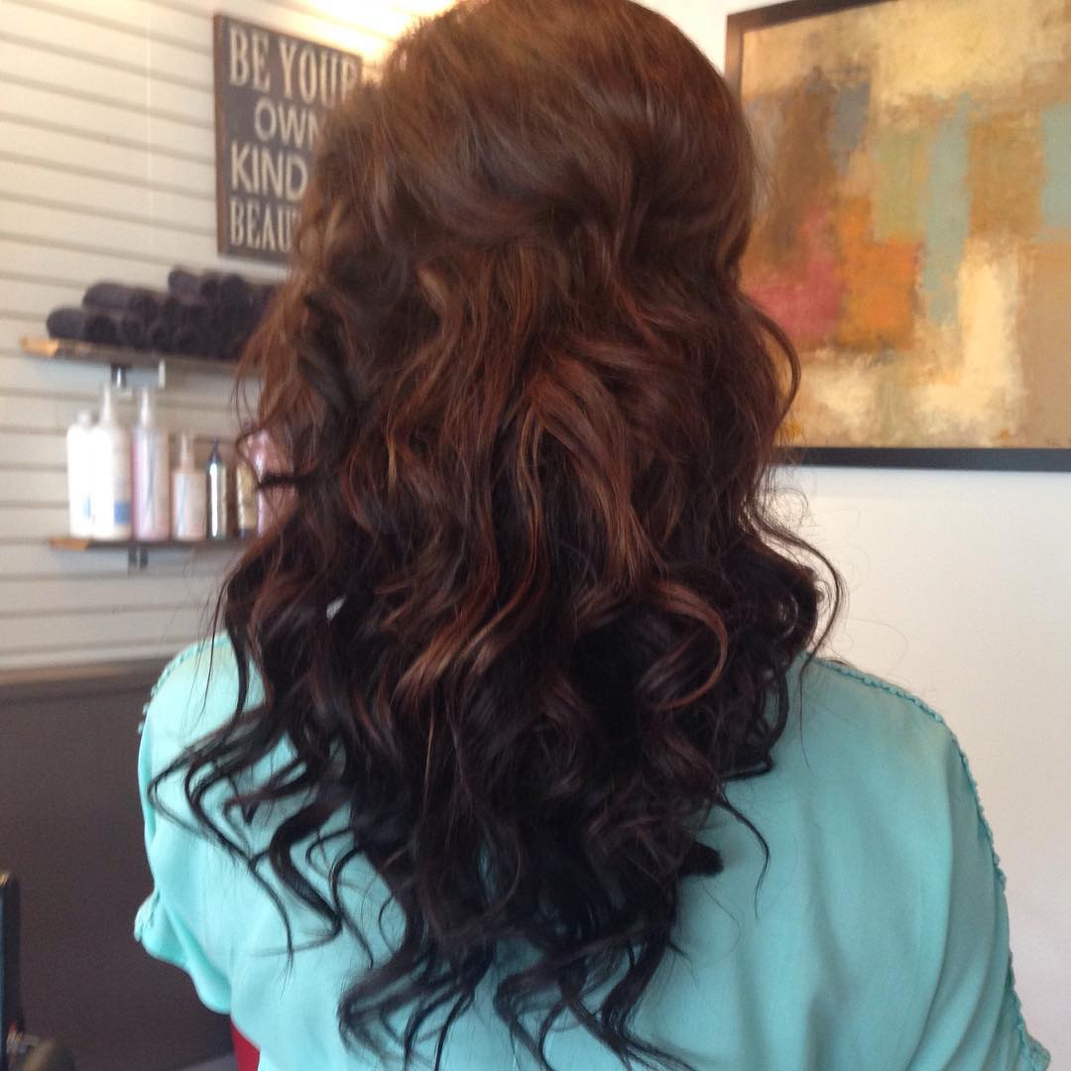
https://www.instagram.com/p/-Vk4w-IsHJ/

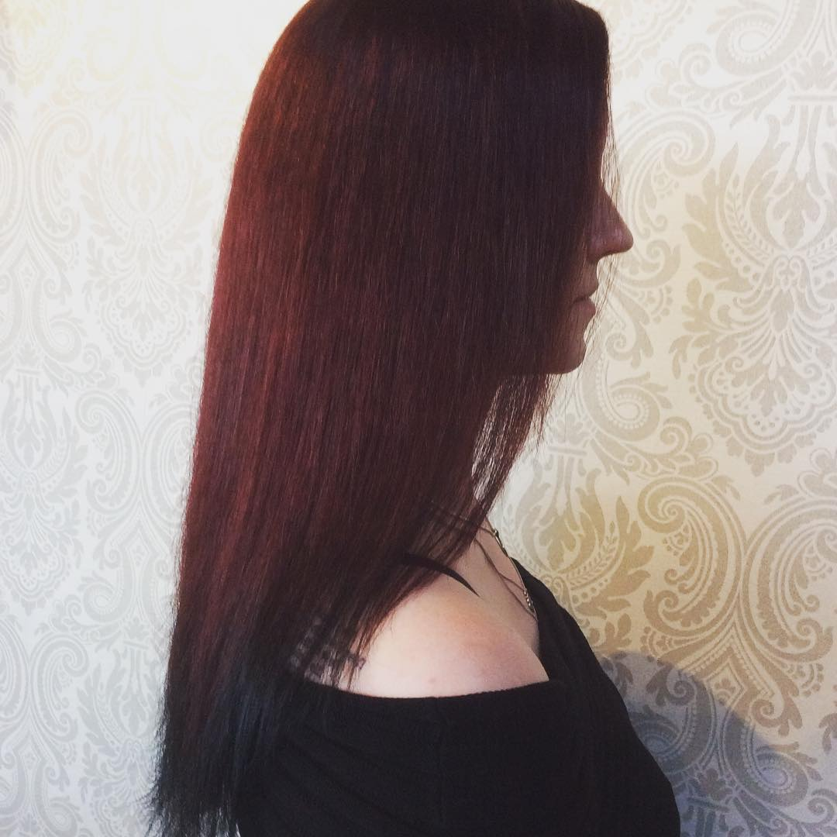
https://www.instagram.com/p/BD0XNx0ldRt/
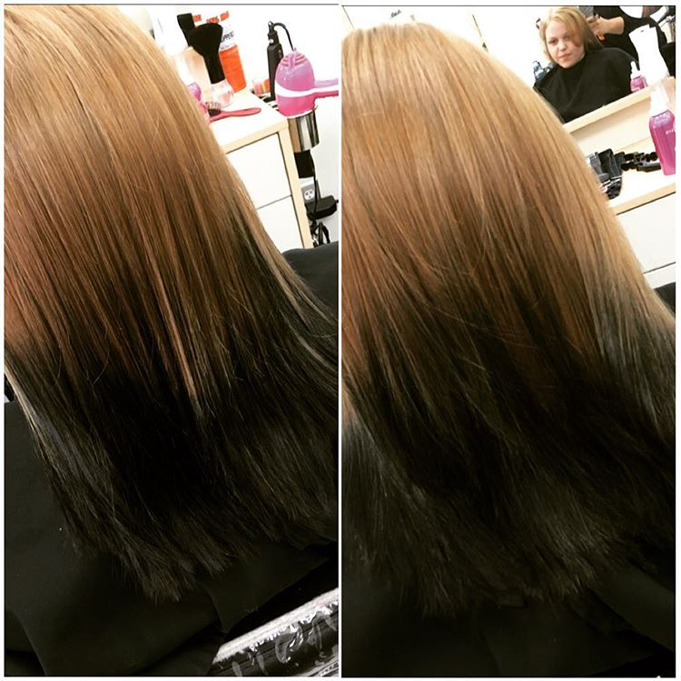
- Brown and blond ombre.
This Ombre represents very smooth transitions of several shades. It is important to keep it a smooth transition from pitch to pitch, so the implementation of such Ombre best left to a professional. If the show imagination and mastery, you can create dazzling effects.
https://www.instagram.com/p/sP7iJTyU75/

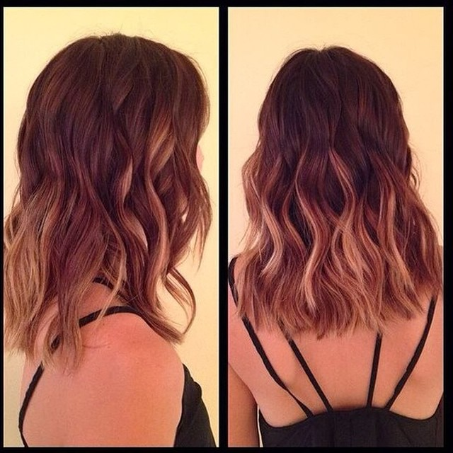
https://www.instagram.com/p/nGs3CXyU2y/
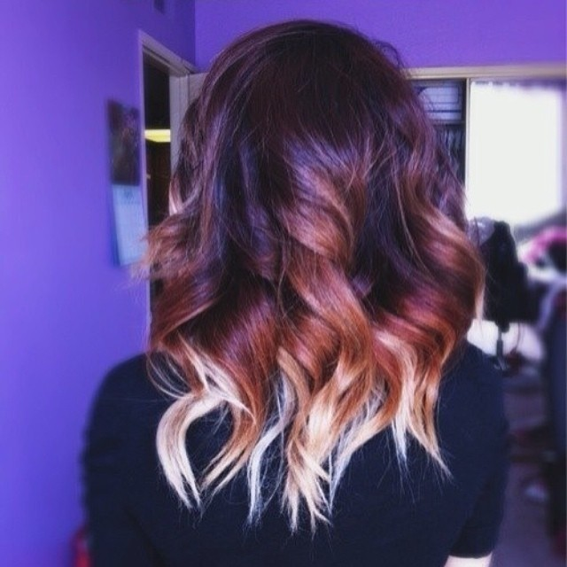
- Blue ombre.
You can simply add blue color to your natural tone, and can radically repaint the hair, making them fully colored. The last option looks, no doubt, incredibly impressive, daring, defiant, striking, but consider that such a transformation can only sustain healthy hair!
https://www.instagram.com/p/4ftRYunP9E/

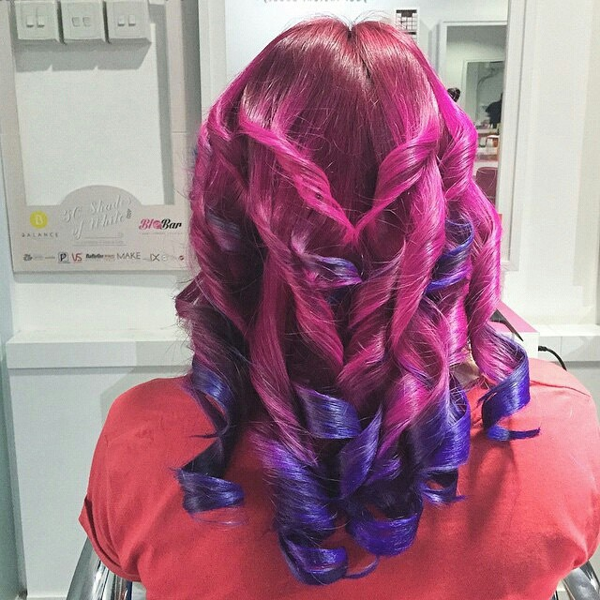
https://www.instagram.com/p/-fgjKgF9aS/

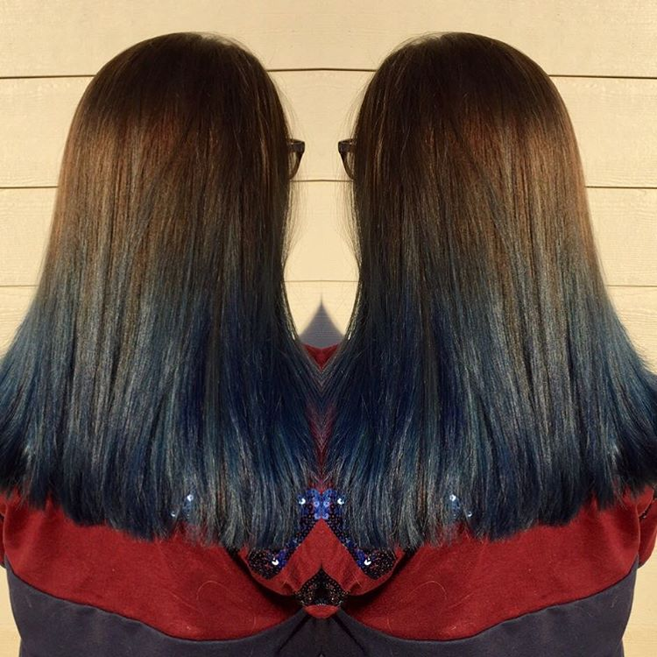
https://www.instagram.com/p/BCsdu-ZiqRo/

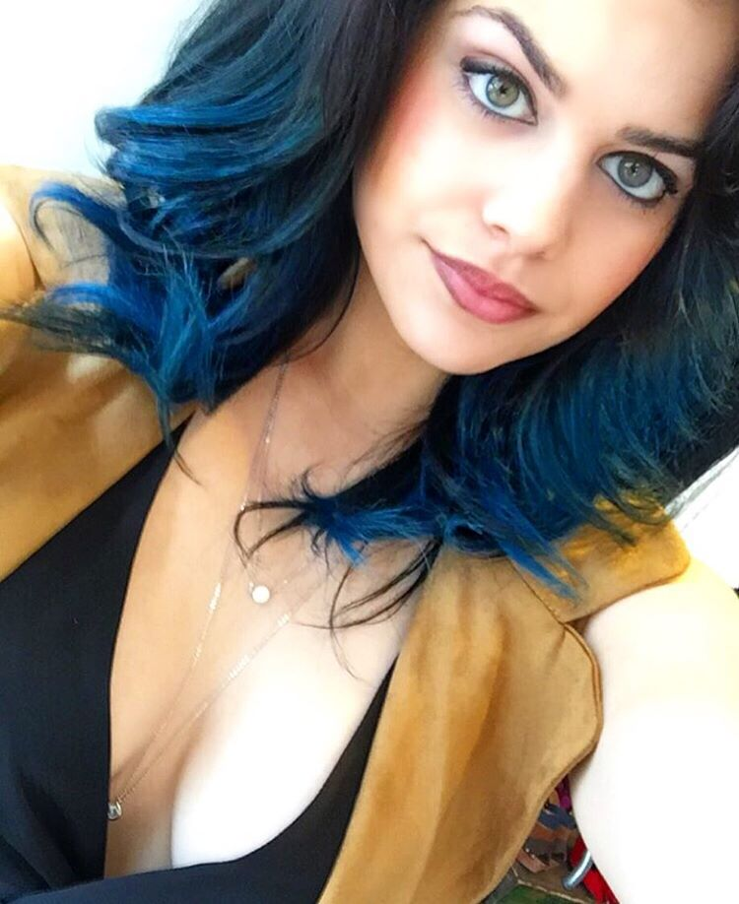
- Green ombre.
This Ombre involves a combination of an unusual color palette. There is a place with chestnut - green - blue combinations. Transitional color can be any color. Such extravagant coloration is suitable for people who love to be in the center of attention in others.
https://www.instagram.com/p/BFApCE9PB3K/

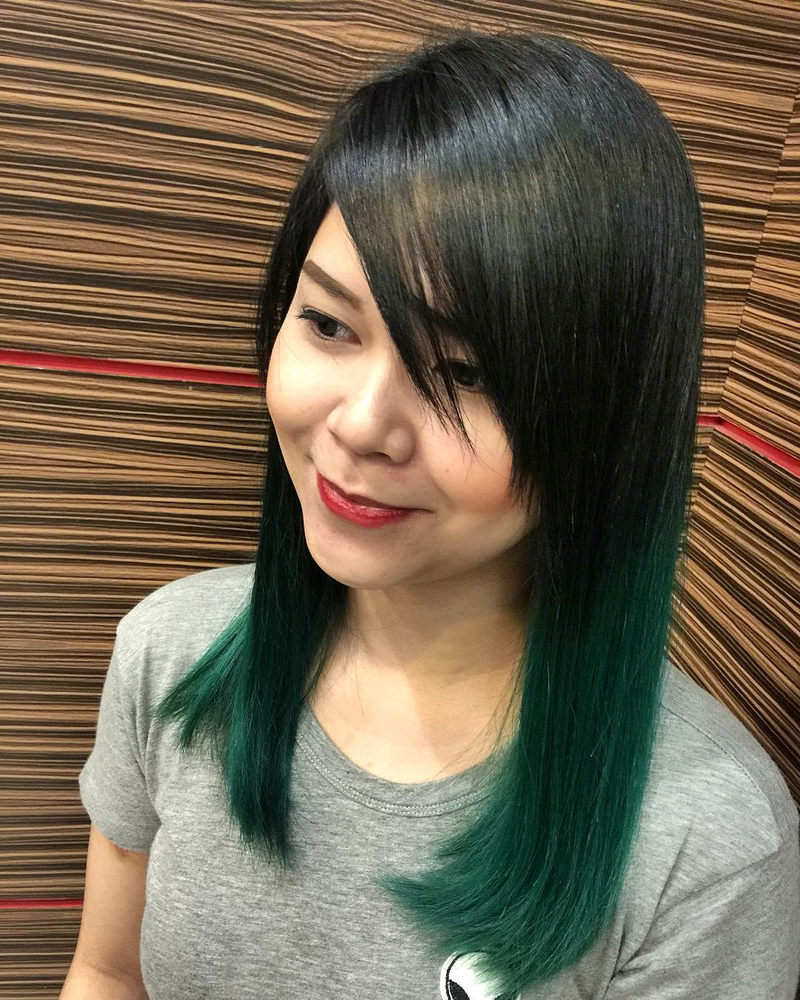
https://www.instagram.com/p/BE0WV7oAkI4/

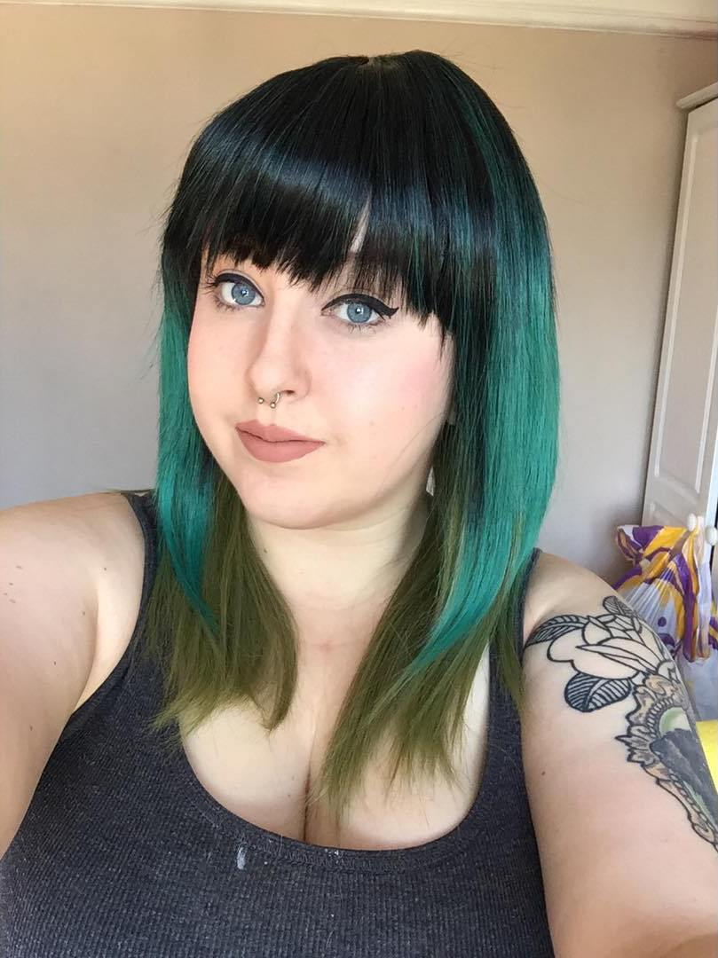
https://www.instagram.com/p/BFeHg76wKnE/

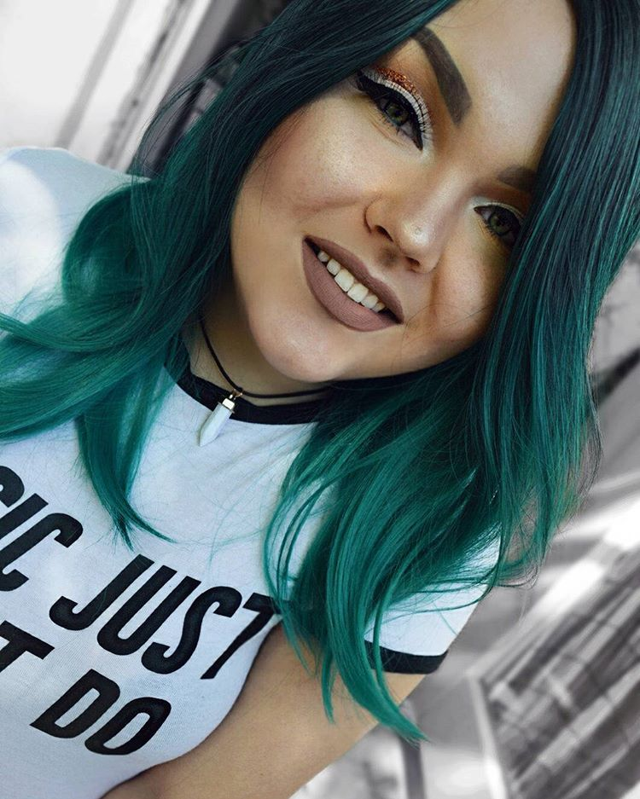
https://www.instagram.com/p/BFP0YSoFzHI/

