The Road to a Successful Career
Nowadays, it is very difficult for teenagers to decide on their future profession. Some people have natural talents as children, while others take longer to understand what they are strong at.
One of the reasons is ignorance of their abilities and skills. Bright talents are easy to spot. But after all, few people can boast of impressive poems, drawings, success in sports or programming. Often, during consultations with a specialist, parents and children are surprised to notice how differently they react to the world, perceive information, and make decisions. And if earlier it was a stress factor, now it becomes an occasion for mutual understanding of the world.
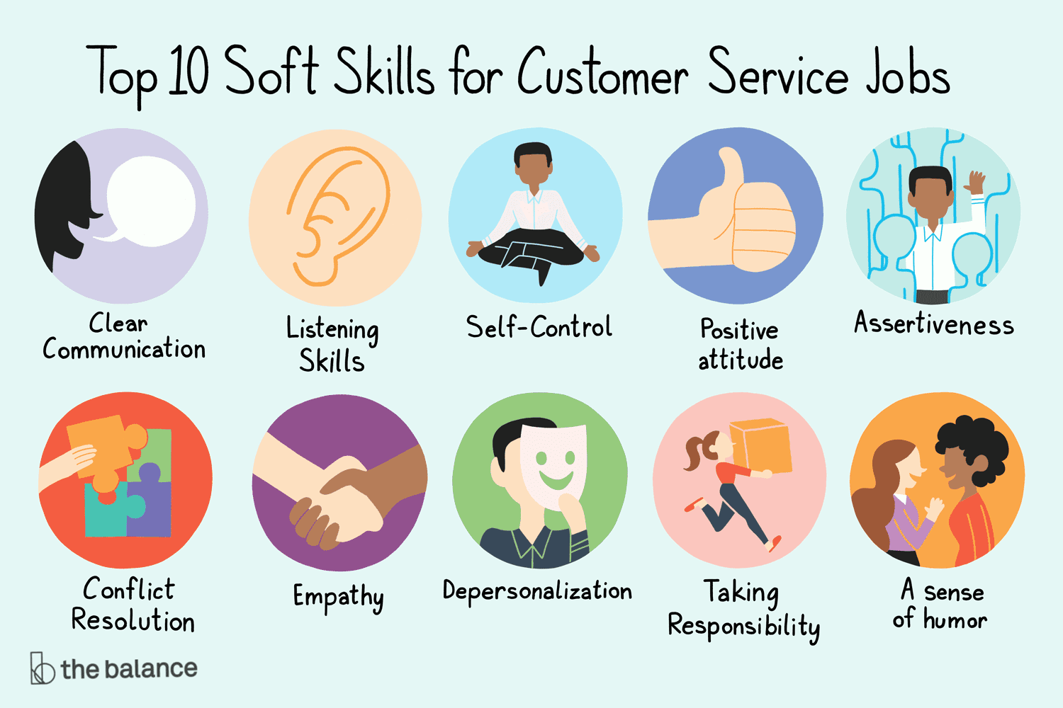
Now, in general, many teenagers are also looking for a profession and a University according to such criteria as: what exams they will need to pass after school and before entering a University. In any case, at school, someone had a favorite and unloved subject, so it is unlikely that anyone will want to “get to know” him again, only at the university and future profession.
I want to give you some advice on how to choose your future profession.
So, first: compare your interests with your future specialty. To do this, you need to write down absolutely all your hobbies on a piece of paper: you like taking care of animals, explaining difficult topics to others, cleaning the house, cooking, learning new languages, programming, etc. Then you need to compare your interests with professions. Each hobby should have a list of professions next to it. Now from the list you need to cross out those that for some reason do not arouse interest. When the list becomes small, you need to analyze your professional qualities and compare them with other professions.

Second: no matter how trite it sounds, but look at the "Salary". It seems to me that no one wants to live in poverty in the future, but with the robot of their dreams. As sad as it may seem, your salary will affect you in the future. In principle, for this we are working to earn this amount for our further development and achievement of goals.

Third: Professionally important qualities. You should not choose a career as a singer with a bad voice or an astronaut with a weak heart. Each profession requires certain skills, knowledge and skills and qualities from a person. Considering different types of professions, think about what qualities a person should have in each of them. After that, ask yourself: “Do I have these professionally important qualities? Will I be able to work well and enjoy this kind of work? ".
At the moment, for me, a huge example of a person who could, despite the fact that his family had a small budget, despite poor grades in school, but he began to fulfill his dream that he had since childhood, and this is Jim Carrey. From early childhood, Jim's favorite hobby was parodying. He stood at the mirror for hours, trying to copy some popular singer, actor or politician. Jim didn't like school so he dropped out after ninth grade. Later, the father was fired from his job, and the child had to go to work. The actor worked as a janitor and security guard. But the family failed to save their home, so he, along with his parents, brother and sister, spent the night in a van on the lawn of one of the relatives. Later, the whole family got a job at the factory, where the children washed floors and toilets. It was difficult for him to combine his studies and work at the Titanium Wheels plant in the suburbs of Toronto, where the family once again moved due to financial problems. Jim soon lost his job at the factory, taking it as a good sign. After all, his life's principle was the following: “It is better to do what you like for a penny than to be a millionaire and do what you hate.” Thus began Jim's ascent. Like any person, he had his ups and downs. But now everyone has heard his name at least once.
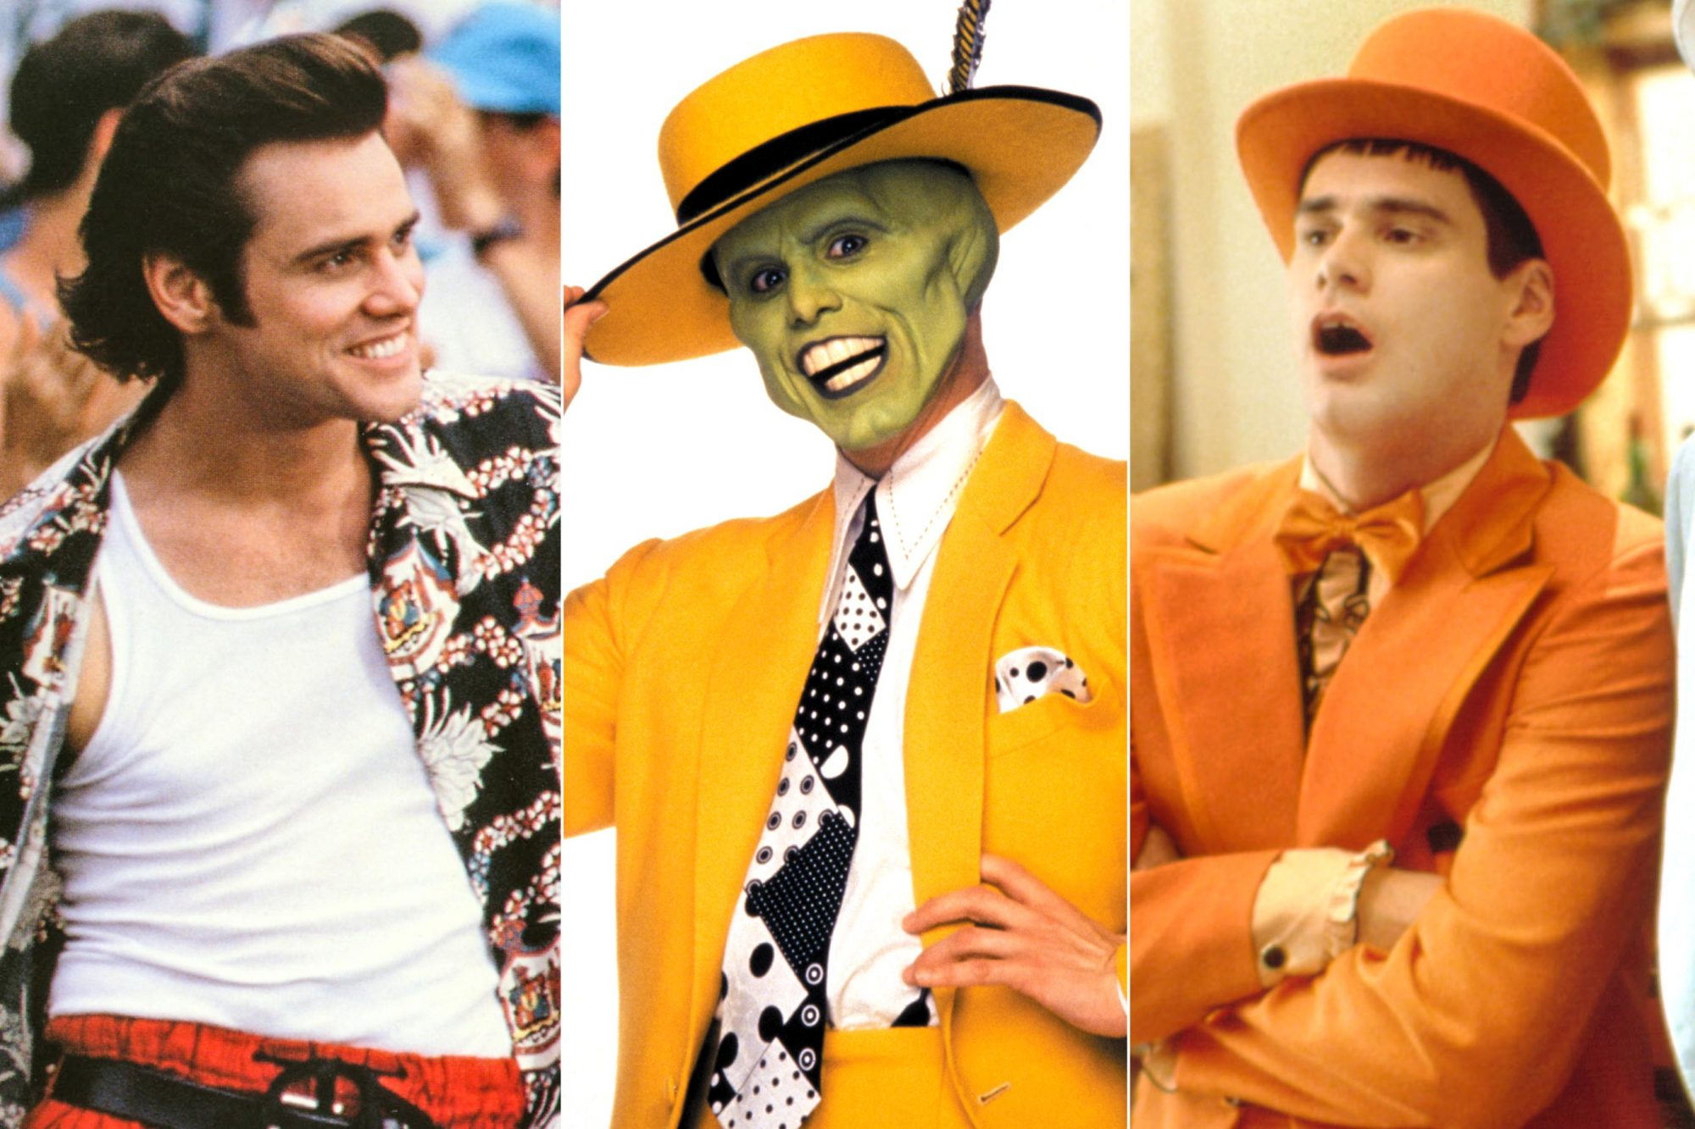
Here it is, an example of how he went from a poor boy who hated school to one of the most popular comedians in the world. And the thing is that he believed in himself, and believed in his dream. Therefore, guys, choose a profession to which your heart and soul!

