Supporting the Planet Through Digital Forms: A Step Towards a Greener Future


The paper we use daily has a hidden toll on the environment. Deforestation, clearing forests to produce paper, is among today's most significant environmental threats. With millions of hectares of forests lost annually, the planet's "lungs" are rapidly depleting. Trees, essential for absorbing carbon dioxide and releasing oxygen, are being cut down at an unsustainable rate, impacting biodiversity and accelerating climate change.

Producing paper also consumes vast amounts of resources. Each sheet represents a large amount of water, energy, and chemicals used in manufacturing. Water scarcity is a critical issue worldwide, and paper production adds to this crisis. The energy needed to process and transport paper also contributes to pollution, affecting air and water quality.

Digital forms offer a powerful solution, allowing individuals and businesses to meet documentation needs while reducing environmental impact. Embracing online forms is a small yet impactful step toward protecting our planet.

Why Is It Crucial to Switch to Online Forms?
Digital forms offer multiple benefits for both individuals and organizations. Among the most essential ones are reduced paper waste and deforestation, conservation of water and energy, and decreased carbon emissions.

Reduction in Paper Waste and Deforestation
Paper production is a significant contributor to deforestation. Globally, about 15 billion trees are cut down yearly, with a large percentage going toward paper production. The World Wildlife Fund (WWF) estimates that the pulp and paper industry is responsible for up to 40% of global industrial wood harvesting.

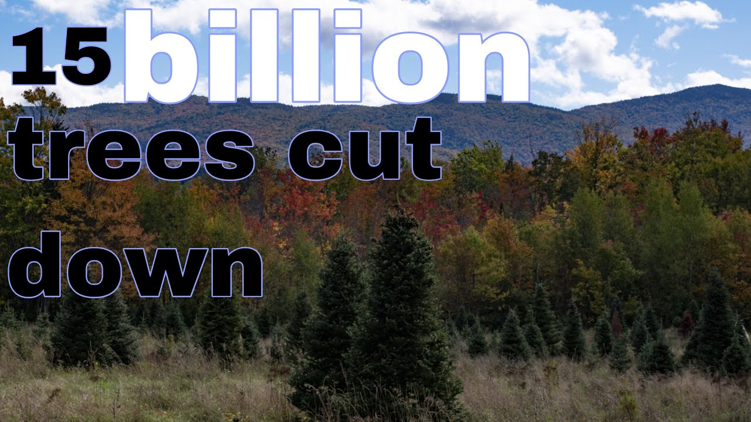

Digital forms directly contribute to forest conservation by reducing paper demand. For instance, if a medium-sized business goes fully digital, it could save approximately 10,000 sheets of paper annually. Over time, these reductions accumulate, helping to preserve forests that play a critical role in carbon sequestration and biodiversity.

Conservation of Water and Energy Resources
According to the World Green Organisation survey, 17 trees and 20,000 gallons of water are needed to produce one ton of paper towels.

In 2018, the Environmental Paper Network published a report titled “The State of the Global Paper Industry 2018: New Challenges and Opportunities for Forests, People and the Climate.” The report indicates that the average American uses around 700 pounds of paper annually, equivalent to significant water use when multiplied across the population. Reducing paper consumption helps conserve this valuable resource, especially as water scarcity affects millions worldwide.

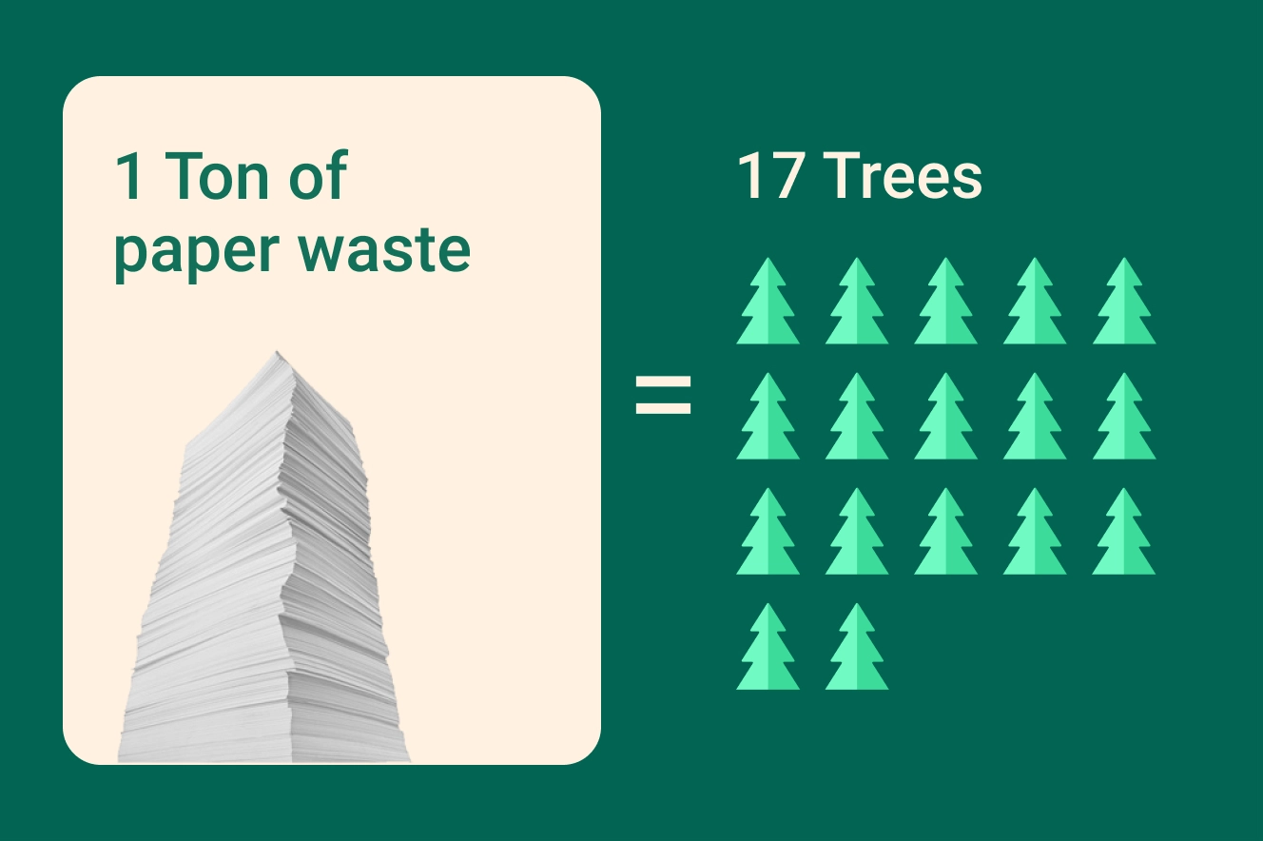

The pulp and paper industry is a major energy consumer, ranking among the largest in the United States. According to the Lawrence Berkeley National Laboratory, it is responsible for more than 9% of the electricity used across the U.S. manufacturing sector. Digital forms eliminate the need for paper, reducing the overall energy footprint associated with document production.

Decreased Carbon Emissions
The carbon footprint of paper primarily arises from the entire lifecycle of paper production, usage, and disposal. This includes the abovementioned energy consumed during manufacturing, the source of the raw materials, and the processes of recycling or landfilling used paper. The disposal of paper via landfilling leads to methane production, a potent greenhouse gas, as paper decomposes anaerobically.

The environmental impact connected with the paper industry goes beyond that. Each printer ink cartridge has an environmental cost, too. According to the Iowa Department of Natural Resources, over 375 million ink cartridges are discarded annually in the U.S. alone. Ink production involves chemicals contributing to pollution, and plastic cartridges add to landfill waste.

Every ton of recycled paper saves 17 trees, 7,000 gallons of water, and 380 gallons of oil while reducing carbon emissions. By avoiding paper altogether with online forms, we reduce the need for recycling processes, further decreasing emissions.

How Online Forms Help Businesses Go Green
Going paperless is more than an eco-friendly choice for businesses—it’s a practical and efficient move. By adopting digital forms, businesses save time, reduce operational costs, and enhance productivity. There’s no need to print, file, or manage large volumes of paper, and transactions can be completed in seconds.

Some of the essential benefits of going green for businesses are:

- Drastic Reduction in Paper Usage
- Lower Energy Consumption
- Decreased Carbon Emissions
- Cost Savings
- Enhanced Efficiency and Productivity
- Improved Data Security
- Positive Brand Image
- Compliance with Environmental Regulations

Apart from the environmental benefits mentioned above, going green also saves money. Businesses spend significantly on paper, printing supplies, storage, and disposal. Switching to online forms can save up to $80 per employee annually on paper-related costs. These savings can be redirected towards sustainable initiatives or other business needs.

Additionally, online forms streamline workflows. Employees spend less time handling paperwork and more time on productive tasks. Digital forms are easier to organize, search, and retrieve. Online PDF editors allow you to work with documents more efficiently, easily editing or merging files. It’s also possible to collaborate on the form with your colleagues.

Another benefit of online documents and templates is data security. Paper documents are vulnerable - they can be lost, stolen, or damaged. Digital forms, on the other hand, offer better security features, like encryption and password protection. These features protect sensitive information and reduce the need to reproduce lost documents, saving resources.

A 2023 Nielsen survey showed that 66% of global consumers are willing to pay more for sustainable brands. Adopting online forms and showcasing green practices can attract eco-conscious customers and enhance a company's reputation. Additionally, businesses that reduce paper waste and adopt digital solutions are better positioned to comply with regulations. This avoids penalties and demonstrates corporate responsibility.

Here are some sample forms businesses can digitize:
- Employment Contracts: Hire new employees with digital agreements.
- Customer Feedback Forms: Collect customer opinions online.
- Invoice and Billing Forms: Manage finances without paper invoices.
- Order Forms: Process sales digitally.
- Vendor Agreements: Handle supplier contracts online.
- Audit and Compliance Forms: Maintain records digitally for easy access.

Embracing online forms allows businesses to contribute to environmental conservation and improve their efficiency and bottom line. It's a win-win situation. The planet benefits, and so does the business.

Ecological Forms and Their Contribution to Environmental Efforts
Certain forms play an essential role in supporting environmental standards in specific industries like construction and real estate. These documents highlight how digital forms contribute to environmental efforts beyond reducing paper usage. They help ensure compliance with safety standards and reduce the need for physical paperwork. Below, you will find a few of the most widely used examples.

Lead-Based Paint Disclosure Form. This form is critical for property transactions in older homes. Any building constructed before 1978 may contain lead paint, which is a health risk, especially for young children. According to the Environmental Protection Agency (EPA), in 2024, about 38 million homes in the U.S. still contained lead-based paint. This form informs new tenants or buyers about the risks and mitigation measures.

Certification of Pollution Form. Construction sites use this form to verify their efforts to minimize environmental impact. Pollution from construction, especially dust and emissions, harms local ecosystems and air quality. Certifying pollution control measures helps communities breathe easier and shows environmental responsibility.

Material Safety Data Sheet (MSDS). This sheet lists hazardous chemicals used in manufacturing or construction, helping prevent contamination and accidents. By using an online MSDS, organizations ensure that workers, residents, and environmental agencies have easy access to safety guidelines for handling or disposing of these materials.

Asbestos Abatement Form. Asbestos remains a significant concern in older buildings. Before renovation or demolition, contractors must verify asbestos removal procedures. According to the Asbestos Disease Awareness Organization, with approximately 39,000 asbestos-related deaths each year in the U.S., this form plays a life-saving role by enforcing safe practices and reducing exposure risks.

Environmental Compliance Report. Commonly used in industries like energy, manufacturing, and agriculture, this report assesses compliance with environmental regulations. Industries are accountable for monitoring their emissions, water usage, and waste.

Form | Purpose | Relevant Data
Lead-Based Paint Disclosure | Informs of lead paint presence in old buildings | 38 million U.S. homes contain lead-based paint (EPA, 2024)
Certification of Pollution | Confirms pollution control on construction sites | 15% of urban PM2.5 emissions from construction sites
MSDS | Lists hazardous chemicals for safety compliance | 9% increase in hazardous incidents due to lack of documentation
Asbestos Abatement | Verifies asbestos removal in older buildings | 39,000 annual asbestos-related deaths in the U.S.
Environmental Compliance | Tracks industrial compliance with regulations | 67% of companies improved compliance with online reporting

We use forms in various fields daily, including rental agreements, financial documents, health forms, and education-related paperwork. We provide these forms online, making them accessible and easy to edit and fill out.

With the ESIGN Act, electronic signatures are legally recognized in the United States, making digital documents as legitimate as their paper counterparts. This means you can sign a contract or fill out an application online with complete confidence that it holds the same legal weight.

The Future of Paperless Operations and Environmental Impact
With technological advancements, the transition to a paperless society is within reach. Digital solutions are evolving rapidly, making it easier for individuals and businesses to go paperless. While some legal documents may still require printing, many forms can now be completed online.

The shift toward a paperless future is reshaping business and environmental landscapes. With every company that goes digital, the world gets closer to reduced waste, cleaner air, and preserved resources. Here’s how paperless operations pave the way for a sustainable future and what that means for our planet:

- Enhanced Resource Efficiency with Digital Storage
- Increased Role of E-Signatures and Blockchain for Security
- Carbon Emission Reductions
- Fewer Office Supplies, Less Plastic Waste
- Work-from-Home and Remote Operations
- Public Awareness and Corporate Responsibility

Each decision can contribute to a greener future in a world facing ecological challenges. By adopting digital forms, individuals and businesses reduce paper waste, conserve resources, and support environmental sustainability. Going paperless is more than just a trend; it's a necessary shift towards a sustainable lifestyle. Next time you fill out a form, consider choosing the digital option. Together, we can make a difference—one digital form at a time.

