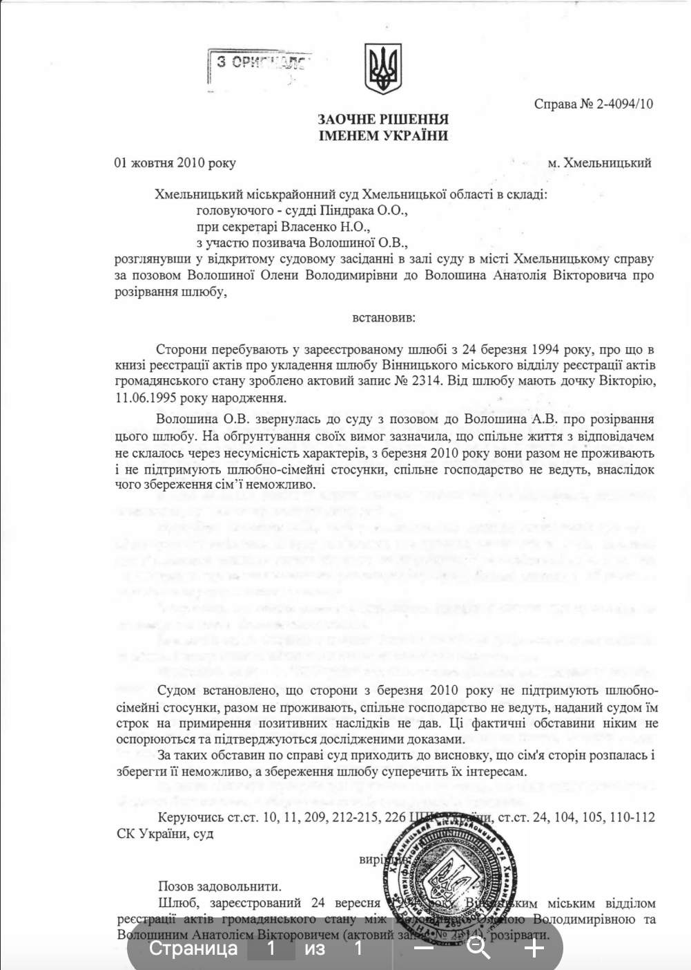

DEFAULT JUDGMENT
IN THE NAME OF UKRAINE
October 1, 2010
Khmelnytskyi
Case No. 2-4094/10
The Khmelnytskyi District Court of Khmelnytskyi Region, composed of:
• Presiding Judge Prylutskyi O.O.,
• Court Clerk Vlasenko N.O.,
• With the participation of the plaintiff Voloshyna O.V.,
having considered in an open court hearing, held in the courtroom in the Khmelnytskyi city, the case concerning the claim of Voloshyna Olena Volodymyrivna against Voloshyn Anatolii Viktorovych regarding the dissolution of marriage,
ESTABLISHES:
The parties have been in a registered marriage since March 24, 1994, as recorded in the Marriage Registration Book of the Vinnytsia City Civil Registry Office under Act No. 2314. They have a daughter, Viktoria who was born on June 11, 1995.
Voloshyna O.V. filed a lawsuit against Voloshyn A.V. seeking the dissolution of their marriage. In support of her claims, she stated that their marital life had not been successful due to incompatibility of personalities. Since March 3, 2010, they have not been living together, have not maintained marital and family relations, and do not share a household. Consequently, preserving the family has become impossible.
The court has established that, since March 3, 2010, the parties have not maintained marital and family relations, do not share a household, and do not engage in joint economic activities. Moreover, the court sees no prospects for restoring positive relations between them. These circumstances are evidence of the breakdown of the marriage and make preserving the family impossible.
Under such circumstances, the court concludes that the family has disintegrated irreversibly and cannot be preserved, and that maintaining the marriage would be contrary to the interests of both parties.
Guided by Articles 10, 11, 209, 212-215, 226 of the Civil Procedure Code of Ukraine, and Articles 24, 104, 105, 110-112 of the Family Code of Ukraine, the court
RULES:
To satisfy the claim.
To dissolve the marriage registered on March 24, 1994, by the Vinnytsia City Civil Registry Office between Voloshyna Olena Volodymyrivna and Voloshyn Anatolii Viktorovych (Marriage Registration Act No. 2314).

