Уважаемый Амазон-предприниматель,
Первый рабочий вариант Вашего листинга готов!

В этом документе вы найдете:
- Keywords/ Ключи*: отсортированы по поисковому объёму и релевантности (когда вбиваем ключ в поисковую строку Амазон, выдача наша). Самые важные ключи мы распределили в Title, чуть менее значимые в Bullets и остальные в Description. Ключи отмечены бирюзовым или зеленым цветом.
- Top Competitors Ideas: интересные идеи/формулировки из листингов конкурентов.
- Our ideas: наши идей.
- TITLE: несколько вариантов заголовка.
- Основные конкуренты: листинги конкурентов, которые мы брали для анализа и сбора семантики.
- Дополнительная информация от клиента: та информация, которую Вы нам предоставили.
- BULLETS/DESCRIPTION: текст листинга с распределением ключей.
* Полную семантику вы получите в отдельном Excel документе.
Что дальше?
- Прочитайте документ. Проверьте все ли описано и понятно. Обсудите с командой, что нужно изменить, усилить, удалить и т.п.
- В течение 48 часов просим дать обратную связь. При необходимости вносите правки и комментарии в текcте документа. Пожалуйста, используйте функцию отслеживание изменений (Track Changes). После внесение всех правок мы повторно отправим Вам рабочий документ.
- Утверждение рабочего варианта. Когда Вас всё устроит, мы отправим листинг на вычитку профессиональному редактору, носителю языка (USA/UK).
- В течение 24-48 часов Вы получите финальную версию листинга + backend + HTML.

Top Keywords
- 3D Puzzles for Adults
- 3D Puzzles
- Model Kit
- Wooden Puzzles
- 3D Puzzle
- 3D Wooden Puzzles
Model Car Kits for Adults
Other Important Keywords (for Bullets)
Search Terms | Search Volume | Competition | PPC orders | RELEVANCE | Source (источник)
model kits | 7626 | 40000 |  | 18% | Helium
wooden puzzle for adults | 7069 | 10000 |  | 29% | Amazon
Model Kits for Adults | 5957 | 10000 |  | 50% | Amazon
Wooden Puzzle | 3993 | 10000 |  | 23% | Amazon
wood puzzles adult | 2670 | 10000 |  | 48% | Amazon
Wooden Puzzles for Adults | 2544 | 10000 |  | 50% | GoogleAdWords
model building kits | 2542 | 20000 |  | 23% | Amazon
models for adults to build | 2015 | 4000 |  | 38% | Helium
wood puzzles | 1498 | 10000 |  | 27% | GoogleAdWords
wood puzzle | 1497 | 10000 |  | 30% | Amazon
3d puzzles for kids | 1497 | 1000 |  | 22% | Helium
3D Wooden Puzzles for Adults | 1327 | 1000 |  | 90% | Helium
building kits for adults | 1277 | 7000 |  | 25% | Helium
hobby kits for adults | 925 | 10000 |  | 14% | GoogleAdWords
puzzle 3d | 628 | 3000 |  | 37% | Helium
wooden 3d puzzles | 626 | 1000 |  | 85% | GoogleAdWords
car building kits for adults | 587 | 3000 |  | 24% | Helium
wood building kits | 585 | 6000 |  | 30% | Helium
car puzzles for adults | 531 | 2000 |  | 30% | Helium
model kits to build for adults | 529 | 6000 |  | 54% | Helium
3D Wooden Puzzle | 518 | 1000 |  | 90% | Title
cars to build for adults | 498 | 10000 |  | 29% | Helium
Wood Model Kit | 426 | 6000 |  | 56% | GoogleAdWords
wooden models for adults to build | 399 | 711 |  | 79% | Helium
wood diy kit | 352 | 20000 |  | 35% | Helium
build wooden car kit | 245 | 2000 |  | 87% | Amazon
antique old cars | 216 | 30000 |  | 30% | GoogleAdWords
car model to build | 214 | 50000 |  | 33% | Amazon
car model kit for adults | 162 | 10000 |  | 26% | Amazon
Vintage Car Model Kits | 155 | 2000 |  | 45% | Amazon
classic model car kit | 134 | 10000 |  | 28% | Amazon
car kits to build | 128 | 10000 |  | 10% | Amazon
laser cut wooden models | 103 | 2000 |  | 90% | Amazon
classic car model kits to build | 89 | 6000 |  | 13% | Helium
Vintage Car Model Kit | 83 | 2000 |  | 27% | Amazon
model car kits to build | 63 | 6000 |  | 18% | Amazon
Less Important Keywords (for Description)

model car kits, gifts for teens, cars toys, diy kits for adults, vintage toys, wooden cars, wood cut puzzles, model car kit, car gifts for men, kids building toys, engineering kit, car models, kids mechanic set, car model, diy toy car, woodworking kit, diy kits for kids, wooden puzzles for kids, building kits for kids, engineering toys, kids wood projects, building kit, car puzzle, building kits, wooden car, wooden toy cars, kids building kit, kids building projects, build a car kit, mechanical engineering gifts, model cars to build, classic car gifts, wood projects for kids to build, building car kits, model kits for kids, diy projects for adults, wooden educational toys, car model kits, puzzle pieces for crafts, engineering kits, wood craft kits for children, woodworking kits for kids, 3d wooden puzzles for kids, engineering kits for adults, mechanical model, wooden building set, collector cars for adults, vintage crafts, car building kits for kids, wooden mechanical puzzles, wood kit, child building kits, mechanical engineering gifts, mechanical puzzle, puzzle toys for kids, collectible car, wooden puzzle pieces for crafts, wood cars, wood building kits for kids, toy models for kids, wood mechanical puzzle, kids wood kits, model building, kids wooden craft kits, super wooden mechanical model puzzle, classic model car, mechanical puzzles, classic car puzzle, 3d puzzle for kids, 3d models for adults, wood building kits for adults, diy mechanical kit, wooden building kits for boys, model building kit, wooden 3d puzzles for adults, 3d wooden puzzle for adults, diy engineering kit, 3d puzzle construction, wood working gift kit for adults, classic car puzzles for adults, wood model kits for adults, building models, wood projects for adults to build, wood kits for kids to build, wooden models for adults, wooden model kits for adults, woodworking kits for boys, wood building kit, model engines kits to build that runs, wood project kits, classic car puzzles, building toys for adults, wooden puzzle toys, mechanical puzzles for adults, wooden models kits to build for kids, model figure kit, wooden models, 3d wood puzzles for adults, kids wood building kits, 3 d puzzles, kids model kits, vintage mechanical toys, vintage car gifts for men, 3d laser cut wooden puzzle, wood projects for adults, retro car model, mechanical models, classic car gifts for men, classic car model kits to build, vintage model cars, rubber band wooden car, vintage car, mechanical car, wood puzzles for adults

Top Competitors Ideas

Antique Look & Feel / Gift for Collection Lover / Classic Car / Vintage Car Craft Gift / Vintage Car / Detailed and Sturdy / Retro Design / Rubber Band Motor / DIY Construction Toy / Parent-child Educational Toy Model Kits / Ideal and Creative Gift to Surprise Adults, Teens or Children / Laser-Cut Model Kit / Stress & Anxiety Reducing / No Glue Required / DIY Kit for Self-Assembly / Decorative Mechanical Gear Model Kit / Functional Model Kit / Construction Engineering Set / Assembly Constructor / Hobbies for Adults / Build It Yourself Kit / Fun and Entertainment / Self-Assembly Mechanical Model / Laser-cut Technology / DIY Educational Building Toys / for Boys and Girls, Teens and Adults

Our ideas

High-Quality / Premium / Unique / Hand-Craft / Creative

TITLE

- UGEARS Сlassic Model Car Kit - 3D Puzzles for Adults and Kids with Folding Roof and Functional 4 Cylinder Engine - Model Car Kits for Adults 3D Wooden Puzzles - DIY Retro Car 3D Puzzle Model Kit

- UGEARS Сlassic Model Car Kit - Vintage Model Car Kits for Adults and Kids with Folding Roof and Functional 4 Cylinder Engine - 3D Puzzles for Adults Gift Idea - DIY Retro Car 3D Puzzle Model Kit

- UGEARS Сlassic Model Car Kit - Vintage Model Car Kits for Adults and Kids with Folding Roof and Functional 4 Cylinder Engine - 3D Puzzle Model Car Kits for Adults - DIY Retro Car 3D Wooden Puzzles Model Kit

- UGEARS Сlassic Model Car Kit - 3D Puzzles for Adults and Kids with Folding Roof and 4 Cylinder Engine - 3D Model Car Kits for Adults 3D Wooden Puzzles - 3D Puzzle Model Kit for Self-Assembly Gift

Основные конкуренты :
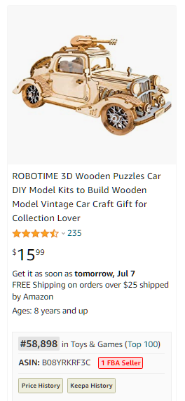 | 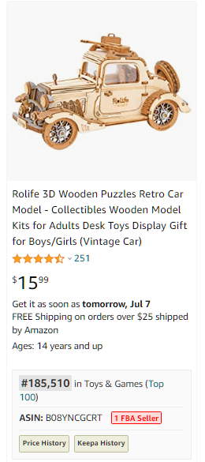 | 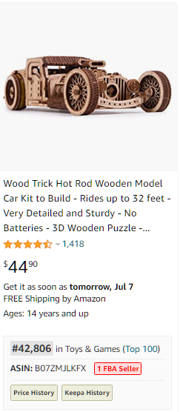
https://www.amazon.com/ROBOTIME-Wooden-Puzzles-Vintage-Collection/dp/B08YRKRF3C | https://www.amazon.com/Rolife-Wooden-Puzzles-Retro-Model/dp/B08YNCGCRT | https://www.amazon.com/Wood-Trick-Wooden-Model-Build/dp/B07ZMJLKFX
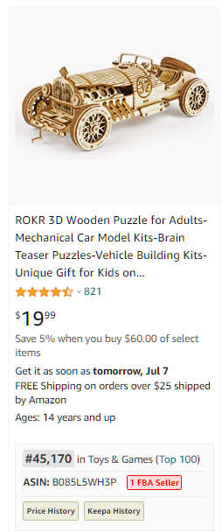 | 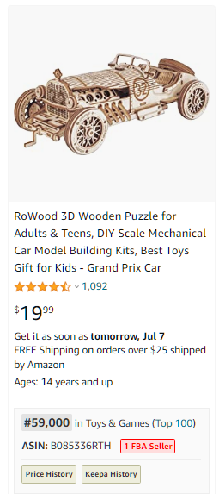
https://www.amazon.com/ROKR-Adults-Mechanical-Kits-Brain-Puzzles-Vehicle-Kits-Unique/dp/B085L5WH3P | https://www.amazon.com/RoWood-Wooden-Puzzle-Mechanical-Building/dp/B085336RTH

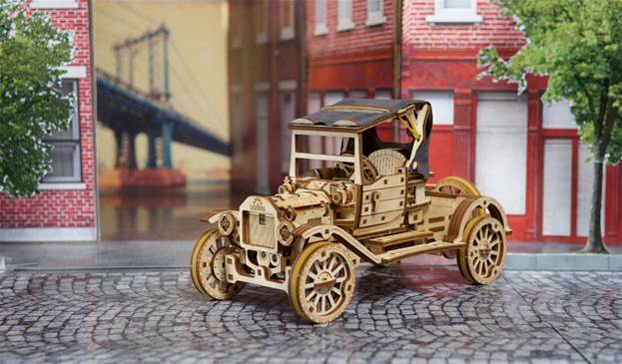
BULLETS

No | TEXT | COMMENTS
Bullet 1 | Vintage design: The Retro Car UGR-T 3D wooden puzzle pays homage to the dawn of the automobile age. Our retro model kits for adults keep the dust of the beautiful antique old cars
Bullet 2 | Amazing detailing: Just like all UGEARS model kits for adults and engineering toys for kids, this vintage car model kit is rich in precise details. You can open the doors and the hood, raise and lower the roof, turn the steering wheel, and more
Bullet 3 | Joyful experience: Prepare for 7+ hours of assembly fun. Vintage car building kits for adults will delight experienced modelers and fans of historic cars alike. Excellent model kits for assembling solo or in good company
Bullet 4 | Smooth ride: Wind the spring-powered motor using the built-in ratchet key, place this mechanical model on a flat surface as you hold it with one hand, press "start," then release it and watch it go
Bullet 5 | Precious gift: A UGEARS classic model car kit is a great holiday, birthday, or anytime gift and a stylish addition to any interior. Reward yourself or delight your loved ones with the gorgeous Retro Car UGR-T

DESCRIPTION
In the mood for a relaxing drive?

The Retro Car UGR-T is a stylish new addition to UGEARS' ever-growing collection of historic and modern cars, racers, motorbikes, trucks and other outstanding wooden toy cars.

You’ll appreciate:

The model building adventure: It will take 7+ hours to assemble this advanced engineering kit. Our DIY project for adults and kids is perfect for family bonding and spending quality time together. Children can snap the pieces out, sand them and set them up for assembly while adults put the pieces together.

Everything in the box: The parts for this vintage car model kit are pre-cut by laser on plywood and come with all necessary tools and even extra parts. The illustrated instructions in 11 languages ensure a successful, frustration-free build.

Outstanding features: All UGEARS laser-cut wooden models are rich in precise, beautiful details, and the Retro Car UGR-T mechanical puzzle is no exception. You’ll love the functional convertible fabric roof; the doors that open; smooth gear movement; realistic sound of a rumbling motor, and more.

Smooth rides: Once assembled, this historic car is ready for graceful rides and imaginative play. Crank the 3D car up, place it on a flat surface as you hold it with one hand, press "start," then release it and watch it go. The car has forward, neutral, and reverse gears.

Beautiful gift: This wooden toy car will delight skilled modelers, hobbyists and lovers of antique cars.

Expand your fleet of vintage toy cars with the graceful Retro Car UGR-T today.

