1. Creating a personal account for Perfect Money
2. Logging into the Perfect Money account
3. Restore login and password in Perfect Money
4. How you can refill your account in Perfect Money?
5. How to withdraw from Perfect Money?
6. Payment process
7. Configuring the security of your personal account in Perfect Money
8. SMS Authentication Perfect Money
9. Protecting your Perfect Money wallet with a code card
10. Advantages and disadvantages of Perfect Money

Creating a personal account for Perfect Money

Perfect Money is a payment system , which works through the Internet and places great emphasis on cryptocurrencies , especially - on Bitcoin. Below will be told , how to become a member of this payment system and how to use it.

Registration on the official website perfectmoney.is

How to register:

1.Go to the official website of Perfect Money.
2. Looking for the "Registration" button

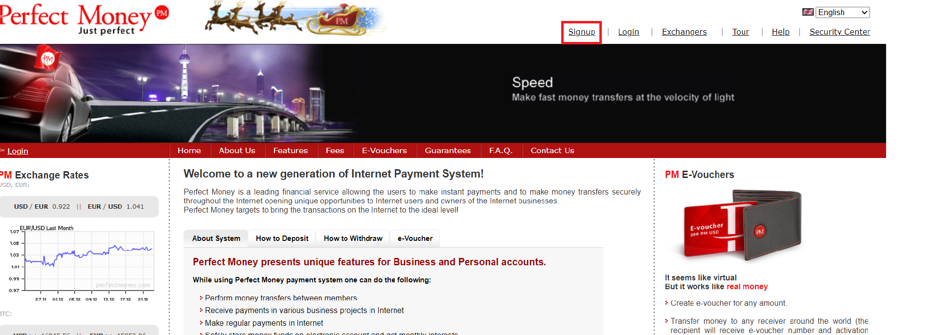

3. Where will be open a large form for entering data. There are both mandatory and optional fields to fill in. And there is a nuance - the field "Phone" is optional, but you still need to fill it in, because without a phone number you will not pass the verification in Perfect Money. Another nuance - you can fill data both in Cyrillic and Latin, the result is perceived by the site the same way.
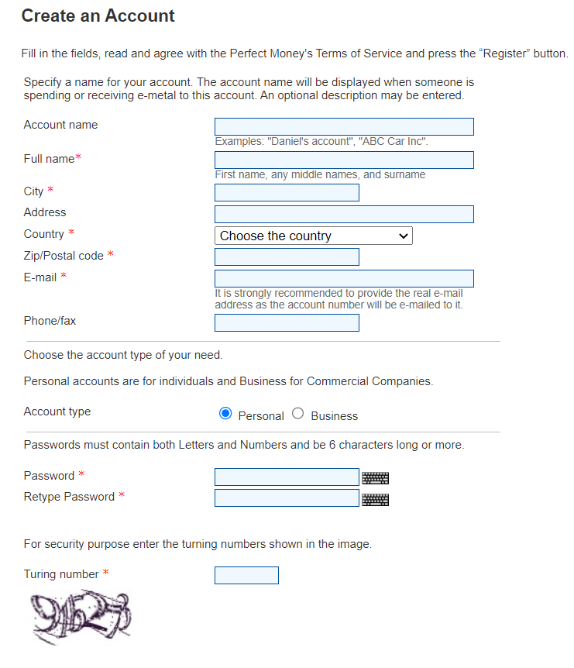
4. When you fill in everything , click on the "Register" button. Then you will be redirected to the next page that says: "Thank you for registering in Perfect Money, your ID has been sent to the mail."

Note: Perfect Money does not allow you to personally set a login, you will need to use a randomly generated ID (which was sent to the mail) to log in to your account.

Logging into the Perfect Money account

To login a personal Perfect Money account, you need to do 3 simple steps:

1. Look for the "Login" button on the site.
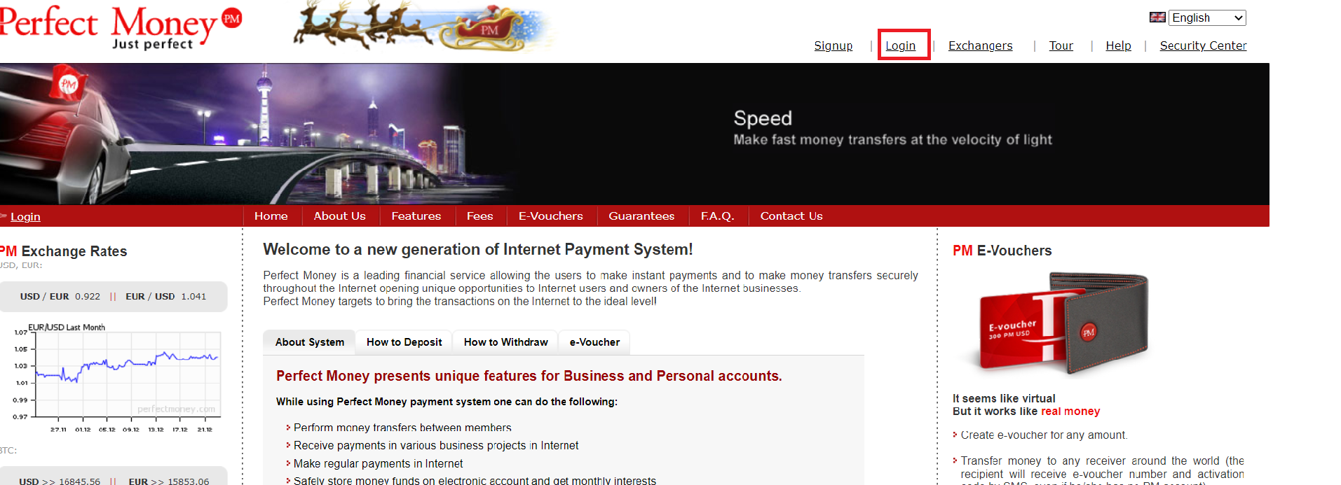

2. Enter your data, click on the login button.

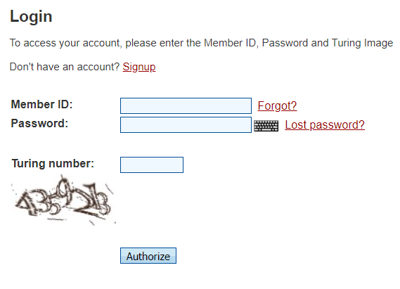
3. You will be taken to the one-time code entry screen. The code will come into an email that was entered during the registration.

4. You have successfully logged into your Perfect Money account.

Restore login and password in Perfect Money

Login (ID) is restored through the mail. On the login page click on "Forgot?", on the next page specify the e-mail. You will receive an email with your login.

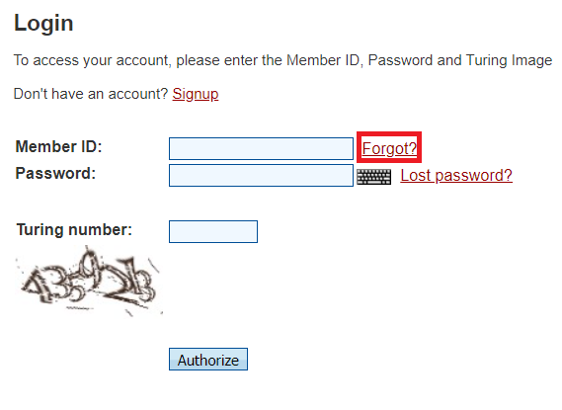

It's much harder to recover a password:

1. On the login page, click on "Lost your password?"
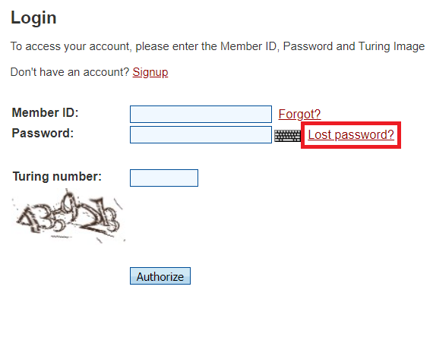

2. This takes you to a page with a recovery request form.
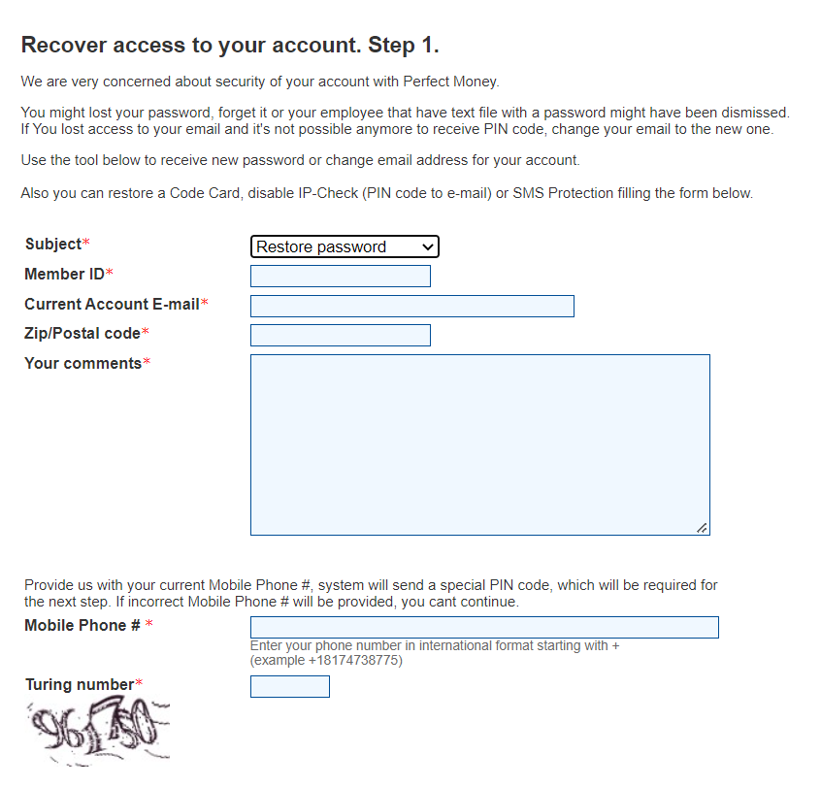

3. Fill in all the data. If you entered all the data correctly - after a while you will be contacted by a security officer of Perfect Money, who will check the rest of the data and ask you to take a picture with your passport. When all the data confirming your identity is with the security service - you will get your password changed.

How you can refill your account in Perfect Money?

The main inconvenience of the system - it does not work with plastic cards.
You can deposit money through bank transfer, electronic vouchers, exchangers, bitcoin, and credit exchange.

With any method of replenishment, the "path" starts from the "Entry" page in the personal cabinet

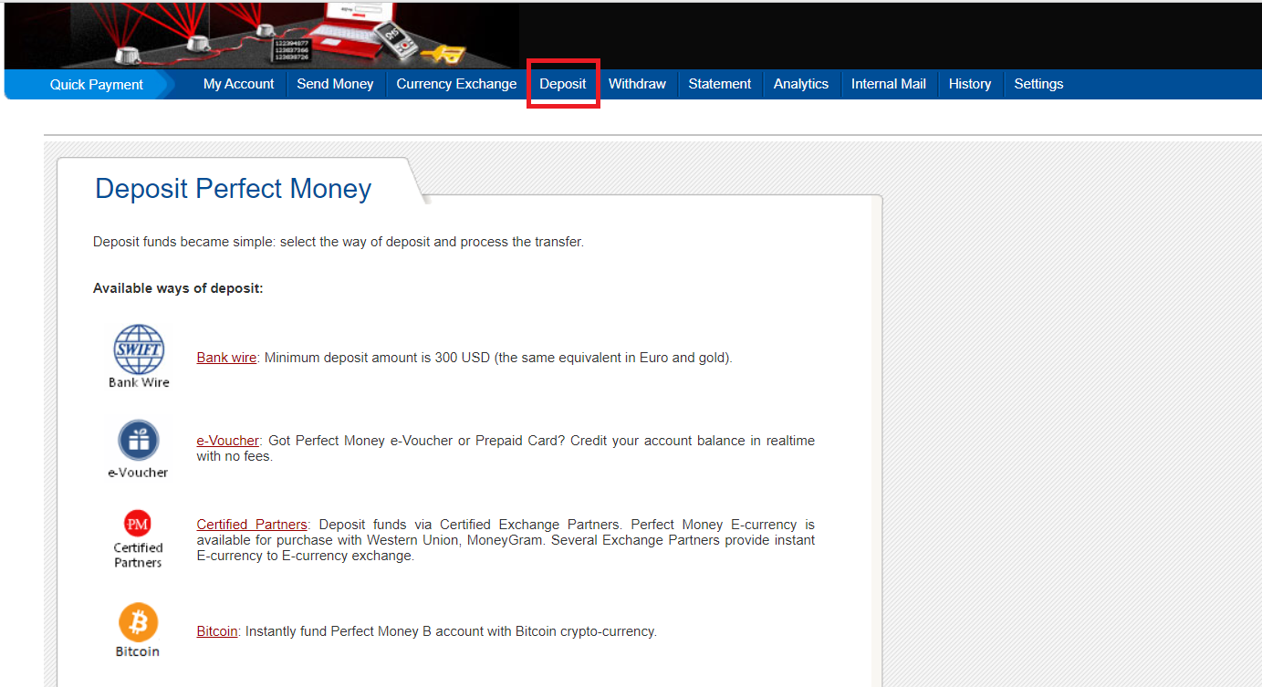

How to withdraw from Perfect Money?

For withdraw is available the same way as for input: bank transfer, voucher, exchangers, cryptocurrency, credit exchange.
The interface for withdrawal is the same as for input, so we'll focus only on the important details.

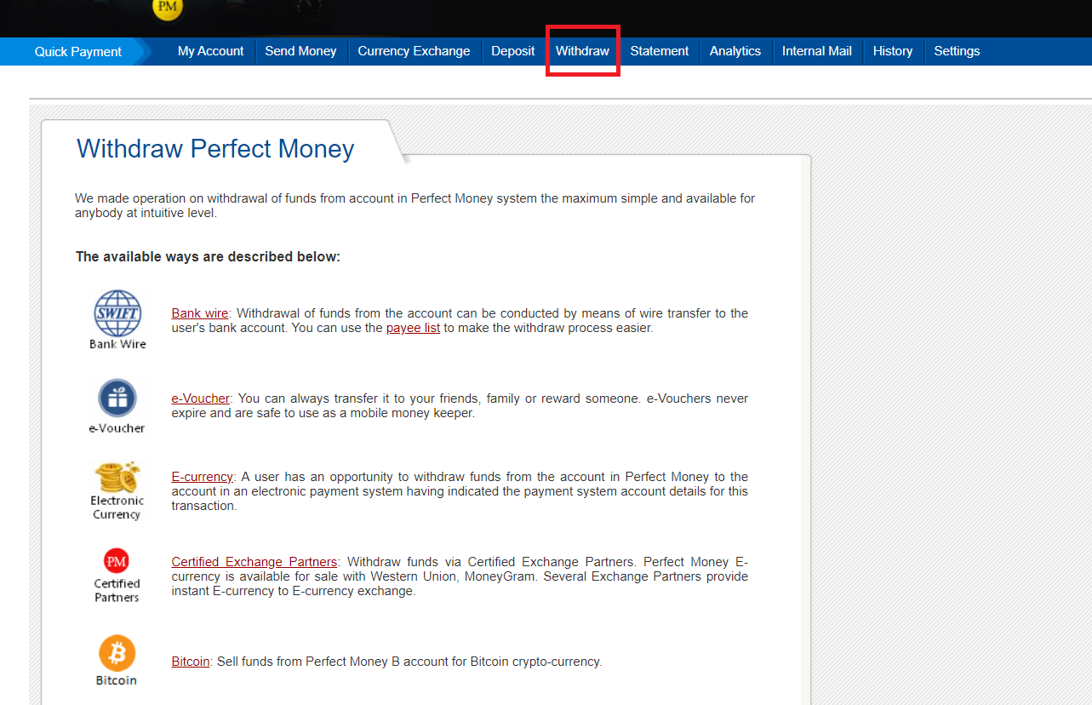

-Bank transfer: the money is credited to the account within 24 hours.

-Voucher: you create a voucher that you can freely sell to someone.

-Electronic money and exchange offices: go to perfectmoney.is/business-partners.html,
Choose an exchanger, set the direction (from Perfect Money to Visa, MasterCard, for example) and withdraw.

-Bitcoin: the transaction is made directly, almost instantaneously.

-Credit exchange: you can not withdraw here, but you can give someone money for interest.

Payment process

If you look at the Perfect Money’s system options for withdrawal of funds , it is noted that it is not very convenient to carry out financial transactions related to transfers, especially for those who do it very rarely and want to get cash as a result. The only way that is offered here is a bank transfer. But there will be a lot of troubles with such kind of transaction because you will have to make an application for withdrawal, in addition, the minimum amount of transfer is $ 100 or the equivalent in another currency. And the money will not come quickly.

Configuring the security of your personal account in Perfect Money

In the personal account of Perfect Money it is possible to configure security by yourself. The system provides IP verification at the initial stage - when you change your IP address, special confirmation code will be sent to your email. It is impossible to log into the wallet without it.
There is an opinion that identity confirmation by email is very unreliable and should be disabled. It is desirable to use additional Perfect Money security settings when logging in to your personal account.

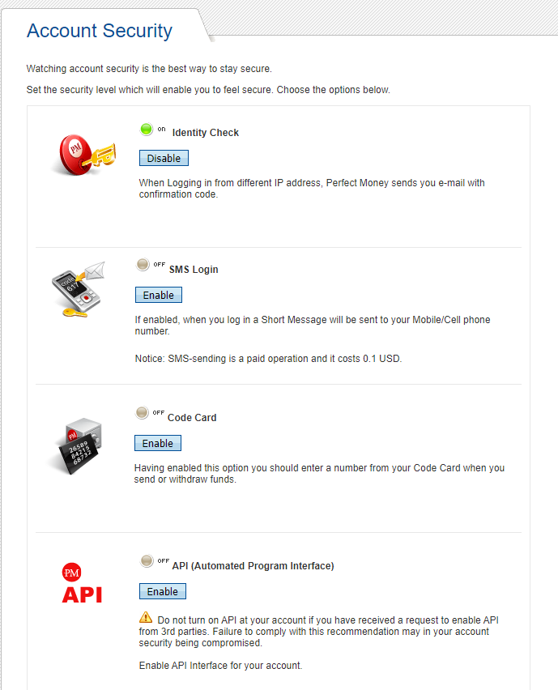

SMS Authentication Perfect Money

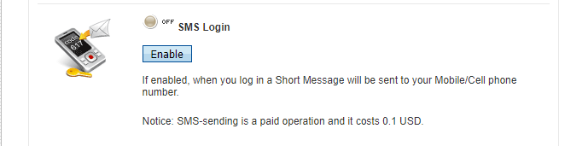

Authorization by text message is available to both verified and anonymous users. The cost of a text message is 10 cents. When you log into your Perfect Money account, you will receive sms with an authorization code. The creators of the system claim that such identification is a perfect protection against hacking, but not every operator accepts SMS from a foreign number, and messages often come with a long delay or don't come at all.

There are situations when SMS-authorization does not pass through the fault of the operator, and technical support also sends an SMS to accept the user's application. A more convenient and high-quality way of protection is a code card.

Protecting your Perfect Money wallet with a code card

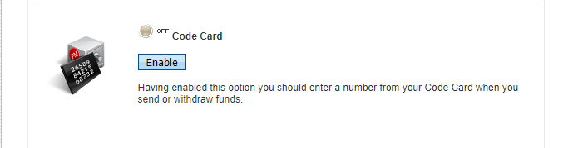

Perfect Money code card comes to your email for your request. It is a picture with a set of numbered codes, called codecard.png. How do these codes work? To confirm any transaction the system asks for one of those codes, which you enter into the appropriate field. A new code card can be requested again, but you will have to enter one code from the old card.

After you receive the letter with code card, write it down to paper and do not store it on a computer or in the mail, to avoid data theft.

There is no live support chat in the system, so all questions are resolved through the internal mail. They are solved slowly, in English, and most often the answers are formulaic. A real dialogue is difficult to achieve.

Advantages and disadvantages of Perfect Money

Advantages: very serious security system, good technical support, the ability to work directly with bitcoin.

Disadvantages: outdated interface, inability to work directly with cards, high commission for transfers and withdrawal (1.99%) for unverified users.

