XXI
It was then that the fox appeared.
"Good morning," said the fox.
"Good morning," the little prince answered politely, though when he turned around he saw nothing.
"I am here," the voice said, "under the apple tree."
"Who are you?" asked the little prince. "You are very pretty!"
"I am a fox," the fox said.
"Come and play with me," the little prince proposed. "I am so sad."
"I can’t play with you," the fox said. "I am not tamed."
"Ah! Please excuse me," said the little prince.
But, after reflection, he added, "What does 'tamed' mean?"
"You’re not from around here," said the fox. "What are you looking for?"
"I am looking for people," said the little prince. "What does 'tamed' mean?"
"People have guns, and they hunt." the fox said. "That’s quite inconvenient. They also raise chickens. That’s the only interesting thing about them. Are you looking for chickens? "
"No," said the little prince. "I am looking for friends. What does 'tamed' mean?"
"That is something that’s been too often neglected," said the fox. "It means to create ties."
"To create ties?"
"That’s right," said the fox. "For me, you are just a little boy just like a hundred thousand other little boys. And I have no need of you. And you have no need of me, either. For you I am just a fox like a hundred thousand other foxes. But if you tame me, we will need each other. You will be the only boy in the world for me. And I will the only fox in the world for you... "
"I am beginning to understand," said the little prince. "There’s a flower... I think she’s tamed me..."
"Possibly," said the fox. "On Earth one sees all kinds of things."
"Oh, but this isn’t on Earth," the little prince said.
The fox seemed surprised. "On another planet?"
"Yes."
"Are there hunters on that planet?"
"No."
"How interesting! Are there chickens?"
"No."
"Nothing’s perfect," sighed the fox.
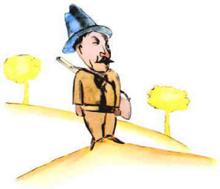
But he returned to his idea.
"My life is monotonous. I hunt chickens; people hunt me. All chickens are just alike, and all men are just alike. So I’m a little bored. But if you tame me, my life will be filled with sunshine. I’ll know the sound of footsteps that will be different from all the rest. Other steps send me back underground. Yours will call me out of my burrow like music. And then, look! You see the wheat fields over there? I don’t eat bread. Wheat is of no use to me. Wheat fields say nothing to me. And that is sad! But you have hair the color of gold. Think how wonderful that will be once you’ve tamed me! The wheat, which is also golden, will remind me of you. And I’ll love the sound of the wind in the wheat... "
The fox fell silent and stared at the little prince for a long time.
"Please…tame me!" he said.
"I’d like to," the little prince replied. 'But I haven’t much time. I have friends to find and so many things to learn."
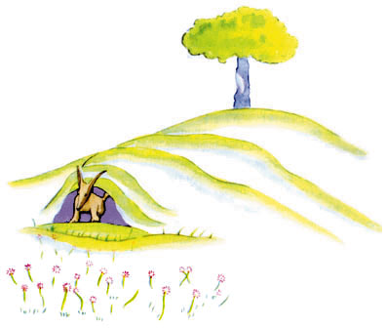
"The only things you learn are the thigs you tame," said the fox. "People have no time to learn anything. They buy things ready-made in shops. But there are no shops where you can buy friends, people no longer have friends. If you want a friend, tame me! "
"What do I have to do for it?" asked the little prince.
"You have to be very patient," the fox answered. "First you’ll sit down a little far from me, over there, in the grass. I’ll watch you out of the corner of my eye and you won’t say anything. Language is the source of misunderstandings. Day by day you will be able to sit a little closer to me..."

The next day the little prince returned.
"It would have been better to return at the same time," the fox said. "For example, if you come at four in the afternoon, I’ll begin to be happy by three. The closer it gets to four, the happier I’ll feel. By four I’ll be all excited and worried. I’ll discover what it costs to be happy! But if you come at any time, I’ll never know when I should prepare my heart ... There must be rites."

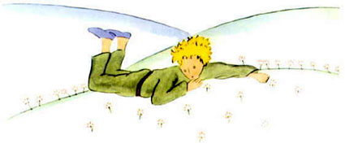
"What is a rite?" asked the little prince.
"That’s another thing that’s been too often neglected," said the fox. "That’s the fact that one day is different from the other days, one hour from the other hours. For example, my hunters have a rite. Every Thursday they dance with the village girls. So Thursday is a wonderful day for me! I can take a walk all the way to the vineyards. But if the hunters danced whenever they chose, the days would be just alike, and I’d have no holiday at all."
That was how the little prince tamed the fox. And when the time to leave was near:
"Ah," the fox said, "I shall cry."
"It is your own fault," the little prince said. "I never wished you any sort of harm but you wanted me to tame you..."
"Yes, of course," the fox said.
"But you are going to cry!" said the little prince.
"Yes, of course," the fox said.
"Then you get nothing out of it?"
"I get something," the fox said, "because of the color of the wheat."
Then he added, "Go look at the roses again. You will understand that yours is the only rose in all the world. Then come back to say goodbye to me, and I will make you the gift of a secret."
The little prince went to look at the roses again.
"You are not at all like my rose. You’re nothing at all yet," he told them. "No one has tamed you and you have tamed no one. You’re the way my fox was. He was just a fox like a hundred thousand other foxes. But I have made him my friend, and now he is the only fox in all the world."
And the roses were humbled.
"You are beautiful, but you are empty," he went on. "One couldn’t die for you. Of course, an ordinary passerby would think that my rose looked just like you. But my rose, all on her own, is more important than all of you together, because she’s the one I’ve watered. Since she’s the one I put under glass. Because she’s the one I sheltered behind the screen. Since she’s the one for whom I killed the caterpillars (except the two or three for butterflies). Because she’s the one I listened to, when she complained, or boasted, or even sometimes when she said nothing at all. Because she is my rose."
And he went back to the fox.
"Goodbye," he said.
"Goodbye," said the fox. "Here is my secret and it’s very simple: One sees clearly only with the heart. Anything essential is invisible to the eyes."
"Anything essential is invisible to the eyes," the little prince repeated in order to remember.
"It is the time you spent on your rose that makes your rose so important."
"It is the time I spent on my rose…" the little prince repeated in order to remember.
"People have forgotten this truth," the fox said. "But you mustn’t forget it.
You become responsible, forever, for what you’ve tamed. You are responsible for your rose..."
"I am responsible for my rose," the little prince repeated in order to remember.

