Title: The most actual rates of Ethereum only on our site!
Description: On our site, you will find the most actual exchange rates of Ethereum cryptocurrency and be able to calculate its value online.
Current rate and calculation of Ethereum on our website

Licenses and security
We work in over 180 countries and almost all US states. We can calculate the value of cryptocurrency and buy it regardless of your location. | Each transaction is reviewed by a Financial Crimes Enforcement Network licensee. Its actions are coordinated by the Treasury Department.

Benefits of cooperation with Paycot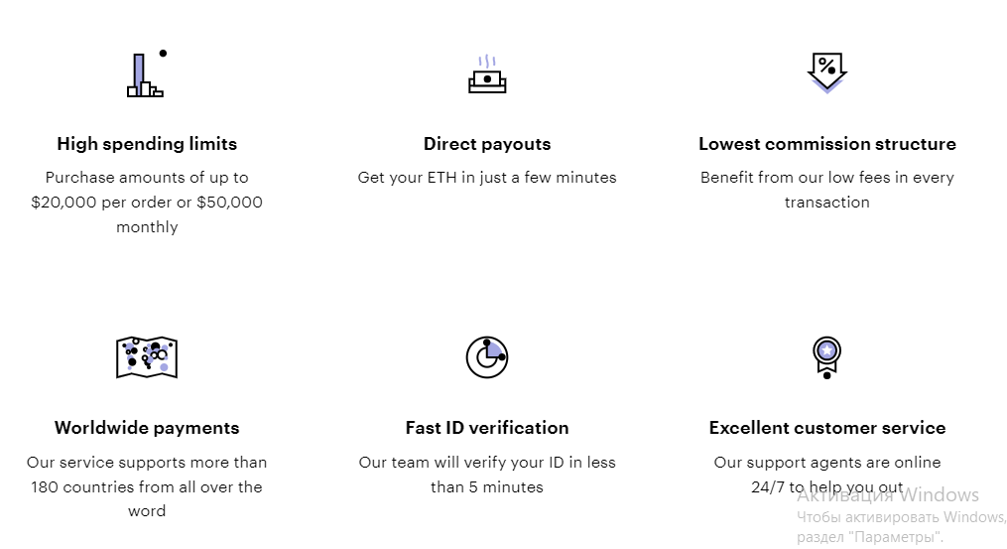

Higher limits  Our clients perform operations up to 50 000 USD monthly |  | Quick transactions  Transactions take only a few minutes to complete. |  | Low transaction fees  Our customers can save on Ethereum buy/sell due to low fees.
Transactions are conducted by customers from all over the world  Ethereum payments and transactions pass through Paycot in over 180 countries. |  | Fast verification  Registration takes no more than 5 minutes. |  | Support experts  Our staff is available 24/7 to help with Ethereum calculations and analytics
Why pay attention to Ethereum
The most popular cryptocurrency is bitcoin, but Ethereum is clearly in second place. It has its advantages:
- Ethereum is not just a cryptocurrency. but an open network for different applications to use. It is used to launch other cryptocurrencies, establish ownership of digital innovation, etc.;
- If a client needs a powerful tool that is profitable in practice, it is worth exploring this cryptocurrency.
Study all the risks and when you're ready, click buy cryptocurrency now!

Package offers for our customers
Our company offers cooperation under the following conditions
Paying 1000 USD  ⇅  you will get 0.8177 ETH. | Paying 5000 USD  ⇅  you will get 4.0975 ETH. |  | Paying 10000 USD  ⇅  you will get 8.1962 ETH. |  | Paying 20000 USD  ⇅  you will get 16.385 ETH.

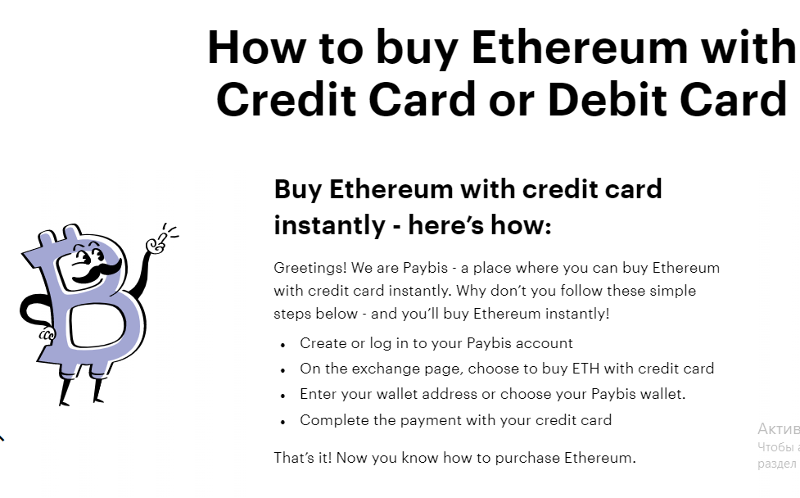
Specify your cryptocurrency
Paycot has the highest level of transaction security. Users can choose how exactly to store cryptocurrency or credit it to a wallet inside the site. The security of such a wallet is guaranteed. The cryptocurrency itself will be stored inside the system. Accordingly, you can conduct all transactions with it much faster. Both beginners and experienced traders will like this way!
How fast are our transactions?
Our company conducts instant Ethereum buy/sell transactions. The cryptocurrency will be credited to the buyer's specified account in a minute after confirmation of the account and the payment made;
Money appears on your account after a few minutes. Unfortunately, technically the operation requires such time. That's why you can close the deal, go get a coffee, and the cryptocurrency will already arrive in your wallet!
In rare cases there are failures. In case Ethereum is not credited to your account after 10 minutes, you need to write to our support team. Specialists hold consultations around the clock and are ready to help clients in solving their problems.
Can I use cards to process transactions?
Banks offer credit and debit cards to users. With our system, you can use both for transactions. Their processing times are identical, as are the steps to create and process a payment. Use your cards for immediate Ethereum purchases on our site according to our calculator rates!
Use apps to pay and buy Ethereum!
Cryptocurrency transactions using bank cards are already used by many. But there are other transaction variations as well. Some of them are more convenient. For example, these are transactions using Apple smartphones. For their owners to do the following steps:
- open the Safari browser and scroll up the page, choosing to start a purchase with the card;
- go to the page with payment details and specify Apple Pay as the method;
- authorize the transaction and wait for the cryptocurrency to be credited!
In this method, you do not have to enter card information. This reduces transaction processing time by several times.
How to use Ethereum!
Everyone understands how to buy and sell the currency, but it's not clear where to apply it after you buy it. Most often cryptocurrency owners:
- keep it until the rate goes up to make money on the exchange rate difference;
- pay for goods and services;
- exchange it for more profitable cryptocurrencies.
The client should remember that there are investment risks in such transactions. Since we've dealt with all the points, in theory, you can open the menu and make your first purchase of Ethereum!
Why can you trust our site?
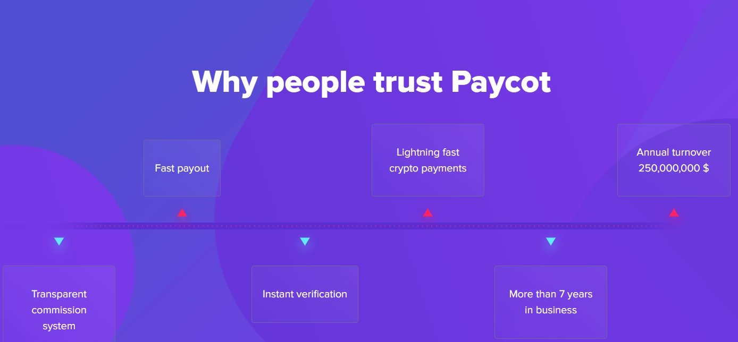

Egal Work | Fast Verification | Instant addition of cryptocurrency
Our site is fully compliant with US and UK regulations. | Registration only takes a few minutes. | Transactions are processed in seconds.
Wide range of currencies and a large number of users  We work with all popular cryptocurrencies and the total turnover reaches 250 000 000 USD. | Highly qualified support  Our employees are ready to consult clients round the clock on any questions. | Positive reputation among the beginners and professionals  Our company has had a positive reputation in the cryptocurrency exchange market for 7 years of operation.

Over 250 000 000 USD turnover in cryptocurrency exchange
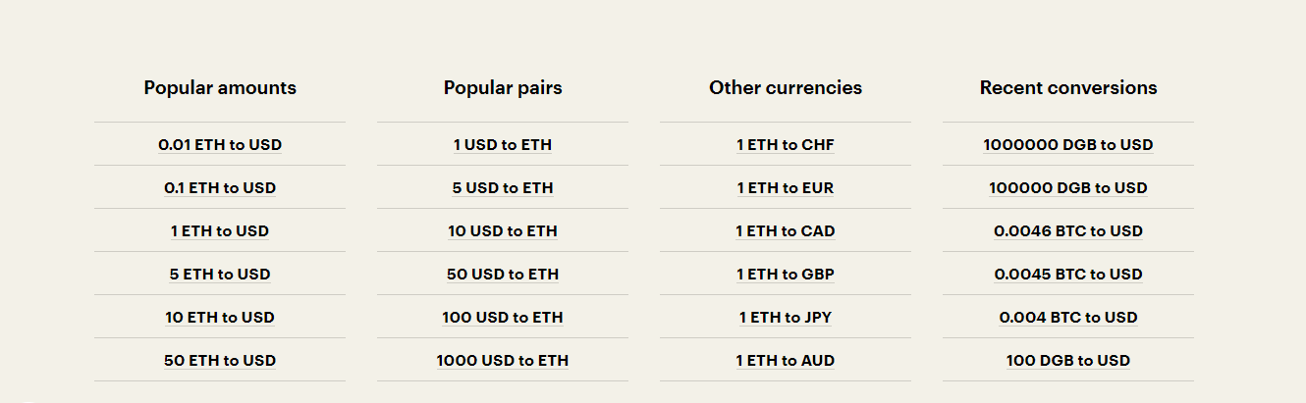
Advantages of our Ethereum calculator
01 | A simple interface with extremely useful information and no annoying small details
02 | Processing not only with USD but with 45 different currencies
03 | Analysts provide at once calculations of the most popular amounts and currency pairs.
04 | Purchase is done directly on the page on the above points!
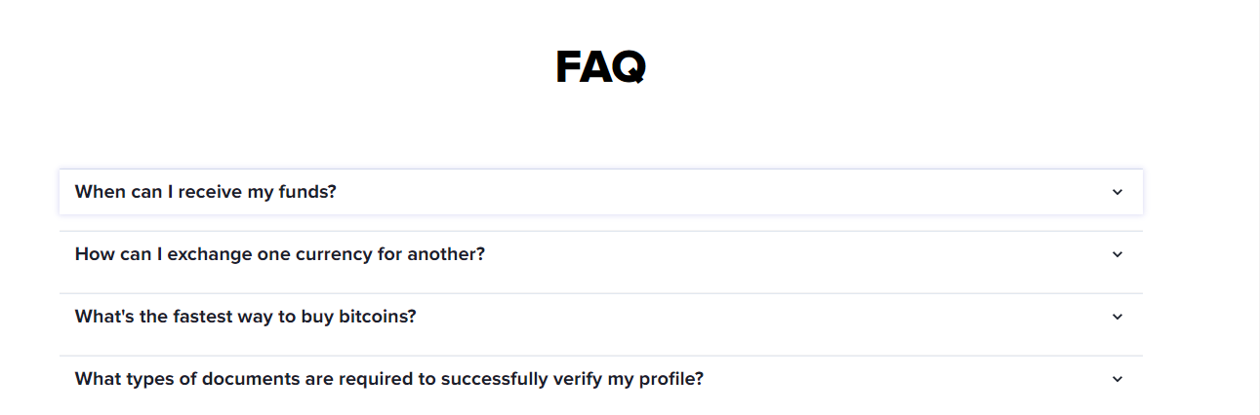

How do I use the Ethereum calculator?
Specify your currency and amount and you will immediately see the amount of Ethereum to be purchased and credited to your account.
Can I buy Ethereum with a non-standard currency?
Our calculator works with 45 of the world's most popular currencies, each of which can be used to buy/sell Ethereum.
Is it safe to conduct such transactions on the site?
Our website has all the encryption protocols in place for every transaction, so any transactions are secure. It is safe. Our company adheres to strict standards and ensures complete transaction security, by EU, UK, and international exchange regulations.

