About us / Projects / Contacts RU / EN Consult / Discuss the Project
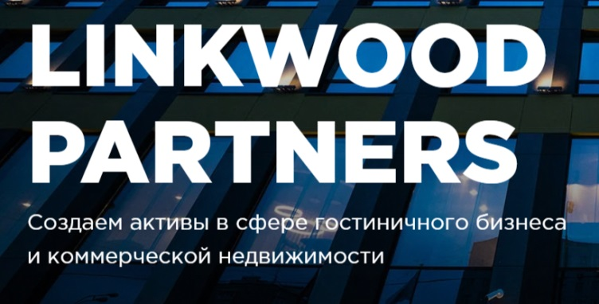
We create assets in the fields of hospitality and commercial real estate
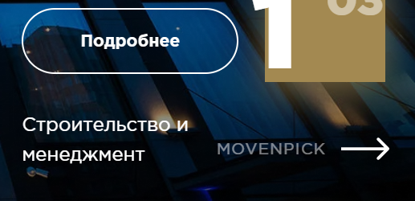
[Кнопка «Подробнее»] – Learn More Construction and management
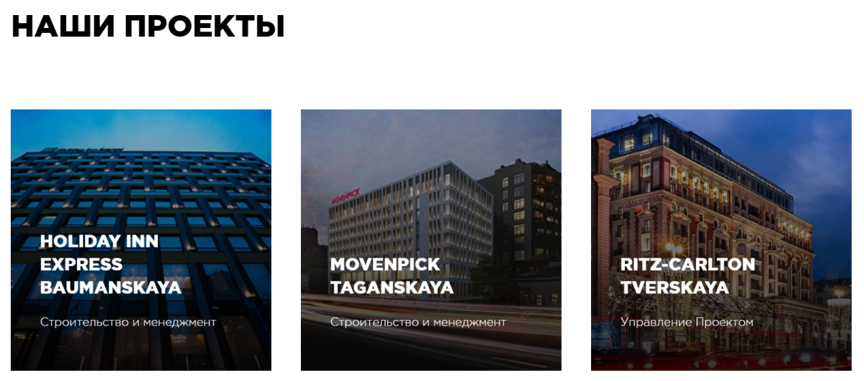
OUR PROJECTS
Holiday Inn Movenpick Ritz-Carlton Construction and Management Construction and Management Project administration
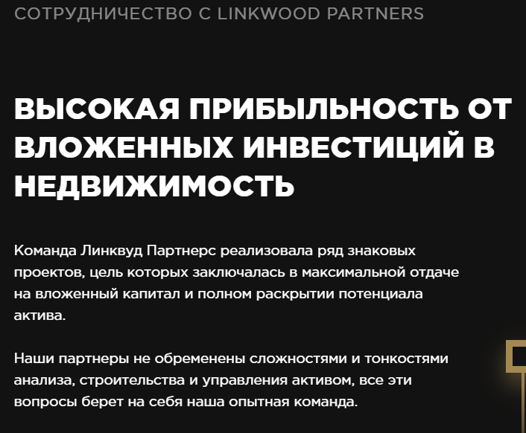
PARTNERSHIP / COOPERATION / WORKING WITH LINKWOOD PARTNERS¹ HIGH PROFITABILITY FROM THE REAL ESTATE INVESTMENTS
The Linkwood Partners group has executed a number of iconic projects, which aimed at maximizing the efficiency of the invested finances and achieving the fullest potential of the asset.
Our partners are never saddled with sophistication and complexities of the analysis, building or overseeing the asset. All of these nuances are handled by our well-trained team.
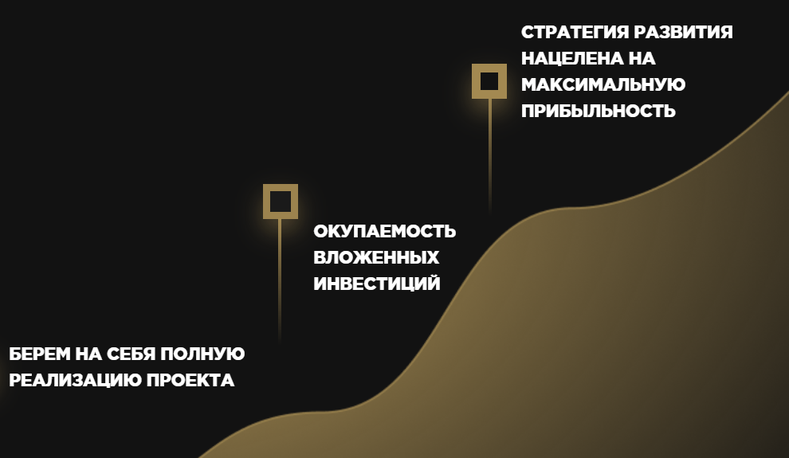
- We take over the entire process of project realization;
- Payback of your investments;
- Development strategy which aims at the maximal profitability;
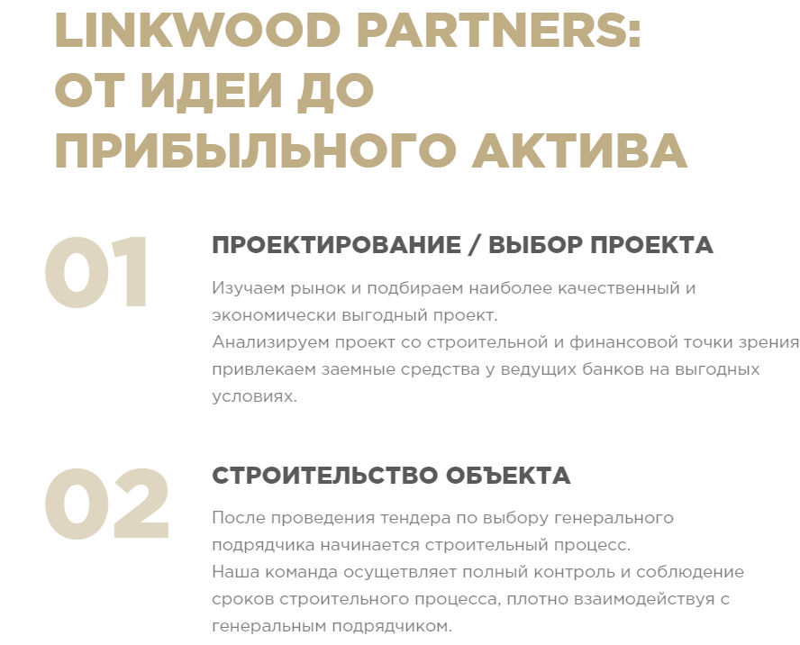
LINKWOOD PARTNERS: from an idea to the profitable asset
01: ESTIMATING / CHOOSING THE PROJECT We closely examine the market and choose the most qualitative and economically beneficial project. We then analyze the project from the construction and financial perspective and attract the loan funds from major banks on favorable terms.
02: CONSTRUCTION
Construction follows immediately after conducting the tender and choosing the general contractor. Our team strictly adheres to the established schedule and carefully oversees the entire process, closely cooperating with the general contractor.
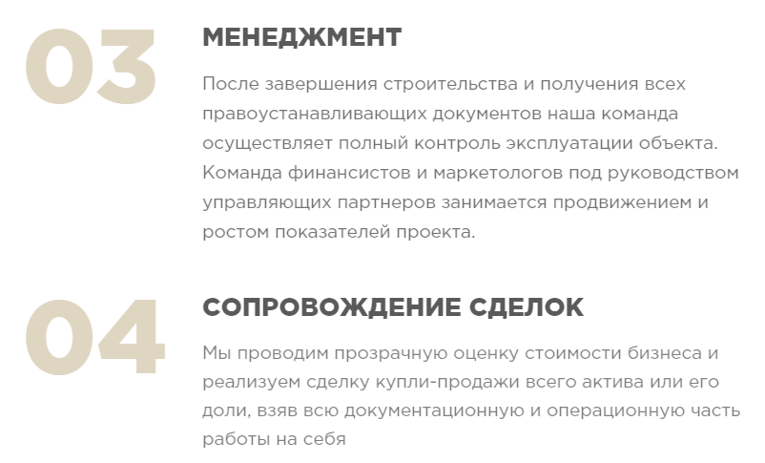
03: MANAGEMENT
After the construction is finished and all the constitutive documents are obtained, our team continues to closely manage the object. A group of financiers and marketers will promote and advance the project’s growth performance under the strict supervision of managing partner.
04: TRANSACTION ADVISORY
We conduct transparent business value estimation and implement purchase and sale transactions of the entire asset or its segment. We take responsibility for the documentation and operational part.
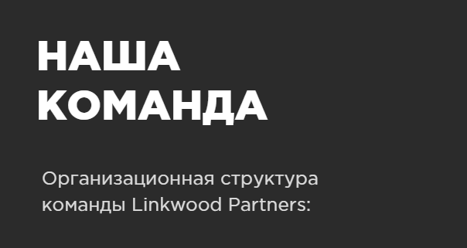
OUR TEAM
The organizational structure of Linkwood Partners’ team
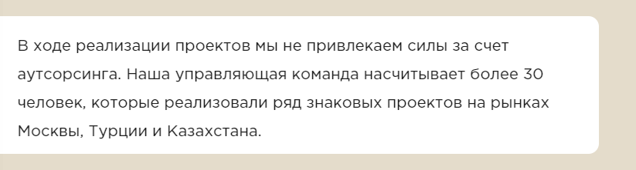
We do not recruit human resources through outsourcing during the project implementation. Currently, our management team comprises more than 30 individuals, who have executed a number of iconic projects on markets of Moscow, Turkey and Kazakhstan.
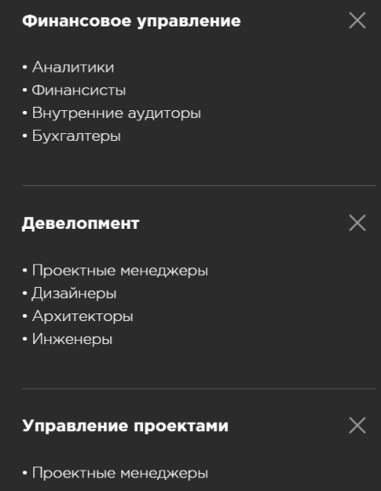
Financial accounting
- Analysts / evaluators
- Financiers
- Internal auditor
- Accountant
Development
- Project managers
- Designers
- Architects
- Engineers
Project management
- Project administrators
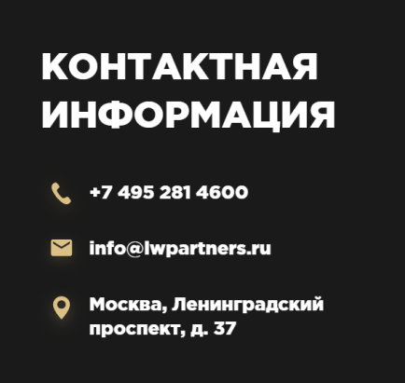 Contact Information / Moscow, 37 Leningrad Ave.
 Contact us / Your mobile
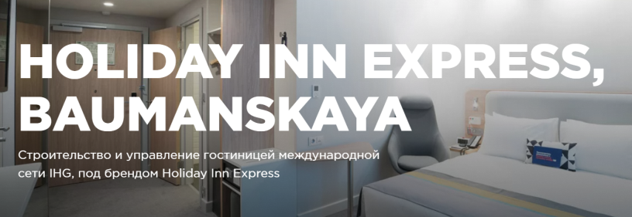
Construction and hotel management: IHG international network, under HIE brand
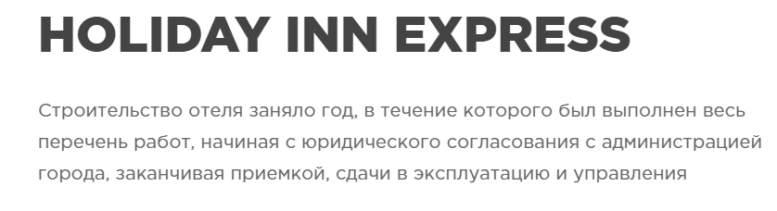
Hotel construction procedures took 1 year to be completed and a whole statement of work was executed, from the city administration’s legal approval to acceptance, commissioning and management. 01: Project key information / Address: Baumanskaya Station, 2A Perevedenovsky al., Moscow
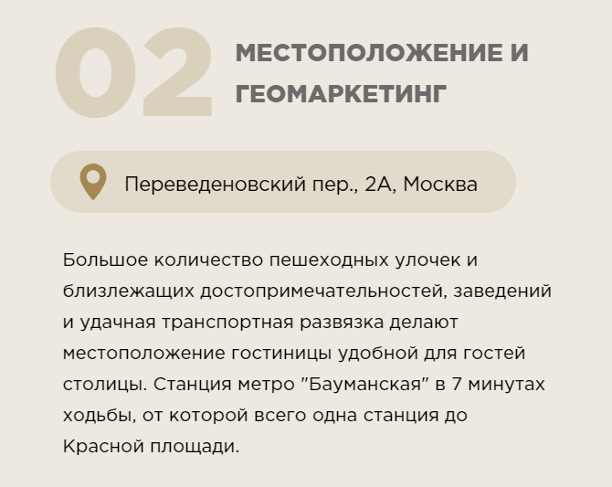
02: Location and Geomarketing: 2A Perevedenovsky al., Moscow.
A significant number of pedestrian streets, nearby attractions, entertainment facilities and advantageous road interchange make the location incredibly convenient for guests and visitors. Baumanskaya metro station is only 7 minutes away by foot and the Red Square is just 1 station away.
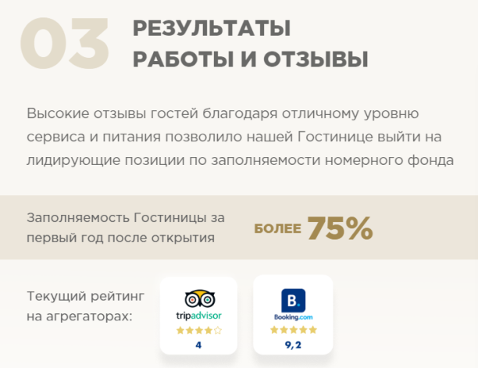
03: Performance outcome and reviews
Positive feedback and high ratings from guests, due to the excellent level of service and dining, allowed our Hotel to take the leading positions in the accommodation inventory occupancy rate.
Occupancy rate within the first year after the opening More than 75%
Current ratings:
 Project’s photo gallery
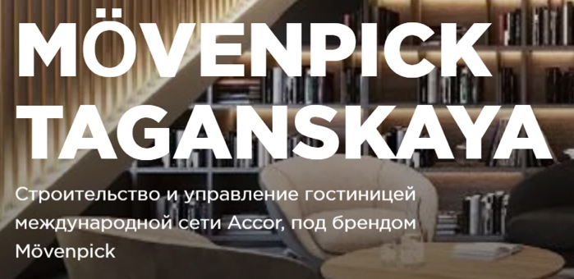
Construction and hotel management: Accor international network, under Movenpick brand
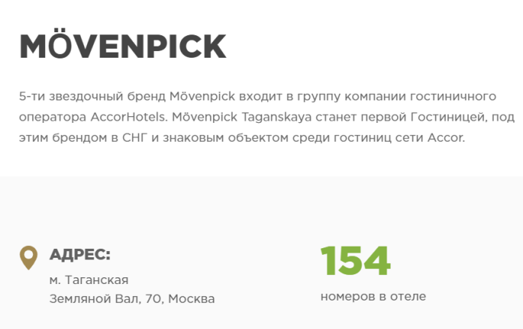
The 5-star brand Movenpick is a member of the AccorHotels hospitality operator. Movenpick Taganskaya will become the very first Hotel under this brand in CIS and consequently will become a landmark object among other hotels of Accor network.
ADDRESS: Taganskaya metro station / 70 Zemlyanoi Val Str., Moscow / 154 hotel rooms
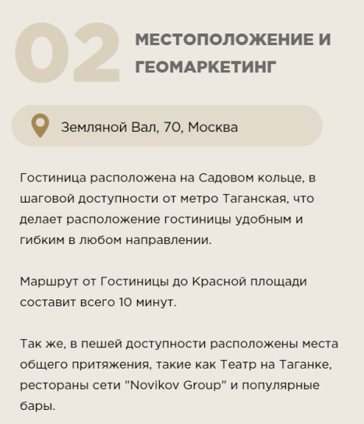
02: Location and Geomarketing / 70 Zemlyanoi Val Str., Moscow
The Hotel is located on the Garden Ring, within a walking distance from Taganskaya metro station, which makes the location convenient and flexible for each destination.
It takes only 10 minutes to get to Red Square from the hotel.
Such public spaces as Taganka Theatre, a chain of restaurants “Novikov Group” and famous bars are situated within the walking distance as well.
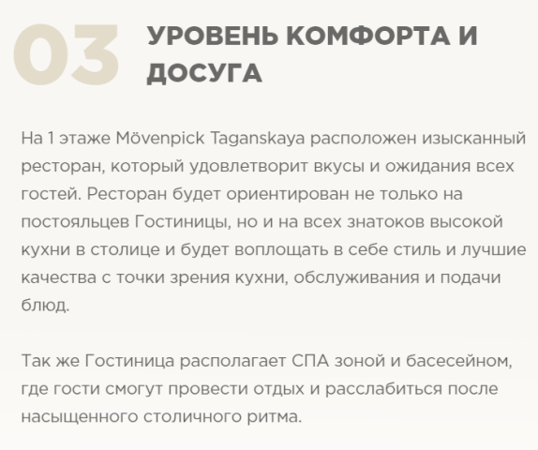
LEVEL OF COMFORT AND LEISURE
The 1 floor of Movenpick Taganskaya is occupied with a gourmet restaurant, which will satisfy the tastes and expectations of every visitor. It is not solely oriented towards the guests of the hotel, but rather towards every fine dining lover in the capital. The restaurant will employ the best nuances of style, customer and plate service.
Furthermore, the Hotel has its own SPA zone with a swimming pool, where guests will be able to rest and relax after a busy eventful pace of the city.
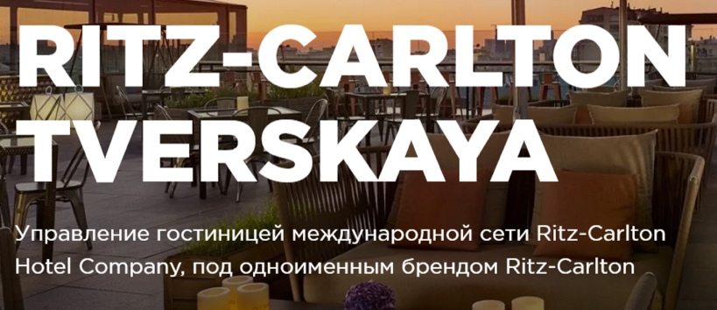
Construction and hotel management: Ritz-Carlton Hotel Company international network, under the Ritz-Carlton self-titled brand.
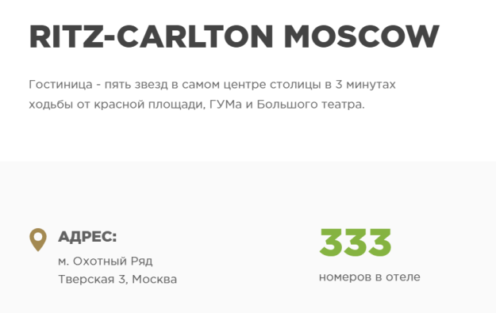
The 5-star Hotel in the heart of the capital-city is located only 3 minutes away from the Red Square, GUM and Grand Theatre. Address: Okhuntiy Ryad metro station / 3, Tverskaya Str., Moscow
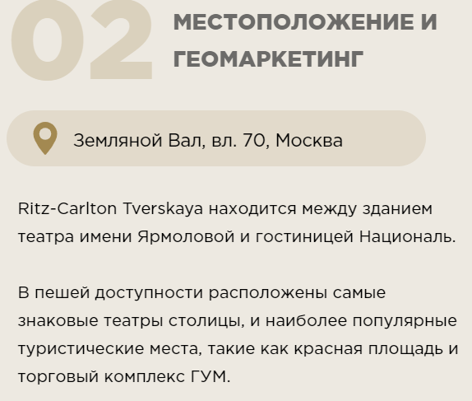
02: Location and geo-marketing
70, Zemlyanoi Val, Moscow
Ritz-Carlton Tverskaya is situated between Yarmolova theatre hall and the National Hotel.
The most iconic theatres of the country, as well as the most popular sightseeing like the Red Square and GUM, are within the walking distance.
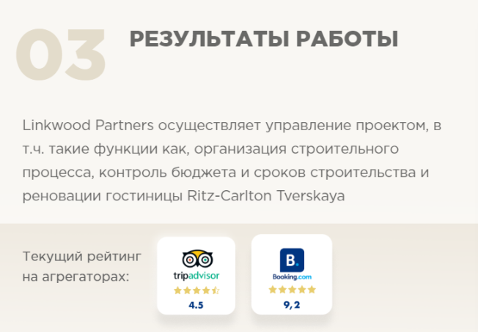
03: Performance outcome
Linkwood Partners implement the project management, including such functions as construction process arrangement, budget and construction schedule management as well as the renovation of the Ritz-Carlton Tverskaya Hotel.
Current ratings:

1 – Самый подходящий перевод «Сотрудничества» – это Partnership. Однако при сочетании с LINKWOOD PARTNERS, фраза в целом звучит нелепо. Cooperation тоже подходит, но я бы упростил и использовал просто слово «working»

