OZONATION OF NITROGEN OXIDES IN COATED-WALL FLOW REACTOR
Pavlo Karnozhytskyi
The affiliation of the author: Lodz University of Technology (LUT),
Faculty of Process and Environment Engineering, Department of Environmental Engineering
Supervisor: Ph.D., D.Sc., Eng. Hab. Eng., Professor of LUT Ireneusz Zbiciński

Abstract: Nitrogen monoxide is being emitted into the atmosphere as a result of combustion processes occurring in nature and as the form of bacterial biological processes product. The total amount of oxides of nitrogen from natural sources globally estimated at 450 million tons/year. Another factor of NO_{x} production is anthropogenous activity. The statisticians noted that in 2007 among 890000 of total nitrogen oxides emission almost 70% were given by the transport and the power plants. As a component of the exhaust gas NO_{x} has to face absorption in solution and reduction. Nitric monoxide is thermodynamically unstable and has low level of solubility in water (0,032 g/dm³).
In order to transform the NO into the higher form of nitrogen oxides, an oxidant is needed. Such oxidant can be the ozone. The ozonation is well-used process for different gaseous and liquid substances treatment and has recommended itself as strong and effective oxidant.
This stage’s result is designing and building of coated-wall reactor CFD model for the injection of ozone and mixing it with nitrogen oxides. After, such parameters of the process as amount of O₃ needed for the ozonation, amount of oxidized NO_{x}, temperature and residence time are going to be explored. Another task is to explore the changes in the process within different parts of the reactor. For the experimental part of the studies, the Fourier transform infrared spectroscopy (FTIR) is going to be used.

Keywords: nitrogen oxides, flow reactor, ozone, modelling

1. Introduction
Nitric oxide performs the role of neurotransmitters in the body, develops the immune responses, and participates in the volatile memory system. At the same time, it has an adverse effect on hemoglobin, which turns into nitrogemoglobin. The impact of NO_{x} on the human body is about 10 times stronger than the effects of CO. Nitrogen oxides are directly connected with such environmental bombs as acid rains, ozone layer depletion and oth.
Because power plants and boilers constantly produce the exhaust gas containing such various pollutants, as nitrogen oxides, sulfur dioxides and mercury the proper removal of multiple pollutants with low investment and working costs attracted considerable attention [Sun, 2014]. So, the possibility of making the process more economically valuable has to be explored.
Attempts to develop effective methods for purifying gases are conducted in different parts of the world for at least last 30 years and. Adsorption, catalytic reduction and non-catalytic reduction with ammonia are among the most common methods. In general there are three ways to handle the problem of NOx emission, they could be: i) reduced to benign product, N2; ii) absorbed in various solutions; iii) adsorbed [Skalska, 2010].
It should be mentioned that nitric monoxide is thermodynamically unstable and has low level of solubility in water (0,032 g/dm3) to compare with other nitrogen oxides (213 g/dm3 for NO₂, 500 g/dm3 for N₂O₅) [Dora, 2009].
In order to transform the NO into the higher form of nitrogen oxides, a strong oxidant is needed. Such oxidant can be the ozone – the 3-oxigen atom molecule produced in the nature by the ultraviolet solar radiation photolysis of O₂. German scientist Christian Friedrich Schonbein first discovered it in 1839 and in 1857, another German scientist and inventor Werner von Siemens created the first known ozonation technical facility.
The reaction between ozone and nitrogen monoxide are carried with ozone decomposition. O₃ is one of the most efficient and promising substances from the practical point of view. On the other hand, its lifetime is quiet short, as well as the process is quiet costliness because of the oxygen demand and high energy consumption [Modlinski, 2013]. The possibility of making the process more economicaly acceptable has to be explored.
In general, the reaction between NO_{x} and ozone includes the next chain:

- $NO+O_{3}→NO_{2}+O_{2}$;
- $NO_{2}+O_{3}→N_{2}O_{3}+O_{2}$;
- $NO_{2}+NO_{3}→N_{2}O_{5}$

Important moment that cannot be ignored is that ozone start to decompose becomes significantly high for temperatures above 120 ºC [Stamate, 2012]:

- $O_{3}→^{t}O_{2}+O$

The absorption of the NO_{x} leads two the formation of nitrous and nitric acids [Chacuk, 2007]. In case of the NO-NO₂ watering, the redox reaction is occurring:

- $NO_{2}+N{O+H}_{2}O→2HNO_{2}$

The product of N2O5 dissolving is nitric acid:

- $H_{2}O+N_{2}O_{5}→2HNO_{3}$

The objective of this project is to design the coated-wall flow reactor capable for the effective ozonation of nitric oxide with possibility of monitoring of the reaction on the different stages of the reaction.
2. Materials and methods
During this work the tubular coated-wall flow will be designed. Nowadays parameters are 500 mm for length, 55 mm for the inlet and for the outlet boundaries, 20 mm for the diameter of the O₃ inlet branch pipe. The same diameter is planned for the NO inlet branch pipe.
The experiments are going to be provided starting with 100 ppm NO. The concentrations and the proportions of the gases will be changed during the experiments, as well as the flow rate (starting from 1.5 l/min). In the long term – increasing the basic experiment temperature of 298 K. Pure nitrogen N₂ will be used as inert gas in order to dilute the mixture.
In order to control the flow of the gases, mass flow meters will be installed on the way of the gases towards the reactor. The process starts at the atmospheric pressure. In case it would be needed to create extra pressure inside of the reactor, it’s highly possible to implement a Venturi tube. The CFD model of the gass flow reactor combined with a Venturi tube is described in the paragraph 3.
For the providing of ozonation procedure, the combination of the “BMT 802” ozone generator together with “BMT 963” ozone analyzer. The “BMT 802” is air-cooled ozone generator with plain ceramic dielectric for oxygen as the feed gas. The input voltage is 230 VAT. The Onyx compressor will produce the oxygen for the ozonation.
The products of the reaction will be explored with using of the JASCO FT/IR-4200 Fourier Transform Infrared Spectrometer with mounted gas cuvette.
Another task for this project is finding a way of doing the measurements in different parts of the reactor. In particular, it’s planned to observe the reaction near the inlet boundary, at the center of the reactor and near the walls. For that reasons, several glass sampling output tubes are going to be located on the reactor, and each tube is supposed to be and outgrowth, from which the gas is transported to the cuvette of the FTIR. The movement of the gases from the reactor across the flatus tubes will be carried out with using of the small vacuum provided with a water-jet air pump.

4. Building of the model
In most engineering cases insertion of detailed reaction mechanism into CFD codes is not recommended due to large computational effort. For many aims, the required information can often be obtained with a less complete chemistry description. CFD simulations usually apply for the simplified global reaction mechanism [Modlinski, 2013].
For the numerical solution of the task of the multi-component mixture in the reactor’s channel the Ansys Fluent software package was used.
As a mathematical model of a current of viscous continuous medium the Reynolds-averaged Navier-Stokes differential equations were implemented:

where Q is the vector of conservative variables, F – the flow vector, p, ρ, u_{i} – pressure, density and the speed component, e - total energy of the mass unit, τ_{ij} – stress tensor, q – thermal flow, d – turbulent diffusion, t – time, x_{i} – space coordinates respectively.
The model of turbulence was k-w SST Menter's model that describes quite well the turbulent flow both in the core and in the boundary layer.
As the numerical method of the solution of the continuous medium motion equation describing the Ansys Fluent method of finite volumes was used.
At the exit from the computational domain static pressure equal to one atmosphere is set. Temperature T=298 K.
On the Figure 1 – Figure 3 the 2-dimensional rated operating conditions are shown. The blending components’ mass fractions are given in the brackets.

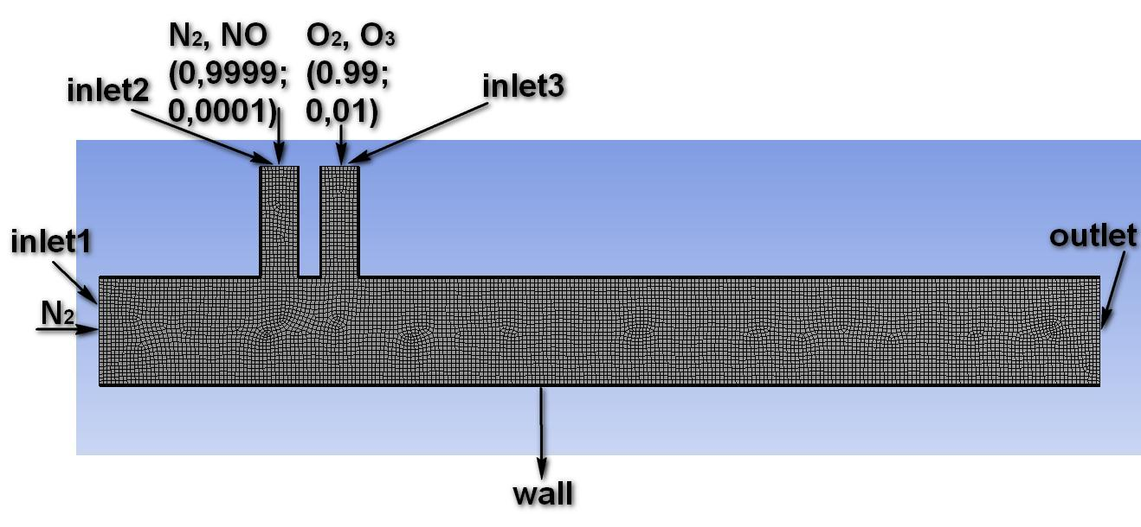

Fig. 1. 2-D rated operating conditions for the tubular reactor
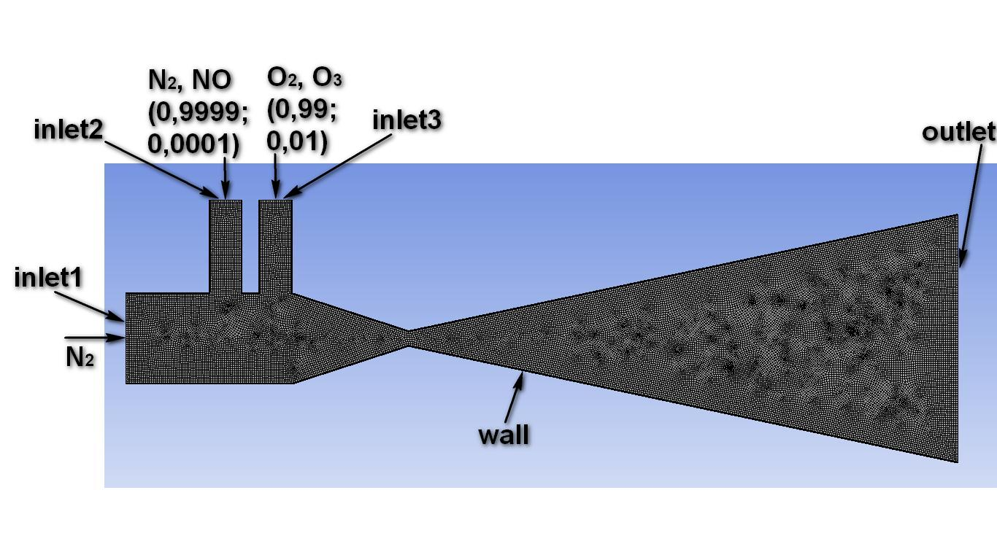
Fig. 2. 2-D rated operating conditions for the tubular reactor with Venturi tube

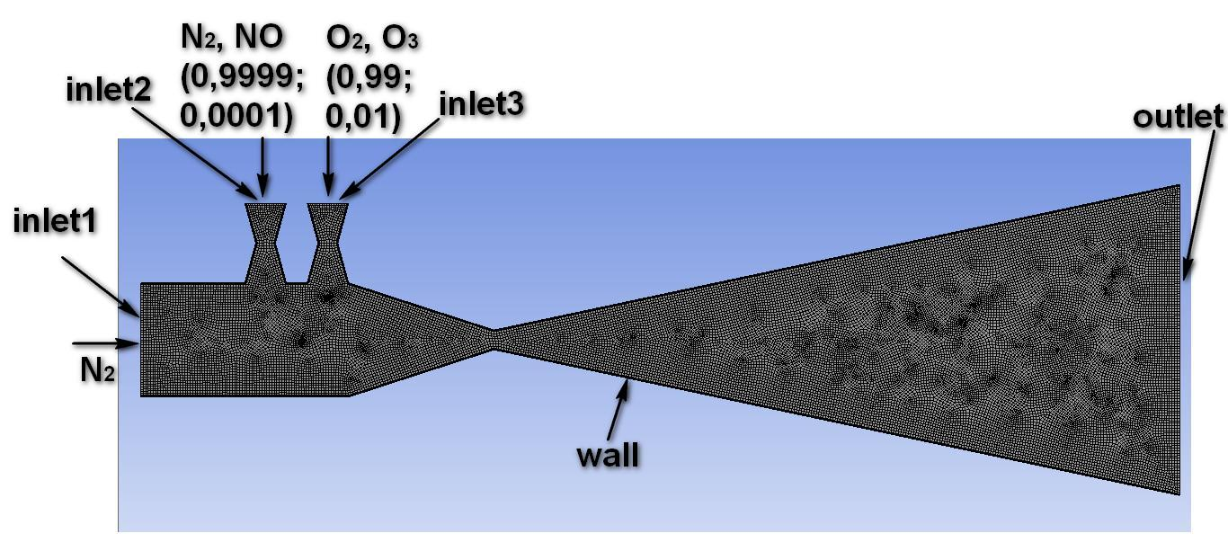

Fig. 3. 2-D rated operating conditions for the tubular reactor with Venturi tube and adding another Venturi tubes as inlet branch pipes

The speed of the gas flow was set as the following: 0,008212 m/c for N₂ (Inlet 1), 0,001592 m/c for the N₂-NO mixture (Inlet 2), and 0,016 m/c for the O₂-O₃ mixture (Inlet 3).
The next three pictures shows the corresponding 3-dimentional models (Fig 4-6).

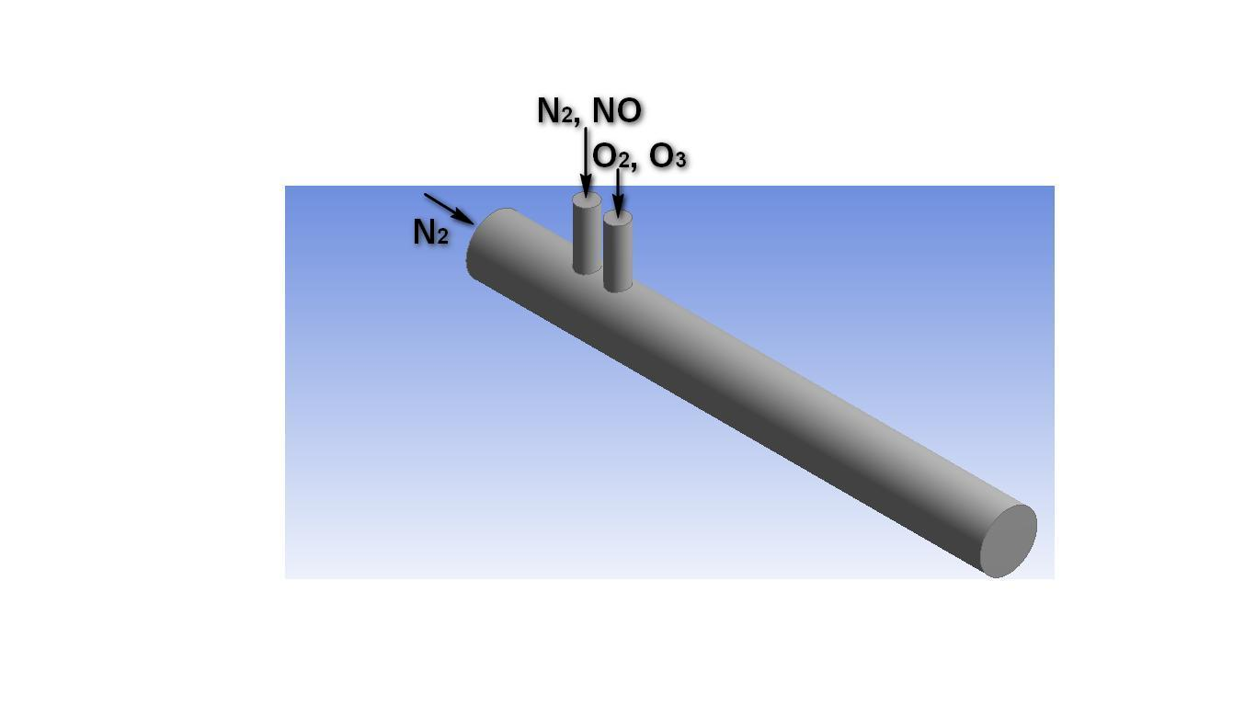

Fig. 4. 2-D rated operating conditions for the tubular reactor

Fig. 5. 3-D rated operating conditions for the tubular reactor with Venturi tube

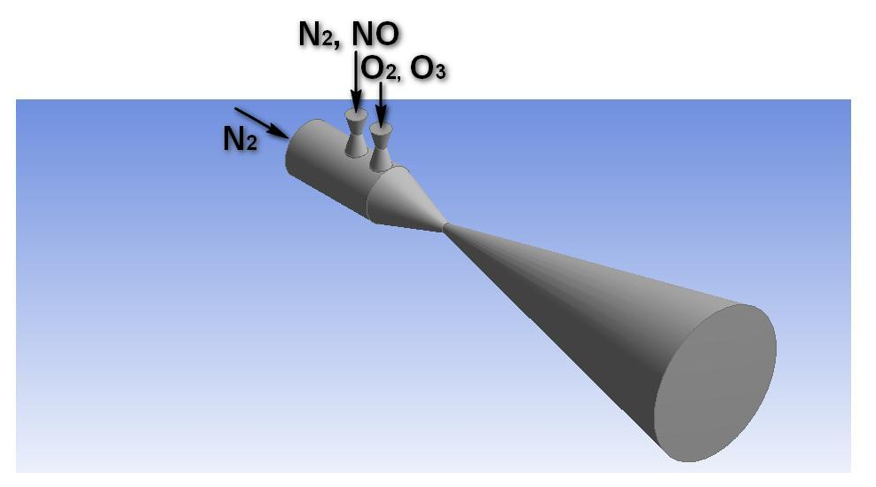

Fig. 6. 3-D rated operating conditions for the tubular reactor with Venturi tube and adding another Venturi tubes as inlet branch pipes

Figure 7 presents the simulation of the velocity distribution for the two-dimensional models. From the picture we can see that the difference between the speed of the flows is sufficient, especially near the Venturi tube’s enter point. The low velocity around this point can increase the residence time. Moreover, it affects the melting process.

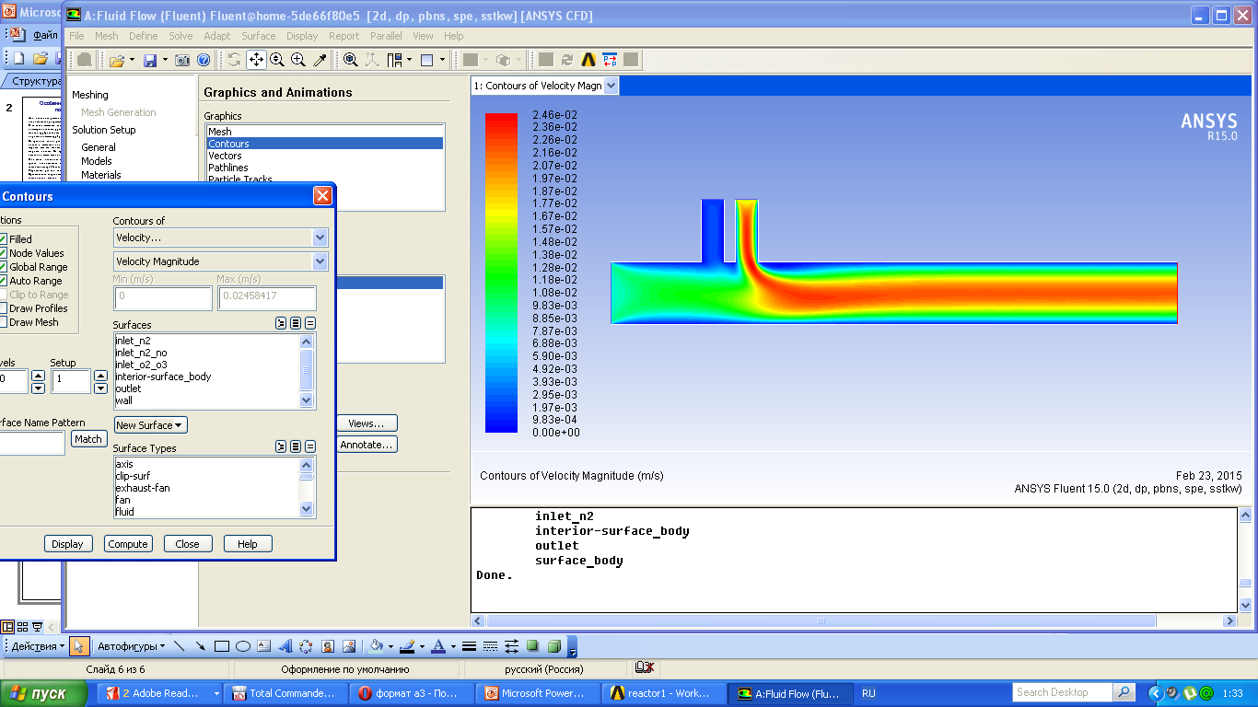
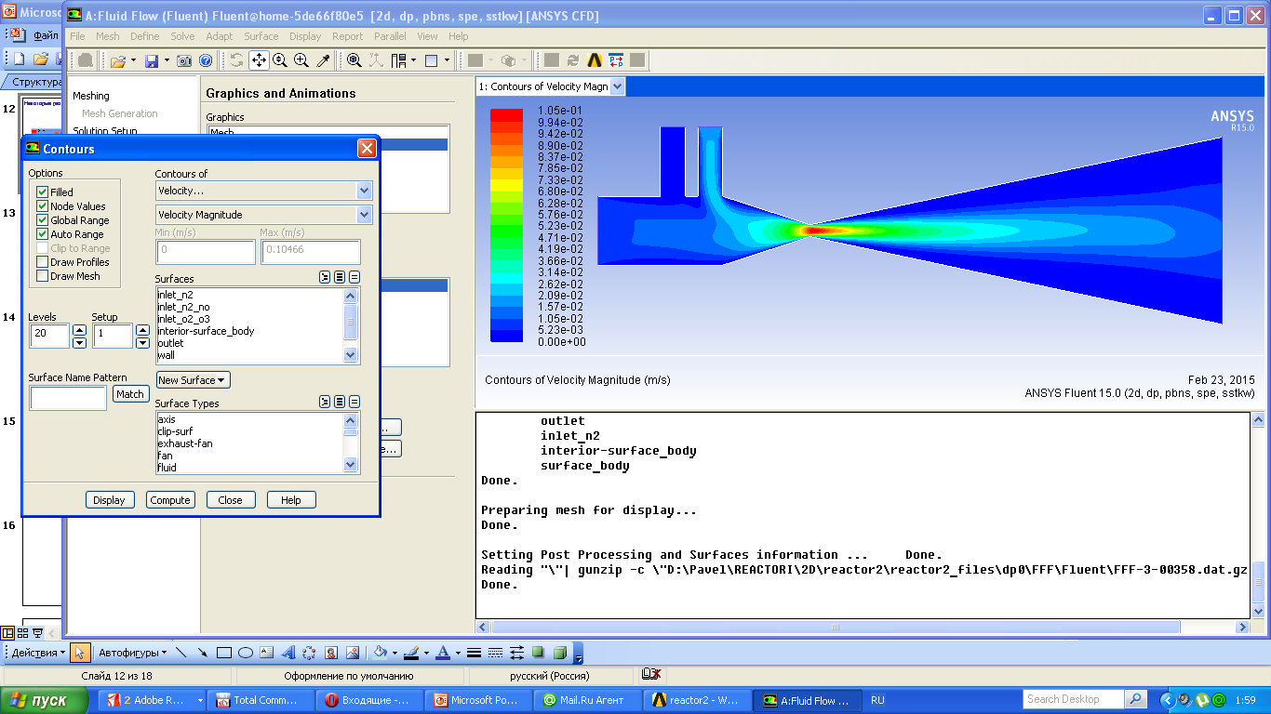
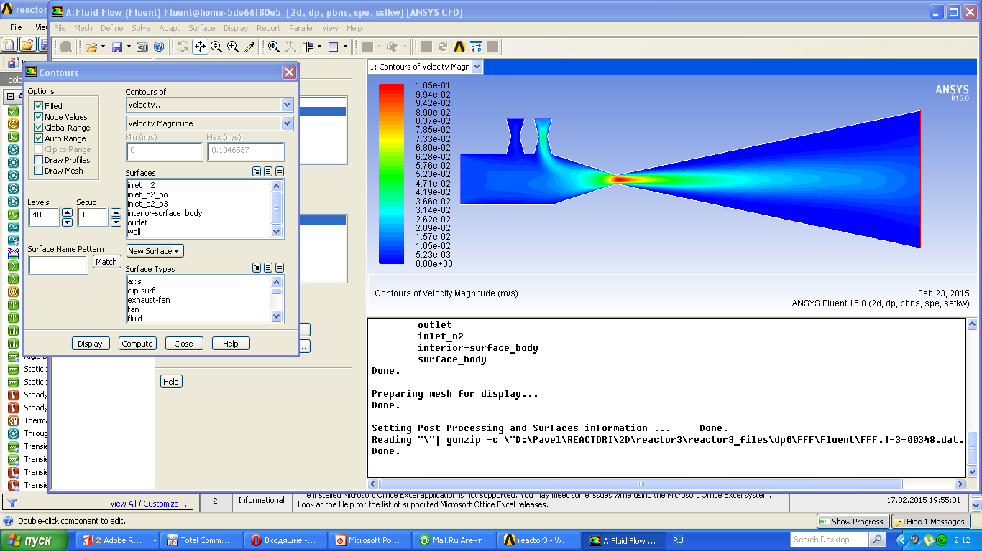

Fig. 7. The simulation of the velocity distribution for the two-dimensional models

5. Conclusions and expected results
Current articles describes the case study project focused on the simulation and designing of the coated-wall flow reactor for the NO_{x} ozonation, combining of the experimental system and providing of the measurements. The distinctive feature of this reactor is the possibility of taking the samples at the different parts of the construction.
It’s highly expected that with using of the designed reactor the optimal result for the nitric oxide ozonation will be achieved.
For the CFD modeling creating of the advanced model capable for more accurate and applied simulations is also expected.

6. References
Chenglang Sun, Nan Zhao, Zhuokai Zhuang, Haiqiang Wang, Yue Liu, Xiaole Weng, Zhongbiao Wu. 2014. Mechanisms and reaction pathways for simulataneous oxidation of NOx and SO2 by ozone determined by in situ IR measurements. Journal of hazardous materials 274: 376-383
Skalska K., Miller J.S., Ledakowicz S. 2010. Effectiveness of nitric oxide ozonation. Chemical Papers 65 (2): 193-197
Dora J, Gostomczyk M., Jakubiak M., Kordylewski W., Mista W., Tkaczuk M. 2009. Parametric studies of the effectiveness of NO oxidation process by ozone. Chemical and Process Engineering
Modlinski N.J., Kordylewski W.K., Jakubiak M.P. 2013. Numerical Simulation of O3 and NO Reacting in a Tubular Flow Reactor. Chemical and Process Engineering 34 (3): 361-373
Chacuk A., Miller J.S., Wilk M., Ledakowicz S. 2007. Intensification of nitric acid oxidation. Chem. Eng. Sci. 62: 7446-7453

The e-mail address: pavlokarno@wipos.p.lodz.pl

