Meta description: Discover the right time to stream on Twitch, based on audience behavior, key strategies, and analytics. Maximize your overall viewership with profound streaming schedules.

When to Stream on Twitch?
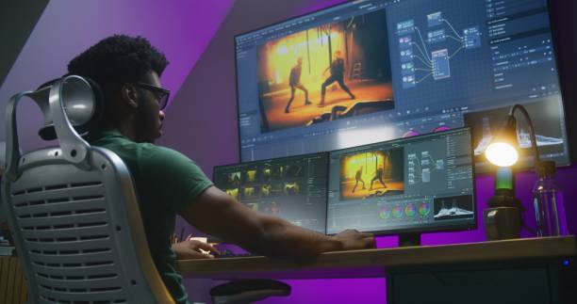
Pixabay
In the ever-growing landscape of Twitch, timing is equally essential. This incredible digital haven, a platform for creators and gamers, comes with numerous opportunities. However, it does not only revolve around what but also when you stream.
Choosing the best time to stream on Twitch is essential, especially when aiming for greater audience attraction. By choosing your perfect time to stream, you can maximize your general visibility hence increasing your viewers.

Determining when to stream on Twitch depends on various aspects from maximum viewership to Twitch analytics.

Twitch Viewership Patterns
Twitching viewership patterns are essential for the streamers who desire to increase their audience and engagement. Understanding the days with highest traffic, how time zones impact viewership, and when viewers are active allows you to create a perfect streaming schedule to capture maximum audience.
Below is a breakdown of vital Twitch viewership patterns;
- Absolute Peak Streaming Time: The absolute peak streaming time is the perfect hour on a Twitch platform. It is the best time to enjoy a huge viewership base. Capturing audiences at this hour is easier both in the U.S and Europe. The absolute peak streaming times; include, 3:00 PM EST, 12:00 PM PST, and 20:00 UTC.
- Optimal Streaming Window: Optimal streaming window include 11:00AM to 7:00 PM EST, 8:00 AM to 4:00 PM PST, and 16:00 to 00:00 UTC. The 8-hour window is all you need to reach wide international audience. It also always you to connect with people thus boosting your viewership level.
- Day of the Week Patterns: Like hour, the day of the week can greatly affect the overall viewership on Twitch. Weekdays (Monday to Thursday) evening are the perfect yet competitive times for Twitch enthusiasts. Subsequently, weekends Friday, Saturday, and Sunday) comes out as the biggest for streamers since most people have free time.
- Global Time Zone Differences: Twitch is a platform used globally, meaning time varies depending on the region. Most twitch users come from North America, Europe and Asia. Therefore, consider checking the time zones when logging on Twitch.
- Event -Driven Spikes: Specific events like Twitch events, game launches, and sport tournaments can spike your viewership. These events often attract audiences thus enhancing viewership domination. Aligning your Twitch with these events can boost your overall viewership.
- Viewer Behavior Pattern: The general behavior of the viewers on Twitch vary depending on the consumed content. The content produced can be in the form of binge-watching, discovery windows, and long-term streams.
- Twitch Category Patterns: Twitch comes with various category patterns. These category patterns have different viewership trends. Just chatting allows the viewers to have an interactive experience with their favorite streamer. Gaming category offers different gaming content, however, viewership might rise or fall depending on the games.
Lastly there is creative and URL content, this pattern offers acts like cooking, music, and art. Unlike gaming, this category tends to have a stable viewership. It is also not competitive compared to others.

Factors to Consider When Choosing Stream Times
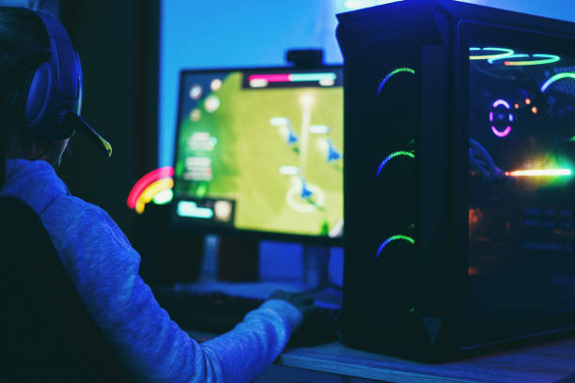
Pexel
There are essential aspects to consider when choosing streaming times. Each aspect plays a vital role in determining the performance and traffic. Here are some of the key factors to consider:

Prime Time vs. Off-Peak Streaming
Prime time - these are hours when most people are online during streaming. It is usually between 7:00 PM and 11:00 PM. Streaming during these hours can greatly impact your viewership through exposure.
Off-Peak Streaming - this often occurs early in the morning and late nights. Unlike peak hours, this time has fewer viewers, but there is less competition. This makes it the best time for smaller or newer streamers to stand out and be discovered.

Analyze Your Current Performance
Understanding how your stream is performing is essential since it helps refine your schedule. You can use analytic tools like third-party services or built-in insights for tracking when you have an active audience. Analyzing your current performance using these tools can help boost your growth and reach.

Create a Consistent Schedule
Consistency is essential to developing a loyal stronger viewer base. Viewers will only return to your Twitch when they know your schedule. Streaming consistently helps retain and gain new viewers, leading to more engagement.

Adapting to Time Zones
Since Twitch is known to be a global platform, adapting to time zones to accommodate viewers internationally can help grow your audience. For instance, streaming late morning can help attract viewers from Europe, especially when you are from the U.S. Understanding different time zones as a streamer helps attract a wider audience.

Balancing Streaming and Real Life
Finding a streaming schedule that fits perfectly within your commitment and personal life is crucial. Streaming can be demanding and tiring, and can lead to a burnout if there is no proper balancing. Generally, it is important to balance your streaming with family, work, social life, and school.

Conclusion
Choosing when to engage in streaming on Twitch is an essential aspect for any gamer or creator who desires to improve their viewer base. Factors like peak times, time zones, competition, and audience behavior must be considered by streamers to maximize engagement and visibility. While it might be challenging for newbies to maintain audience, being consistent and analyzing data will ultimately boost your overall growth.

