[MB-1] Сan use too easy password Created: 23/Nov/17 Updated: 23/Nov/17
Status: | Done
Project: | My bugs
Component/s: | None
Affects Version/s: | None
Fix Version/s: | None

Type: | Bug | Priority: | Medium
Reporter: | Stanislav | Assignee: | Stanislav
Resolution: | Unresolved | Votes: | 0
Labels: | None
Remaining Estimate: | Not Specified
Time Spent: | Not Specified
Original Estimate: | Not Specified
Environment: | PC/Windows 10/ Google Chrome 62.0.3202.94, Opera 49.0.2725.39, Mozila 57.0  Phone/Androin 6.0.1/Google Chrome 62.0.3202.84

Attachments: | 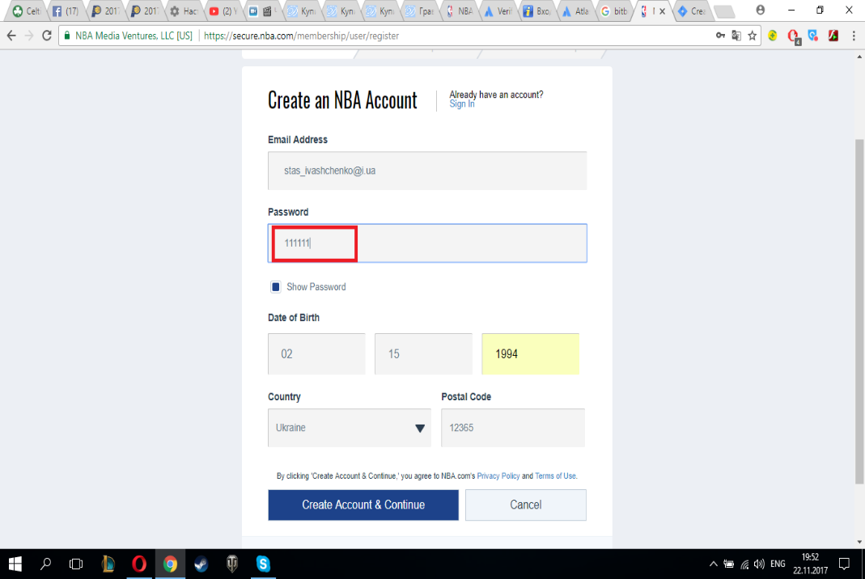

Description

Step to reproduce:
1. Go to the http://www.nba.com
2. Open the authorization panel (in the upper right corner)
3. Create a new account (enter your email and the easiest password, for example: "111111")
Expected results: There should be a notification about the easy password and an offer to complicate it
Results: Registration successful

Generated at Thu Nov 23 21:18:55 UTC 2017 by Stanislav using Jira 1001.0.0-SNAPSHOT#100073-sha1:56c4144faa59a857c3fda8de23c2046a1fb9d211.

[MB-2] You can create a name consisting of spaces Created: 23/Nov/17 Updated: 23/Nov/17
Status: | Done
Project: | My bugs
Component/s: | None
Affects Version/s: | None
Fix Version/s: | None

Type: | Bug | Priority: | Medium
Reporter: | Stanislav | Assignee: | Stanislav
Resolution: | Unresolved | Votes: | 0
Labels: | None
Remaining Estimate: | Not Specified
Time Spent: | Not Specified
Original Estimate: | Not Specified
Environment: | PC/Windows 10/ Google Chrome 62.0.3202.94, Opera 49.0.2725.39, Mozila 57.0  Phone/Androin 6.0.1/Google Chrome 62.0.3202.84

Attachments: | 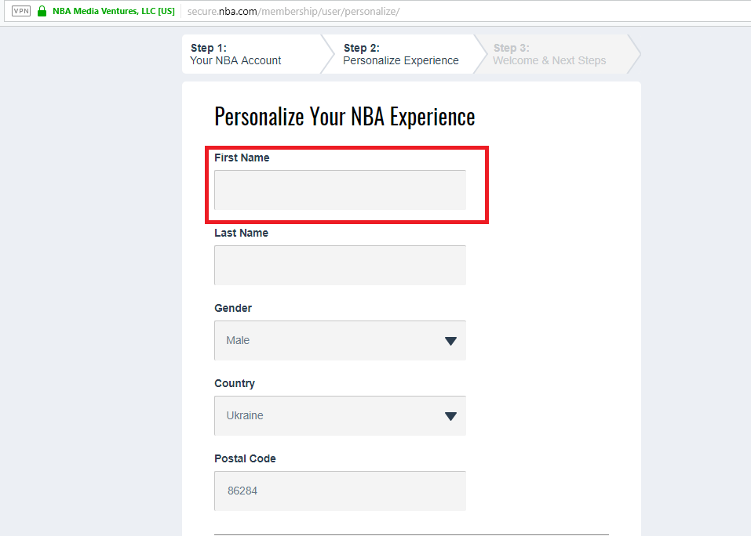

Description

Step to reproduce:
1.Go to the www.nba.com
2. Open the authorization panel (in the upper right corner)
3. We go into your account and click edit name
4. Enter a name consisting of spaces
Expected results: You receive an error message (It is not possible to use the name)
Result: Changes saved

Generated at Thu Nov 23 21:19:31 UTC 2017 by Stanislav using Jira 1001.0.0-SNAPSHOT#100073-sha1:56c4144faa59a857c3fda8de23c2046a1fb9d211.

[MB-3] The scroller does not work Created: 23/Nov/17 Updated: 23/Nov/17
Status: | Done
Project: | My bugs
Component/s: | None
Affects Version/s: | None
Fix Version/s: | None

Type: | Bug | Priority: | Highest
Reporter: | Stanislav | Assignee: | Stanislav
Resolution: | Unresolved | Votes: | 0
Labels: | None
Remaining Estimate: | Not Specified
Time Spent: | Not Specified
Original Estimate: | Not Specified
Environment: | PC/Windows 10/ Google Chrome 62.0.3202.94, Opera 49.0.2725.39, Mozila 57.0  Phone/Androin 6.0.1/Google Chrome 62.0.3202.84

Attachments: | 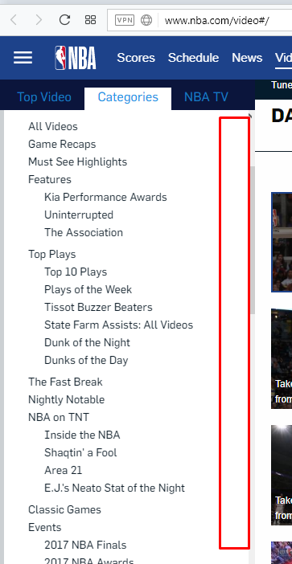

Description

Step to reproduce:
1.Go to the www.nba.com
2.Select the video section
3.Push the «categories» (from the left in the upper corner)
4.Scroll down with the help of scrolling
Expected results: Scroll down and view all categories
Result: The scrolling does not work

Generated at Thu Nov 23 21:19:37 UTC 2017 by Stanislav using Jira 1001.0.0-SNAPSHOT#100073-sha1:56c4144faa59a857c3fda8de23c2046a1fb9d211.

[MB-4] Graphic bug, buttons touch the bar Created: 23/Nov/17 Updated: 23/Nov/17
Status: | Done
Project: | My bugs
Component/s: | None
Affects Version/s: | None
Fix Version/s: | None

Type: | Bug | Priority: | High
Reporter: | Stanislav | Assignee: | Stanislav
Resolution: | Unresolved | Votes: | 0
Labels: | None
Remaining Estimate: | Not Specified
Time Spent: | Not Specified
Original Estimate: | Not Specified
Environment: | PC/Windows 10/ Mozila 57.0

Attachments: | 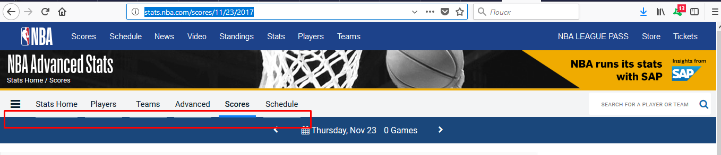

Description

Step to reproduce:
1. Go to the www.nba.com
2. Choose a «scores» section
Expected results: The page works fine
Result: buttons touch the bar

Generated at Thu Nov 23 21:19:43 UTC 2017 by Stanislav using Jira 1001.0.0-SNAPSHOT#100073-sha1:56c4144faa59a857c3fda8de23c2046a1fb9d211.

[MB-5] The «hide scores» button should be enabled to hide ratings when logging into the site Created: 23/Nov/17 Updated: 23/Nov/17
Status: | Done
Project: | My bugs
Component/s: | None
Affects Version/s: | None
Fix Version/s: | None

Type: | Bug | Priority: | High
Reporter: | Stanislav | Assignee: | Stanislav
Resolution: | Unresolved | Votes: | 0
Labels: | None
Remaining Estimate: | Not Specified
Time Spent: | Not Specified
Original Estimate: | Not Specified
Environment: | PC/Windows 10/ Google Chrome 62.0.3202.94, Opera 49.0.2725.39, Mozila 57.0  Phone/Androin 6.0.1/Google Chrome 62.0.3202.84

Attachments: | 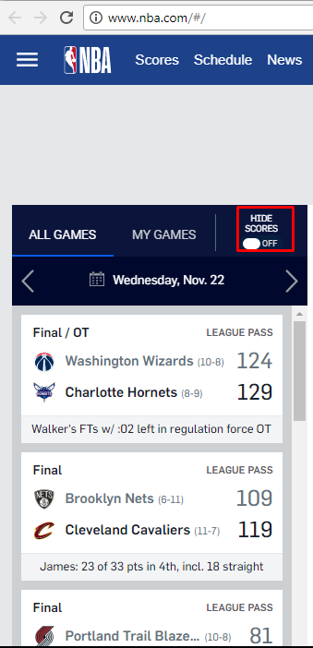

Description

Step to reproduce:
1. Go to the www.nba.com
2. We look at the button (from the left in the upper corner)
Expected results: The «hide scores» button will be pressed (according to the logic it should be, in order that there would be no spoilers on the account)
Result: The «hide scores» button is off

Generated at Thu Nov 23 21:19:47 UTC 2017 by Stanislav using Jira 1001.0.0-SNAPSHOT#100073-sha1:56c4144faa59a857c3fda8de23c2046a1fb9d211.

[MB-6] In the "Schedule, Stats, Players, Teams" sections, there is no panel to sign in to your account Created: 23/Nov/17 Updated: 23/Nov/17
Status: | Done
Project: | My bugs
Component/s: | None
Affects Version/s: | None
Fix Version/s: | None

Type: | Bug | Priority: | Highest
Reporter: | Stanislav | Assignee: | Stanislav
Resolution: | Unresolved | Votes: | 0
Labels: | None
Remaining Estimate: | Not Specified
Time Spent: | Not Specified
Original Estimate: | Not Specified
Environment: | PC/Windows 10/ Google Chrome 62.0.3202.94, Opera 49.0.2725.39, Mozila 57.0  Phone/Androin 6.0.1/Google Chrome 62.0.3202.84

Attachments: | 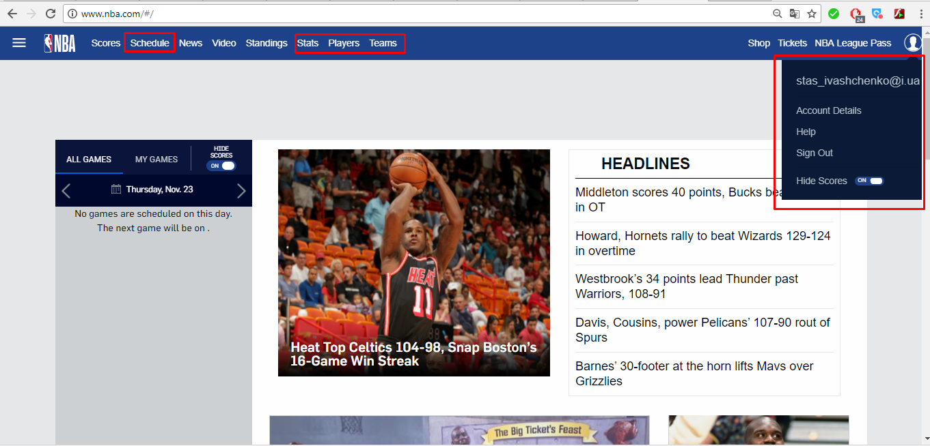

Description

Step to reproduce:
1. Go to the www.nba.com
2. We go to "Schedule, Stats, Players, Teams" sections
Expected results: The account login bar will be displayed
Result: The account login bar is not displayed

Generated at Thu Nov 23 21:19:52 UTC 2017 by Stanislav using Jira 1001.0.0-SNAPSHOT#100073-sha1:56c4144faa59a857c3fda8de23c2046a1fb9d211.

[MB-7] A white rectangle is displayed on the page Created: 23/Nov/17 Updated: 23/Nov/17
Status: | Done
Project: | My bugs
Component/s: | None
Affects Version/s: | None
Fix Version/s: | None

Type: | Bug | Priority: | Medium
Reporter: | Stanislav | Assignee: | Stanislav
Resolution: | Unresolved | Votes: | 0
Labels: | None
Remaining Estimate: | Not Specified
Time Spent: | Not Specified
Original Estimate: | Not Specified
Environment: | PC/Windows 10/ Google Chrome 62.0.3202.94, Opera 49.0.2725.39, Mozila 57.0  Phone/Androin 6.0.1/Google Chrome 62.0.3202.84

Attachments: | 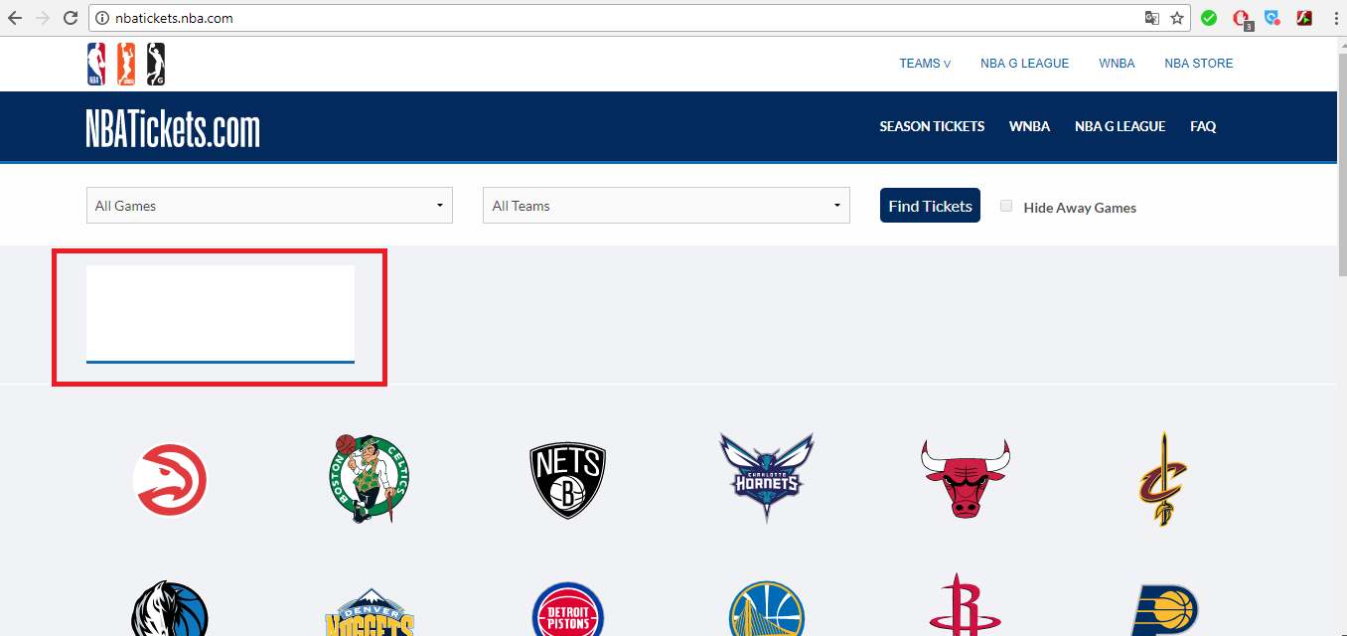

Description

Step to reproduce:
1. Go to the www.nba.com
2. Go to the «tickets» section
Expected results: There are no bugs on the page, everything works well
Result: on the page is a white rectangle (left in the upper corner)

Generated at Thu Nov 23 21:19:57 UTC 2017 by Stanislav using Jira 1001.0.0-SNAPSHOT#100073-sha1:56c4144faa59a857c3fda8de23c2046a1fb9d211.

[MB-8] After clicking the "Back" button, page is navigated to a page that was not previously located Created: 23/Nov/17 Updated: 23/Nov/17
Status: | Done
Project: | My bugs
Component/s: | None
Affects Version/s: | None
Fix Version/s: | None

Type: | Bug | Priority: | Highest
Reporter: | Stanislav | Assignee: | Stanislav
Resolution: | Unresolved | Votes: | 0
Labels: | None
Remaining Estimate: | Not Specified
Time Spent: | Not Specified
Original Estimate: | Not Specified
Environment: | PC/Windows 10/ Google Chrome 62.0.3202.94, Opera 49.0.2725.39, Mozila 57.0  Phone/Androin 6.0.1/Google Chrome 62.0.3202.84

Attachments: | 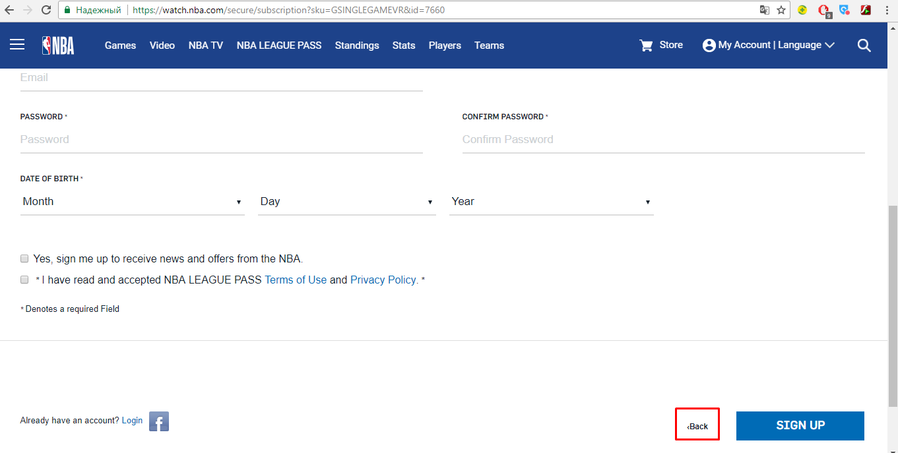

Description

Step to reproduce:
1.Go to the www.nba.com
2.Go to the menu, which is on the left in the top corner, select the «NBA VR» category
3.Scroll down and press the «Buy single game» button
4.Scroll down and press the «Back» button
Expected results: Let's return to the previous page
Result: After clicking a «Back» button the another page is should

Generated at Thu Nov 23 21:20:03 UTC 2017 by Stanislav using Jira 1001.0.0-SNAPSHOT#100073-sha1:56c4144faa59a857c3fda8de23c2046a1fb9d211.

