Слова:

solitaire
games
spider solitaire
harvest
patience
klondike solitaire
pyramid
harvest moon
solitaire games
casino games
free solitaire
solitaire card games
island

solitaire free
card
card games

adventure island
solitario
solitaire card games free

solitaire gratuit
oysho

tripeaks
grand
solitaire classic
tiki
solitaire tripeaks
tri peaks solitaire
free solitaire games
card games free
peak
classic solitaire
games for free
game
patience card game
traveland
solitaire blitz

card solitaire
island survival
ocean breeze

tripeaks solitaire free
patience game
solitaire collection
solitaire cube
solitare
cards
card games poker
card games for free
classic solitare cruise
solitare classic
tiki solitaire
solitario pro
card battles
classic solitaire card games

Текст:

Take a break and relax with our new tri peaks classic solitaire card games!

Take a Solitaire Cruise and enjoy your classic solitaire tripeaks journey! Train your brain & patience with tripeaks solitaire free card games!

Bored of your gray, mundane everyday life? Tired of your tedious, routine job? Need a break after a hard day’s work? Why not to choose solitaire collection card games for free?

Go on a luxurious adventure and take a relaxing Classic Solitaire Cruise with successful and respected people!

Experience the thrill of a fabulous sea voyage where you can feel ocean breeze: solve solitario puzzles, adventure island, oysho and discover colorful locations all over the world thanks to free solitaire. Try to make island survival there! Beautiful modern architecture, historical sites and natural landscapes await you in traveland in classic solitaire card games. Forget about luggage and exhausting flights! Relax and have patience with a free solitaire games that’s more interesting and challenging than Tri Peaks solitaire or Three Towers. Its clean cards and polished design let you immerse yourself in this addictive patience game full of fun, excitement and new experiences. Train your brain with thousands of unique levels and enjoy your journey on a first-class cruise liner in a real card battles.

Say goodbye to boredom and misery. Enjoy a rich life and a world of entertainment in card games free from your mobile device. Have a refreshing cocktail in that island and check out what Solitare Cruise has to offer:

- Play challenging Solitaire card games free, Dice Tournaments, Tiki Solitaire, Solitare Classic, Klondike Solitaire, Spider Solitaire and even Solitario Pro with numerous events.
- Visit all 25 magnificent venues, including glitzy Las Vegas, majestic Paris, alluring Nassau, romantic Venice, stunning Dubai and other spectacular locations via solitaire free.
- Enjoy striking graphics and admire stunning views of modern cities, historical locations, harvest moon, mountain peak, tiki, pyramid and natural landscapes.
- Discover the solitaire classic from a new angle thanks to a huge number of grand bonuses and mechanics.
- Collect stars, spin the Wheel of Fortune, hunt down the Jackpot and win HUGE prizes in card games poker and other games for free.
- Build up your reward in solitaire cube and multiply it risk-free.
- Earn money to take part in our Tournament of solitaire gratuit.
- Place bets and win even more through solitaire tripeaks!

Games of solitaire blitz are available offline or online without ads - no Wi-Fi or internet connection required. It’s a real patience card game! Age doesn’t matter - the only thing that’s important is your desire to succeed and the lure of a better life via classic solitaire. Make your harvest of money! Still weighing up the options? Thousands of people around the world have already made their choice. Say “yes” to games.

Solitaire Cruise - a stylish card solitaire game, premium travel and extravagant leisure for true connoisseurs. Download solitaire games now to embark upon your amazing personal adventure!
https://play.google.com/store/apps/details?id=com.belkagames.solitaire&hl=en_US&gl=US
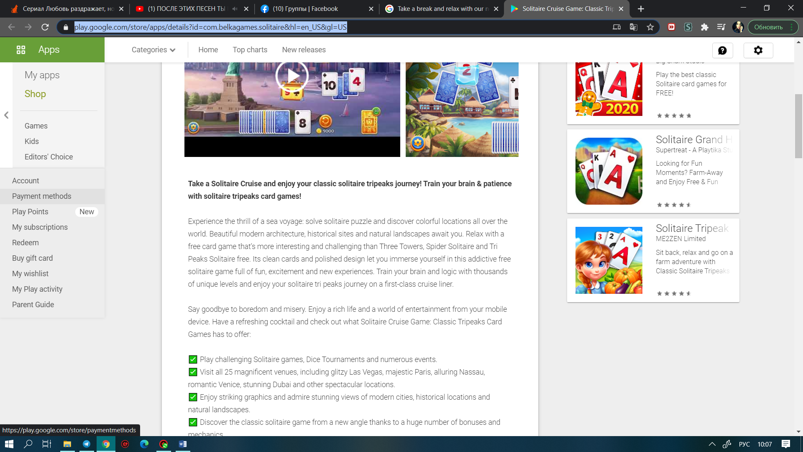
https://play.google.com/store/apps/details?id=com.belkagames.solitaire&hl=da&gl=US
https://play.google.com/store/apps/details?id=com.belkagames.solitaire&hl=af&gl=US

