B.F. Skinner: The Skinner Box
The explanation of the theory
B. F. Skinner is an American psychologist best known for his input in the behaviourism field in psychology. In 1926, he went to Hamilton College to get a degree in English literature. Later he tried to become a writer, but after publishing only a few articles in a newspaper, he quickly gave up on this idea. When he was working as a clerk in a bookstore, he found information about Ivan Pavlov’s and James Watson’s works, which changed his life. Skinner then applied to the psychology graduate program at Harvard University and graduated in 1931 with a Ph.D. in psychology. While being in university, he developed his work on operant conditioning. B. F. Skinner designed “The Skinner Box” to explore his idea that actions which have a positive and pleasurable outcome are more likely to be repeated rather than those which have a negative one. A rat was put in the box, where it was rewarded with food each time it pressed the bar. After a small period of time, the animal has discovered it has no limit and gives pellet each time the rat pushes the bar and started madly pushing the bar. The behavior that is followed by encouragement stimulus has high chances to be repeated throughout time. However, when the rat does not receive the food anymore by doing previous actions, it stops pressing the bar. This can be explained as extinction.
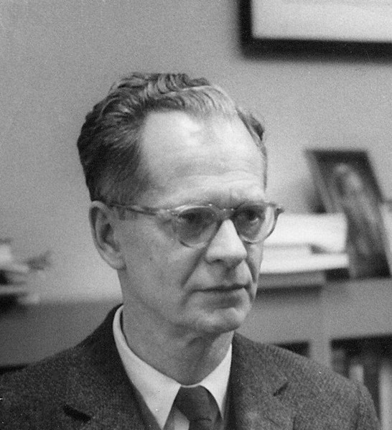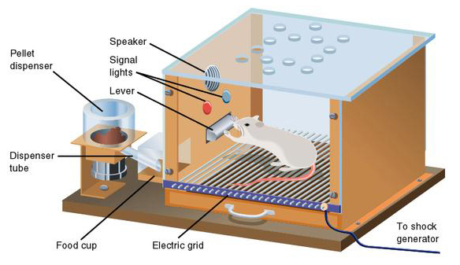
Ethical Issues
Considering ethics this experiment is found inappropriate. The study of behaviourism does not require an animal to understand what it is doing. The relevance of the experiment can be questioned to the point when a rat actually understands the meaning of its actions when practice used to teach the complicated human behaviour. According to the Canadian Code of Ethics, researchers should avoid using animals in their research unless there is a reasonable expectation that the research will increase understanding of the structures and processes underlying behaviour or increase understanding of the particular animal species used in the study or result in benefits to the health and welfare of humans or other animals (The Canadian Code of Ethics: Principle II: Responsible Caring: Care of animals II.49). The Skinner Box is considered too small for animals of the experiment, which causes discomfort for the rat while it is in the cage. The box as well deprive the animal of all social interactions among species.
The Personal Connection
Since my brother and I were in high school, our parents used different methods to encourage us to score good grades. We were both promised to receive a thing we always wanted. In my brother’s case whose name is Victor, he wanted to get an expensive gadget. To “earn it” his task was to have all marks higher than 10 (in Ukraine the highest mark is 12). He quickly agreed to do what he was told to receive his dream device, which helped Victor to improve his academic performance. At the end of the year, the gadget was given to him and this “experiment” continued for a few years after. My parents did not have any negative motives while doing it, they simply believed that this kind of behavior might have taught my brother to set goals, manage the time and be successful in the future. Yet, I cannot be sure if they succeeded as my brother is still in high school. However, I have noticed the act of extinction in his behavior later. After he was no longer offered a reward for the high academic performance, Victor decided that some subjects do not require as much effort as others he is interested in. As a result, in certain subjects, his marks went down. His behavior in this situation can be compared to the results Skinner got.

Works Cited:
https://www.simplypsychology.org/skinner%20box.jpg
https://cpa.ca/docs/File/Ethics/CPA_Code_2017_4thEd.pdf
December 20, 2019. B. F. Skinner. Retrieved December 20, 2019, from https://psychology.fas.harvard.edu/people/b-f-skinner
Cherry, Kendra. “B. F. Skinner: The Life of Psychology's Radical Behaviorist.” Verywell Mind, Verywell Mind, 19 June 2019, https://www.verywellmind.com/b-f-skinner-biography-1904-1990-2795543.
Mcleod, Saul. “Skinner - Operant Conditioning.” B.F. Skinner | Operant Conditioning | Simply Psychology, https://www.simplypsychology.org/operant-conditioning.html.
“Skinner Box.” GoodTherapy.org Therapy Blog, 29 Jan. 2016, https://www.goodtherapy.org/blog/psychpedia/skinner-box.
“B.F. Skinner.” B.F. Skinner, https://upload.wikimedia.org/wikipedia/commons/3/3f/B.F._Skinner_at_Harvard_circa_1950.jpg

