Text 1
Word of the day
gravity | ˈɡravədē | noun
1 Physics the force that attracts a body toward the center of the earth, or toward any other physical body having mass. For most purposes Newton's laws of gravity apply, with minor modifications to take the general theory of relativity into account. • the degree of intensity of gravity, measured by acceleration.
2 extreme or alarming importance; seriousness: crimes of the utmost gravity.
3 seriousness or solemnity of manner: has the poet ever spoken with greater eloquence or gravity?

Do cats always
land on their feet?
While felines are often able to land on their feet, the height of the fall is an important factor in how safe of a landing they make.
LAURA MOSS
July 24, 2013, 11:02 a.m.
https://www.mnn.com/family/pets/stories/do-cats-always-land-on-their-feet
- an extraordinary gravity-defying abilities | надзвичайні здатності контролювати сили тяжкості
- to absorb the shock of the landing | поглинати удар посадки
- an innate ability | вроджена здатність
- to reorient its body | переорієнтувати своє тіло
- the righting reflex | рефлекс вирівнювання
- the consecutive frames | послідовні кадри
- a vestibular apparatus | вестибулярний апарат
- an inner ear | внутрішнє вухо
- a unique skeletal structure | унікальна структура скелета
- a low body-volume-to-weight ratio | низьке співвідношення тіло-об'єм-вага

A vestibular apparatus
Inner ear

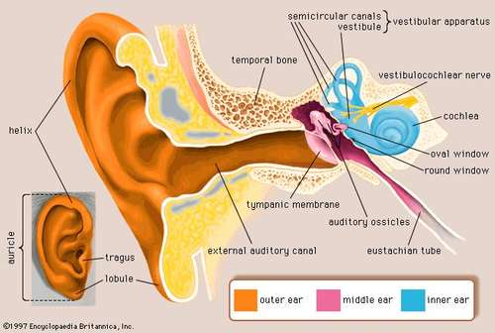
The vestibular system, in most mammals, is the sensory system that provides the leading contribution to the sense of balance and spatial orientation for the purpose of coordinating movemen twith balance.

The inner ear (internal ear, auris interna) is the innermost part of the vertebrate ear. In vertebrates, the inner ear is mainly responsible for sound detection and balance.

Feline
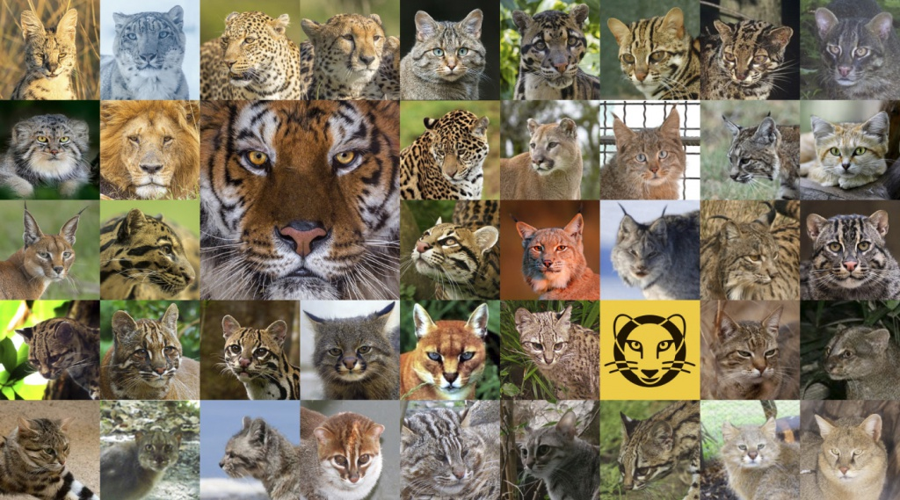
Feline
adjective UK ​ /ˈfiː.laɪn/ US ​ /ˈfiː.laɪn/
belonging or relating to the cat family:
feline leukaemia
appearing or behaving like a cat:
She had pretty, almost feline features.

Chronophotographic camera

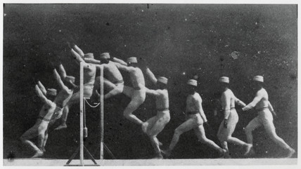
Chronophotography is an antique photographic technique from the Victorian era (1867–68), which captures movement in several frames of print. These prints can be subsequently arranged either like animation cels or layered in a single frame. It is a predecessor to cinematography and moving film, involving a series of different cameras, originally created and used for the scientific study of movement.

Do cats always land on their feet?

You’ve likely heard that cats always land on their feet, but while felines have extraordinary gravity-defying abilities, they don’t always safely nail the landing. Most of the time, a falling cat will land on its feet, but the height of a cat’s fall plays a role in how likely it is to right itself and absorb the shock of the landing without injury. A cat’s innate ability to reorient its body during a fall is called the righting reflex, and it’s observable in kittens as young as 3 weeks old. By 7 weeks, this skill is fully developed.

The physics of a falling feline
French scientist Etienne Jules Marey tested the reflex in 1890 by dropping a cat and using his chronophotographic camera to capture up to 60 consecutive frames a second of the cat’s fall. Afterward, he was able to watch in slow motion how the cat began to shift its balance the second the fall began.
A vestibular apparatus in a cat’s inner ear acts as its balance and orientation compass so that it always knows which way is up. Once a falling feline has determined which part of its body should be facing up, it rotates its head to see where it’s going to land.
Next, the cat’s spine comes into play. Cats have a unique skeletal structure consisting of no collarbone and an unusually flexible backbone with 30 vertebrae (humans have 24).
A feline’s backbone allows it to correct its position during freefall. As its back arches, the cat positions its front feet under him with the front paws close to the face to protect it from impact. When he lands, the leg joints bear the weight of the impact.
Like flying squirrels, cats have a low body-volume-to-weight ratio, which allows them to slow their velocity when falling.

Not all falls are equal
A cat’s ability to right itself midair and safely land on its feet is certainly impressive, but certain falls can be dangerous — or even deadly — for a cat.
Typically, felines that fall from greater heights, such as more than five floors, tend to suffer less severe injuries than those falling from just a couple stories. The longer freefall gives cats more time to right themselves and position their bodies correctly.
In 1987, New York City’s Animal Medical Center conducted a study of felines that had fallen from tall buildings. While 90 percent of the animals survived, most suffered serious injuries, but the cats that fell from heights of seven to 32 stories were less likely to die than those that fell from two to six stories.
The buttered cat paradox
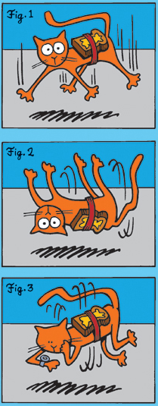
Just as a cat almost always lands on its feet, it’s pessimistcally accepted that buttered toast will always land butter-side down.Toast, of course, lacks a righting reflex, so its tendency to land butter-side down can be attributed to the fact that it usually falls at an angle and most dining tables are about waist high. Therefore, when the buttered toast slips from a plate, it can manage only half a rotation before hitting the floor.The buttered cat paradox arises when you consider what would happen if you attached a piece of buttered toast to a cat’s back and then dropped the feline. According to the faux paradox, the cat’s fall will slow as it nears the ground and the animal will begin to rotate.
Каракал чи каракуль?
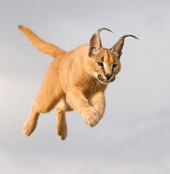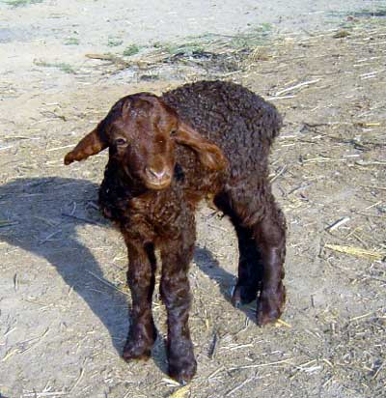
The caracal /ˈkærəkæl/  (Caracal caracal) is a medium-sized wild cat native to Africa, the Middle East, Central Asia, and India.  Карака́л пусте́льний, або пусте́льна рись, бербері́йська рись (Caracal caracal) — вид роду Каракал родини Котових. Довгий час каракала відносили до роду Рись через зовнішню схожість. Близькими родичами каракала є золота кішка й азіатська золотиста кішка[2]. Мешкає в саванах, пустелях і передгір'ях Африки, Аравійського півострова, Малій і Середній Азії.  https://uk.wikipedia.org/wiki/Каракал_пустельний | Persian lamb astrakhan  Каракуль (хутро) - Ягня каракульської породи  Каракуль дослівно перекладається з тюркської, як чорне озеро (кара куль) - шкіра з хутром, знята з ягнят каракульської породи на 1-3 добу після народження, коли їх шерсть відрізняється густим, пружним, шовковистим волосяним покривом, що створює завитки різної форми і розмірів.

https://www.youtube.com/watch?v=sepYP_knGWc

- remarkable design
- flexible spine
- to rorate front and back ends
- a clockwise rotation
- spin in the opposite direction
- to be effectively pushing against itself
- spinning ice-skater
- pull its front legs close
- make front of its body spin faster
- twist of its spine

Word of the day
avant-garde | ˌaväntˈɡärd |
noun (usually the avant-garde) new and unusual or experimental ideas, especially in the arts, or the people introducing them: works by artists of the Russian avant-garde.
adjective favoring or introducing experimental or unusual ideas: a controversial avant-garde composer.
DERIVATIVES avant-gardism | ˌäˌvänˈɡärˌdizəm | noun avant-gardist | ˌäˌvänˈɡärdəst | noun
ORIGIN late Middle English (denoting the vanguard of an army): from French, literally ‘vanguard’. Current senses date from the early 20th century.

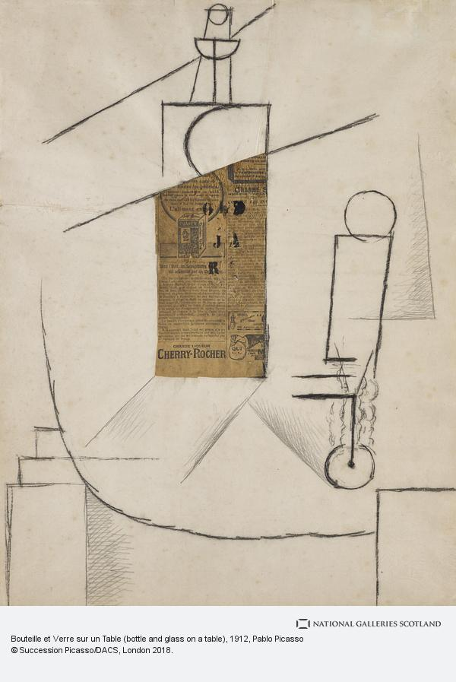
If bottle can be a newspaper, a newspaper can be a bottle.

avant- | ˈavänt, ˈaväN | combining form (especially with reference to popular music) original or innovative; avant-garde: even in avant-rock, a song's words are usually its focus. | garde – guard  noun1 a person who keeps watch, especially a soldier or other person formally assigned to protect a person or to control access to a place: a security guard | [as modifier] : he distracted the soldier on guard duty. • [treated as singular or plural] a body of soldiers serving to protect a place or person: the hound belonged to a member of the castle's guard. • (Guards) the household troops of the British army.

Status quo is a Latin phrase meaning the existing state of affairs,
particularly with regard to social or political issues.^{[1]}
In the sociological sense, it generally applies to maintain or change existing social structure and values.
It is the nominative form of the prepositional Latin phrase "in statu quo" – literally "in the state in which", which itself is a shortening of the original phrase in statu quo res erant ante bellum, meaning "in the state in which things were before the war".
To maintain the status quo is to keep the things the way they presently are.
The related phrase status quo ante, literally "the state in which before",^{[4]}
means "the state of affairs that existed previously".

Avant-garde is French for ‘vanguard’; a military term used to describe the front-line of an army moving into battle. Artists were compared with these soldiers, as they were often a group force, challenging long-established concepts and ideas about art and fighting an entrenched establishment. | status quo | ˌstādəs ˈkwō |  noun (usually the status quo) the existing state of affairs, especially regarding social or political issues: they have a vested interest in maintaining the status quo.  ORIGIN Latin, literally ‘the state in which’

Vocabulary trick:

Emerge (v) – з’являтися
a world of emerging economic giants.

emergence (n)– поява  the emergence of the environmental movement | emergency (n)– надзвичайна ситуація  an emergency exit
emergent (adj)– у процессі розвитку  the emergent democracies of eastern Europe | submerge (v)- поринати  the U-boat had had time to submerge  * a German submarine used in World War I or World War II.
Nota bene:

- відділення екстреної допомоги (англ. emergency department, ED) — відділення лікарні, де надається допомога при невідкладних станах пацієнтам з захворюваннями та травмами.
he was rushed into emergency.

- (also state of emergency) надзвичайне положення

facult|y | BrE ˈfak(ə)lti, AmE ˈfækəlti | noun1 (power, aptitude) спосо́бность▸ in possession of one's -ies в здра́вом уме́ 2 (British, part of university) факульте́т3 (US, body of teachers) профе́ссорско-преподава́тельский соста́в



WHAT IS LHC?

A collider is a type of particle accelerator involving directed beams of particles. Colliders may either be ring accelerators or linear accelerators, and may collide a single beam of particles against a stationary target or two beams head-on.

Colliders are used as a research tool in particle physics by accelerating particles to very high kinetic energy and letting them impact other particles. Analysis of the byproducts of these collisions gives scientists good evidence of the structure of the subatomic world and the laws of nature governing it. These may become apparent only at high energies and for tiny periods of time, and therefore may be hard or impossible to study in other ways.

17-mile loop
time machine
matter
particle accelerator
beams of protons
millisecond | ˈmiləˌsekənd | noun one thousandth of a second.

energy density
convert into mass

further back in time

What does “CERN” stand for?
At an intergovernmental meeting of UNESCO in Paris in December 1951, the first resolution concerning the establishment of a European Council for Nuclear Research (in French Conseil Européen pour la Recherche Nucléaire) was adopted.
Two months later, an agreement was signed establishing the provisional Council – the acronym CERN was born.
Today, our understanding of matter goes much deeper than the nucleus, and CERN's main area of research is particle physics. Because of this, the laboratory operated by CERN is often referred to as the European Laboratory for Particle Physics.
CERN, Європе́йська організація з я́дерних дослі́джень (ЦЕРН) (фр. l'Organisation européenne pour la recherche nucléaire) — міжнародний дослідницький центр європейської спільноти, найбільша у світі лабораторія фізики високих енергій.

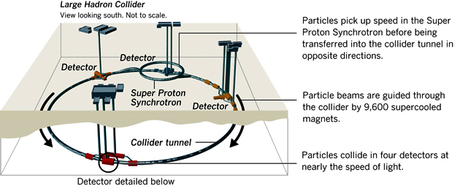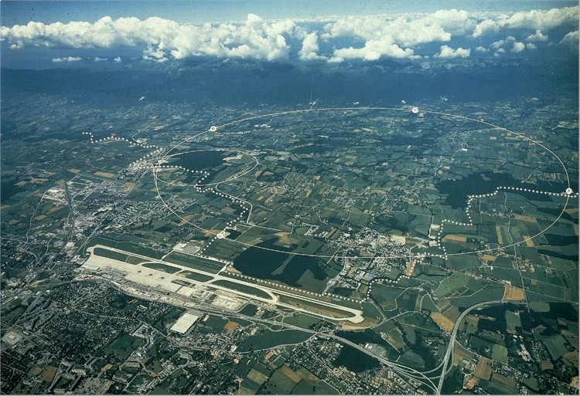

Big Bang Theory

Big Bang Theory - The Premise
The Big Bang theory is an effort to explain what happened at the very beginning of our universe. Discoveries in astronomy and physics have shown beyond a reasonable doubt that our universe did in fact have a beginning. Prior to that moment there was nothing; during and after that moment there was something: our universe. The big bang theory is an effort to explain what happened during and after that moment.
According to the standard theory, our universe sprang into existence as "singularity" around 13.7 billion years ago. What is a "singularity" and where does it come from? Well, to be honest, we don't know for sure. Singularities are zones which defy our current understanding of physics. They are thought to exist at the core of "black holes." Black holes are areas of intense gravitational pressure. The pressure is thought to be so intense that finite matter is actually squished into infinite density (a mathematical concept which truly boggles the mind). These zones of infinite density are called "singularities." Our universe is thought to have begun as an infinitesimally small, infinitely hot, infinitely dense, something - a singularity. Where did it come from? We don't know. Why did it appear? We don't know.
After its initial appearance, it apparently inflated (the "Big Bang"), expanded and cooled, going from very, very small and very, very hot, to the size and temperature of our current universe. It continues to expand and cool to this day and we are inside of it: incredible creatures living on a unique planet, circling a beautiful star clustered together with several hundred billion other stars in a galaxy soaring through the cosmos, all of which is inside of an expanding universe that began as an infinitesimal singularity which appeared out of nowhere for reasons unknown. This is the Big Bang theory.
Big Bang Theory - Common Misconceptions
There are many misconceptions surrounding the Big Bang theory. For example, we tend to imagine a giant explosion. Experts however say that there was no explosion; there was (and continues to be) an expansion. Rather than imagining a balloon popping and releasing its contents, imagine a balloon expanding: an infinitesimally small balloon expanding to the size of our current universe.
Another misconception is that we tend to image the singularity as a little fireball appearing somewhere in space. According to the many experts however, space didn't exist prior to the Big Bang. Back in the late '60s and early '70s, when men first walked upon the moon, "three British astrophysicists, Steven Hawking, George Ellis, and Roger Penrose turned their attention to the Theory of Relativity and its implications regarding our notions of time. In 1968 and 1970, they published papers in which they extended Einstein's Theory of General Relativity to include measurements of time and space.^{1, 2}According to their calculations, time and space had a finite beginning that corresponded to the origin of matter and energy."³ The singularity didn't appear in space; rather, space began inside of the singularity. Prior to the singularity, nothingexisted, not space, time, matter, or energy - nothing. So where and in what did the singularity appear if not in space? We don't know. We don't know where it came from, why it's here, or even where it is. All we really know is that we are inside of it and at one time it didn't exist and neither did we.
Big Bang Theory - Evidence for the Theory
What are the major evidences which support the Big Bang theory?
- First of all, we are reasonably certain that the universe had a beginning.
- Second, galaxies appear to be moving away from us at speeds proportional to their distance. This is called "Hubble's Law," named after Edwin Hubble (1889-1953) who discovered this phenomenon in 1929. This observation supports the expansion of the universe and suggests that the universe was once compacted.
- Third, if the universe was initially very, very hot as the Big Bang suggests, we should be able to find some remnant of this heat. In 1965, Radioastronomers Arno Penzias and Robert Wilson discovered a 2.725 degree Kelvin (-454.765 degree Fahrenheit, -270.425 degree Celsius) Cosmic Microwave Background radiation (CMB) which pervades the observable universe. This is thought to be the remnant which scientists were looking for. Penzias and Wilson shared in the 1978 Nobel Prize for Physics for their discovery.
- Finally, the abundance of the "light elements" Hydrogen and Helium found in the observable universe are thought to support the Big Bang model of origins.

