“Showcasing Expertise in WordPress, WooCommerce & Multilingual Web Development”

🛍️ Beauty & Cosmetics WooCommerce Store (Loki Template

1. Project Overview

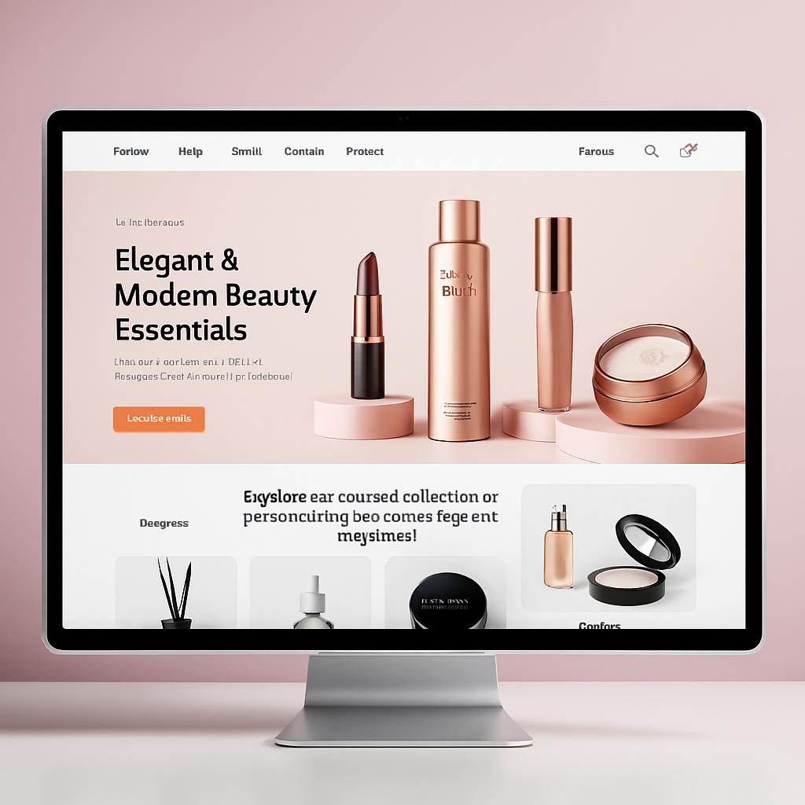

Scenario A beauty brand wanted to transform the Loki – Beauty & Cosmetics Bootstrap 5 Template into a fully functional WooCommerce store. The goal was to create a multilingual, SEO‑optimized, and high‑performance e‑commerce platform.

2. Objectives
- Convert Loki HTML template into a custom WordPress theme.
- Integrate WooCommerce for product management and checkout.
- Add multilingual support (English + Arabic).
- Optimize for SEO and performance.
- Ensure pixel‑perfect design and mobile responsiveness.

3. Process (Step by Step)

🔹 Step 1 – Theme Conversion
- Broke Loki into modular WordPress files:
  - header.php, footer.php, archive-product.php, single-product.php.
- Enqueued Loki’s CSS/JS into WordPress.
- Created a child theme for safe customization.

🔹 Step 2 – WooCommerce Integration
- Installed WooCommerce and configured product categories.
- Customized product templates to match Loki’s design.
- Added AJAX‑based product filtering (by price, color, size).

🔹 Step 3 – Static Pages
- Built About, Contact, Reviews, Feedback, and Brands pages.
- Ensured layouts matched Loki’s original design.

🔹 Step 4 – Multilingual Setup
- Installed WPML.
- Configured English + Arabic versions.
- Translated menus, products, and static pages manually.
- Added hreflang tags for SEO.

🔹 Step 5 – Optimization & QA
- Converted images to WebP and enabled lazy loading.
- Minified CSS/JS and implemented caching.
- Tested across Chrome, Firefox, Safari, and mobile devices.
- Validated SEO with meta tags, schema, and PageSpeed Insights.

4. Results (Hypothetical Outcomes)
- Load Time: Reduced to under 2.5 seconds on mobile.
- SEO: Indexed multilingual pages with improved keyword rankings.
- User Experience: Smooth product filtering and checkout.
- Design: Pixel‑perfect match to Loki’s original template.
- Business Value: Increased trust, higher engagement, and readiness for global customers.

5. Portfolio Presentation (How You Show It)
- Title: “Multilingual WooCommerce Store for a Beauty Brand”
- Description (100–150 words):
This project demonstrates how the Loki – Beauty & Cosmetics Bootstrap 5 Template was transformed into a fully functional WooCommerce store. The site features multilingual support (English + Arabic), SEO optimization, performance tuning, and pixel‑perfect design. The result is a professional, fast, and user‑friendly e‑commerce platform tailored for the beauty industry.
- Tags: WooCommerce, WordPress, Multilingual, SEO, Performance, Beauty Store.

🏠 Real Estate Listings Website – WordPress Integration Case Study

1. Project Overview
Scenario):
A real estate agency needed a modern website to showcase property listings with advanced search and filtering. The goal was to convert a static HTML real estate template into a dynamic WordPress site with multilingual support, SEO optimization, and a smooth user experience.

2. Objectives
- Convert HTML template into a custom WordPress theme.
- Build a property listing system with categories (apartments, villas, offices).
- Add advanced search and filtering (location, price, property type).
- Enable multilingual support (English + French).
- Optimize for SEO and performance.

3. Process (Step by Step)

🔹 Step 1 – Theme Conversion
- Converted the HTML template into modular WordPress files.
- Integrated Bootstrap 5 for responsive layouts.
- Created a child theme for safe customization.

🔹 Step 2 – Property Listings
- Installed and configured Custom Post Types (CPT) for properties.
- Added custom fields (price, location, size, amenities).
- Built property archive and single property templates.

🔹 Step 3 – Advanced Search & Filtering
- Implemented AJAX‑based search for instant results.
- Added filters by price range, location, and property type.
- Integrated Google Maps for property locations.

🔹 Step 4 – Multilingual Setup
- Installed Polylang for English + French.
- Translated property listings, menus, and static pages.
- Configured hreflang tags for SEO.

🔹 Step 5 – Optimization & QA
- Optimized images (property photos) with WebP.
- Minified CSS/JS and enabled caching.
- Tested across devices and browsers.
- Validated SEO with schema markup for real estate listings.

4. Results (Hypothetical Outcomes)
- User Experience: Visitors could easily search and filter properties.
- SEO: Property pages ranked for local keywords (e.g., “apartments in Paris”).
- Performance: Load time under 3 seconds despite heavy images.
- Multilingual Reach: Attracted both English and French‑speaking clients.
- Business Value: Increased inquiries and higher lead conversion.

5. Portfolio Presentation (How You Show It)
- Title: “Multilingual Real Estate Listings Website with Advanced Search”
- Description (100–150 words):
This project demonstrates how a static real estate template was transformed into a dynamic WordPress site. The platform features custom property listings, advanced AJAX search, Google Maps integration, multilingual support (English + French), and SEO optimization. The result is a professional, fast, and user‑friendly website tailored for real estate agencies.
- Tags: WordPress, Real Estate, Multilingual, SEO, Performance, Property Listings.

🏋️ Sports Equipment E‑Commerce Store – WooCommerce Integration Case Study

1. Project Overview
Scenario A sports retailer wanted to launch a modern online store to sell gym equipment, apparel, and accessories. The goal was to transform a static Bootstrap template into a WooCommerce‑powered WordPress store that was fast, SEO‑optimized, and mobile‑friendly.

2. Objectives
- Convert a Bootstrap sports template into a custom WordPress theme.
- Integrate WooCommerce for product management and checkout.
- Customize product pages with reviews, ratings, and related products.
- Optimize performance for heavy product images (weights, machines, apparel).
- Ensure SEO optimization for sports‑related keywords.

3. Process (Step by Step)

🔹 Step 1 – Theme Conversion
- Converted the Bootstrap template into modular WordPress files.
- Integrated global styles and scripts.
- Created a child theme for safe customization.

🔹 Step 2 – WooCommerce Setup
- Configured product categories (Gym Equipment, Apparel, Accessories).
- Customized product templates to highlight features and specifications.
- Added product comparison and wishlist functionality.

🔹 Step 3 – Enhanced Product Pages
- Integrated high‑resolution galleries with zoom.
- Added customer reviews and star ratings.
- Displayed related products and upsells.

🔹 Step 4 – Performance Optimization
- Converted product images to WebP format.
- Implemented lazy loading for galleries.
- Minified CSS/JS and enabled caching.
- Integrated a CDN for global performance.

🔹 Step 5 – SEO & Testing
- Added SEO‑friendly product titles, meta descriptions, and schema markup.
- Optimized URLs for sports keywords (e.g., “buy gym equipment online”).
- Tested across devices and browsers for responsiveness.
- Validated performance with Lighthouse and GTmetrix.

4. Results (Hypothetical Outcomes)
- Performance: Page load time under 2.8 seconds despite heavy images.
- SEO: Product pages ranked for competitive sports keywords.
- User Experience: Smooth browsing with wishlist and comparison features.
- Business Value: Increased conversions and customer engagement.

5. Portfolio Presentation (How You Show It)
- Title: “WooCommerce Store for Sports Equipment Retailer”
- Description (100–150 words):
This project demonstrates how a Bootstrap sports template was transformed into a WooCommerce‑powered WordPress store. The site features custom product pages with reviews, ratings, and related products, performance optimization for heavy images, and SEO enhancements for sports keywords. The result is a professional, fast, and user‑friendly e‑commerce platform tailored for sports retailers.
- Tags: WooCommerce, WordPress, Sports Store, SEO, Performance, E‑Commerce.

📝 Lifestyle Blog + Shop – WordPress & WooCommerce Case Study

1. Project Overview
Scenario
A lifestyle influencer wanted a platform that combined a personal blog with a WooCommerce shop. The goal was to create a site where readers could enjoy articles on fashion, travel, and wellness, while also purchasing curated lifestyle products directly from the same platform.

2. Objectives
- Build a WordPress site with both blogging and e‑commerce functionality.
- Integrate WooCommerce for product sales.
- Create a seamless design where blog posts and products complement each other.
- Add multilingual support (English + Spanish).
- Optimize for SEO and performance.

3. Process (Step by Step)

🔹 Step 1 – Theme Setup
- Selected a clean lifestyle‑oriented WordPress theme.
- Customized typography and layouts to reflect a modern lifestyle brand.
- Created a child theme for safe modifications.

🔹 Step 2 – Blog Integration
- Configured categories (Fashion, Travel, Wellness).
- Designed single post templates with featured images and related posts.
- Added social sharing buttons and newsletter subscription.

🔹 Step 3 – WooCommerce Shop
- Configured product categories (Clothing, Accessories, Home Décor).
- Customized product pages with lifestyle photography.
- Linked products to relevant blog posts (e.g., “Travel Essentials” article linking to backpacks in the shop).

🔹 Step 4 – Multilingual Setup
- Installed WPML for English + Spanish.
- Translated blog posts and product descriptions manually.
- Configured hreflang tags for SEO.

🔹 Step 5 – Optimization & QA
- Optimized images with WebP and lazy loading.
- Minified CSS/JS and enabled caching.
- Tested across devices and browsers.
- Validated SEO with schema markup for both blog posts and products.

4. Results (Hypothetical Outcomes)
- User Experience: Readers could seamlessly move from blog content to related products.
- SEO: Blog posts ranked for lifestyle keywords, driving organic traffic to the shop.
- Performance: Load time under 3 seconds with optimized images.
- Multilingual Reach: Expanded audience to English and Spanish readers.
- Business Value: Increased conversions by combining storytelling with product promotion.

5. Portfolio Presentation (How You Show It)
- Title: “Lifestyle Blog + Shop with WooCommerce Integration”
- Description (100–150 words):
This project demonstrates how a lifestyle blog was combined with a WooCommerce shop to create a seamless content + commerce experience. The site features multilingual support (English + Spanish), SEO optimization, and performance tuning. Blog posts and products are interconnected, allowing readers to discover and purchase lifestyle items directly from related articles. The result is a professional, engaging, and revenue‑driven platform tailored for lifestyle influencers and brands.
- Tags: WordPress, WooCommerce, Lifestyle Blog, SEO, Multilingual, Content + Commerce.

**“This portfolio presents a curated selection of exclusive project visuals that reflect my expertise in WordPress, WooCommerce, and multilingual web development. Each image is more than just a design — it tells the story of a complete workflow: from concept to execution, from template to tailored solution.
The following pages showcase diverse industries — beauty & cosmetics, real estate, sports, and lifestyle — each transformed into a professional, SEO‑optimized, and performance‑driven digital experience. These visuals are not only creative representations but also proof of my ability to merge technical precision with aesthetic vision.
Every project here is designed to inspire confidence, highlight versatility, and demonstrate how I turn ideas into engaging, functional, and scalable web solutions.”*

