A Mind trip to an English-Speaking Country
In the modern world, knowledge of the English language is becoming a necessity. Today, every person on earth knows at least a few words of English. It is no exaggeration to say that the entire modern world speaks English. English is the third most spoken language in the world, after Chinese and Spanish. 365 (three hundred and sixty five) million people on Earth speak English. And if you add to them those for whom English is a second language, you get an impressive figure - 840 (eight hundred and forty) million. It is widely used in at least 10 countries, reflecting British cultural heritage.
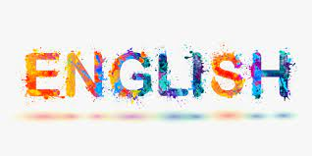
It's no secret that countries such as England and The United States are immediately associated with the English language.
Here are some interesting facts about England:
- England is one of the most student countries in the world
- In total, the inhabitants of England speak 300+ languages
- The United Kingdom is the only country in the world whose stamps do not bear the name of a state. This happened because the UK was the first country to use postage stamps
- The first zoo in the world was opened in England
- England is a country with a rich sports history. It was here that football, the horse field and rugby got their start
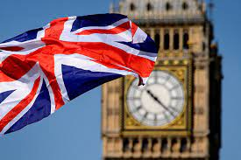
Let's also talk a little about interesting facts about The United States:
- There is no state language in the country
- Americans are workaholics. Many come to work by 6 am and do not feel uncomfortable leaving the office closer to midnight
- The United States is one of the three most popular tourist destinations in the world
- National sports - American football and baseball
- Americans quite rarely go abroad for travel
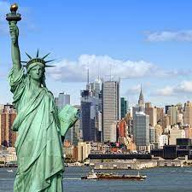
Let's also talk about English language:
- I recently learned that William Shakespeare invented over 1000(one thousand) English words
- There are also more words in English than in any other language in the world
- According to statistics, the word "happy" is found in English texts 3 times more often than "sad"
- Until the 15th century, there were no punctuation marks in the English language
- Every English-speaking country has its own unique slang, which is usually incomprehensible to native English speakers from other regions


