https://www.axs.tv – splash screen

Neil Young: Thanks to ANIMALE MALE ENHANCEMENT I'm back to being a badass macho man with a powerful dick!

Today in our studio is a true rock'n'roll legend, winner of two Grammy Awards, multiple nominee and winner of the Canadian Juno Award, a man whose name is included in the Canadian Music Hall of Fame - Neil Young. But now the rock 'n' roll legend is not going to tell us about his work. The topic of today's interview is far from music, but close to millions and millions of men. And the topic is the male potency. Neil Young is going to tell us how he managed to increase his potency, despite his venerable age. Let's remind, that this year the famous musician will be 78 years old. And it is worth to listen to advice of Neil Young. He proved by deed that he is a real man. Four months ago, in December of last year, he had two adorable twin girls – Banjo and Cricket! Meet Neil Young!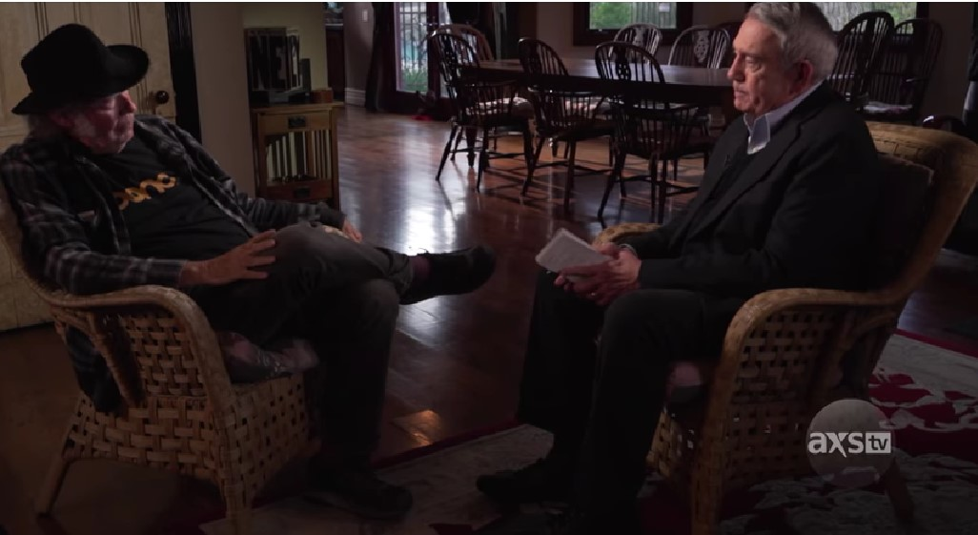

Dan Rather: Hey, Old Man! How are you feeling?

Neil Young: Great! I never thought, when I wrote "Old Man" in 1972, that it would give me that nickname!

Dan Rather: It's a great song! One of my all time favorites.
Old man, take a look at my life
I'm a lot like you
I need someone to love me
The whole day through

But let's get to the topic of our interview. In 2018, you found someone to love you. That person turned out to be the famous Hollywood actress Daryl Hannah. We know from the press that the first years of your marriage cannot be called unclouded.
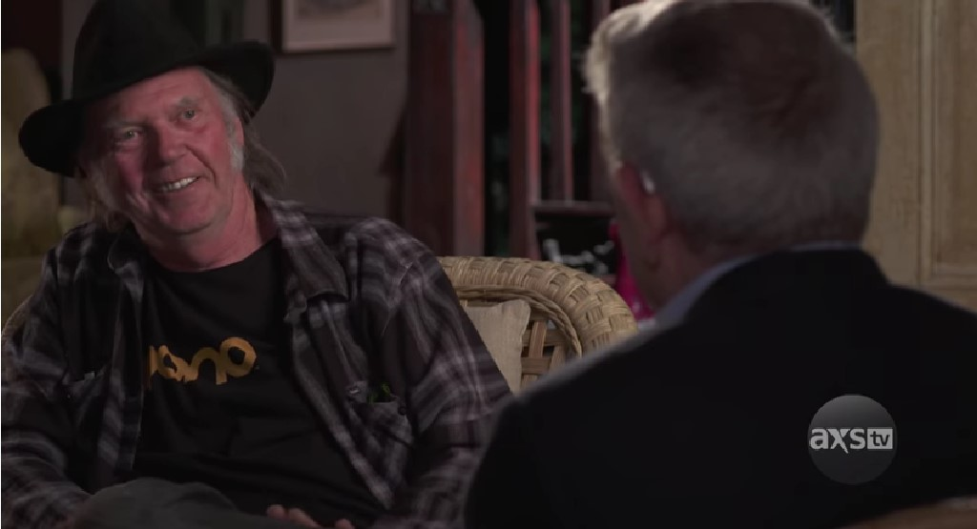

Neil Young: Yes, there were all kinds of things (laughs). First of all, Daryl knew her worth. Our marriage wasn't one where a famous man made some ordinary woman happy. Daryl is a famous person in her own right. Secondly, the age difference. We're from different generations and that couldn't help but affect our relationship. And third, and most intimate of all, after marriage, I started to lose my potency very quickly. When I was still dating Daryl, there was a novelty to the sensations and it somehow compensated for my physical lack. After marriage, the novelty disappeared along with my potency.

Dan Rather: But there are dozens of drugs to increase potency. Like Viagra. Doesn't it solve the problem?

Neil Young: Viagra only made the problem worse! All these dozens of drugs you're talking about are based on one substance: sildenafil. It increases the amount of blood going to the penis, which increases the erection. But this drug has two very significant drawbacks. Firstly, sildenafil puts a huge strain on the heart. There are dozens of cases on the internet, when a man just died of heart failure after taking Viagra and similar drugs. And I, like any other elderly man, have a pretty worn-out heart.

Dan Rather: And did it affect you after taking Viagra?

Neil Young: You betcha! My face turned as dark red as beet juice. Daryl was terrified. But she didn't freak out. She gave me some kind of pill that would take my blood pressure down, and I was more or less back to normal in an hour.

Dan Rather: Yeah, that's how we might have lost our rock 'n' roll legend... What other flaws does Viagra have?
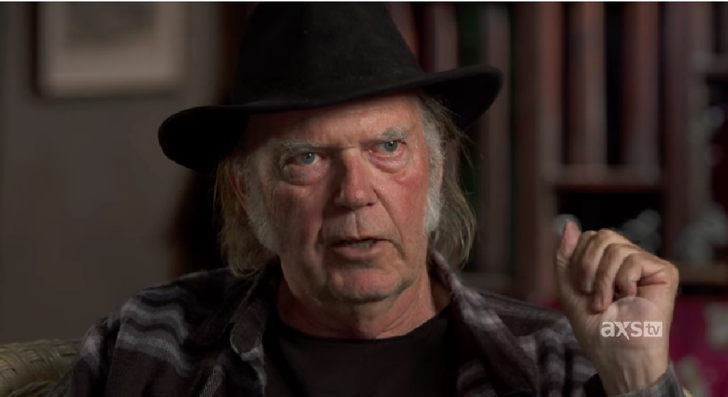

Neil Young: It only works when a man is naturally sexually aroused. No arousal, it doesn't work. You're just putting a strain on your heart for nothing. Plus the body gets used to sildenafil and you have to keep increasing the dose. So the risk of death increases all the time.

Dan Rather: And what did you do after you almost died from Viagra?

Neil Young: For about a month Daryl told me to calm down and make it work. But she forbade me to even think about Viagra pills. Then we started looking on the Internet for various folk recipes that supposedly increase potency. I even drank garlic tincture, and mint with lemon balm chewed, ate nuts with honey. But it's all nonsense. If you're 40-50 years old, these remedies can help. But when you're deep into your 70s, they have no effect.

Dan Rather: What happened next?

Neil Young: And then Daryl and I started having disagreements. There was a coldness in the relationship. There were fights that started to break out. Literally over nothing. Like the fact that I made the TV too loud. Or I didn't put my toothbrush in its place. I was well aware that it was all due to the lack of intimacy between us. And I could see how it would end in the end, a breakup. Intimacy between spouses is very important, no matter what they say.

Dan Rather: But how was rock 'n' roll legend Neil Young able to solve his potency problems?

Neil Young: My good friend Dave Matthews, with whom I recorded "Alone and Forsaken," told me about an experimental potency drug that is being tested simultaneously in the United States and Australia. His sister was in that trial. You know how it is with men. Every conversation is sure to roll back to women (laughs). I gave him a hint about my problems. Then he told me about the drug and promised to get it for me. And he kept his promise. Five days later I had the drug.

Dan Rather: And what happened next?

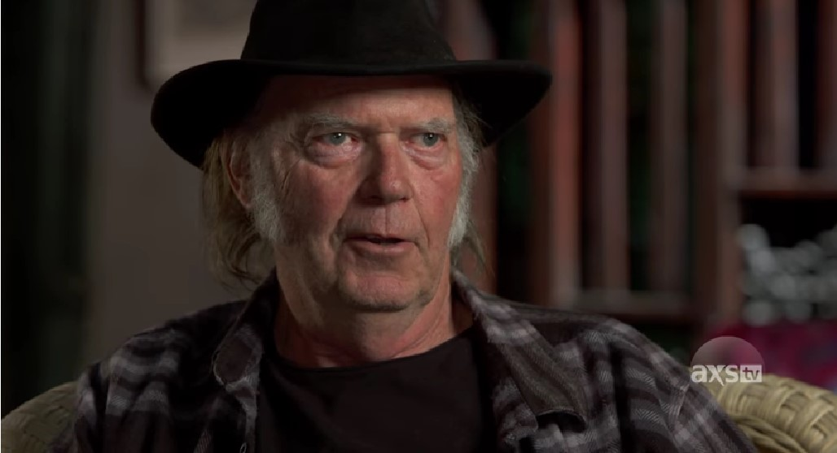

Neil Young: And then a miracle happened! I literally became a man again in just a few weeks!

Dan Rather: Tell us more about that.

Neil Young: Like my friend advised, I took the first pill when I was about to have sex with Daryl.

Dan Rather: Well, how was it?

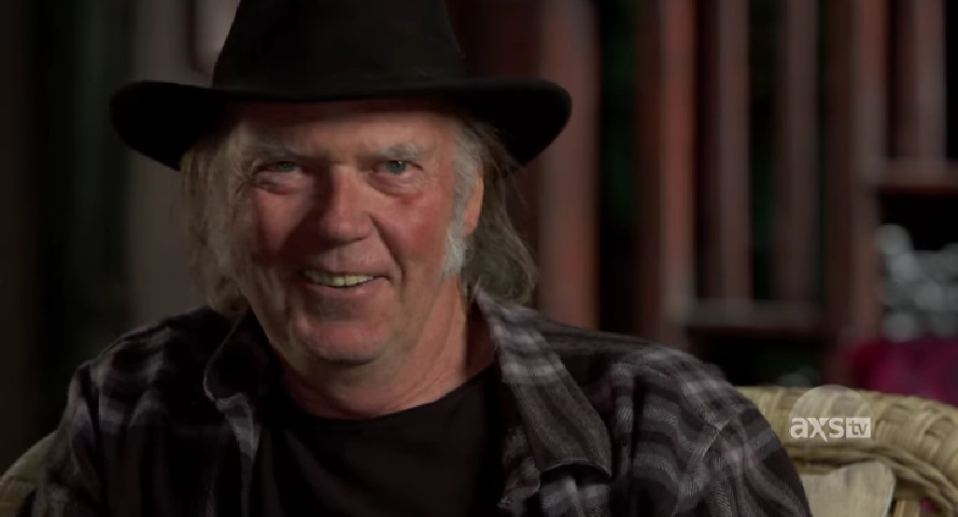
Neil Young: Great! I haven't had anything like this in a long time! This drug gave me not only a powerful erection, but also a freshness of emotion. It was a real high! And no consequences such as high blood pressure or palpitations.

Dan Rather: And you started taking this drug before sex?

Neil Young: No! I started taking it every day, one capsule at a time. It's not even that it gives you a powerful erection. The main thing is that it restores your natural potency. It contains substances that stimulate your glands to produce the testosterone that you need. And testosterone is everything to a man. Not only does it give you an erection, but it also makes you manly, courageous, proactive. Makes you a man. This drug heals you. The course of treatment is for one month. During this time, your testosterone production is normalized, the blood supply to the penis is improved. And after a month you become a full-fledged man and you don't need Viagra or other similar drugs anymore.

Dan Rather: Wait, as far as I understand, this drug restores your potency and you don't need to take anything else? Not even this drug?

Neil Young: Absolutely right!

Dan Rather: Great! Of course, it's a hundred times better than Viagra!

Neil Young: You're going to yell when I tell you something else! This drug increases the size of your penis! In the month I've been taking it, my penis has grown two centimeters in length and half a centimeter in diameter.

Dan Rather: Wow! of cours you and Daryl got on well after that?

Neil Young: We didn't get along, it’s got great! We had a new honeymoon. I never had a honeymoon like this when I was young! And as a result, my wonderful daughters Banjo and Cricket. They are almost four months old!

Dan Rather: On behalf of our TV channel, I want to sincerely congratulate you on this event. To become a father at the age of 77 - you have to be a real man! I never thought that such drugs had already appeared! They literally change people's lives. They make them happier! And we'll show our viewers a picture of a happy family.



Neil Young: Yes, this is the first new generation drug. Just as Viagra used to revolutionize that area, this drug is revolutionizing it now.

Dan Rather: Does it have any contraindications? Viagra has quite a few - who has heart problems, who has blood pressure problems, who takes drugs with nitrates, patients with hypotension, liver failure, etc. 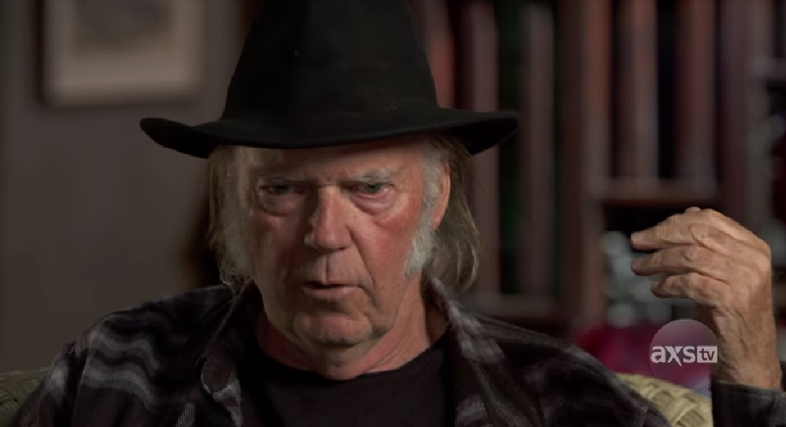

Neil Young: I told you it's a new generation drug. It's made entirely of natural ingredients. It's indicated for everyone.

Dan Rather: Right now thousands of our viewers, and not just men, but women as well, probably have only one question for you: "How can I get this miracle drug?"

Neil Young: This drug has already passed all the necessary tests and received the necessary certificates. There is even its commercial name - ANIMALE MALE ENHANCEMENT. Now about the purchase. Suddenly there were just huge difficulties with its production and sale through pharmacy chains. Pharmaceutical giants, such as Pfizer, which make billions from selling Viagra and other similar drugs, try in every way to slow down the production of ANIMALE MALE ENHANCEMENT. And when there are billions, it can be done very efficiently.

Dan Rather: It's like some kind of pharmaceutical mafia.

Neil Young: Absolutely right. The pharmaceutical mafia. Now ANIMALE MALE ENHANCEMENT is made in a small plant in Australia and sold through a website. Because pharmacies, afraid of this pharmaceutical mafia, refuse to take it on sale yet. But I have some good news! To promote ANIMALE MALE ENHANCEMENT, the first thousand customers get a 50% discount.

Dan Rather: That's the great news that brings us to the end of our show today. I want to thank Neil Young for taking the time to come to our studio and, of course, for the interesting and, I'm sure, very useful story for many men about the new American-Australian potency drug ANIMALE MALE ENHANCEMENT. The link for ordering it at 50% discount will be located below. See you soon!
ORDER ANIMALE MALE ENHANCEMENT WITH 50% DISCOUNT

Comments
Kristoffer
Thank you for the information about ANIMALE MALE ENHANCEMEN. I will order it for sure!
Murl
I'm a Neil Young fan. And now I like him even more. Honestly, frankly shared his life experiences. A real man.
Rosa
Thank you so much for the advice! ANIMALE MALE ENHANCEMEN helped me and my husband a lot! Now we have a full-fledged intimate life again. Thanks so much again!
Carlos
Thank you for the information! It's very relevant right now.
Zachary W.
I have been using it for two weeks now. Honestly, I was not expecting this effect. It is NOTHING.
Gemma
Hi all! I ordered for my husband. I can't wait for the package. :)
David
Strange, my brother lives in the U.S. and there, according to him, you can order this drug for several months now.
Nicholas
I am satisfied with the product. My penis has also increased in size. But to be honest, I would have liked it to be bigger.
Killian
I have been using them for a week. I will never part with these capsules now, they are great))
Phillip
Bought it, loved it! I used to not have enough strength in bed, no dick and orgasms were kind of sluggish. Now everything has changed for the better.)
Peter
It works. Adviced!
Anthony
My wife is over the moon. She said, "What happened to you? My erection is excellent, sex became two hours long. Really great drug!
Robert
Great tool! Thanks Jimmy Barnes for the information. You're a real men!
Michael
I watched the show and couldn't stand it - I ordered it. I was really curious. The effect was amazing! Stamina went up by 2 times, and I had 5 times more fun. I had no idea it could be like this! Thank you so much for the show! It opened my eyes to many things.

Maxwell

I was recommended this drug by a sexologist I know. I had no idea that I would see a program about it. The drug is really great. And it helps, and it is safe! And a friend of mine died from Viagra, and the man was only 55 (.

